**JAVA**

* What is java?

**Solution:**

* Java is a programming language and a platform.
* Java is a high level, robust, object-oriented, and secure programming language.

**Note:**

* Java is case sensitive language.
* Extension for saving will be .java.
* Java was developed by sun-microsystems (which is now the subsidiary of Oracle) in the year 1995 by James Gosling and his team.
* James Gosling known as father of java.
* What is platform?

**Solution:**

* Any hardware or software environment in which a program runs, is known as a platform.
* Since, java has run time environment (JRE) and API, it is called a platform.
* Whether Java is platform independent or dependent?

**Solution:**

* Java is platform independent where java code will be write once run anywhere in any OS.
* What is JDK, JRE and JVM?

**Solution:**

JDK-Java Development Kit

JRE-Java Runtime Environment

JVM-Java Virtual Machine

* Whether JDK, JRE and JVM are platform independent or dependent?

**Solution:**

JDK, JRE and JVM are platform dependent.

* What is API?
* API-Application Programming Interface.
* Set of predefined rules and specifications for accessing for accessing a web-based software application or web tool.
* At which java code run?
* Java source code compiles into class file using compiler which is ***compile time environment***.
* When the class file forward to JVM and it’s been interpreted using interpreter and shows the output for the code which is ***run time environment***.
* Explanation on Java Architecture?

**Java Architecture:**

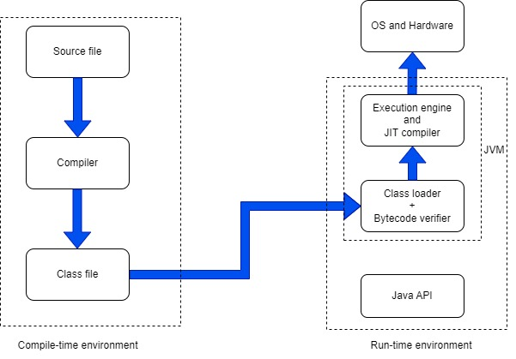

* What are all the features in java?

**Solution:**

There are 12 features in java.

* + Simple
  + Object oriented.
  + Portable
  + Platform independent
  + Secured
  + Robust
  + Architecture neutral
  + Interpreted
  + High performance
  + Multithreaded
  + Distributed
  + Dynamic
* Platforms in java?

**Solution:**

* Java SE-Java Standard Edition
* It is a java programming platform.
* It includes java programming API’s such as java.lang, java.io, java.util, java.math etc.
* It includes core topics such like OOPs, String, Regex, Exception, Multithreading, I/O streams, collections etc.
* Java EE or J2EE-Java Enterprise Edition
* It is an enterprise platform that is mainly used to develop web and enterprise applications.
* It is built on top of Java SE platform.
* It includes topics like Servlet, JSP, Web Services, JPA etc.
* Java ME-Java Micro Editon
* It is a micro platform that is dedicated to mobile applications.
* JavaFX
* It is used to develop rich internet applications.
* It uses lightweight user interface API.
* What are all the applications that we can develop through java?

**Solution:**

* Standalone applications or Desktop applications or Window based applications.
* Web applications.
* Enterprise applications.
* Mobile applications.
* Whether java is a purely object-oriented or not purely object-oriented and illustrate it?

**Solution:**

* Java is not a purely object-oriented as it contains primitive datatypes.
* But we can make it into purely object-oriented by converting primitive datatypes into object using **wrapper class** so that we can say at that point that java is a purely object-oriented.
* Explain about **Wrapper class**?

**Solution:**

It is conversion process to make datatypes into object.

* Converting primitive datatype into object is known as autoboxing.
* Converting object into primitive datatype is known as unboxing.

**Autoboxing**

* int-Integer
* float-Float
* char-Character
* double-Double
* byte-Byte
* boolean-Boolean
* short-Short
* long-Long