**SECTION 1**

Nowadays owning a four-wheeler is the number one priority for the majority of people. But most of them can’t afford it at the initial stage so, they go for a used vehicle.

A used car dealership specializes in selling cars from various brands. The mileage of these cars is a good predictor of their sale prices. What other factors might play a role in deciding the price a customer might be willing to pay?

For a better understanding of that it is necessary to do EDA and build a model to predict the multiple aspects that are most influencing the price of a vehicle.

Data frame:

This data frame includes some outliers, null values, and some empty cells also.

This has both Numerical and categorical values.

RangeIndex: 7253 entries, 0 to 7252

Data columns (total 14 columns):

# Column Non-Null Count Dtype

--- ------ -------------- -----

0 Unnamed: 0 7253 non-null int64

1 Name 7253 non-null object

2 Location 7253 non-null object

3 Year 7253 non-null int64

4 Kilometers_Driven 7253 non-null int64

5 Fuel_Type 7253 non-null object

6 Transmission 7253 non-null object

7 Owner_Type 7253 non-null object

8 Mileage 7251 non-null object

9 Engine 7207 non-null object

10 Power 7207 non-null object

11 Seats 7200 non-null float64

12 New_Price 1006 non-null object

13 Price 6019 non-null float64

dtypes: float64(2), int64(3), object(9)

memory usage: 793.4+ KB

If we see the correlation between each aspect,

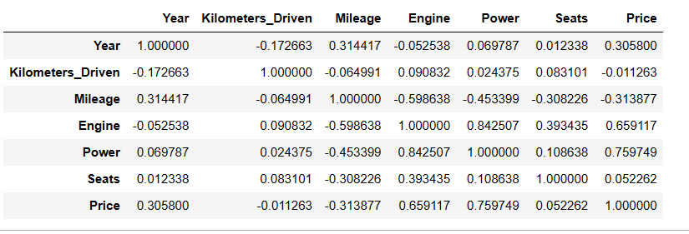

**SECTION 2**