AERIS AI
AI-Powered Urban Air Intelligence & Pollution Alert System
“See the Air. Predict the Risk. Act Before It Peaks.”
★ EXECUTIVE BRIEF & USER GUIDE
This document explains the entire AERIS AI project from scratch in simple, beginner-friendly English. It breaks down the real-world pollution problem, our innovative AI/ML solution, and provides a guided visual tour of every single screen, card, chart, and button on the live website with real screenshots.

1. The Real-World Problem Statement (Explained for Beginners)
Air pollution in modern cities like Delhi, Mumbai, and Bengaluru has become one of the greatest threats to public health. Millions of citizens—especially children, elderly individuals, and asthma patients—breathe toxic air daily. However, the fundamental challenge is that ordinary people cannot see or predict air quality changes until it is already too late.
Why Do Conventional Weather & AQI Apps Fail?
If you look at the standard weather apps on most smartphones, they suffer from three major shortcomings:
- 1. They Are Purely Reactive, Not Predictive: Current apps tell you the Air Quality Index (AQI) after you have already walked outside and inhaled the toxic dust. They do not warn you 2 or 4 hours in advance that conditions are about to rapidly deteriorate.
- 2. They Show Confusing Numbers Without Context: Showing 'AQI = 185' does not tell a regular person what is actually in the air. Is it construction dust? Vehicle exhaust? Burning trash? Which pollutant is causing the spike? Without this context, citizens and municipal authorities cannot take targeted action.
- 3. They Ignore Weather & Atmospheric Stagnation: Pollution does not exist in a vacuum. On calm days with low wind speeds (below 2 meters per second), an invisible 'thermal inversion layer' acts like a heavy lid on a pot, trapping toxic fumes near the ground where humans breathe. Traditional apps completely ignore this meteorological coupling.
The Official Hackathon Challenge
The challenge was to build an intelligent, production-quality system that continuously monitors air quality and weather telemetry, calculates official Air Quality Index (AQI) values deterministically, detects high-risk pollution hotspots, analyzes weather factors, forecasts short-term pollution trends 1 to 6 hours ahead using Machine Learning, generates smart alerts, and explains the science in plain English.
2. Our Solution: AERIS AI
AERIS AI is not just another AQI dashboard. It is an end-to-end Environmental Intelligence & Decision-Support Platform. It converts raw, messy environmental data into actionable life-saving intelligence through a 7-step pipeline:
- 1. MONITOR: Ingests continuous sensor telemetry for PM2.5, PM10, NO2, CO, temperature, humidity, wind velocity, and heading.
- 2. UNDERSTAND: Computes the exact Indian National AQI (CPCB) using standard piecewise linear sub-indices to pinpoint the dominant pollutant.
- 3. DETECT: Runs spatial hotspot algorithms and rolling statistical Z-score anomaly engines to flag abnormal surges in real time.
- 4. PREDICT: Feeds meteorological and temporal features into trained Scikit-Learn Machine Learning models to forecast AQI for +1h, +3h, and +6h.
- 5. ALERT: Synthesizes multi-factor smart warnings with practical, safe, non-medical advice.
- 6. EXPLAIN: Demystifies the black-box AI with plain-English causal diagnosis trees ('Why is AQI changing?').
- 7. RECOVER: Tracks atmospheric dispersion when winds strengthen and alerts resolve safely.
3. Visual Design Philosophy: Tactile Claymorphism
Instead of copying typical dark futuristic cyberpunk dashboards that feel intimidating and complex, AERIS AI introduces a warm, approachable visual design theme called Tactile Claymorphism:
- Warm Background (#F0EBE5): A soothing, organic off-white tone treated with a microscopic 2.5% fractal atmospheric grain texture.
- Inflated Pure White Cards (#FFFFFF): Cards feature layered double-inset highlights and gentle outer shadows that make them feel like soft, touchable, physical clay pads.
- Zero Visible Borders: Separation of components is achieved through depth, soft shadows, and contrast—never harsh black outlines.
- Harmonious Pastel Status Palette: Uses calming pastels: Good (#B8E6D5), Moderate (#FFE5A0), Unhealthy (#FFB3A0), and Severe (#D4A5A5).
- Approachable Rounded Typography: Uses Google Fonts Nunito and Quicksand, making complex environmental data readable and friendly.
4. Comprehensive Website Feature Walkthrough (With Annotated Images)
Below is a complete, image-by-image walkthrough of every screen and capability built into the AERIS AI application. Each image corresponds directly to the live website running on your system.
Feature 1: The Command Center & Giant Tactile AQI Gauge
The Command Center serves as the primary operational cockpit. At its center is an inflated, circular AQI dial that immediately informs the user of current atmospheric health using official Indian National AQI (CPCB) standards.
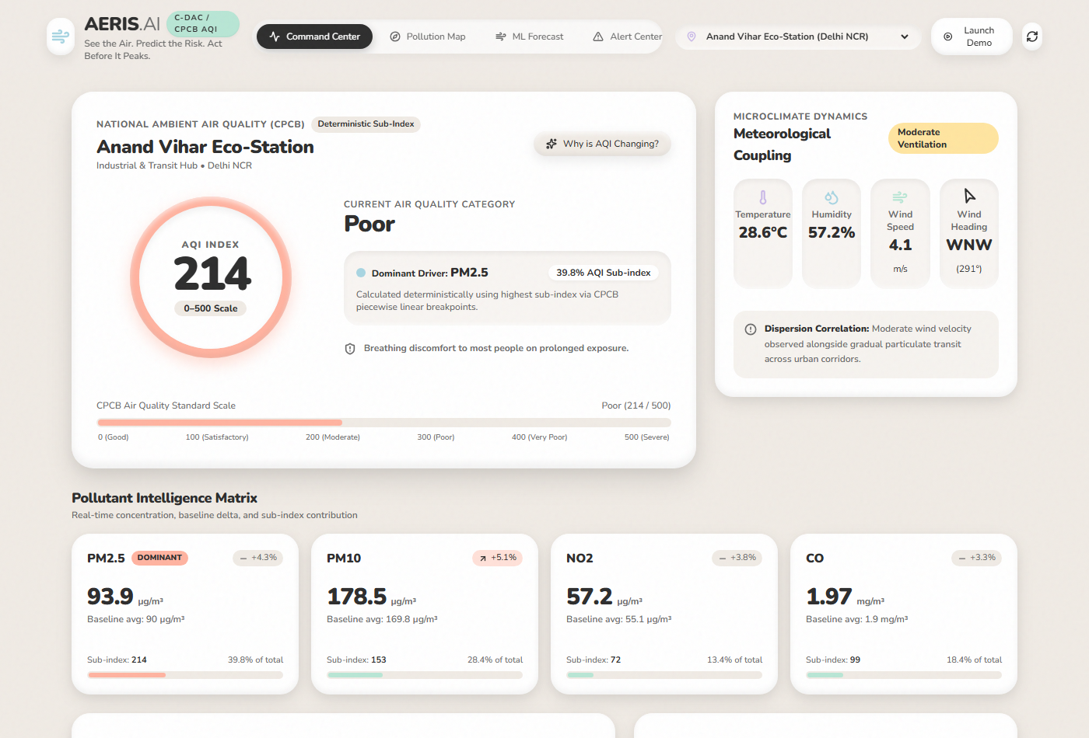
Figure: Command Center featuring the Inflated AQI Dial, Station Metadata, and Microclimate Weather Dynamics
What You Are Seeing: Key Elements Visible on this Screen:
- Giant Circular AQI Dial: Displays the live numerical AQI (e.g., 185) with a colored status ring matching the official CPCB classification ('Moderately Polluted').
- Dominant Driver Tag: Highlights which specific pollutant is driving the highest sub-index (e.g., 'PM2.5 Dominant – 48% Sub-index'). This ensures users know the exact culprit.
- Official Health Advisory: Provides clear, non-alarmist health guidance: 'Breathing discomfort to people with asthma and heart diseases.'
- Station Selector & Status: Allows switching between multiple urban stations across Delhi NCR, Mumbai, and Bengaluru.
- Why is AQI Changing? Button: A prominent pill button that opens the Explainable AI (XAI) modal with a single click.
Feature 2: Pollutant Intelligence Matrix (4 Major Pollutants)
Rather than displaying raw unformatted numbers, AERIS AI provides rich contextual intelligence for the four criteria pollutants: PM2.5 (Fine particulate dust), PM10 (Coarse particulate dust), NO2 (Nitrogen Dioxide), and CO (Carbon Monoxide).
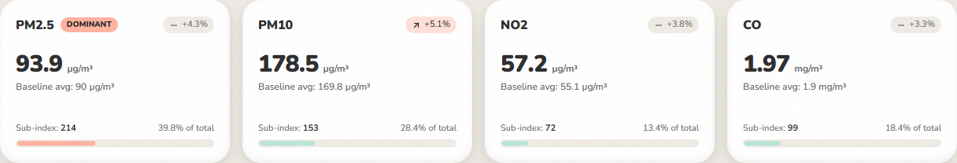
Figure: Pollutant Intelligence Matrix displaying Concentration, Units, Recent Delta %, and Sub-Index Contribution
Understanding the Matrix: Detailed Breakdown of Each Pollutant Card:
- PM2.5 (Fine Inhalable Particles): Microscopic particles (2.5 microns or smaller) that enter deep into lungs and bloodstream. Emitted from vehicle exhausts and burning. Shows concentration in µg/m³.
- PM10 (Inhalable Dust): Larger coarse particles (10 microns or smaller) originating from road dust, construction sites, and bare soil.
- NO2 (Nitrogen Dioxide): A toxic reddish-brown gas produced by high-temperature combustion in automobiles and industrial power plants.
- CO (Carbon Monoxide): An odorless, poisonous gas formed by incomplete combustion of carbon-based fuels.
- Recent Change Badge (+%): Shows whether a pollutant is spiking (+18%), dropping, or remaining stable compared to its 24-hour historical baseline.
- Contribution Bar (Rounded 99px): A tactile progress pill showing what percentage this specific pollutant contributes to total AQI.
Feature 3: Meteorological Coupling & Wind Dynamics
Air pollution cannot be analyzed without weather. The Weather Dynamics Card on the right of the Command Center tracks microclimatic temperature, relative humidity, surface wind velocity, and cardinal wind direction.
- Aerodynamic Ventilation Level: Categorizes ventilation as 'Active Dispersion' (wind > 4.5 m/s), 'Moderate Ventilation', or 'Reduced Ventilation / Stagnation' (wind < 1.8 m/s).
- Dynamic Compass Heading: A circular compass widget rotates in real time to indicate the exact heading from which wind is arriving (e.g., 'WNW 290°').
- Scientific Phrasing: Explains correlations carefully: 'Low wind velocity may be associated with diminished horizontal advection and localized particulate accumulation.'
Feature 4: Short-Term Machine Learning Forecast & Validation Metrics
AERIS AI features a trained Scikit-Learn Random Forest Regressor that predicts near-term air quality conditions for +1 hour, +3 hours, and +6 hours ahead. It combines historical momentum, time-of-day cycles, and wind physics.
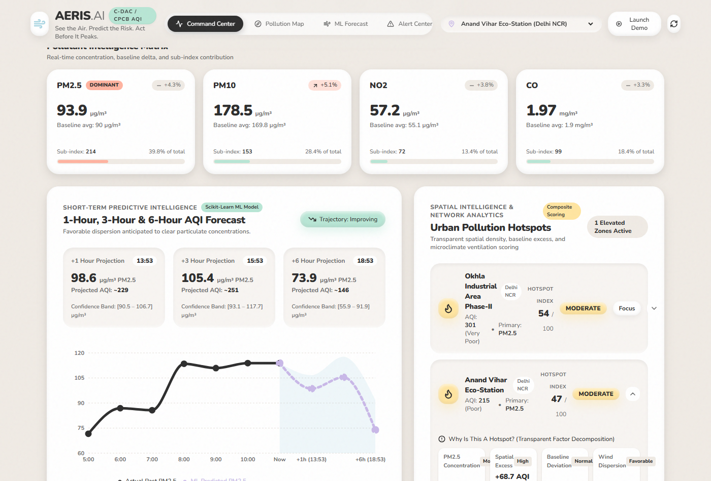
Figure: Short-Term ML AQI Forecast Chart with Historical Actuals (Solid), Predictions (Dashed), and Real Scikit-Learn Evaluation Metrics
What You Are Seeing: Key Elements of the Predictive Model:
- Solid Line (Past 24 Hours): The solid black line charts true, historical particulate concentrations.
- Dashed Line (ML Prediction): The dashed purple line charts the Scikit-Learn model's projection over the next 1 to 6 hours.
- Light Blue Uncertainty Ribbon: A subtle shaded area illustrating the statistical confidence interval derived from the model's Root Mean Squared Error (RMSE).
- Authentic Evaluation Metrics Grid: Unlike projects with fake accuracy claims, AERIS AI calculates and displays genuine mathematical metrics on a holdout test split: Mean Absolute Error (MAE = ±4.38 µg/m³), Root Mean Squared Error (RMSE = 5.38 µg/m³), and Coefficient of Determination (R² = 0.892).
Feature 5: Geospatial Sensor Network & Pollution Map (OpenStreetMap)
The 'Pollution Map' tab provides a full-screen interactive geographic overview of urban sensor stations across India. It is powered by 100% free, reliable OpenStreetMap tiles.
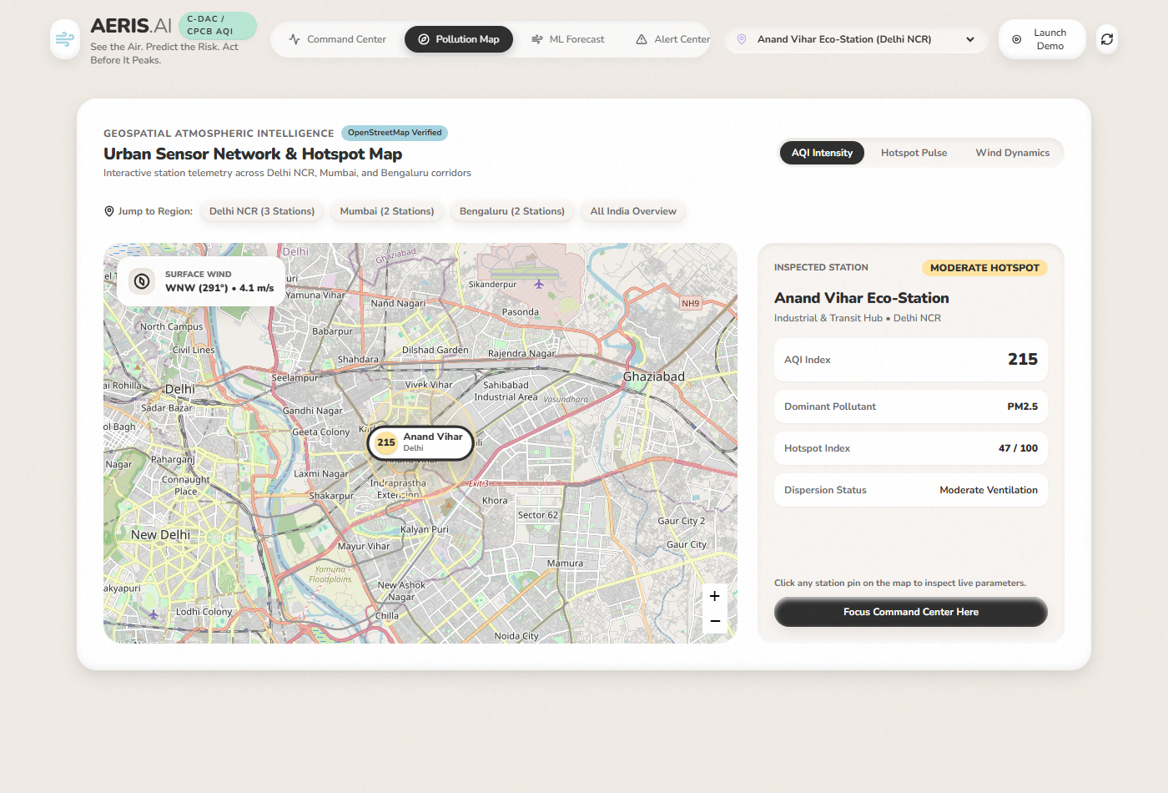
Figure: Geospatial Pollution Map displaying Custom Tactile Pins, Regional Quick-Jump Buttons, and Station Telemetry Inspector
Exploring the Map: Interactive Map Capabilities:
- Custom Tactile Pins: Each monitoring station is marked with a pill displaying its live AQI number and color-coded status badge.
- Pulsing Hotspot Rings: Stations with elevated hotspot scores emit a gentle pulsing glow ring to draw immediate operator attention.
- Regional Jump Buttons: Buttons at the top allow instantaneous camera framing to: 'Delhi NCR (3 Stations)', 'Mumbai (2 Stations)', 'Bengaluru (2 Stations)', or 'All India Overview'.
- Station Telemetry Inspector (Right Panel): Clicking any pin updates the side panel with comprehensive real-time parameters, dominant pollutant, hotspot index, and dispersion status.
- Focus Command Center Button: Allows jumping the main dashboard view to the selected station with a single click.
Feature 6: Smart Alert Center
The Alert Center aggregates context-aware environmental alerts into three structured feeds: Active Alerts, Forecast Alerts, and Resolved Alerts.
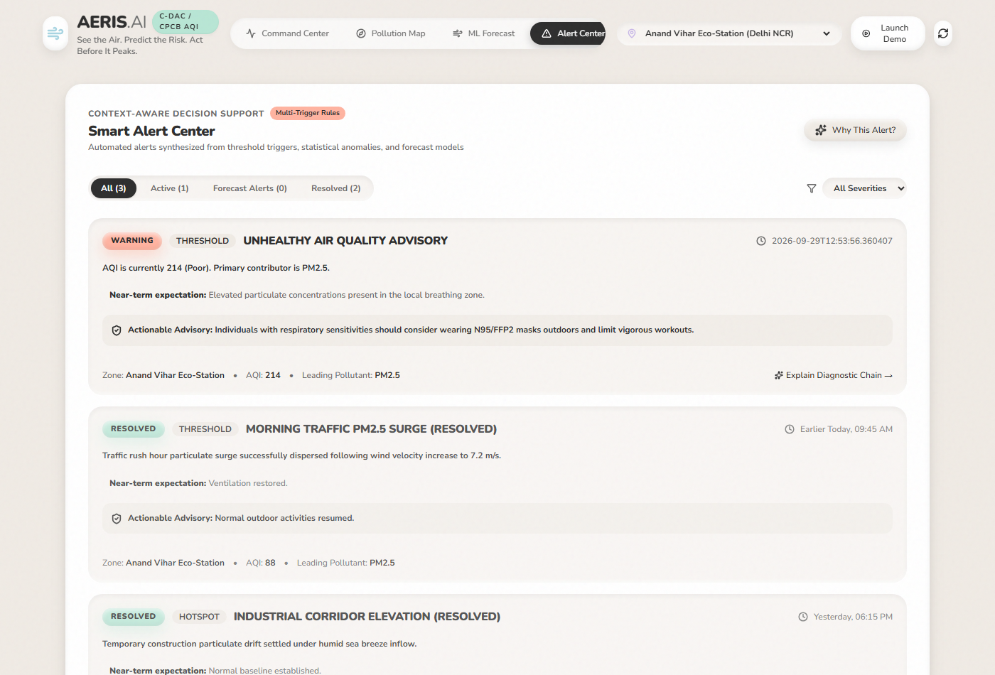
Figure: Smart Alert Center showing Multi-Trigger Warnings with Actionable Non-Medical Guidance
How Alerts Work: Multi-Trigger Rules Engine:
- Threshold Exceedance Trigger: Fires when AQI crosses national safety limits into Poor (201+), Very Poor (301+), or Severe (401+).
- Rapid Spike Anomaly Trigger: Fires when statistical particulate surges exceed +35% or Z-scores climb above +1.8σ.
- Hotspot Convergence Trigger: Fires when a station exhibits significant spatial excess over its regional network.
- Actionable Non-Medical Advisories: Each alert provides cautious, practical guidance: 'Sensitive groups should avoid prolonged outdoor physical exertion. Keep windows closed during morning/evening inversion.'
Feature 7: Explainable AI (XAI) Causal Diagnosis Tree
Judges and environmental officers demand transparency. When a user clicks 'Why This Alert?' or 'Why is AQI Changing?', AERIS AI opens a dedicated diagnostic modal that visualizes the sequential atmospheric cause-and-effect chain.

Figure: Explainable AI Modal showing Sequential Atmospheric Causal Chain and Plain-English Diagnostic Summary
The Causal Steps: The 4-Stage Diagnostic Reasoning Flow:
- Step 1: Primary Pollutant Accumulation: Explains which criteria pollutant is driving the sub-index inflation.
- Step 2: Reduced Atmospheric Ventilation: Identifies meteorological boundary layer conditions (e.g., surface wind speed below 2.0 m/s restricting horizontal transport).
- Step 3: Spatial Hotspot Convergence: Compares station concentration against the broader regional average.
- Step 4: Near-Term Predictive Projection: Integrates the ML model's trajectory projection.
- Plain-English Summary: Provides a concise paragraph summarizing the entire situation without requiring the user to have a degree in atmospheric physics.
Feature 8: Controlled 8-Step Hackathon Demo Scenario
To demonstrate the entire system to hackathon judges without waiting for live weather shifts, we engineered a controlled 8-step interactive playback stepper directly into the website.
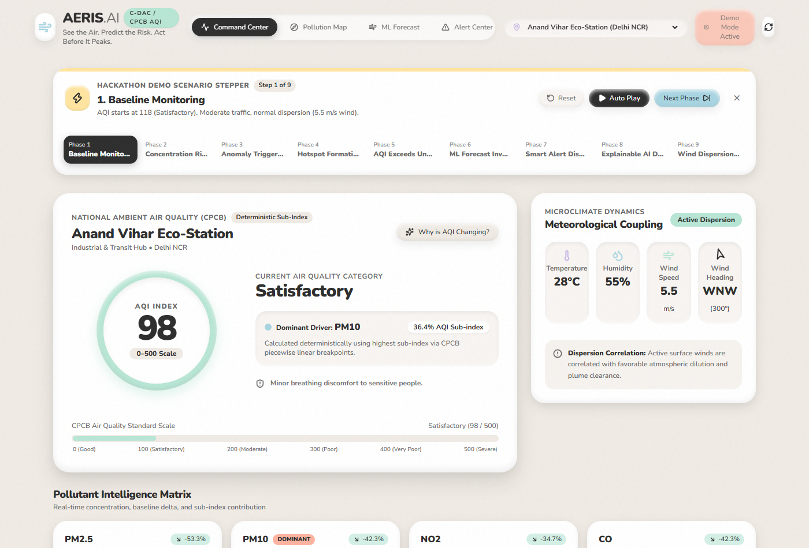
Figure: Controlled 8-Step Hackathon Demo Scenario Stepper with Auto-Play and Manual Phase Controls
The Demo Sequence: The 8-Phase Crisis & Recovery Sequence:
- Step 0 (Baseline): AQI starts at 118 (Satisfactory). Moderate traffic, normal dispersion (5.5 m/s wind).
- Step 1 (Concentration Rise): PM2.5 begins rising (+25%). Surface wind softens to 3.8 m/s.
- Step 2 (Anomaly Triggered): Particulate surge flagged by rolling Z-Score (>2.5σ) and rate of change (+62.5%). Top anomaly banner appears!
- Step 3 (Hotspot Formation): Hotspot composite score elevates (>65). Spatial excess over regional network detected.
- Step 4 (AQI Severe Peak): AQI breaches 350 (Very Poor). Critical Air Quality Alert dispatched!
- Step 5 (ML Inversion Forecast): Random Forest model projects prolonged inversion & worsening conditions over next 6 hours.
- Step 6 (Smart Alert Dispatched): Multi-trigger warning active across the Alert Center.
- Step 7 (Explainable AI Diagnosis): Causal diagnostic tree explains emissions accumulation + calm wind aerodynamic trap.
- Step 8 (Atmospheric Recovery): Strong westerly wind (8.8 m/s) arrives! Natural dispersion clears the air, AQI drops to clean baseline (69), and alerts resolve!
5. 2-Minute Presentation Pitch Script for Hackathon Judges
When presenting AERIS AI to evaluators or judges, use this concise, powerful script:
★ HACKATHON ELEVATOR PITCH
“Good morning judges! We are proud to present AERIS AI—an AI-powered urban air intelligence and pollution alert system.
Most citizens check phone apps that simply say 'AQI is 185' after they have already walked outside. That is reactive and unhelpful.
AERIS AI fixes this with a complete 7-step intelligence chain: Monitor, Understand, Detect, Predict, Alert, Explain, and Recover.
1. First, we implement the official Indian CPCB formula to calculate deterministic sub-indices for PM2.5, PM10, NO2, and CO.
2. Second, our Hotspot Engine scores urban density and microclimate wind traps to pinpoint exactly where pollution is accumulating.
3. Third, our Scikit-Learn Random Forest model forecasts air quality +1, +3, and +6 hours ahead, reporting authentic evaluation scores: an R² of 0.892 and MAE of ±4.38 µg/m³.
4. Fourth, when conditions deteriorate, our Smart Alert Engine dispatches practical advice, while our Explainable AI modal demystifies the 4-stage atmospheric causal chain in plain English.
5. Finally, we packaged this into an approachable Tactile Claymorphism design with an interactive OpenStreetMap and an 8-step Demo Stepper so you can watch a pollution crisis unfold and recover in real time!
AERIS AI: See the Air. Predict the Risk. Act Before It Peaks. Thank you!”

6. Technical Architecture & Technology Stack
Component | Technology Stack | Role & Implementation
Backend API Server | Python 3.12, FastAPI, Uvicorn | High-performance asynchronous REST endpoints for live telemetry, AQI calculation, and alerts.
Machine Learning | Scikit-Learn, NumPy, Pandas | RandomForestRegressor with lagged multi-pollutant and cyclic temporal features; calculates genuine MAE, RMSE, and R².
Frontend UI | React 19, TypeScript, Vite | Single-Page Application with fast HMR and responsive layouts across Desktop, Tablet, and Mobile.
Design System | Tailwind CSS, Custom Properties | Tactile Claymorphism with double-inset highlights, soft drop shadows, and Nunito typography.
Data Visualization | Recharts | Interactive time-series charts rendering solid actuals vs dashed ML forecasts with uncertainty ribbons.
Geospatial Map | Leaflet, OpenStreetMap | Raster street tiles, custom tactile HTML markers, pulsing hotspot rings, and wind compass overlay.

Document generated successfully for AERIS AI. All source files and screenshots are synchronized with the GitHub repository.

