EXPT NO:4 | Visual encoding of data
DATE: 20.01.2026 | Visual encoding of data

PRE-LAB QUESTIONS
- How does the human visual system process visual variables?
Answer: The human brain processes visual variables (like color, size, shape, and spatial position) through "preattentive processing." This means the brain subconsciously detects differences in these properties in milliseconds before we even consciously think about them. For example, a red dot among blue dots instantly stands out without needing to be searched for.
- Why is improper encoding misleading in analytics?
Answer: Improper encoding forces the brain to misinterpret the underlying data. For instance, using a 3D pie chart distorts the size of the slices, making smaller data points appear larger because of the perspective. This can lead stakeholders to draw incorrect conclusions.
- What are perceptual limitations in visualization?
Answer: Humans have limited working memory and visual acuity. We struggle to distinguish between more than 5-7 different colors or shapes in a single chart. Additionally, we are poor at comparing the areas of circles (size) but excellent at comparing lengths (bar charts).
- How does color choice affect interpretation?
Answer: Color carries heavy psychological and cultural associations. Red is almost universally interpreted as "danger" or "stop," while green implies "safe" or "good." Using a red-to-green scale for a neutral variable (like temperature) can confuse users. Furthermore, choosing the wrong palette can make the chart completely unreadable for the 1 in 12 men who have color vision deficiency.
- Why should AI dashboards be perceptually optimized?
Answer: AI dashboards are often used in high-stakes, time-sensitive environments (like emergency traffic control). Operators need to grasp the AI's output instantly. Perceptual optimization reduces "cognitive load," allowing the user to make rapid, accurate decisions based on the AI's predictions.

OBJECTIVE: To apply effective visual encoding principles for meaningful data communication.
SCENARIO: A city traffic department analyzes accident data to identify high-risk zones and accident severity patterns.
IN-LAB TASKS (Using R Language) • Encode severity using color gradients • Represent accident frequency using size • Use shape to indicate accident type

Code:
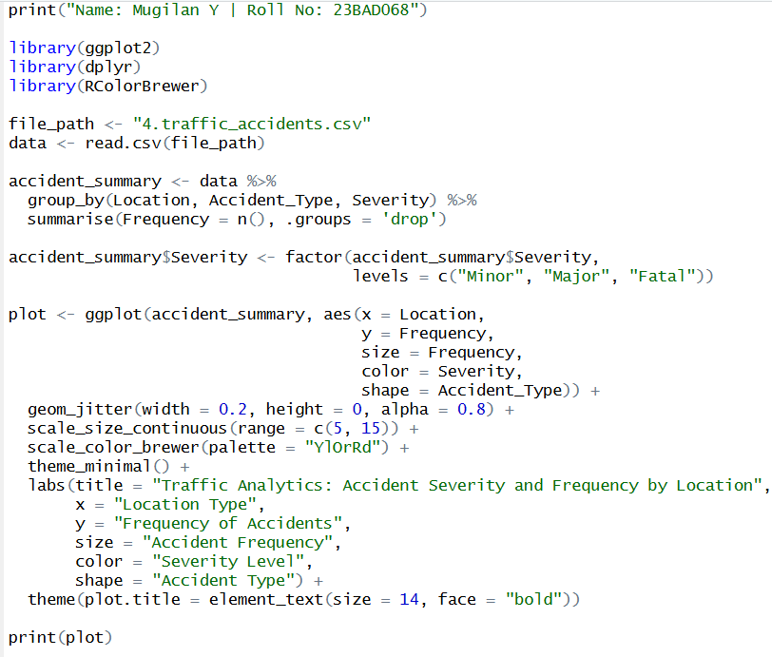
Output:
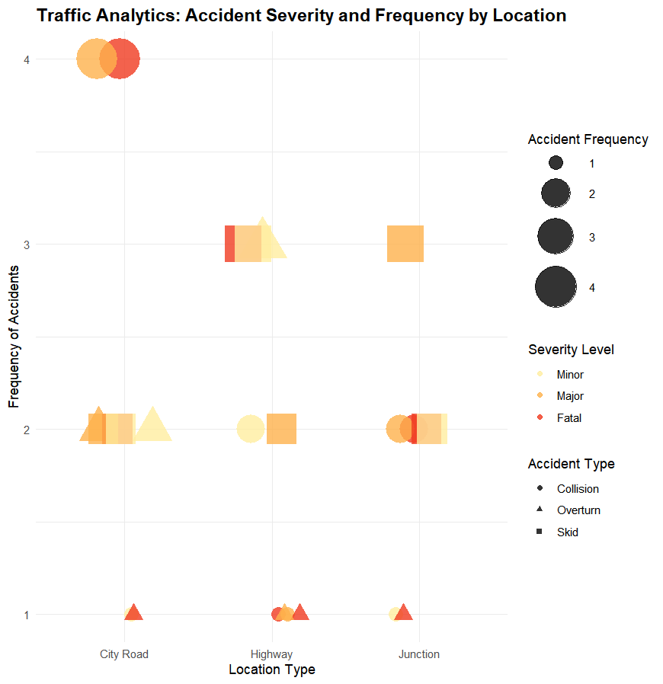

POST-LAB QUESTIONS
- Which visual variable best conveys severity and why?
Answer: Color gradient is the best variable for severity. By using a sequential palette (e.g., light yellow for minor, dark red for fatal), it taps into our psychological association that "darker/redder equals more intense or dangerous," making the risk instantly recognizable.
- How can poor encoding mislead policy decisions?
Answer: If a chart uses raw counts (frequency) instead of rates (accidents per 1,000 cars), a heavily trafficked junction will look like a "high-risk zone" simply because more cars drive there. A policy maker might waste budget redesigning a safe junction while ignoring a truly dangerous, low-traffic rural highway.
- What precautions should be taken for color-blind users?
Answer: Always use color-blind accessible palettes (like the Viridis palette or ColorBrewer). Additionally, use "redundant encoding"—meaning you represent the data with a second visual variable as a backup. In your code, even if a user cannot see the red/yellow colors, they can still identify the accident type through the shape.
- How does visual encoding affect AI explainability?
Answer: Visual encoding makes the "black box" of AI transparent. If an AI predicts high accident risk at a junction, proper visual encoding can show the user why (e.g., by highlighting that 80% of accidents there happen at "Night" and are "Skids," implying poor street lighting).
- Suggest improvements for large-scale public dashboards.
Answer:
- Interactivity: Add tooltips so users can hover over a data point to see the exact counts and dates.
- Drill-down Capability: Allow users to click on a "Highway" to see a breakdown by specific highway mile markers.
- Geospatial Mapping: Plot the accidents on a literal map of the city using heat density, which is far more intuitive for a public audience than a standard chart.

LEARNING OUTCOME: Students learn perceptually effective visual communication for AI systems.

ASSESSMENT
Description | Max Marks | Marks Awarded
Pre Lab Exercise | 5
In Lab Exercise | 10
Post Lab Exercise | 5
Viva | 10
Total | 30
Faculty Signature

