SMART PUBLIC TRANSPORT MANAGEMENT SYSTEM
Section A — Data Modeling and Database (25 Marks)
MIT714 — Database Systems Management · International University of East Africa
Mugisho Mugobe · 25/IUEA/MIT/119-M · MIT, Year 1 Semester 1

1. Entity Relationship Diagram
(10 marks)
The diagram below reflects the schema exactly as migrated — it is not a proposal drawn separately from the implementation. Nine entities: seven operational (User, Profile, Passenger, Driver, Vehicle, Route, Trip, Booking) plus one standalone content entity (Carousel) with no foreign keys. Trip is the junction resolving Vehicle + Driver + Route into one scheduled run; Booking is the junction resolving Passenger + Trip into one seat reservation.
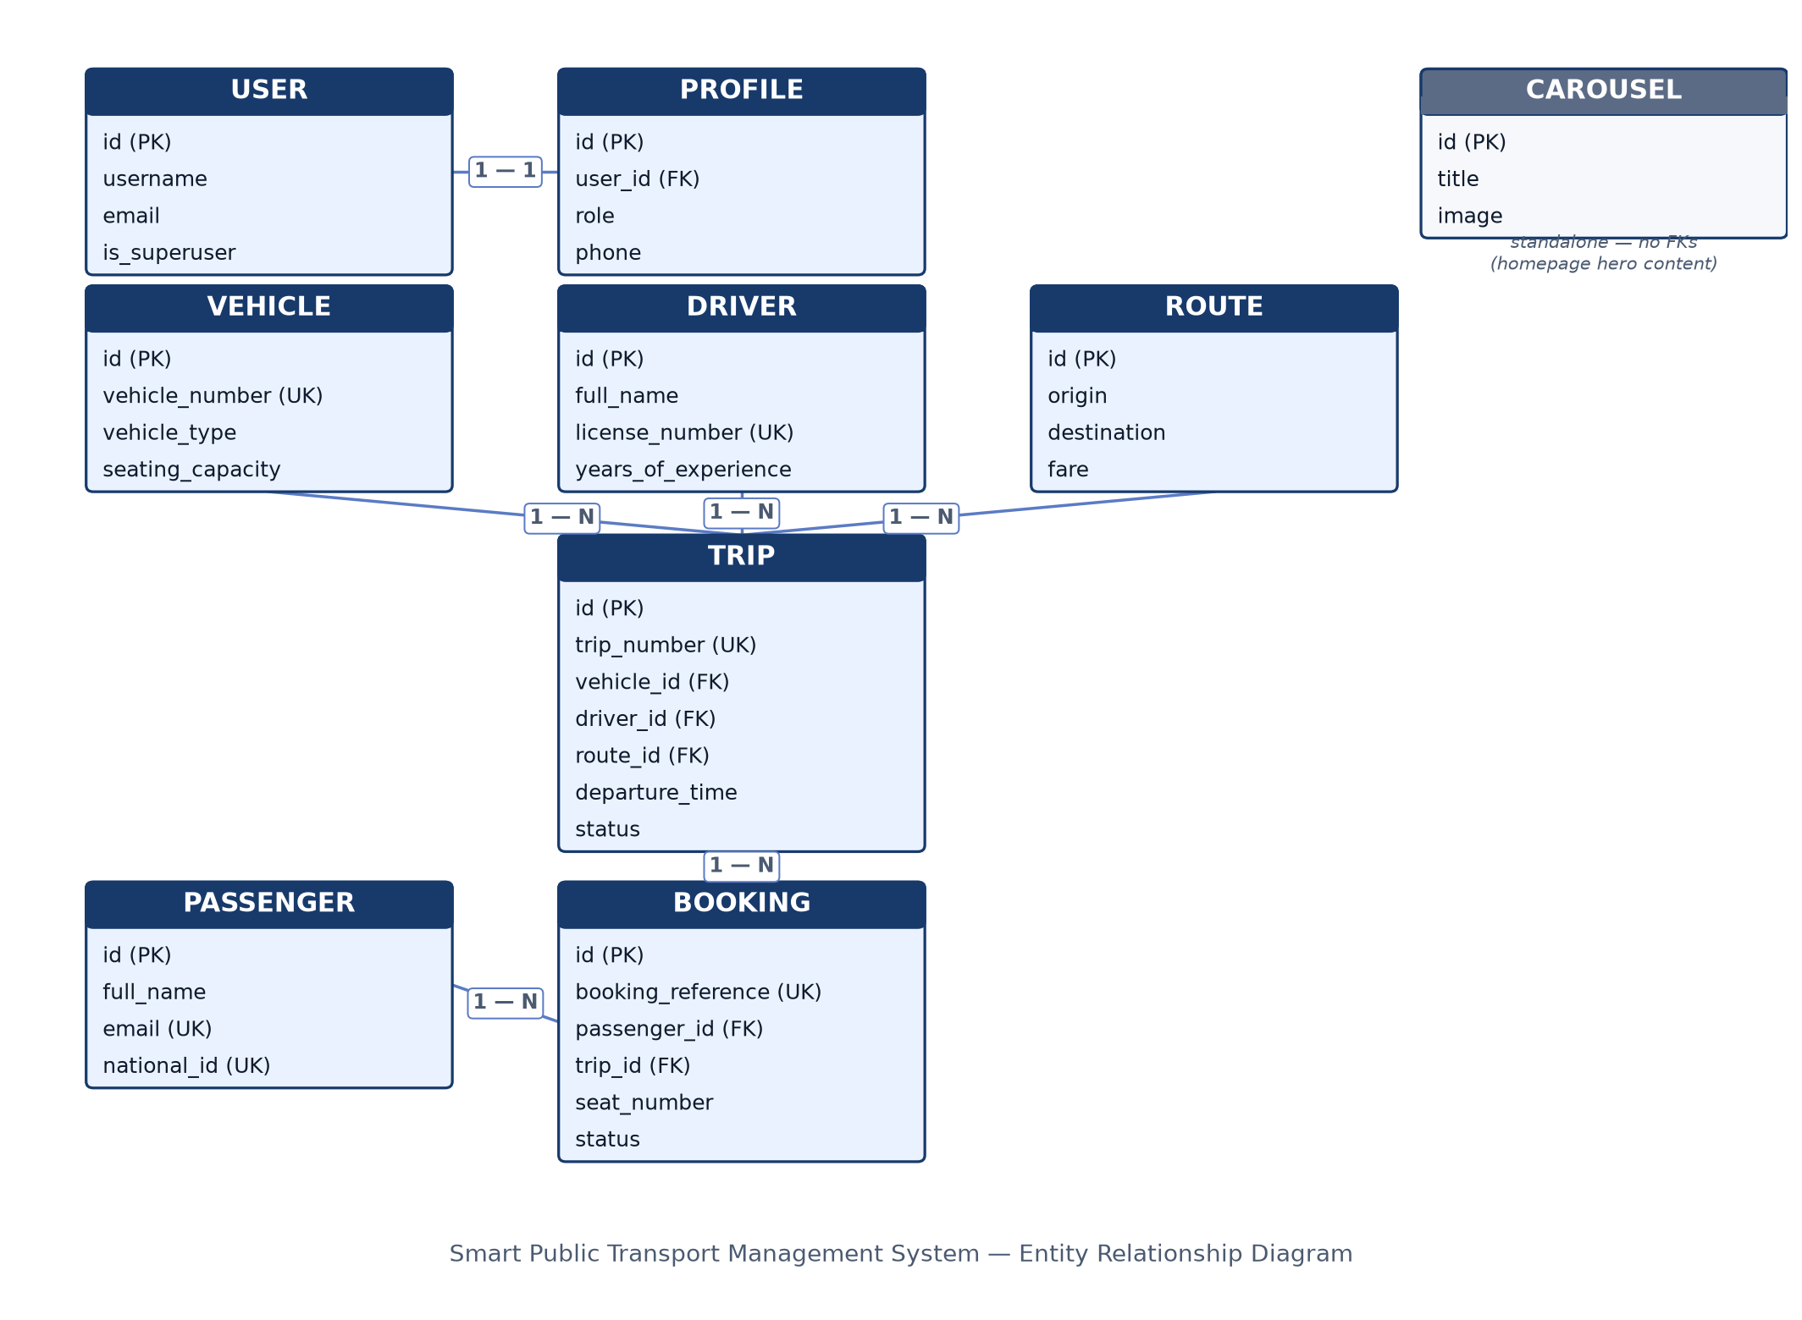
Figure 1. Entity Relationship Diagram — Smart Public Transport Management System

2. Database Schema
(8 marks)
Every table below is a real, migrated table in the running database (SQLite in development; MySQL in the deployed production environment) — not a design sketch. Each row names the Django model/app it comes from, its key columns, and the constraints enforced at the database and/or application layer.
Table (Django model) | App | Key columns | Constraints
auth_user | Django built-in | username, email, password, is_superuser, is_staff | username unique
accounts_profile | accounts | user_id, role, phone, address, profile_picture | user_id OneToOne → auth_user; role restricted to ADMIN / STAFF / PASSENGER
passengers_passenger | passengers | full_name, email, phone, address, national_id | email unique, national_id unique
drivers_driver | drivers | full_name, phone, license_number, years_of_experience, photo | license_number unique
vehicles_vehicle | vehicles | vehicle_number, vehicle_type, seating_capacity, model, manufacturer, year, image | vehicle_number unique; vehicle_type ∈ {Bus, Taxi, Minibus}
routes_route | routes | origin, destination, distance, estimated_duration, fare, status, description | status ∈ {Active, Inactive}
trips_trip | trips | trip_number, vehicle_id, driver_id, route_id, departure_time, arrival_time, available_seats, status, notes | trip_number unique; FKs → Vehicle, Driver, Route (CASCADE); status ∈ {Scheduled, In Progress, Completed, Cancelled}
bookings_booking | bookings | booking_reference, passenger_id, trip_id, seat_number, amount, booking_date, payment_status, status, qr_code | booking_reference unique (auto-generated BK00001…); FKs → Passenger, Trip (CASCADE); one seat per trip enforced in bookings/services.py
carousel_carousel | carousel | title, description, image | none

Note: auth_user is Django's built-in authentication table, not a custom model — accounts_profile extends it 1:1 to add the role field the whole access-control system is built on.

3. What Each Entity Represents
(7 marks)
User / Profile — User is Django's built-in authentication record (login credentials). Profile extends it 1:1 (auto-created via a post_save signal in accounts/signals.py) and carries the one field the whole authorization model hinges on: role. ADMIN gets the Django admin, STAFF gets the operations dashboard, PASSENGER gets the public booking flow — accounts/views.py routes login by this field.
Passenger — A rider profile, distinct from User. Kept separate because passengers can be recorded by staff (e.g. walk-in bookings) without every passenger needing a login account.
Driver — The person assigned to operate a vehicle on a trip. Holds licensing data (license_number) used to keep trips legally staffed.
Vehicle — A physical bus, taxi or minibus in the fleet, with seating capacity, which directly caps how many bookings a Trip on that vehicle can accept.
Route — A fixed origin → destination path with a fare and expected duration. Routes are reusable: many trips run the same route on different days or times.
Trip — One scheduled departure: a specific Vehicle and Driver running a specific Route at a specific time. available_seats is decremented on every confirmed booking and incremented back on cancellation, so it always reflects live capacity.
Booking — A passenger's reservation of one seat on one trip. Generates a unique reference and a scannable QR ticket on save. The seat-uniqueness and overbooking checks in bookings/services.py are the actual business rule enforcing “one seat, one passenger, one trip.”
Carousel — Homepage hero content (image and caption) shown to visitors before login — purely presentational, with no operational relationships to the rest of the schema.

Relationship summary
- User 1—1 Profile — every account has exactly one role.
- Vehicle 1—N Trip, Driver 1—N Trip, Route 1—N Trip — a trip is the junction where a vehicle, a driver and a route meet for one scheduled run.
- Trip 1—N Booking, Passenger 1—N Booking — a booking is the junction where a passenger claims one seat on one trip; Booking is effectively the many-to-many resolver between Passenger and Trip, carrying its own attributes (seat, amount, status, QR code).
Full project repository (including the REST API, role-based access control, automated tests, and deployment configuration for Sections B–E): https://github.com/MugishoMugobe/SMART_TRANSPORT_SYSTEM · Live application: https://sts.mac-rdc.com

