Data Model — ERD, Schema and Entity Reference

Data Model — Smart Public Transport Management System
This document covers Section A of the exam brief: the Entity Relationship Diagram, the full database schema as implemented, and what each entity represents. The schema below is not a proposal — it is a direct description of the Django models already migrated into db.sqlite3 (see each app’s models.py and migrations/).

1. Entity Relationship Diagram
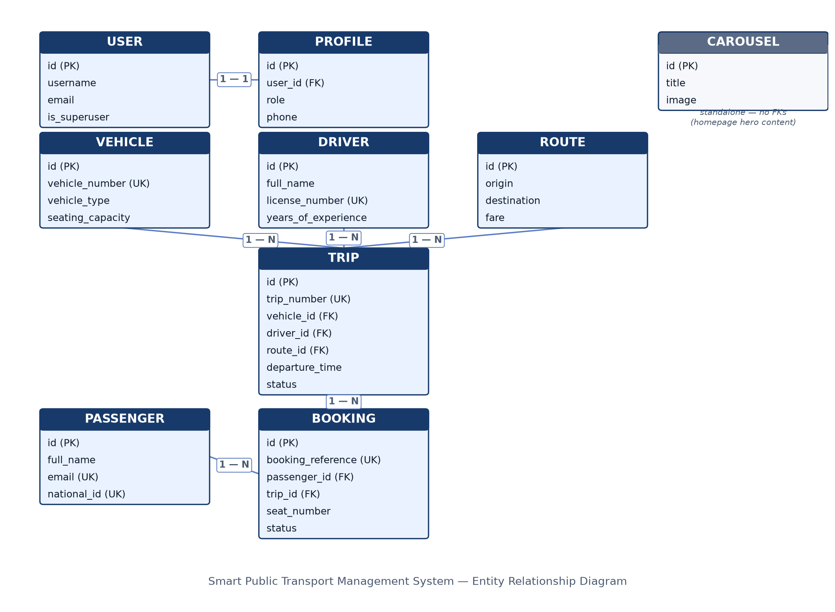
Entity Relationship Diagram
Same diagram, as Mermaid source (renders natively on GitHub too):
erDiagram
USER ||--|| PROFILE : "has"
VEHICLE ||--o{ TRIP : "runs"
DRIVER ||--o{ TRIP : "operates"
ROUTE ||--o{ TRIP : "scheduled on"
TRIP ||--o{ BOOKING : "receives"
PASSENGER ||--o{ BOOKING : "makes"
USER {
int id PK
string username
string email
string password
bool is_superuser
}
PROFILE {
int id PK
int user_id FK
string role "ADMIN, STAFF, PASSENGER"
string phone
string address
image profile_picture
datetime created_at
}
PASSENGER {
int id PK
string full_name
string email UK
string phone
string address
string national_id UK
datetime created_at
}
DRIVER {
int id PK
string full_name
string phone
string license_number UK
int years_of_experience
image photo
datetime created_at
}
VEHICLE {
int id PK
string vehicle_number UK
string vehicle_type "Bus, Taxi, Minibus"
int seating_capacity
string model
string manufacturer
int year
image image
datetime created_at
}
ROUTE {
int id PK
string origin
string destination
decimal distance
duration estimated_duration
decimal fare
string status "Active, Inactive"
text description
datetime created_at
}
TRIP {
int id PK
string trip_number UK
int vehicle_id FK
int driver_id FK
int route_id FK
datetime departure_time
datetime arrival_time
int available_seats
string status "Scheduled, In Progress, Completed, Cancelled"
text notes
datetime created_at
}
BOOKING {
int id PK
string booking_reference UK
int passenger_id FK
int trip_id FK
int seat_number
decimal amount
datetime booking_date
bool payment_status
string status "Confirmed, Cancelled"
image qr_code
}
CAROUSEL {
int id PK
string title
text description
image image
datetime created_at
}
CAROUSEL has no foreign keys — it is standalone homepage content (hero images shown to visitors) and is intentionally not part of the operational domain graph above.

2. Schema — tables as implemented
Table (Django model) | App | Key columns | Constraints
auth_user | Django built-in | username, email, password, is_superuser, is_staff | username unique
accounts_profile | accounts | user_id, role, phone, address, profile_picture | user_id OneToOne → auth_user; role restricted to ADMIN/STAFF/PASSENGER
passengers_passenger | passengers | full_name, email, phone, address, national_id | email unique, national_id unique
drivers_driver | drivers | full_name, phone, license_number, years_of_experience, photo | license_number unique
vehicles_vehicle | vehicles | vehicle_number, vehicle_type, seating_capacity, model, manufacturer, year, image | vehicle_number unique; vehicle_type ∈ {Bus, Taxi, Minibus}
routes_route | routes | origin, destination, distance, estimated_duration, fare, status, description | status ∈ {Active, Inactive}
trips_trip | trips | trip_number, vehicle_id, driver_id, route_id, departure_time, arrival_time, available_seats, status, notes | trip_number unique; FKs → Vehicle, Driver, Route (on_delete=CASCADE); status ∈ {Scheduled, In Progress, Completed, Cancelled}
bookings_booking | bookings | booking_reference, passenger_id, trip_id, seat_number, amount, booking_date, payment_status, status, qr_code | booking_reference unique (auto-generated BK00001…); FKs → Passenger, Trip (on_delete=CASCADE); one seat per trip enforced in bookings/views.py
carousel_carousel | carousel | title, description, image | none

3. What each entity represents
User / Profile — User is Django’s built-in authentication record (login credentials). Profile extends it 1:1 (auto-created via a post_save signal in accounts/signals.py) and carries the one field the whole authorization model hinges on: role. ADMIN gets the Django admin, STAFF gets the operations dashboard, PASSENGER gets the public booking flow — accounts/views.py routes login by this field.
Passenger — a rider profile, distinct from User. Kept separate because passengers can be recorded by staff (e.g. walk-in bookings) without every passenger needing a login account.
Driver — the person assigned to operate a vehicle on a trip. Holds licensing data (license_number) used to keep trips legally staffed.
Vehicle — a physical bus/taxi/minibus in the fleet, with seating capacity, which directly caps how many bookings a Trip on that vehicle can accept.
Route — a fixed origin→destination path with a fare and expected duration. Routes are reusable: many trips run the same route on different days/times.
Trip — one scheduled departure: a specific Vehicle + Driver running a specific Route at a specific time. available_seats is decremented on every confirmed booking and incremented back on cancellation, so it always reflects live capacity.
Booking — a passenger’s reservation of one seat on one trip. Generates a unique reference and a scannable QR ticket on save (generate_qr_code in bookings/models.py). The seat-uniqueness and overbooking checks in bookings/views.py are the actual business rule enforcing “one seat, one passenger, one trip.”
Carousel — homepage hero content (image + caption) shown to visitors before login; purely presentational, no operational relationships.

4. Relationship summary
- User 1—1 Profile: every account has exactly one role.
- Vehicle 1—N Trip, Driver 1—N Trip, Route 1—N Trip: a trip is the junction where a vehicle, a driver and a route meet for one scheduled run.
- Trip 1—N Booking, Passenger 1—N Booking: a booking is the junction where a passenger claims one seat on one trip. Booking is effectively the many-to-many resolver between Passenger and Trip, carrying its own attributes (seat, amount, status, QR code).

