Use Case Diagram

Use Case Diagram — Smart Public Transport Management System
Companion to docs/ERD.md (the data model) — this covers the behavioural view: who can do what, and how a few of the more interesting use cases are actually built.
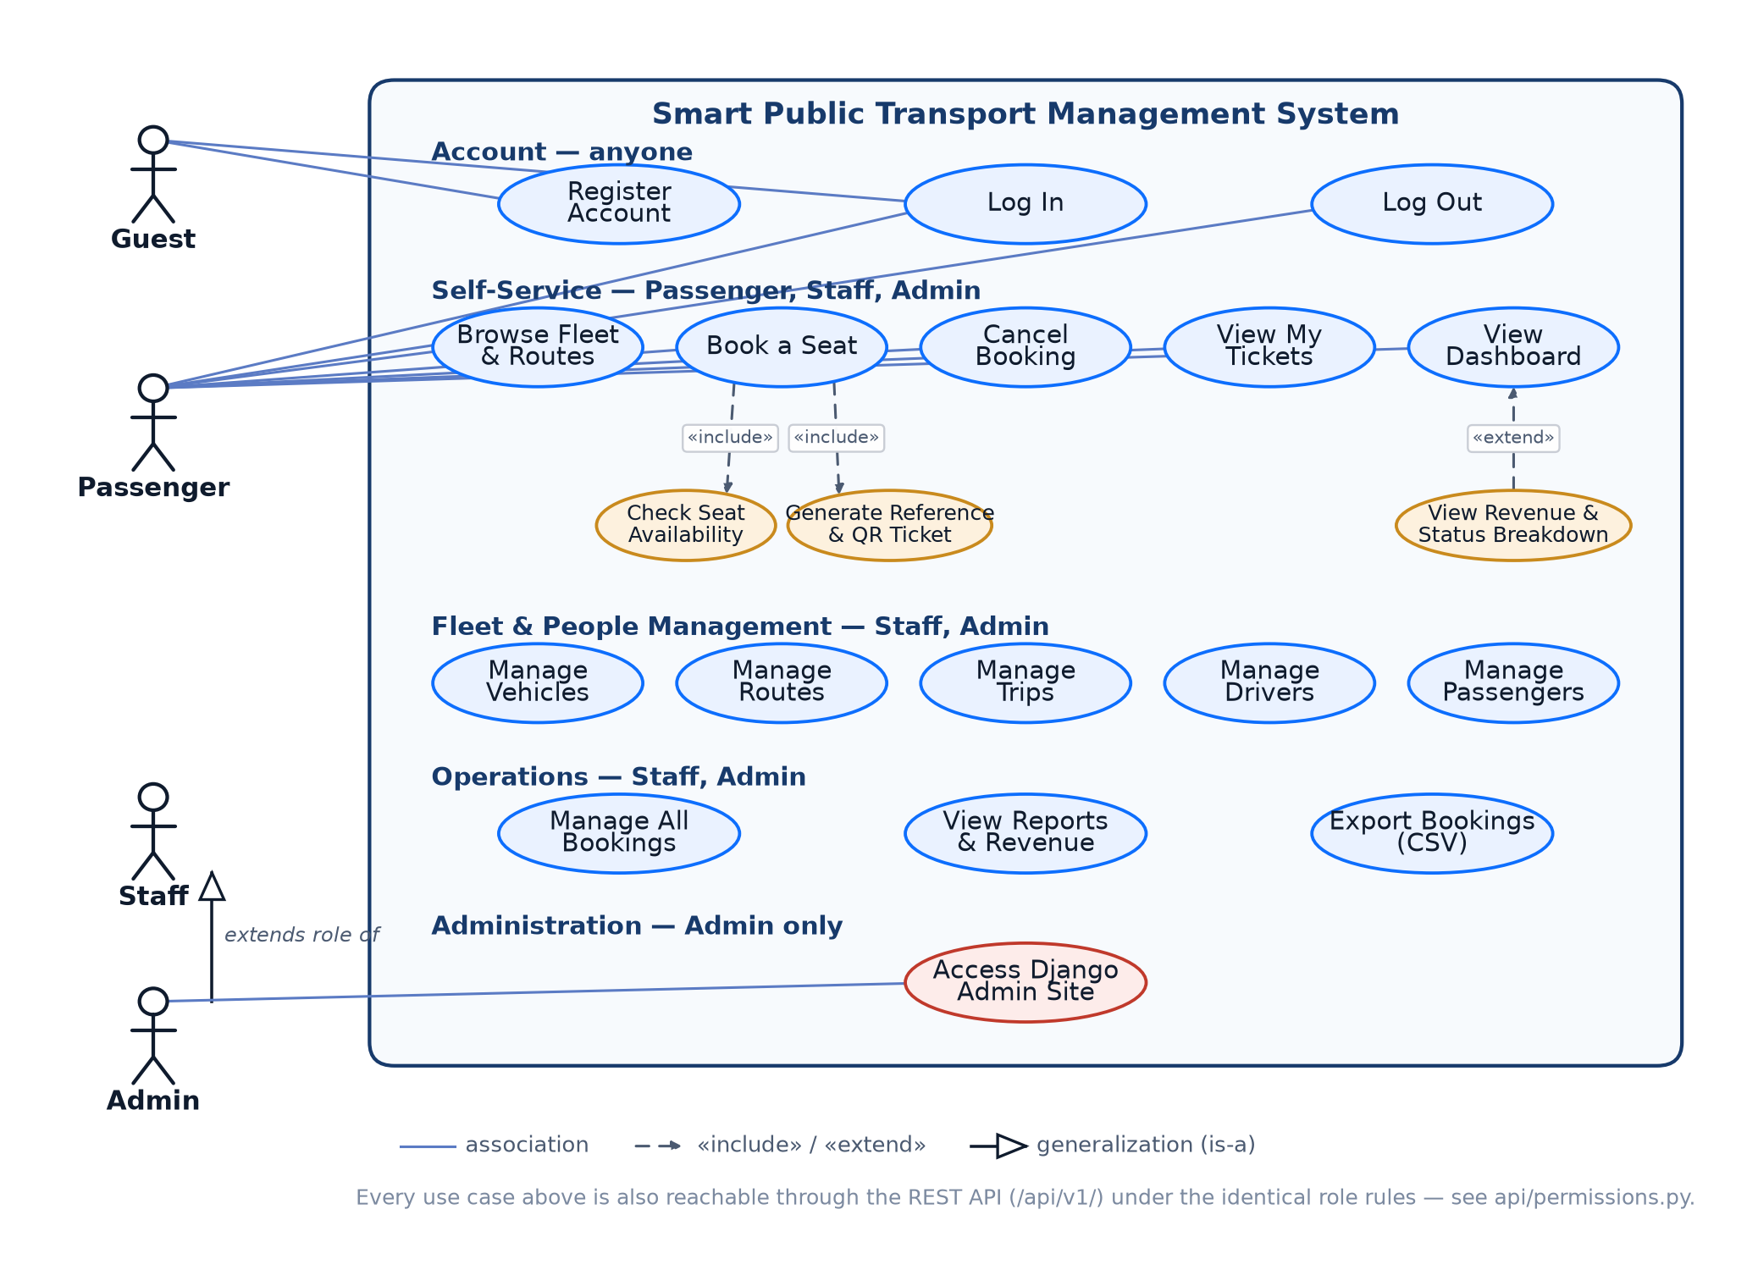
Use case diagram

1. Actors
Actor | Who | Maps to
Guest | Anyone not signed in | No account
Passenger | A rider | Profile.role = "PASSENGER"
Staff | Operations staff | Profile.role = "STAFF"
Admin | System administrator | Profile.role = "ADMIN" or is_superuser
Admin generalizes Staff in the diagram (the hollow-triangle arrow) — every use case Staff can perform, Admin can too, plus the Django admin site exclusively. This mirrors is_staff_or_admin() in accounts/decorators.py, the single function both the HTML views and the API’s permission classes call.

2. Use cases by group
Account (anyone) — Register Account, Log In, Log Out.
Self-Service (Passenger, Staff, Admin) — Browse Fleet & Routes, Book a Seat, Cancel Booking, View My Tickets, View Dashboard. This is the only group where the diagram draws individual actor lines, since this is where the per-actor differences actually matter: a Guest gets none of it (must register/log in first); a Passenger’s bookings and tickets are scoped to their own account (bookings/views.py::_can_manage_booking); Staff/Admin implicitly get the same self-service actions plus everything in the groups below.
Fleet & People Management (Staff, Admin only) — Manage Vehicles, Manage Routes, Manage Trips, Manage Drivers, Manage Passengers. Grouped under one role label rather than drawn with individual lines to keep the diagram legible — the point that matters (who can reach this group at all) is the same for all five.
Operations (Staff, Admin only) — Manage All Bookings, View Reports & Revenue, Export Bookings (CSV).
Administration (Admin only) — Access Django Admin Site.

3. Why the include/extend relationships are there
Not decorative — each one names a real mechanism in the code:
- Book a Seat «include» Check Seat Availability — every booking attempt runs the overbooking/duplicate-seat checks in bookings/services.py::create_booking before anything is saved. This isn’t optional or conditional, which is exactly what «include» means: it happens on every execution of the base use case.
- Book a Seat «include» Generate Reference & QR Ticket — the same function also always generates the BK##### reference and (via Booking.save()) the scannable QR ticket. Two separate include arrows because they’re two distinct, independently-nameable steps, not because they happen at different times.
- View Revenue & Status Breakdown «extend» View Dashboard — this is a conditional addition, not a guaranteed step, which is what «extend» means (as opposed to «include»): a Passenger’s dashboard is just the base use case; a Staff/Admin dashboard is the base use case plus this extension. See dashboard/views.py — show_operations_panel is set only if is_staff_or_admin(request.user), and the template branches on exactly that flag.

4. One more access path, not shown as a separate actor
Every use case above is also reachable through the REST API at /api/v1/, under the identical role rules — api/permissions.py is built on the same is_staff_or_admin() check as the HTML views. It’s deliberately not drawn as a second actor lane: the business use cases are the same regardless of which interface reaches them, and duplicating the whole diagram to show “the same things, but via HTTP JSON instead of HTML” would add clutter without adding information. See the API reference table in the README instead.

