Computer programming

Final Project

Report

I.E.S. San Vicente
San Vicente del Raspeig (Alicante)
2017/2018

Teachers:
José Ignacio Cabanes / Ignacio Iborra

Student:
Marcos Cervantes Matamoros

1. Introduction
Project name
Max Ell Power

Made by
Marcos Cervantes Matamoros

Short description of the project
This is a 2d platform shooter game, with few gamemodes for 1 player. It is a graphical application that uses the SDL graphics library.

2. Functionality of the project
After entering the program, a welcome screen will we displayed, where the user can choose between:

• Play a level.
• Continue last game.
• Horde mode (static screen).
• Coming soon….
• Watch ranking table.
• Help/Controls
• Options
• Credits
• Quit the game.

If the user chooses play a level, then he will be able to choose a determinate level of the game. In each level the player will have to cross all the map avoiding enemies shoots and tramps without loose his lives. The game ends if the player achieve get through all the levels, If the player loose his lives or if the player decide quit the game.

If continue last game is chosen the player will be able to return to the last checkpoint keeping his score at that level so far. In this case the score wont be added to the scoreboard, this only happens when the player dies or accomplish all levels.

The horde mode is an alternative mode of the video game that consist in survive in a closed map all the time that you can with limited lives trying to obtain the highest score, surviving killing enemies and recollecting enemy item drops.

You can watch scores of the different game modes pressing watch ranking table.

Selecting options you will be able to change different settings.

3. Screen prototype
The game screen will look like this:

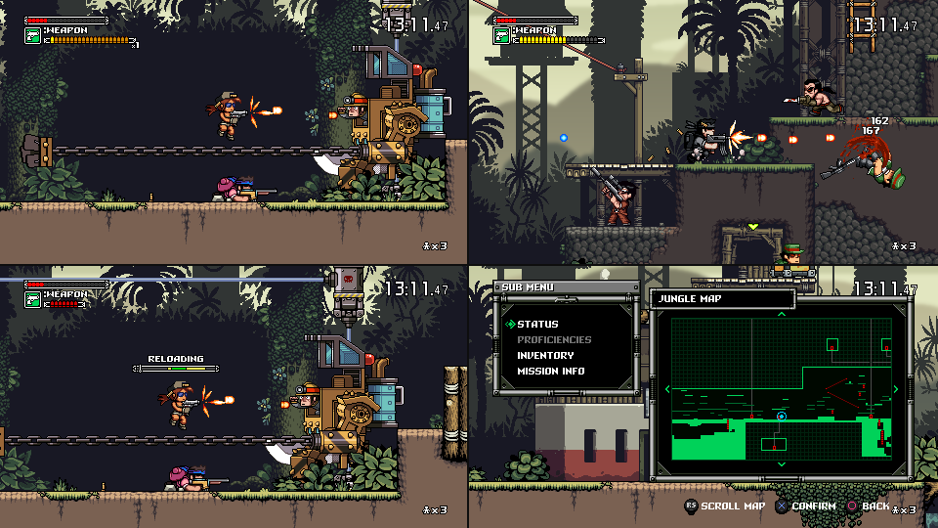

4.Analysis

4a. Requisites

Requisite | Date achieved
The program will allow a player play a complete level in a big map with scroll.
The program will allow a player play a survival mode in a map without scroll and infinite enemies spawns, challenging the player to survive as long as possible.
In the principal game mode the player will be able to stop the game, exit of the application and continue his last game from a checkpoint in another moment saving all his progress so far.
There will be different kind of enemies and different main character to choose.
The game will start with a short intro screen and after pressing a key show a main menu from which you will be able to select the different game modes and options.
The Main menu screen will allow he user to enter a Help/Control screen, which will display hints on how to play
The Main menu will allow the user to enter a Credits screen, which will display data about the programmer
The game can be paused pressing "P", the pause will display a menu to choose different options in-game like load last checkpoint quit the game or continue.
The main character will have 3 lives and he’ll loose a live being hit for different dangerous things like enemy bodies, enemy bullets, traps or dangerous floor like water, falls and spikes. The game end if you loose your 3 lives.
Enemies will die with 1 hit of any of the weapon of the main character, falling in a trap or dangerous floor.
The Main character will have 3 different type of attacks: basic attack, melee attack and grenades.
The basic attacks will shoot a bullet that displaces in a straight line of the 3 possibles orientations, head on, upwards, and diagonal. The bullet will destroy in a contact with an enemy, a wall, or if the bullet is a certain distance away from the player, only will be able to have 3 bullet in the map at the same time.
The melee attack will have a short range and will hit only the nearest enemy.
The grenade will do damage in a big area arround it. Will be able to throw it.

4b. Basic pseudocode

4c. Classes diagram

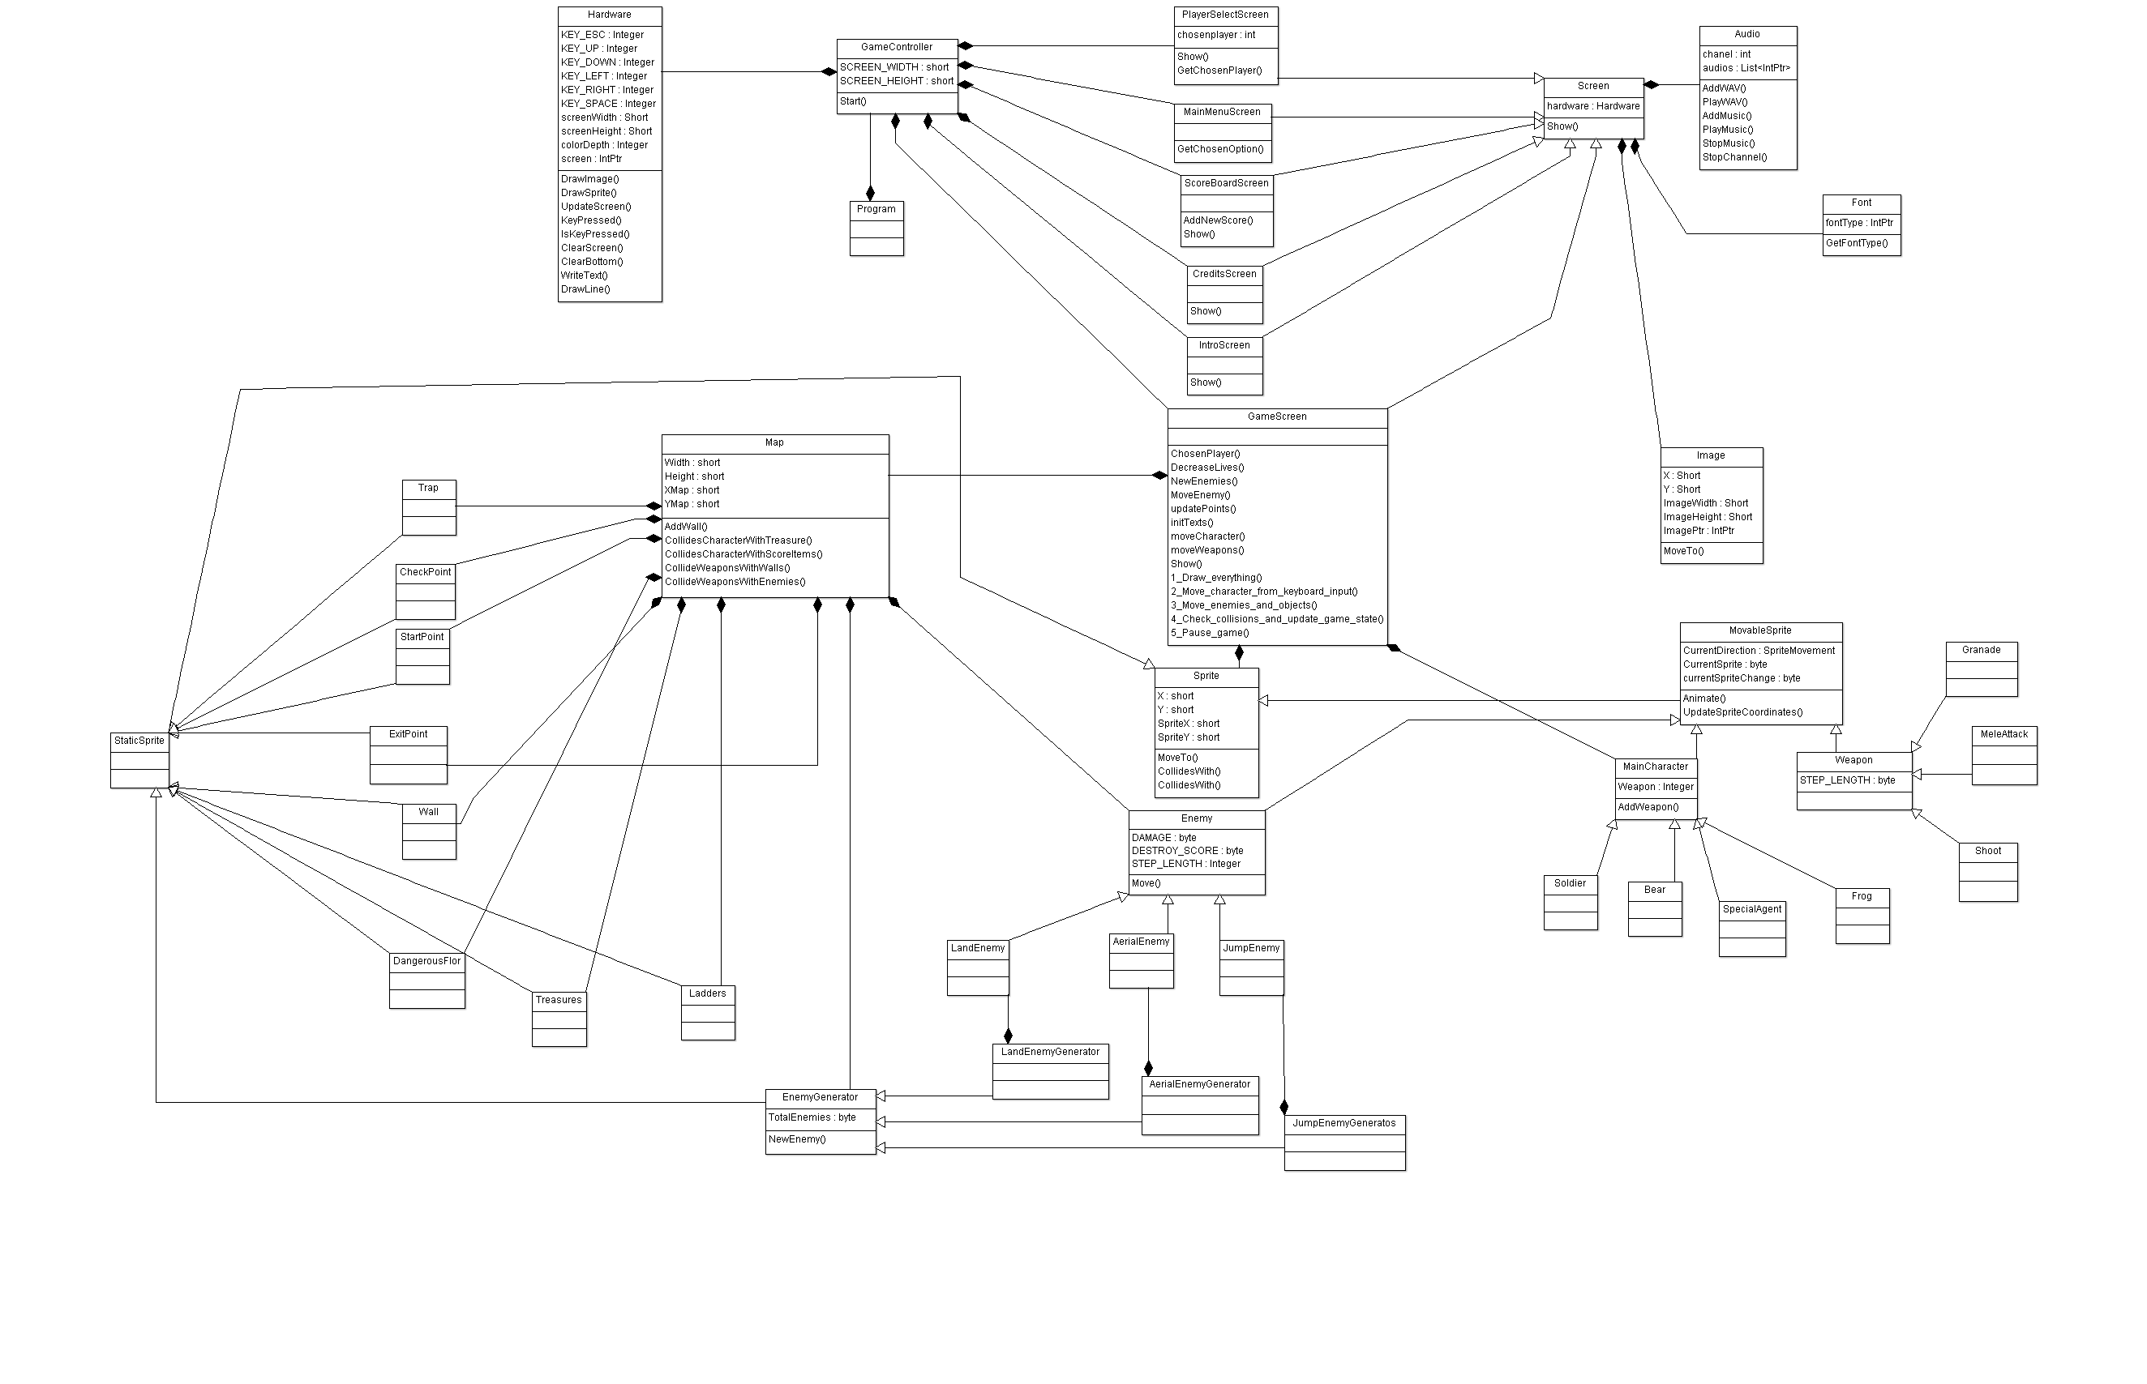

5. Initial planning and expected deliveries

5a. Expected deliveries

1-Create the program “frame” with the classes attributes and methods
And complete the class hardware Audio font screen and image.

2-Create a main menu with the future different options doing it functional and decorated, remarking the chosen option with a different colour, doing a sound when you move in the menu and being able to navigate in the menu with the keyboard key or a controller.

3-Implement the class sprite and movable sprite that inherit of sprite and implement the class main character a the methods to control the movements of the character.

4-Implement a screen to choose the player character and the respective classes of each character.

5-Create the enemy class and the 3 types of enemies (land enemies aerial enemies and jumping enemies) and implements in the game.

6-Implement map class, walls, floor, and all surfaces with their collisions with the different movable sprites.

7-Create the class shoot and weapon that permit different type of shoots with your character: frontal shoot upward shoot and diagonal shoot. And 2 different type of bullets. The rifle will shoot and individual shoot and the shotgun will shoot 4 disperse bullets in an arc.

8-Implements all shoot impacts in the game (against character, enemies walls…) and the respective consequences in the different elements (loose a life kill the enemy destroy the bullet). Enemies will shoot you when approaching a certain distance.

9-Implement different abilities for the main character like a melee attack for the main character grenades and environment traps. Traps will be a static sprite that damage you if you pass over. When you pass over an a spike trap the trap will activate in a second and will do damage to all what is on top at that moment

10-Create jump and gravity system in the game.

11-Create a complete functional level for the game with scroll, different heights, ladders, falls.

12-Implement checkpoints in the game and the option of let the game (the application) and continue later saving the progress in a file.

13-Implement different ways to obtain score in the game doing a score system and implement treasures that the enemies will drop when they die. When you do determinate actions like take a check point, kill an enemy, pass the level in a determinate time or with more or less lives you will obtain points and implement.

14-Implement the scoreboard option and scoreboard screen. The score will be saved at the end of each game (loosing all lives or completing the level) in that moment the game will ask you to enter a name using the keyboard. The score will be saved with your name, your punctuation in that game and the date of the game.

15-Create an alternative mode part1: Create the map, put random enemy spawns for time and main character in the middle.

16-Create an alternative mode part2: Continue the last point for the new game mode: Polish the new game mode features implement a countdown and scores of the new game mode, add this scores to a scoreboard section exclusive for this new game mode.

17-Implements real options to change from the main menu (resolution, sound controls, etc.) put pause button in the game.

5b. Real deliveries
- Version 1 (May 14): As expected: Program frame created, all classes with their respective methods and attributes. Still not playable.
- Version 2 (May 15): As expected: Main menu created with sounds and pointer option image implemented that change when you navigate in the menu, the colour of the selected option is marked in a different colour. The application didn’t
- recognize the controller keys for now.

6. File formats

6a. Plain files format
The scores table is saved to a text file, which contains the name of a player in one line, and the corresponding score in the following line, and so on, to complete the 10 highest scores, as in this example:

John
125
Peter
116
…

6b. Entity-Relationship Diagram (If needed)
(…)

7. Problems found and solutions

8. Improvements or restrictions to the starting design
I have had time enough to include the effect of animation when the pieces fall (…)

I have not been able to implement (…) because of (…)

9. Screenshots of the final project
(…)

10. Source code of the final project
(…)

