**CONTENTS PAGE NO**

1. **INTRODUCTION** 
   1. Overview
   2. Purpose
2. **PROBLEM DEFINITION & DESIGN THINKING**
   1. Empathy Map
   2. Ideation & Brainstorming Map
3. **RESULT**
4. **ADVANTAGES & DISADVANTAGES**
5. **APPLICATIONS**
6. **CONCLUSION**
7. **FUTURE SCOPE**
8. **APPENDIX**
   1. Source Code

**INTRODUCTION:**

The app is a sample project that demonstrates how to use the Android compose UI toolkit to build a survey app. The app allows the user. To answer a series of questions and view their results. It showcases some of the key features of the compose UI toolkit, including layouts, animations,data management, and user interactions.

**1.1 OVERVIEW**

* Compose is **a modern declarative UI. Toolkit for Android**.
* Compose makes it easier to write and maintain your app UI by providing a declarative API that allows you to render your app UI without theimperatively mutating frontend views.
* The Compose input should allow usersto customize their input feed based on their interests, location or input.

**1.2 PURPOSE**

* Text is a central piece of any UI, and Jetpack Compose makes it easier to display or write text.
* Compose leverages composition of its building blocks, meaning you don’t need to overwrite properties and methods or extend big classes to have a specific composable design and logic working the way want.

**DEFINITION & DESIGNTHINKING**

2.1Empathy Map:

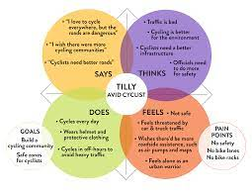

**IDEATION & BRAINSTORMING MAP**

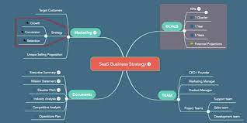

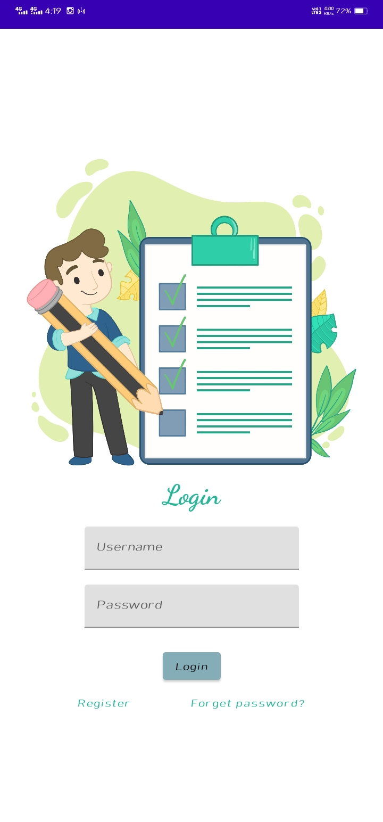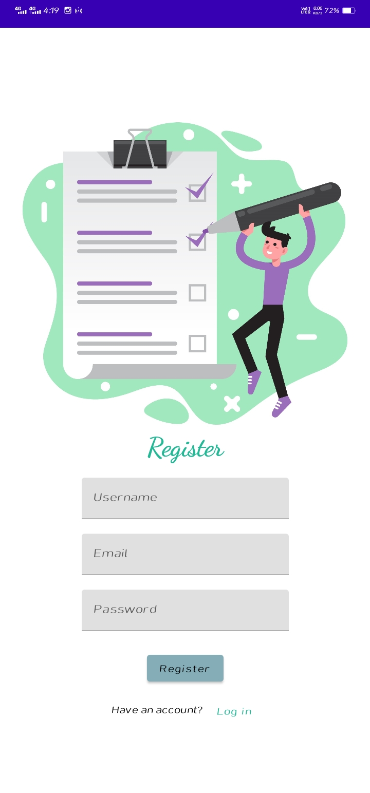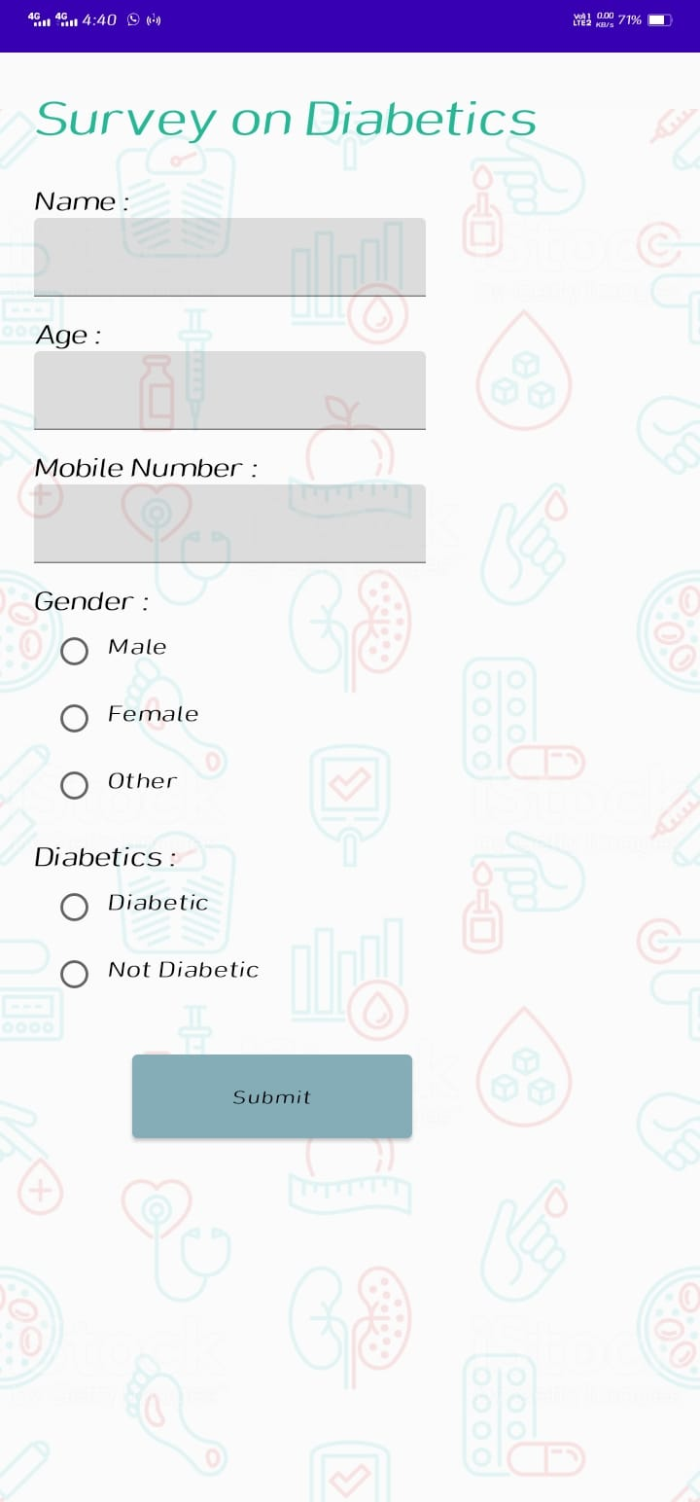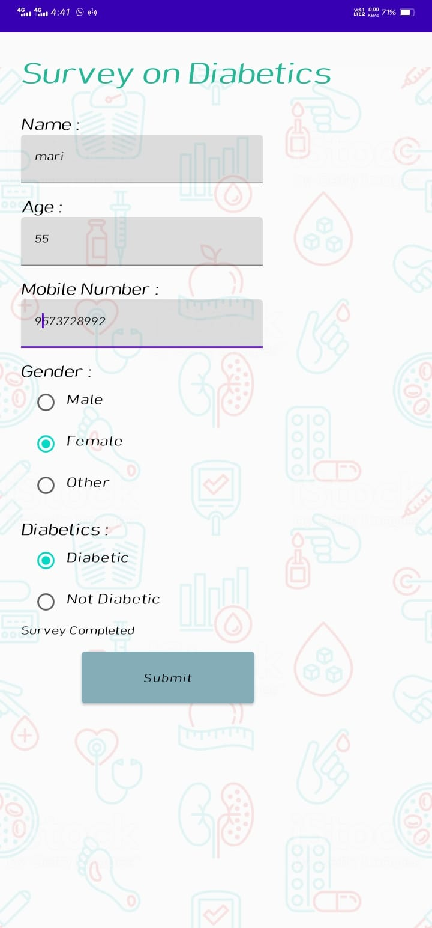

**ADVANTAGES&DISADVANTAGE**

**Advantages:**

Compose enables you to create beautiful apps with direct access to the Android platform APIs and built-in support for Material Design, Dark theme, animations, and more: “Compose has also solved more than declarative UI -- accessibility aphis, layout, all kinds of stuff have been improved the input.

**Disadvantages:**

Sometimes disadvantage are necessary, for example, to trigger a one-off event such as showing a snack bar or navigate to another screen given a certain state condition. These actions should be called from a controlled environment that is aware of the lifecycle of the composable. In this page, you'll learn about the different side-effect APIs Compose offers.

**APPLICATION:**

* Understanding the prevalence of diabetes: Diabetes survey applications can be used to collect data on the prevalence of diabetes among a particular population. This information can help healthcare professionals and policymakers to better understand the scope of the diabetes problem and develop targeted interventions.
* Identifying risk factors: Diabetes survey applications can be used to identify risk factors for diabetes, such as lifestyle behaviors, family history, and demographic factors. This information can be used to develop interventions to prevent or delay the onset of diabetes in high-risk populations.
* Assessing diabetes knowledge and self-management: Diabetes survey applications can be used to assess patients' knowledge of diabetes and their ability to manage the disease. This information can be used to develop patient education materials and support programs that address patients' specific needs.
* Evaluating diabetes treatment and outcomes: Diabetes survey applications can be used to evaluate the effectiveness of diabetes treatments and outcomes. This information can be used to identify areas where improvements can be made and develop strategies to improve patient outcomes.
* Monitoring trends and changes over time: Diabetes survey applications can be used to monitor trends and changes in diabetes prevalence, risk factors, knowledge, self-management, treatment, and outcomes over time. This information can be used to evaluate the impact of interventions and inform future policy and practice decisions.

**CONCLUSION:**

The survey app provides valuable insights into the experiences and concerns of individuals living with diabetes. Through the app, users were able to share their personal experiences and provide feedback on their treatment options, lifestyle changes, and overall quality of life. The data collected from the survey can be used to improve diabetes care and management by healthcare professionals and policymakers. Overall, the survey app serves as an important tool for understanding the needs and challenges faced by people living with diabetes and can help to inform future research and policy decisions.

**FUTURE ENHANCEMENT:**

* Integration with electronic health records (EHR): Diabetes survey applications could be integrated with EHR systems to allow for more efficient and accurate data collection and analysis. This could also facilitate the sharing of data among healthcare providers and improve patient care coordination.
* Use of artificial intelligence (AI): AI could be used to analyze diabetes survey data and identify patterns or trends that may not be immediately apparent. This could help healthcare providers to develop more targeted interventions and improve patient outcomes.
* Incorporation of wearable technology: Diabetes survey applications could be integrated with wearable technology, such as glucose monitors and fitness trackers, to provide more comprehensive data on patients' health status and behaviors. This could help healthcare providers to develop personalized treatment plans and improve patient outcomes.
* Gamification: Diabetes survey applications could be gamified to make the survey-taking experience more engaging and motivating for patients. This could improve patient participation and data quality.
* Mobile app development: Diabetes survey applications could be developed as mobile apps to make them more accessible to patients. This could increase patient participation and improve the accuracy and completeness of data collection.

Overall, future enhancements to diabetes survey applications should focus on improving the accuracy, efficiency, and patient engagement of data collection and analysis, with the goal of improving patient outcomes and reducing the burden of diabetes on individuals and healthcare systems.

**APPENDIX**

**Source Code:**