Insert your centre number, name and candidate number into the header above.
Save this evidence document as evidence_ followed by your centre number_ candidate number. For example: evidence_ zz999_9999
Screenshots or program listings must be copied into appropriate cells in the following table.
Examiners must be able to read the contents including any screenshots without the use of a magnifying glass. Answers that are not readable or missing will not be awarded any marks.
Save this evidence document at regular intervals, for example every 10 minutes.
Question 1
Part 1(a)
{Copy and paste the program code listing for question 1(a) here}

player_names = []
player_scores = []

Part 1(b)
{Copy and paste the program code listing for question 1(b) here}

def read_highscores():
filename = "HighScore.txt"
try:
file = open(filename, "r")
lines = file.readlines()
for i in range(0, len(lines), 2):
name = lines[i].strip().replace("\n", "")
score = int(lines[i + 1].strip().replace("\n", ""))
player_names.append(name)
player_scores.append(score)
file.close()
except IOError:
print(f"{filename} not found!")

Part 1(c)
{Copy and paste the program code listing for question 1(c) here}
def output_highscores():
for i in range(0, len(player_names)):
print(f"{player_names[i]} {player_scores[i]}")

Part 1(d)(i)
{Copy and paste the program code listing for question 1(d)(i) here}
def main():
read_highscores()
output_highscores()

main()
Part 1(d)(ii)
{Copy and paste the screenshot for question 1(d)(ii) here}
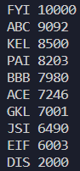

Part 1(e)(i)
{Copy and paste the program code listing for question 1(e)(i) here}

def main():
read_highscores()
output_highscores()
input_player_name = input("Please enter the player name: ")
while len(input_player_name) != 3:
input_player_name = input("Please enter a VALID player name: ")
input_player_score = int(input("Please enter the player score: "))
while input_player_score > 100000 or input_player_score < 1:
input_player_score = int(input("Please enter a VALID player score: "))
Part 1(e)(ii)
{Copy and paste the program code listing for question 1(e)(ii) here}

def insert_player(player_name, player_score):
player_names.append(player_name)
player_scores.append(player_score)
length_of_arrays = len(player_names)
for i in range(length_of_arrays - 1):
for j in range(length_of_arrays - i - 1):
if player_scores[j + 1] > player_scores[j]:
player_names[j], player_names[j + 1] = player_names[j + 1], player_names[j]
player_scores[j], player_scores[j + 1] = player_scores[j + 1], player_scores[j]

Part 1(e)(iii)
{Copy and paste the program code listing for question 1(e)(iii) here}

def main():
read_highscores()
output_highscores()
input_player_name = input("Please enter the player name: ")
while len(input_player_name) != 3:
input_player_name = input("Please enter a VALID player name: ")
input_player_score = int(input("Please enter the player score: "))
while input_player_score > 100000 or input_player_score < 1:
input_player_score = int(input("Please enter a VALID player score: "))
output_highscores()
insert_player(input_player_name.upper(), input_player_score)
output_highscores()

Part 1(e)(iv)
{Copy and paste the screenshot for question 1(e)(iv) here}

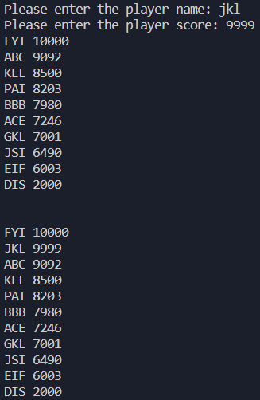

Part 1(f)
{Copy and paste the program code listing for question 1(f) here}

def write_topten():
filename = "NewHighScore.txt"
file = open(filename, "a")
for i in range(0, 10):
file.write(player_names[i])
file.write("\n")
file.write(str(player_scores[i]))
file.write("\n")
file.close()

Question 2
Part 2(a)
{Copy and paste the program code listing for question 2(a) here}

class Balloon:
# PRIVATE health : INTEGER
# PRIVATE colour : STRING
# PRIVATE defence_item : STRING
def __init__(self, colour, defence_item):
self.__health = 100
self.__colour = colour
self.__defence_item = defence_item

Part 2(b)
{Copy and paste the program code listing for question 2(b) here}
def get_defence_item(self):
return self.__defence_item

Part 2(c)
{Copy and paste the program code listing for question 2(c) here}
def change_health(self, health):
self.__health += health

Part 2(d)
{Copy and paste the program code listing for question 2(d) here}
def check_health(self):
return True if self.__health <= 0 else False

Part 2(e)
{Copy and paste the program code listing for question 2(e) here}
def main():
colour = input("Enter a colour for your balloon: ")
defence_item = input("Enter a defence item for your balloon: ")
ballon_1 = Balloon(colour, defence_item)

main()
Part 2(f)
{Copy and paste the program code listing for question 2(f) here}

def defend(balloon):
opponent_strength = input("Enter your opponent's strength: ")
balloon.change_health(int(f"-{opponent_strength}"))
print(balloon.get_defence_item())
health_status = balloon.check_health()
message = "No health remaining!" if health_status else f"Health remaining!"
print(message)
return balloon

Part 2(g)(i)
{Copy and paste the program code listing for question 2(g)(i) here}

def main():
colour = input("Enter a colour for your balloon: ")
defence_item = input("Enter a defence item for your balloon: ")
balloon_1 = Balloon(colour, defence_item)
updated_balloon_1 = defend(balloon_1)

Part 2(g)(ii)
{Copy and paste the screenshot for question 2(g)(ii) here}

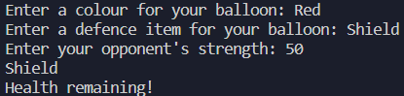

Question 3
Part 3(a)
{Copy and paste the program code listing for question 3(a) here}

queue_array = [None for i in range(0, 10)]
head_pointer = 0
tail_pointer = 0
queue_length = 0

Part 3(b)
{Copy and paste the program code listing for question 3(b) here}

def enqueue(data):
global queue_array, tail_pointer, queue_length
if queue_length == len(queue_array):
return False
queue_array[tail_pointer] = data
if tail_pointer >= 9:
tail_pointer = 0
else:
tail_pointer += 1
queue_length += 1
return True

Part 3(c)
{Copy and paste the program code listing for question 3(c) here}

def dequeue():
global queue_array, head_pointer, queue_length
if queue_length == 0:
return False
queue_array[head_pointer] = None
if head_pointer >= 9:
head_pointer = 0
else:
head_pointer += 1
queue_length -= 1
return True

Part 3(d)(i)
{Copy and paste the program code listing for question 3(d)(i) here}

def main():
for i in range(0, 11):
user_input = input("Please enter a string value: ")
is_successful = enqueue(user_input)
message = "Enqueue successful." if is_successful else "Enqueue failure."
print(message)
print(dequeue())
print(dequeue())

main()

Part 3(d)(ii)
{Copy and paste the screenshot for question 3(d)(ii) here}

