Insert your centre number, name and candidate number into the header above.
Save this evidence document as evidence_ followed by your centre number_ candidate number. For example: evidence_ zz999_9999
Screenshots or program listings must be copied into appropriate cells in the following table.
Examiners must be able to read the contents including any screenshots without the use of a magnifying glass. Answers that are not readable or missing will not be awarded any marks.
Save this evidence document at regular intervals, for example every 10 minutes.
Question 1
Part 1(a)
{Copy and paste the program code listing for Question 1(a) here}
stack_data = [0 for i in range(0, 10)]
stack_pointer = 0
Part 1(b)
{Copy and paste the program code listing for Question 1(b) here}

def output_values():
[print(stack_data[i]) for i in range(0, len(stack_data))
Part 1(c)
{Copy and paste the program code listing for Question 1(c) here}
def push(data):
global stack_data, stack_pointer
if stack_pointer == len(stack_data) - 1:
return False
else:
stack_data[stack_pointer] = data
stack_pointer += 1
return True
Part 1(d)(i)
{Copy and paste the program code listing for Question 1(d)(i) here}
def main():
for i in range(0, 11):
user_input = int(input("Please enter a number: "))
is_added = push(user_input)
message = f"{user_input} has been added to the stack!" if is_added else f"{user_input} hasn't been added to the stack!"
print(message)
output_values()

main()

Part 1(d)(ii)
{Copy and paste the screenshot for Question 1(d)(ii) here}
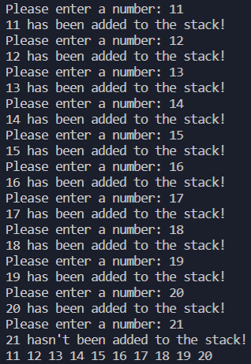
Part 1(e)(i)
{Copy and paste the program code listing for Question 1(e)(i) here}

def pop():
global stack_data, stack_pointer
if stack_pointer == 0:
return -1
else:
data = stack_data[stack_pointer - 1]
stack_data[stack_pointer - 1] = 0
stack_pointer -= 1
return data

Part 1(e)(ii)
{Copy and paste the screenshot for Question 1(e)(ii) here}

Question 2
Part 2(a)
{Copy and paste the program code listing for Question 2(a) here}
from random import randint

array_2d = [[randint(1, 100) for i in range(10)] for i in range(0, 10)]

Part 2(b)(i)
{Copy and paste the program code listing for Question 2(b)(i) here}

Part 2(b)(ii)
{Copy and paste the program code listing for Question 2(b)(ii) here}

Part 2(b)(iii)
{Copy and paste the screenshot for Question 2(b)(iii) here}

Part 2(c)(i)
{Copy and paste the program code listing for Question 2(c)(i) here}

Part 2(c)(ii)
{Copy and paste the screenshot for Question 2(c)(ii) here}

Question 3
Part 3(a)
{Copy and paste the program code listing for Question 3(a) here}

Part 3(b)
{Copy and paste the program code listing for Question 3(b) here}

Part 3(c)
{Copy and paste the program code listing for Question 3(c) here}

Part 3(d)
{Copy and paste the program code listing for Question 3(d) here}

Part 3(e)(i)
{Copy and paste the program code listing for Question 3(e)(i) here}

Part 3(e)(ii)
{Copy and paste the screenshot for Question 3(e)(ii) here}

