**DHAANISH AHMED COLLEGE OF**

**ENGINEERING**

**Domain Name: Data Analytics with Cognos**

**Project Title: Covid-19 Cases Analysis**

**Phase 2: Innovation - Implementing the Design**

**Introduction:**

In Phase 1, we defined the design for analyzing COVID-19 cases and deaths data using IBM Cognos. In this phase, we will outline the detailed steps to implement this design and transform it into a functional solution. The objective is to turn our design into a practical and innovative system for gaining insights from the data.

**Steps for Implementation:**

**1. Data Preparation and Collection:**

Obtain the COVID-19 Dataset: We will download the dataset from the provided source (Kaggle) and ensure it is up-to-date.

Data Cleaning: Perform data cleaning tasks to handle missing values, duplicates, and inconsistencies. Ensure data quality and accuracy.

**2. IBM Cognos Setup:**

Environment Configuration: Set up the IBM Cognos environment, including software installation and configuration.

Data Connection: Establish a connection between IBM Cognos and the prepared COVID-19 dataset.

**3. Data Preprocessing:**

Data Transformation: Aggregate daily cases and deaths, calculate metrics (mean and standard deviation), and format data for analysis.

Data Integration: Integrate additional data sources for contextual analysis (e.g., population data).

Data Export: Export the cleaned and preprocessed dataset in a format compatible with IBM Cognos.

**4. Data Analysis and Visualization:**

Visualization Design: Create visualizations (line charts, bar charts) to effectively communicate mean values and standard deviations.

Dynamic Interactivity: Ensure interactivity in visualizations for users to explore data by adjusting parameters and filtering.

**5. Insights Dashboard:**

Dashboard Creation: Design and develop an interactive dashboard within IBM Cognos to present key findings, trends, and correlations.

Key Findings: Present insights, including mean values, standard deviations, trends, regional variations, and identified correlations.

User Interaction: Allow users to interact with the dashboard, customize views, and explore data.

**6. Documentation:**

Data Source Documentation: Create detailed documentation of the COVID-19 dataset, its source, structure, and metadata.

Data Transformation Documentation: Document data cleaning, preprocessing, and integration steps, along with any transformations applied.

Visualization Documentation: Explain visualization choices, configurations, and parameters.

Insights Documentation: Record and explain the insights derived from the analysis, including trends and correlations.

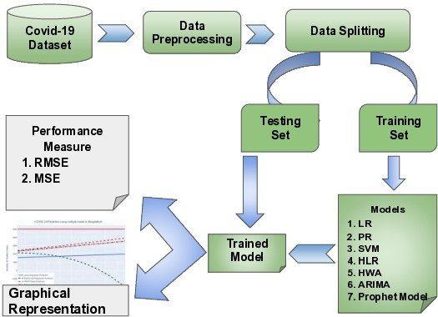

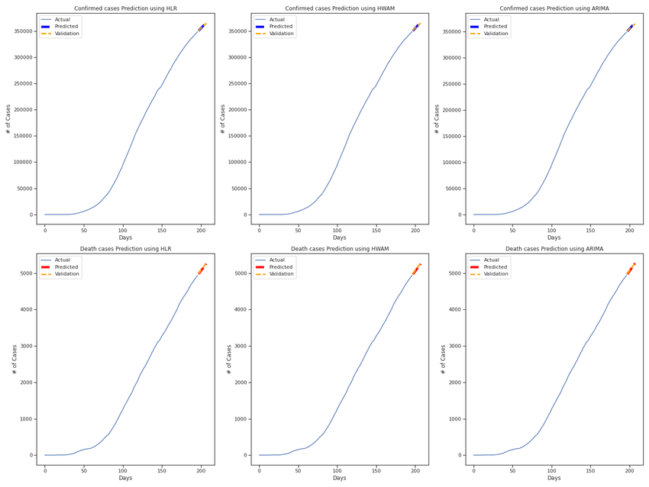

**7. Testing and Quality Assurance:** Testing: Conduct rigorous testing of the entire system to identify and rectify any errors or issues.

Quality Assurance: Ensure the accuracy and reliability of data and visualizations.

**8. Deployment:**

Deployment Planning: Plan for the deployment of the system, including hardware and software requirements.

User Training: Train users on how to use the system effectively.

**9. User Feedback and Iteration:**

Feedback Collection: Gather feedback from users to understand their needs and preferences.

Iterative Improvements: Implement iterative improvements based on user feedback to enhance the system's usability and effectiveness.

**10. Final Assessment and Presentation:**

Assessment: Evaluate the system's performance, accuracy, and user satisfaction.

Presentation: Present the final results, insights, and the implemented system to stakeholders.

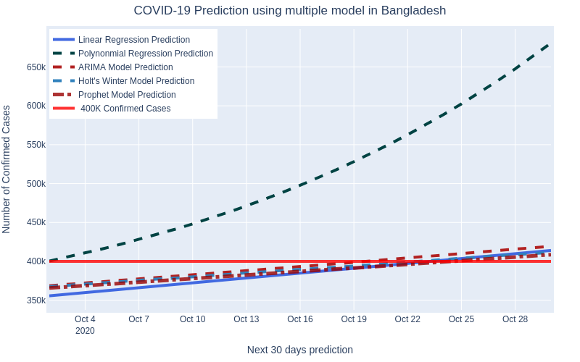

**Conclusion:**

In Phase 2, we have detailed the steps for implementing the design developed in Phase 1. By following these steps, we will transform our design into a functional and innovative system for analyzing COVID-19 data using IBM Cognos. This system will provide valuable insights and help stakeholders make data-driven decisions in response to the pandemic within the EU/EEA.

The implementation process will involve careful data handling, visualization design, interactivity, documentation, testing, and deployment. It will culminate in a system that empowers users to explore and understand the COVID-19 data effectively, contributing to better decision-making and response efforts.