F10 T4a W2 & W3 HOMEWORK: SPEAKING MOCKS PRACTICE
*Module 4- THEMATIC CONTEXT: Lifestyle and well-being
You’ve got some great vocabulary from this module to kickstart your ideas, but the real magic happens when you make the language your own and build thoughtful, developed answers. For each question, use the success criteria below to guide your progress, and tick each box in the grid as you reach your targets.

Success criteria | 1 | 2 | 3 | 4 | 5 | 6 | 7 | 8 | 9 | 10
Included a relevant answer
Answered in the correct tense
Included a relevant answer
Used a variety of connectives
Used interesting vocabulary (amusant and ennuyeux are banned!)
Used sophisticated opinion starters
Used at least TWO complex structures per answer  complex negatives  DOPs  Comparative  Superlative  il faut  reflexive verbs  depuis + present tense  imperfect tense  je voudrais + infinitive,  si clauses,  modal verbs (je peux/on peut/je veux/on veut/  je dois/on doit) etc. | 
Expanded your answer (by either talking about another person or adding in another tense)

*Question 1 : Qu’est-ce qu’il faut faire pour être en bonne santé ?
Choose one of the prompts and adapt the sentence builder below to write down an answer following the success criteria (see example)
- Selon moi, pour être en bonne santé on doit … et on doit ...
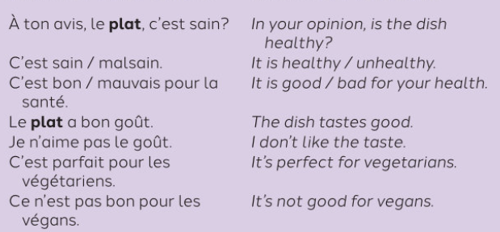
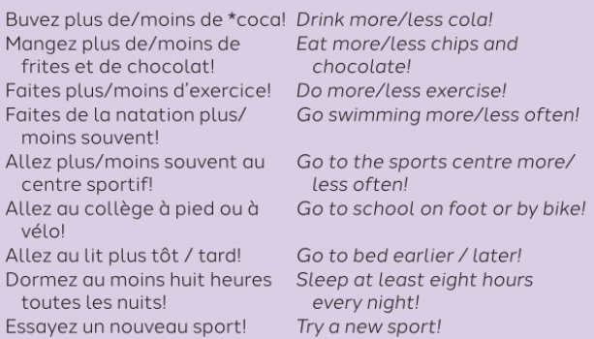
- A mon avis, pour être en bonne santé , il faut …

Example : buvez moins de coca ! > Selon moi, pour être en bonne santé on doit boire moins de coca et on doit manger plus de légumes.
____________________________________________________________________________________________________________________________________________________________________________________________________________________________________________________________________________________________________________________________________
Question 2 : Qu’est-ce que tu prends pour le petit-déjeuner ? Le midi ? Après les cours ? Le soir ?
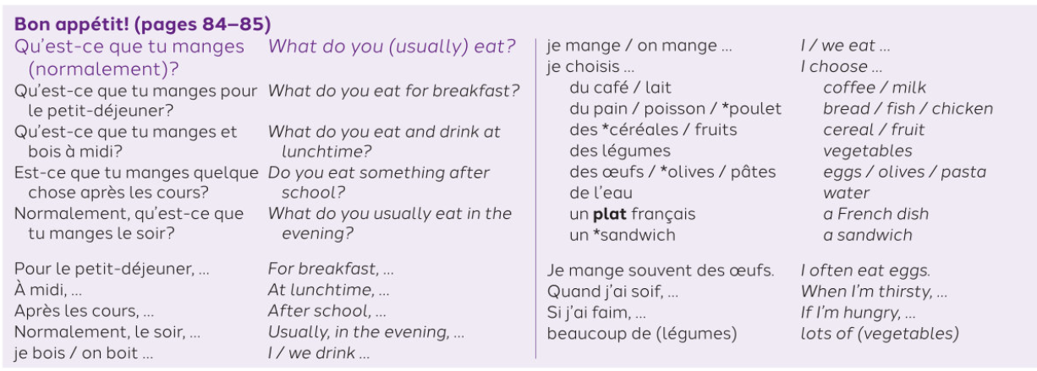
______________________________________________________________________________________________________________________________________________________________________________________________________________________________________________________________________________________________________________________________________________________________________________________________________________________________________________________________________________________________________
*Question 3 : Qu’est-ce que tu as mangé pour le diner hier soir ?
Use the sentence builder used in question 2: ‘Bon appétit!
Be careful to change the present tense into the perfect tense
E.g : je bois > j’ai bu – Je mange > j’ai mangé – je choisis > j’ai choisi
Then, give an opinion using the imperfect tense at the end of your paragraph!
_____________________________________________________________________________________________________________________________________________________________________________________________________________________________________________________________________________________________________________________________________________________________________________________________________________________

*Question 4 : Qu’est-ce que tu voudrais manger demain et pourquoi ?
Use the sentence builder used in question 2: ‘Bon appétit!
Be careful to change the present tense into the conditional tense (E.g: je mange > je voudrais manger).
Then, give an opinion using the near future tense (it is going to be + adjective) at the end of your paragraph!
_____________________________________________________________________________________________________________________________________________________________________________________________________________________________________________________________________________________________________________________________________________________________________________________________________________________

*Question 5 : Quelle nourriture est-ce que tu aimes bien acheter ?
Use the two prompts below (for food items, use one option):
- C’est une bonne question, d’habitude j’aime bien acheter des légumes bio/ des fruits / de la viande / des snacks puisque c’est/ce n’est pas …
- Cependant je déteste/j’adore acheter des produits sucrés/ des boissons gazeuses/ des fruits bio/ du poulet /du poisson car …
_____________________________________________________________________________________________________________________________________________________________________________________________________________________________________________________________________________________________________________________________________________________________________________________________________________________
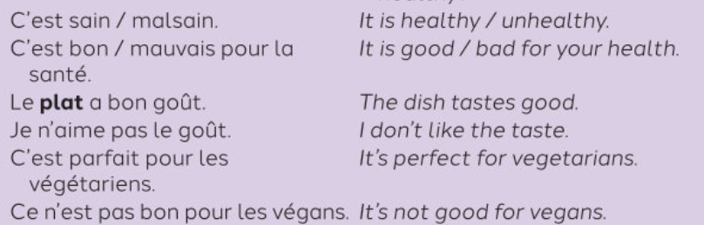
Question 6 : Quel est ton avis sur les restaurants fast-food ?

____________________________________________________________________________________________________________________________________________________________________________________________________________________________________________________________________________________________________________________________________
*Question 7 : Qu’est-ce que tu fais pour être en forme ?
Use the ideas in the sentence builders: you must change the imperative form into the present tense E.g : écoute de la musique > j’écoute de la musique
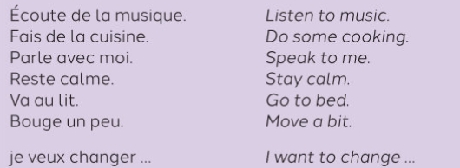
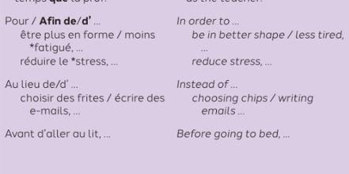
_____________________________________________________________________________________________________________________________________________________________________________________________________________________________________________________________________________________________________________________________________________________________________________________________________________________

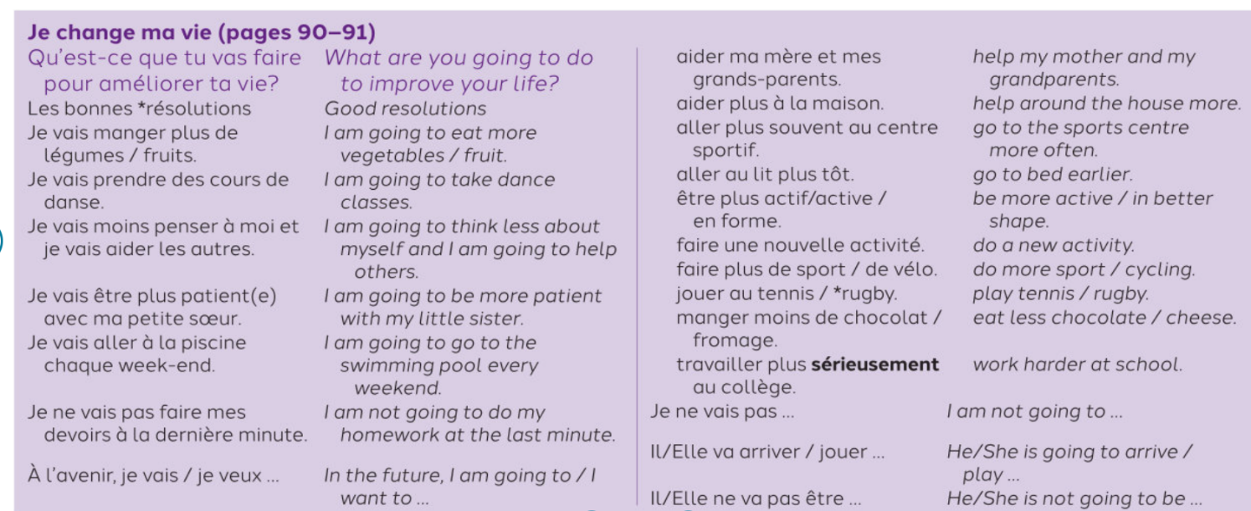
Question 8 : A l’avenir, qu’est-ce que tu feras pour avoir une vie plus saine ?
_____________________________________________________________________________________________________________________________________________________________________________________________________________________________________________________________________________________________________________________________________________________________________________________________________________________

Question 9 : Quand tu étais jeune, ta vie était comment ?
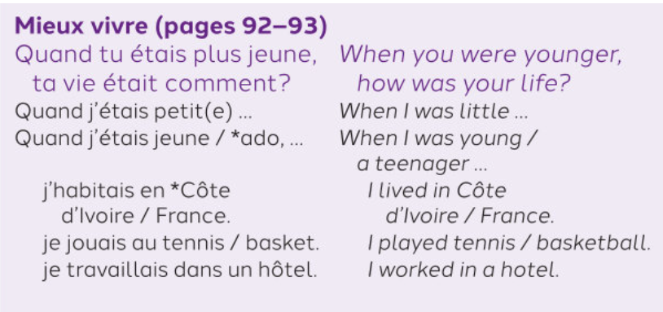

_____________________________________________________________________________________________________________________________________________________________________________________________________________________________________________________________________________________________________________________________________________________________________________________________________________________

Question 10 : Décris ta vie maintenant.
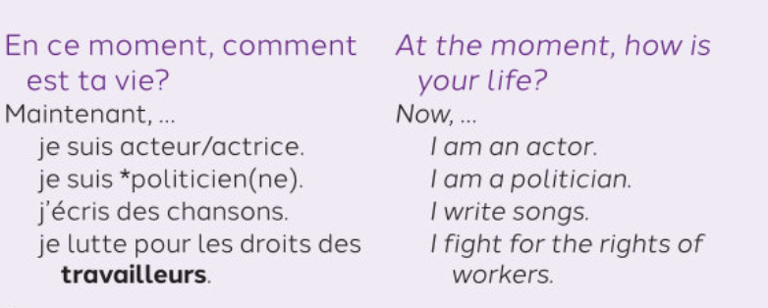
_____________________________________________________________________________________________________________________________________________________________________________________________________________________________________________________________________________________________________________________________________________________________________________________________________________________
For Partner’s feedback only (questions 1, 3, 4, 5 and 7 only)
 | WWW | EBI
Tenses

Complexity
(complex language, complex structures)

Expansions

