PART 1 - Interleaving recall (past topics)
- What separation technique would you use to separate an insoluble solid from a liquid?
- Give 3 properties of metals.
- Describe metallic bonding. You may draw a diagram.
- Explain why metals can conduct electricity.
- Explain why metals have a high melting point.

PART 2 - Current topic recall –
- What is the name given to the Group 1 elements?
- Write a word equation for the reactions of these Group 1 elements with water:
- Lithium
- Sodium
- Potassium
- What would observe during all of the reactions above?
- Describe the trend in reactivity in Group 1.
- Explain the trend in reactivity in Group 1.

PART 3 - Exam Style Questions
1. | A teacher places a small piece of metal into a test tube of water.  The metal floats and fizzes on the surface of the water.  What is the name of the metal?
  A | Copper
  B | Iron
  C | Lithium
  D | Silver
  Your answer |  | [1]

2(a). | Table 14.1 shows the melting points of some of the Group 1 metals.  - Plot the data in Table 14.1 on the grid in Fig. 14.1.  Draw a line of best fit.  - Describe the relationship between the atomic number of the Group 1 metals and their melting points shown in Fig. 14.1.  [1]
  Group 1 metal | Atomic number | Melting point (°C)
  Lithium | 3 | 181
  Sodium | 11 | 98
  Potassium | 19 | 63
  Rubidium | 37 | 39
  Caesium | 55 | 29
  Table 14.1
  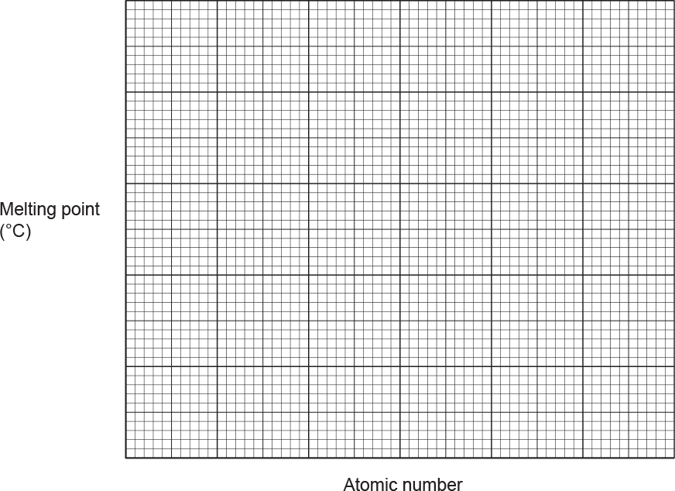
  Fig. 14.1
  [3]

(b). | Fig. 14.2 shows the structure of sodium.  - Describe the metallic bonding in sodium.  Use information from Fig. 14.2 in your answer.  [2]  - Look at the melting points of sodium and lithium in Table 14.1.  Suggest a reason for the difference in their melting points.  [1]
  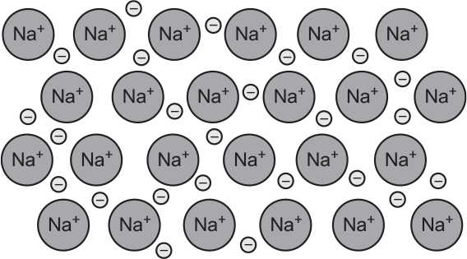
  Fig. 14.2

3(a). | Some Group 1 and Group 7 elements are very reactive.  Look at the reaction cycle.  Identify element A.  [1]
  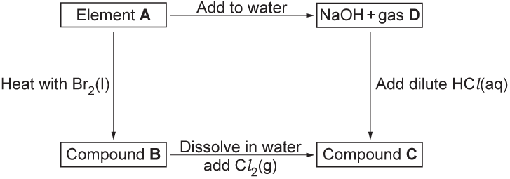

(b). | - Identify compound B.  [1]  - Write a balanced equation for the reaction of element A with Br₂(l).  Include state symbols in your answer.  [2]

(c). | - Identify compound C.  [1]  - Give a reason for your answer to (i).  [1]

(d). | D is a colourless gas.  How can you show if the gas is carbon dioxide, hydrogen or oxygen?  Describe the tests for carbon dioxide, hydrogen and oxygen and the results you would expect with gas D.
  test for carbon dioxide
  result with gas D
  test for hydrogen
  result with gas D
  test for oxygen
  result with gas D
  [3]

4. | This question is about Group 1 and Group 7 elements.  A Group 1 element D reacts with water.  This is the equation:  2D + 2H₂O → 2NaOH + E  - Name element D.  [1]  - A teacher shows this reaction to his class.  Describe one safety precaution he should use.  [1]  - E is a colourless gas.  How can you show if the gas is hydrogen or oxygen?  Describe the tests for hydrogen and oxygen, and the results you would expect with gas E.  - Group 1 elements are very reactive.  Write down the reason why.  [1]
  test for hydrogen
  result with gas E
  test for oxygen
  result with gas E
  [2]

