Purpose and relevance of the work

Organization of a rescue operation (mission) with the creation of a flight task in rough terrain using a integrated drone system using a neural network: detection, cargo delivery (without dumping), transmission of coordinates. The task is designed for independent cargo collection. We were inspired to this project by the volunteer search team "LizaAlert", which aims to provide rapid response for civilian assistance in the search for the missing

The use of artificial intelligence technologies allows not only to improve the accuracy of object identification, but also contributes to adaptation to environmental changes and continuous self-improvement of the system through training on the collected data.

BACKGROUND AND SUMMARY OF THE PROJECT

The project was created at the request of a real search party, the present development is a prototype of its implementation.

The result of the UAV's work is thousands of images that need to be processed as quickly as possible. The chances of the missing person surviving decrease by the hour, and with the onset of cold weather – by the minute. The issue can be solved with the use of modern technologies.

The moment of discovery of the missing person is a factor on which the result of the entire rescue operation depends. After detecting an object with the help of a UAV, a rover is sent to it, which delivers a first aid kit and a minimum survival kit. A rover is an unmanned vehicle that moves on the ground. In rough terrain, it is necessary because the UAV often cannot land in the required place. In addition, the rover is more energy efficient because it allows you to use batteries of higher weight.

FUNCTIONAL REQUIREMENTS

Task for the copter

* Take off from the takeoff point. Light indication Lime.
* Fly around the polygon. Light indication Crimson.
* When detecting a Rover, change the color of the LED strip to Yellow , when detecting a stone(ball), blink Blue color, when detecting a tree(flower), blink SaddleBrown, when detecting a person (Mannequin), blink Green . Identify objects using computer vision.
* In the topic, sign The name of all objects is , indicate their color and outline all detected objects.
* Create a report, which will contain information about all detected objects, their location and color.
* Landing at the take-off point. Light indication Purple

Task for the rover

* Exit the parking area. Lights on.
* Start the trajectory movement algorithm, avoiding collisions with polygon elements
* Find an object. Blink the headlights three times. Transfer the cargo
* Return to the parking area. Lights off

DETAILED DESCRIPTION OF ALGORITHMS AND METHODS,

USED TO ANALYZE DATA FROM CAMERAS AND SENSORS

Analyzing data from cameras on the rover, such as DH Contact, using the YOLOv8 model uses advanced computer vision techniques to detect objects in real time. This process is based on several key algorithms and methods that ensure high accuracy of object recognition, tracking and analysis. The following is a detailed description of these methods and algorithms.

1. YOLOv8 (You Only Look Once, version 8)

YOLOv8 is one of the most advanced versions of the YOLO architecture designed for real—time object detection. The main improvement of YOLOv8 compared to previous versions is a lighter and more efficient architecture that provides high speed and accuracy in object detection.

The principle of operation of YOLOv8:

• Single pass through image: YOLO (like her eighth version) analyzes the entire image in one pass (hence the name "You Only Look Onc

• Normalization: The pixels of the image are normalized (for example, dividing by 255 so that the values are in the range from 0 to 1), which helps the model to work better with different levels of illumination and contrast.

Object detection algorithms

YOLOv8 uses several key algorithms to detect objects:

• Convolution Neural Networks (CNN): Convolution networks extract features from an image (for example, edges, textures) and pass them on for analysis at a higher level. Each convolution layer processes a certain level of features, starting with simple ones such as faces and corners, and up to complex objects at higher levels.

• Pyramid Feature Networks (FPN, Feature Pyramid Networks): YOLOv8 uses FPN to better identify objects of different scales. FPN processes images at different resolution levels, which allows the model to effectively identify both large and small objects.

4. Object Tracking Algorithms

Tracking objects allows the system to "

5. Algorithms for suppression of unwanted objects (Non-Maximum Suppression, NMS) When

YOLOv8 finds several objects with a high degree of overlap, it uses the NMS method to filter duplicate predictions. This algorithm leaves only the most likely prediction for each object, removing less accurate predictions.

6. Metrics for evaluating the quality of detection

Various metrics are used to evaluate the quality of the model's work on detecting objects from the rover's camera:

• mAP (mean Average Precision): The average accuracy (AP) is calculated for each feature class. mAP is the average AP value for all classes. It measures the accuracy of predictions and their correspondence to real objects.

• IoU (Intersection over Union): This is a metric that measures how accurately the predicted area of an object matches the real area. IoU is the ratio of the area of intersection of the predicted and real frames to their combined area.

7. Optimization and post-processing

After the objects are recognized

8. Integration with on-board systems and sensors

YOLOv8 can integrate with other rover sensors and systems such as LIDAR or GPS. This helps the model to obtain more accurate data on the position and distance to objects, which is important for the control and autonomous navigation of the rover.

9. Using machine learning algorithms

• Supervised Learning: The YOLOv8 model is trained on marked-up data, where each object in the image is assigned its own class and frame. Large datasets such as COCO or rover-specific datasets are used.

• Fine-tuning (Fine tuning): The model can be further trained on data specific to the rover (for example, objects in the conditions of Mars or another planet), which allows it to better recognize objects in a specific environment.

CHARTS AND GRAPHS,

ILLUSTRATING THE DATA ANALYSIS PROCESS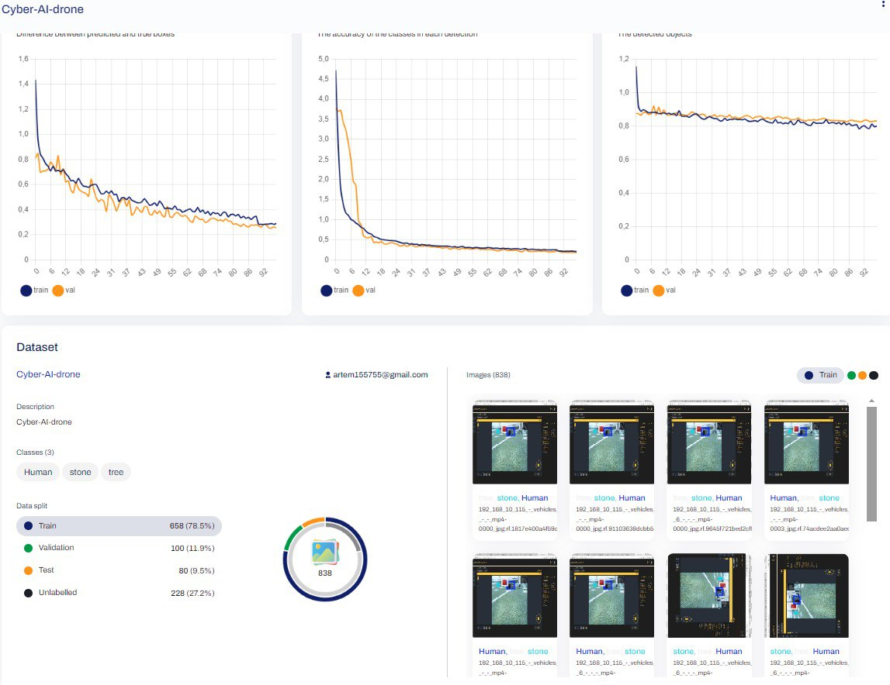

PROTOTYPES OF USER INTERFACES

TO DISPLAY THE RESULTS OF DATA ANALYSIS

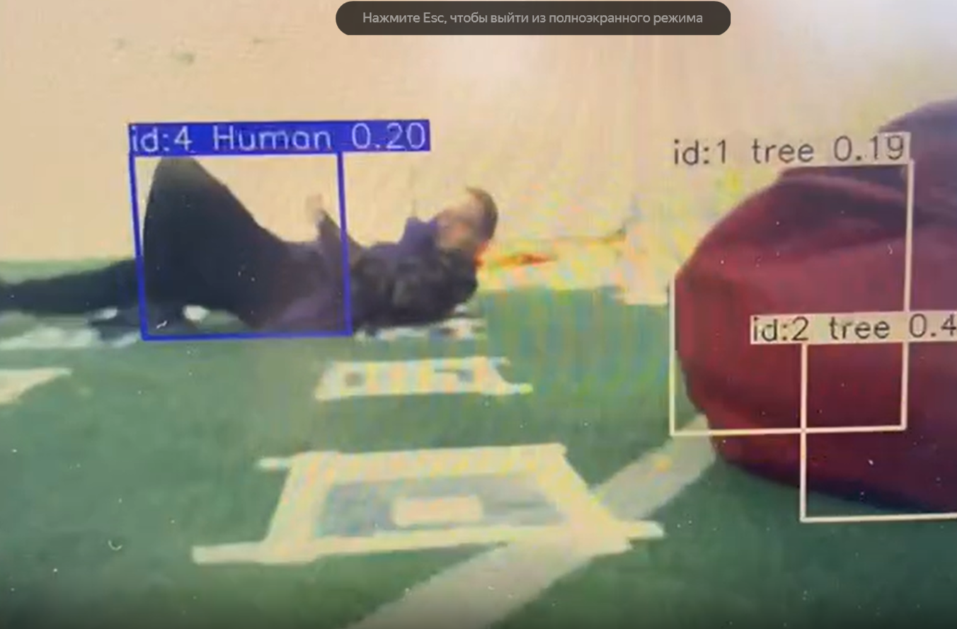

A VIDEO SHOWING

THE OPERATION OF THE COMPLEX

[*https://disk.yandex.ru/i/mKpjEilXAF9ebw*](https://disk.yandex.ru/i/mKpjEilXAF9ebw)