Task1
It is not always possible to achieve BOTH BCNF and dependency preservation (DP)
Advisor( s_id, i_id, department )
i_id department
s_id, department i_id
i_id is not a superkey and any decomposition of Advisor will not include all the attributes in s_id, department i_id, thus Advisor not in BCNF, and it will NOT be DP.
Functional depencies are important in database design because they allow us to eliminate redundancies.

Task2
Version #1:
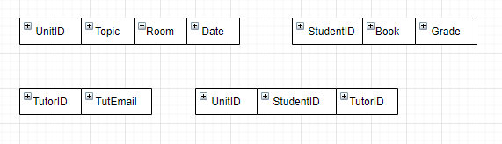
Version #2:
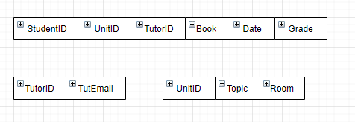
Task3
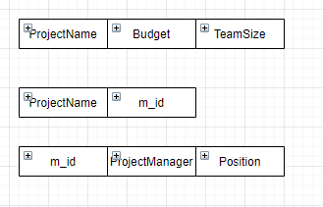
Task4
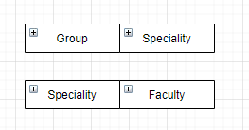
Task5
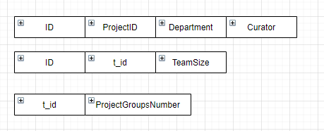
Task6

1. Lossless-join decomposition
2. Dependency preserving decompositions
3. Minimization pf repetition of the information

We can keep an precise, correct database, which is easy to maintain, navigate. Use small amount of space.

Undesirable:
Let us decompose employee(ID, name, street, city, salary)
Into e1(ID, name) and e2(name, street, city, salary). If there is repetition of name then we lose information, hence this is lossy decomposition.
Desirable:
R = (A, B, C) into r1 = (A, B) and r2 = (B, C), then we don’t lose information, thus it is lossless decomposition.

