Course: CSE:221, Sec-4, Quiz: 2, Time: 15 Minutes

[ 5 + 3 + 7 = 15 ]

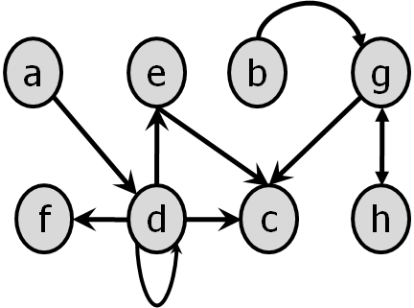

Answer the following queries based on the above graph.

(a) Represent the graph using Adjacency List.

(b) Is it possible to reach vertex “b” from “h”? If yes then what is the minimum cost of the path? Which Graph searching algorithm will you need to apply and why?

(c) Determine those neighbours who are at distance=1 and distance=2 from vertex “d” using BFS. Draw the corresponding BFS Tree.