Course: CSE:221, Sec-4, Quiz: 2, Time: 15 Minutes

[ 5 + 7 + 3 = 15 ]

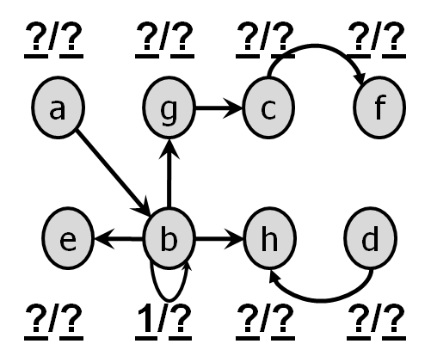

Answer the following queries based on the above graph.

(a) Represent the graph using Adjacency List.

(b) Fill in the discovery and finishing time for all the vertices. Generate the Depth First Forest.

(c) Is it possible to determine topologically sort the vertices? If YES mention the order of the vertices in topologically order. If NO then reason your answer.