HEART RISK PREDICATION

Project Members
Muhammad Shahan
Syed Noor Hussain

-- ** Identifying High-Risk Groups **
-- Identifying heart attack risk factors such as high cholesterol, BP , and diabetes among different demographic groups (e.g., age, sex).

SELECT
Sex,
AVG(CASE WHEN Cholesterol > 200 THEN 1 ELSE 0 END) AS HighCholesterol,
AVG(CASE WHEN Blood_Pressure >= 140 OR Blood_Pressure <= 90 THEN 1 ELSE 0 END) AS HighBloodPressure,
AVG(CASE WHEN Diabetes = 'Yes' THEN 1 ELSE 0 END) AS DiabetesPrevalence
FROM
patients_table
GROUP BY
Sex;

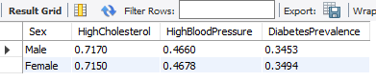

-- ** Assessing life style impact **
-- Analyze the association between lifestyle factors (e.g., smoking, obesity, sedentary behavior) and heart attack risk.
SELECT
Smoking,
Obesity,
AVG(`Heart_Attack_Risk`) AS AvgHeartAttackRisk
FROM
Patients_table
GROUP BY
Smoking, Obesity;
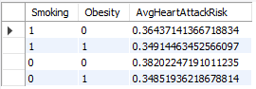

-- Identify patients with elevated stress levels and high cardiovascular risk

SELECT
Patient_ID,
Stress_Level,
Heart_Attack_Risk
FROM
patients_table
WHERE
Stress_Level >= 5 AND `Heart_Attack_Risk`>=0;

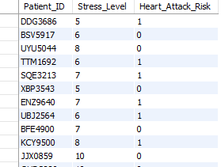

-- ** Understanding Geographic Variations **

-- Explore geographic variations in heart attack risk and associated factors across different countries and continents.

SELECT
Country,
Continent,
AVG(`Heart_Attack_Risk`) AS AvgHeartAttackRisk,
AVG(CASE WHEN Cholesterol > 200 THEN 1 ELSE 0 END) AS HighCholesterol,
AVG(CASE WHEN Blood_Pressure >= 140 OR Blood_Pressure <= 90 THEN 1 ELSE 0 END) AS HighBloodPressure,
AVG(CASE WHEN Diabetes = 'Yes' THEN 1 ELSE 0 END) AS DiabetesPrevalence
FROM
patients_table
GROUP BY
Country, Continent;

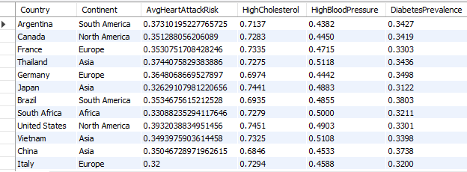

-- ** Risk Factor Correlations **
-- Develop risk assessment tools or algorithms that consider multiple risk factors to better predict individualized risk levels for patients

SELECT
Patient_ID,
(Cholesterol * 0.3) + (Blood_Pressure * 0.4) + (Age * 0.3) AS Risk_Score
FROM
patients_table;

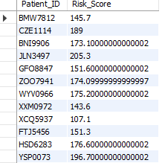

-- ** Medication Use and Adherence **
-- Examine the prevalence of medication use among patients with previous heart problems and its impact on heart attack risk.
SELECT
Medication_Use,
COUNT(*) AS Patients_Count,
avg(Heart_Attack_Risk) AS Average_HeartAttack_Risk
FROM
patients_table
GROUP BY
Medication_Use;

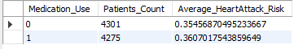

-- ** Psychosocial Factors **
-- Identify patients with elevated stress levels and high cardiovascular risk

SELECT
Patient_ID,
Stress_Level,
Heart_Attack_Risk
FROM
patients_table;
-- WHERE
-- Stress_Level >= 'low' AND `Heart_Attack_Risk` >= 0;

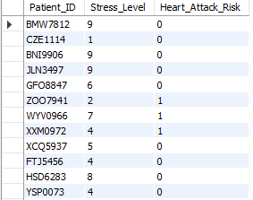

-- Dietary Patterns and Recommendations **
-- Identify patients with specific dietary patterns and cardiovascular risk factors

SELECT
Patient_ID,
Diet,
Cholesterol,
Triglycerides,
Blood_Pressure,
Heart_Rate
FROM
patients_table
WHERE
Diet IN ('Unhealthy', 'Average')
AND (Cholesterol > 200 OR Triglycerides > 150 OR Blood_Pressure >= 140 OR Heart_Rate >= 100);

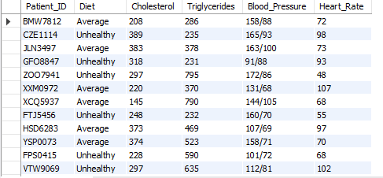

-- ** Educational Interventions **
-- Identify key insights for educational interventions

SELECT
Age,
Sex,
Smoking,
Diabetes,
AVG(`Heart_Attack_Risk`) AS Average_HeartAttack_Risk,
COUNT(*) AS Number_of_Patients
FROM
patients_table
GROUP BY
Age , Sex, Smoking, Diabetes
ORDER BY
Average_HeartAttack_Risk DESC;

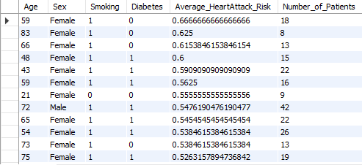

-- **Demographic Analysis**
-- Are there any differences in heart attack risk between males and females

SELECT sex,
AVG(Heart_Attack_Risk) AS average_prediction,
COUNT(*) AS total_patients
FROM patients_table
GROUP BY sex;

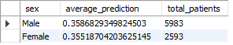

-- What is the distribution of patients by age and sex

SELECT sex,
COUNT(*) AS total_patients,
AVG(age) AS average_age,
MIN(age) AS min_age,
MAX(age) AS max_age
FROM patients_table
GROUP BY sex;

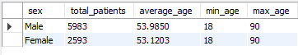

-- How does heart attack risk vary across different age groups?
SELECT
CASE
WHEN age BETWEEN 0 AND 20 THEN '0-20'
WHEN age BETWEEN 21 AND 30 THEN '21-30'
WHEN age BETWEEN 31 AND 40 THEN '31-40'
WHEN age BETWEEN 41 AND 50 THEN '41-50'
WHEN age BETWEEN 51 AND 60 THEN '51-60'
WHEN age BETWEEN 61 AND 70 THEN '61-70'
WHEN age BETWEEN 71 AND 80 THEN '71-80'
ELSE 'Above 80'
END AS age_group,
AVG(Heart_Attack_Risk) AS average_prediction,
COUNT(*) AS total_patients
FROM patients_table
GROUP BY age_group
ORDER BY MIN(age);

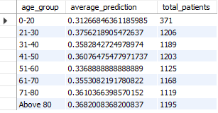

-- ** Health Indicators **
-- Is there a relationship between heart rate and heart attack risk?

SELECT
CASE
WHEN Heart_Rate < 60 THEN 'Low Heart Rate'
WHEN Heart_Rate BETWEEN 60 AND 100 THEN 'Normal Heart Rate'
WHEN Heart_Rate BETWEEN 101 AND 120 THEN 'Elevated Heart Rate'
ELSE 'High Heart Rate'
END AS heart_rate_category,
AVG(Heart_Attack_Risk) AS average_prediction,
COUNT(*) AS total_patients
FROM patients_table
GROUP BY heart_rate_category
ORDER BY AVG(heart_rate);

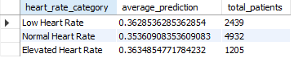

-- How does the prevalence of diabetes differ among patients who smoke vs. non-smokers?
SELECT
Smoking,
AVG(CASE WHEN Diabetes = 'Diabetic' THEN 1 ELSE 0 END) * 100 AS percentage_diabetic,
COUNT(*) AS total_patients
FROM patients_table
GROUP BY Smoking;

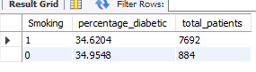

-- **Financial Impact **
-- Does income level correlate with heart attack risk?

SELECT
Income,
AVG(Heart_Attack_Risk) AS average_prediction,
COUNT(*) AS total_patients
FROM patients_table
GROUP BY Income
ORDER BY average_prediction DESC;

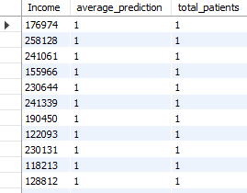

-- ** Physical Activity and Sedentary Behavior **
-- How does exercise frequency relate to heart attack risk?

SELECT
Exercise_Hours_Per_Week,
AVG(Heart_Attack_Risk) AS average_prediction,
COUNT(*) AS total_patients
FROM heart_attack_prediction_dataset
GROUP BY Exercise_Hours_Per_Week
ORDER BY average_prediction DESC;

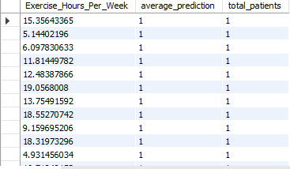

-- Does alcohol consumption impact heart attack risk
SELECT
Alcohol_Consumptio,
AVG(Heart_Attack_Risk) AS average_prediction,
COUNT(*) AS total_patients
FROM patients_table
GROUP BY Alcohol_Consumptio
ORDER BY average_prediction DESC;
