Arch

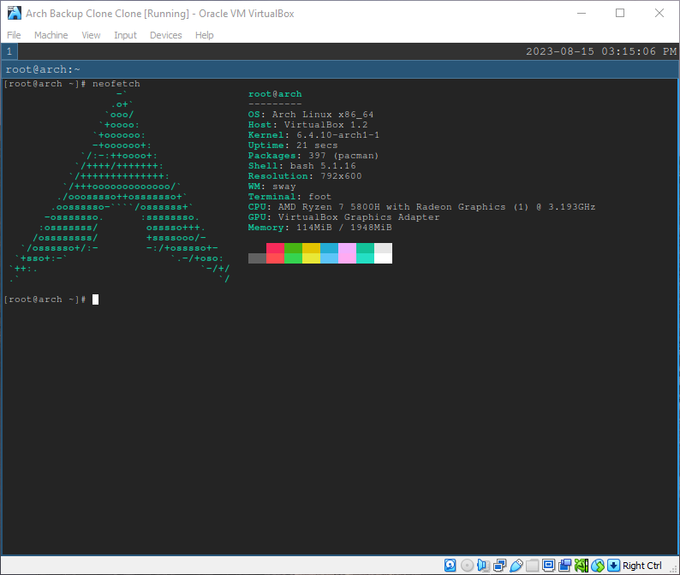

Video: <https://youtu.be/uYXXeizUiUo>

Gentoo

Video: <https://youtu.be/W2l8QNn4qbU>