Standard Deviation
The Standard Deviation is a measure of how spread out numbers are.
Its symbol is σ (the greek letter sigma)
The formula is easy: it is the square root of the Variance. So now you ask, "What is the Variance?"

Variance
The Variance is defined as:
The average of the squared differences from the Mean.
To calculate the variance follow these steps:
- Work out the Mean (the simple average of the numbers)
- Then for each number: subtract the Mean and square the result (the squared difference).
- Then work out the average of those squared differences. (Why Square?)

Example
You and your friends have just measured the heights of your dogs (in millimetres):
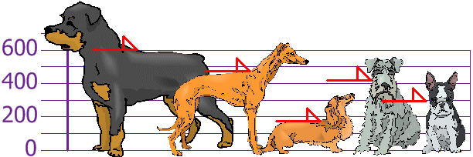
The heights (at the shoulders) are: 600mm, 470mm, 170mm, 430mm and 300mm.
Find out the Mean, the Variance, and the Standard Deviation.
Your first step is to find the Mean:

Answer:
Mean | = | 600 + 470 + 170 + 430 + 3005
 | = | 19705
 | = | 394
so the mean (average) height is 394 mm. Let's plot this on the chart:
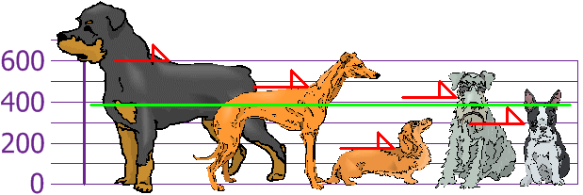
Now we calculate each dog's difference from the Mean:
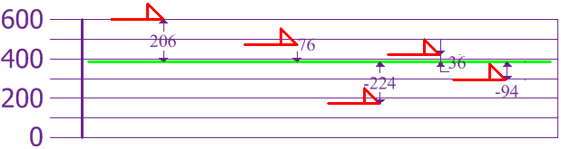
To calculate the Variance, take each difference, square it, and then average the result:
Variance
σ² | = | 206² + 76² + (−224)² + 36² + (−94)^{2 /}5
 | = | 42436 + 5776 + 50176 + 1296 + 8836 /5
 | = | 108520/5
 | = | 21704
So the Variance is 21,704
And the Standard Deviation is just the square root of Variance, so:
Standard Deviation
σ | = | √21704
 | = | 147.32...
 | = | 147 (to the nearest mm)

Mean Absolute Error (MAE)
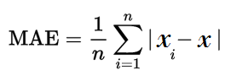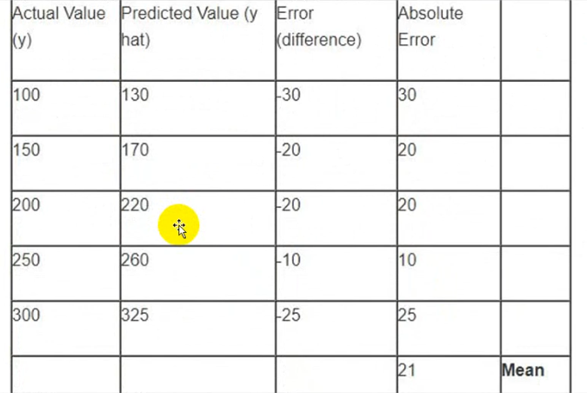
Mean Square Error (MSE)

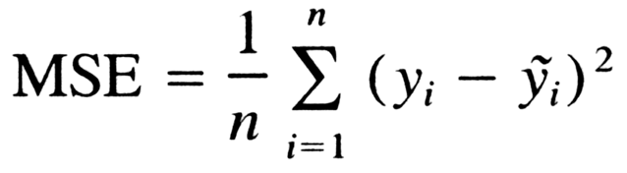
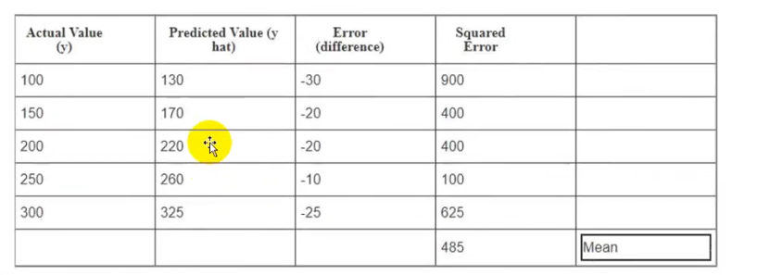
Root Mean Square Error (RMSE)
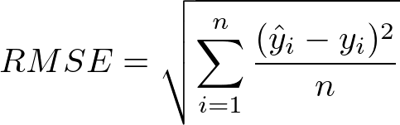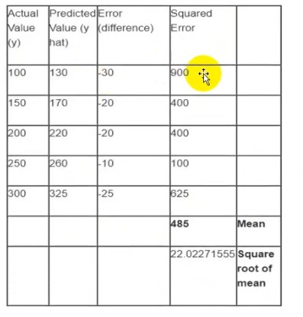
Root Mean Square Log Error (RMSLE)

