AI-Powered English ↔ Urdu Translation System



Session 2023-2027
Submitted by:
Muhammad Talha 2023-CS-12

Supervised by:
Sir Samyan Wahla

Course:
Programming for AI

Department of Computer Science

University of Engineering and Technology
Lahore Pakistan

Contents
1. Executive Summary 2
2. Introduction 2
2.1 Background 2
2.2 System Purpose 3
3. Problem Statement 3
4. Project Motivation 3
5. Project Objectives 3
5.1 Primary Objective 3
5.2 Secondary Objectives 3
6. Scope 4
6.1 In Scope 4
6.2 Out of Scope 4
7. Target Audience & User Profiling 4
8. System Requirements 5
8.1 Functional Requirements (FR) 5
8.2 Non-Functional Requirements (NFR) 6
9. System Architecture & Component Design 7
9.1 High-Level Architecture Diagram 7
9.2 Pipeline Module Descriptions 8
10. Cold-Start Few-Shot Benchmark Scenarios 8
11. Quality, Risk, Cost, & Latency Evaluation 9
11.1 Evaluation Metrics 9
11.2 Risk Routing Matrix 9
12. Complete Use Cases (UC-01 to UC-18) 9
13. Technology Stack 10
14. Implementation Plan 11
15. Error Handling & Fallback Matrix 12
16. Success Criteria 12

1. Executive Summary
The AI-Powered Urdu ↔ English Translation System ("Bilangual") is an enterprise-grade, context-aware text translation and natural language understanding platform designed specifically to handle the linguistic complexities of Urdu and English communication.
Unlike conventional translation tools that treat every sentence as an isolated, stateless event—often failing when encountering pronouns, conversational references, or mixed-language code-switching—Bilangual incorporates conversation state tracking, hybrid script/language identification, prompt engineering, frozen golden exemplars, and deterministic risk evaluation.
The system accepts standard Nastaliq Urdu script, English, Roman Urdu (Urdu written in Latin script), and mixed Urdu-English sentences. Before forwarding requests to the underlying foundation model (Google Gemini), the input undergoes rigorous preprocessing and language script classification. The system dynamically constructs a context-aware prompt containing previous conversation turns, target domain instructions, and few-shot exemplars.
Once the LLM generates a candidate translation, it passes through a Deterministic Quality & Risk Evaluation Engine. High-confidence, verified translations are immediately returned to the user or cached for zero-cost instant retrieval. Potentially problematic translations—such as those with missing financial numbers, inverted transaction states (debit vs. credit), or ambiguous inputs—are flagged for human review.
The system is designed around three fundamental AI Engineering constraints:
Cost Efficiency: Minimizing API token usage via high-speed deterministic caching and context window capping.
Translation Quality: Ensuring 100% entity and numerical preservation while maintaining natural native fluency.
Latency Optimization: Keeping response times low through cached hits and stream-ready async architecture.

2. Introduction

2.1 Background
Urdu and English co-exist in educational, commercial, governmental, financial, and daily digital communication across South Asia and global diaspora communities. A vast majority of digital communications (SMS, WhatsApp, customer support tickets, social media) do not use pure formal Urdu script or pure standard English. Instead, users frequently employ Roman Urdu (e.g., "Mera account lock ho gaya hai"), code-switching (mixing Urdu grammar with English terms), and context-dependent shorthand.
Commercial off-the-shelf translation tools struggle with:
1. Context Loss: Failing to resolve cross-sentence pronouns ("us ne", "wahan").
2. Script Ambiguity: Treating Roman Urdu as broken English or unrecognized gibberish.
3. Financial / Entity Hallucination: Dropping critical identifiers, numbers, or transaction multipliers (e.g., turning "2 dafa 5000 cut gaye" into "some money was debited").

2.2 System Purpose
This system provides an end-to-end AI engineering solution that bridges the gap between raw, informal user inputs and high-fidelity target translations or formal structured tickets.

3. Problem Statement
Standard neural machine translation APIs operate on single sentences in isolation and lack deterministic safety nets against hallucinations. The problem addressed by this project is:
> How can we build an end-to-end AI-powered Urdu ↔ English translation pipeline that accurately identifies script variations (Urdu script, English, Roman Urdu, Mixed), maintains conversational history across turns, applies dynamic prompt engineering, and deterministically audits outputs for entity preservation, financial state consistency, quality, cost, and latency?

4. Project Motivation
Consider the following multi-turn customer conversation:
Turn 1 User: "Ahmed went to Lahore yesterday."
Turn 2 User: "He stayed there for three days and opened a bank account."
A stateless translator processing Turn 2 in isolation cannot determine who "He" is or what "there" refers to. A context-aware pipeline injects Turn 1 into the prompt, allowing the LLM to retain referential integrity.
Furthermore, in high-stakes domains such as fintech customer support, code-switched inputs like:
"Bhai Raast transfer fail ho gaya, account se 5000 cut gaye par dost ko nahi mile."
require precise handling. A general translator might output "My transfer failed", dropping the PKR 5,000 amount or confusing whether the funds were debited or credited. Bilangual guarantees numerical preservation and financial state consistency before approving the output.

5. Project Objectives

5.1 Primary Objective
To design, implement, and evaluate a context-aware, multi-script AI translation system between Urdu and English, backed by deterministic risk verification and cost-latency monitoring.

5.2 Secondary Objectives
- Script Identification: Classify input into Urdu script, English script, Roman Urdu, or Mixed language.
- Input Preprocessing: Clean whitespace, normalize unicode, and eliminate repeated noise without altering semantic numbers.
- Context Management: Maintain a sliding-window session context (default: past 3–5 turns) to support referential translation.
- Prompt Engineering: Dynamically assemble system instructions, advisory hints, sliding conversation history, and domain exemplars.
- Few-Shot Exemplar System: Inject frozen benchmark scenarios to enforce domain-specific formatting and safety rules.
- Foundation Model Orchestration: Interface with Google Gemini API models with automatic fallback mechanisms.
- Deterministic Risk Engine: Validate numerical entity preservation, state consistency (debit vs. credit), and multiplier retention.
- Instant Caching: Cache verified translations for zero-cost, sub-5ms retrieval.
- Human Review Routing: Automatically flag ambiguous or entity-mismatched outputs for human audit.
- Telemetry & Monitoring: Record latency (ms), risk flags, confidence scores, and token overhead.

6. Scope

6.1 In Scope
Bidirectional English ↔ Urdu translation.
REST API built with FastAPI exposing endpoints for translation, health check, supported languages, and session context management.
Web Frontend featuring responsive dark-mode UI, single-click copy, clear history, and direction toggling.
Context-aware multi-turn conversation memory.
Deterministic numerical entity extractor and financial state validator.
High-speed memory caching layer for common queries.
Comprehensive evaluation dataset and benchmark suite.

6.2 Out of Scope
Speech-to-speech voice synthesis and real-time audio interpretation.
OCR document scanning from image/PDF files.
Fine-tuning raw LLM weights from scratch (system utilizes API-based foundation models).
Multi-language translation beyond English, Urdu script, and Roman Urdu.

7. Target Audience & User Profiling
User Class | Characteristics | Primary Need | System Feature
Bilingual Student | Frequently switches between English and Roman Urdu | Casual conversation & academic translation | Flexible language detector & context memory
Fintech / Support Agent | Processes customer complaints in Roman Urdu / Mixed script | Formal English compliance ticket generation | Structured ticket prompt & frozen exemplars
General User | Translates Urdu news, phrases, or daily messages | Simple, fast translation with pronunciation guides | High-speed cache, Nastaliq text rendering
Compliance Auditor | Audits high-risk financial or legal translations | Verification of numbers and dispute details | Risk Engine flags & Human Review interface

8. System Requirements

8.1 Functional Requirements (FR)
ID | Title | Description | Acceptance Criteria
FR-01 | Text Input | System accepts raw text strings in Urdu script, English, or Roman Urdu. | Accepts non-empty string up to 4000 characters.
FR-02 | Script & Language Detection | System classifies input script and calculates confidence. | Returns code (`ur`, `en`, `roman_urdu`), script type, and confidence score.
FR-03 | Language Direction Validation | System validates that input script matches the selected translation direction. | Raises explicit `LanguageMismatchError` if user enters English in Urdu mode.
FR-04 | Text Preprocessing | System normalizes whitespace and punctuation while preserving financial numbers. | Retains numbers, currency terms (`25k`, `5000`), and dates exactly.
FR-05 | Session Context Retrieval | System maintains sliding-window history per `session_id`. | Appends up to N previous turns into prompt memory.
FR-06 | Prompt Construction | System constructs structured JSON prompt with instructions, context, and exemplars. | Generates valid prompt formatted for LLM JSON output.
FR-07 | Foundation Model Query | System queries Google Gemini models with fallback redundancy. | Tries primary model (`gemini-3.5-flash`), falls back to alternative models on error.
FR-08 | Response Parsing | System parses LLM JSON output containing translation, detected script, pronunciation, and definitions. | Robustly handles direct JSON or regex-extracted JSON.
FR-09 | Deterministic Risk Engine | System audits candidate translation for number loss, state inversion, or ambiguity. | Returns status (`LOW_RISK_APPROVED`, `HIGH_RISK_NUMBER_MISMATCH`, etc.).
FR-10 | Caching Layer | System checks in-memory cache for exact text + direction matches. | Cache hit returns response in `< 5ms` with zero API cost.
FR-11 | Human Review Routing | High-risk translations are tagged for human audit rather than silently approved. | Sets `risk_level` flag in response payload.
FR-12 | Context History Management | System provides endpoints to view and delete conversation history. | `GET /context/{id}` and `DELETE /context/{id}` operate cleanly.

8.2 Non-Functional Requirements (NFR)
NFR-01 (Quality & Safety): Zero tolerance for dropped financial numbers or inverted transaction states (debit vs. credit).
NFR-02 (Performance): End-to-end API response time under 1500ms for fresh LLM queries, and under 5ms for cached hits.
NFR-03 (Cost Efficiency): Reduce API call frequency via deterministic caching and cap conversation context window to 3–5 turns.
NFR-04 (Reliability & Availability): Graceful error handling for API 429 quota limits, model timeouts, and malformed inputs.
NFR-05 (Usability): Responsive web application displaying RTL for Urdu, LTR for English, copy buttons, and status indicators.
NFR-06 (Maintainability): Modular architecture separating API routes, pipeline orchestrator, language detector, prompt builder, LLM client, and risk engine.

9. System Architecture & Component Design

9.1 High-Level Architecture Diagram
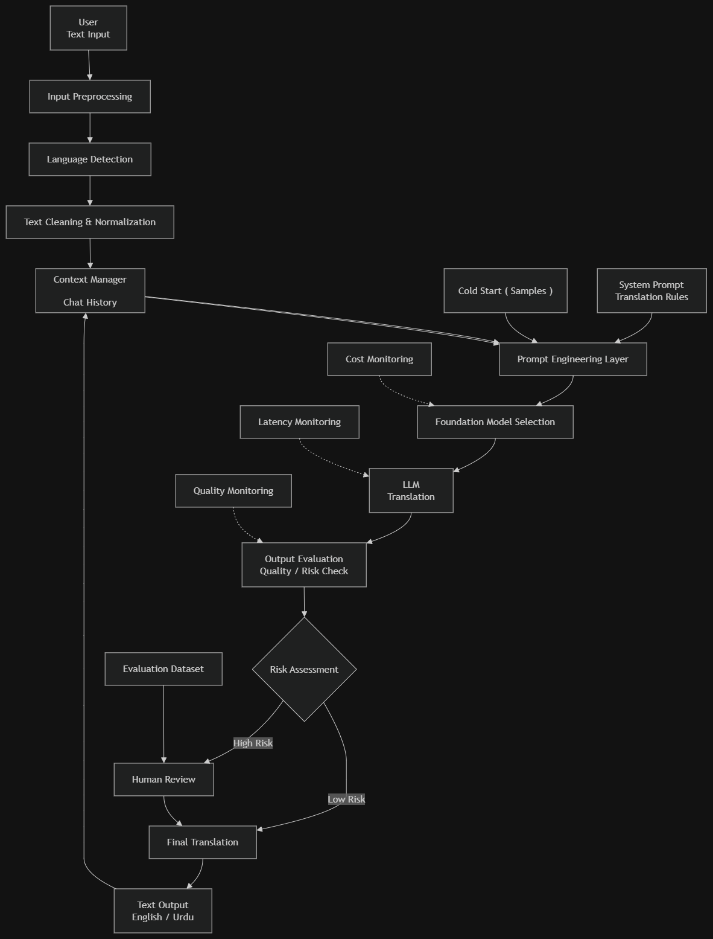

9.2 Pipeline Module Descriptions
- Preprocessor (`pipeline/preprocessor.py`): Cleans text, normalizes whitespace, eliminates duplicate punctuation marks while leaving numbers (`5000`, `25k`) untouched.
- Language Detector (`pipeline/language_detector.py`): Uses regex pattern matching across Unicode ranges (`\u0600-\u06FF`, `\u0750-\u077F`, `\uFB50-\uFDFF`, `\uFE70-\uFEFF`) and Latin characters (`a-zA-Z`) to compute script ratio and confidence.
- Context Manager (`core/context_manager.py`): Manages in-memory session stores, keeping sliding conversation history to provide multi-turn context.
- Prompt Builder (`pipeline/prompt_builder.py`): Assembles instructions, target descriptions, past turns, advisory hints, and injects 7 Frozen Golden Benchmark Exemplars.
- LLM Client (`pipeline/llm_client.py`): Manages Google Gemini API invocation (`gemini-3.5-flash` with redundant model candidates), forcing structured JSON outputs (`application/json`).
- Risk Engine (`pipeline/risk_engine.py`): Applies deterministic regex rules to verify that:
  - All numbers in source text are present in output text (handling shorthand like `25k`
->`25000`).
  - Financial states (debit vs. credit) match between input and output.
  - Multipliers (`2 dafa` -> `twice` / `duplicate`) are retained.
  - Hardware states (`phans gaya` ->`stuck`) are preserved.

10. Cold-Start Few-Shot Benchmark Scenarios
The prompt builder incorporates 7 frozen golden fintech/dispute benchmark scenarios:
# | Category | Input String | Target Compliance Ticket | Risk Audit Rule
1 | ATM Hardware Failure | "Bhai ATM me card dala tha chal nahi raha, wahi phans gaya hai." | "Customer inserted credit card into the ATM machine; the card is currently stuck and the machine is unresponsive." | Preserve hardware jam state (`phans gaya` -> `stuck`); do not misinterpret as account lock.
2 | Failed Transfer | "Mera Raast transfer fail ho gaya, account se 5000 cut gaye par dost ko nahi mile." | "Customer reports failed Raast transfer of PKR 5000. Funds debited from sender account but not credited to beneficiary." | Preserve `5000` amount. Maintain debit-no-credit state consistency (`cut gaye`  ->debited, `nahi mile` -> not credited).
3 | Double Deduction | "Maine foodpanda pe pay kiya, error aya toh dobara kiya, ab 2 dafa paise kat gaye hain." | "Customer experienced a payment gateway error on Foodpanda resulting in a duplicate charge; funds deducted twice."* | Preserve multiplier (`2 dafa` ->`twice` / `duplicate charge`).
4 | App Crash / Timeout | "Payment process ho rahi thi aur app achanak band ho gayi, ab status pending hai." | "Application crashed during payment processing; transaction status is currently pending." | Preserve pending state (`status pending hai`); do not hallucinate success or failure.
5 | Unauthorized Scam | "Mujhe OTP ka message aya aur foran 25k nikal gaye halanke maine koi transaction nahi ki." | "Customer reports unauthorized transaction of PKR 25,000 immediately following an OTP SMS. Fraud suspected." | Preserve `25,000` (from `25k`). Maintain chronological sequence (OTP before debit).
6 | Biometric Lockout | "Mera thumbprint accept nahi ho raha pichle 3 din se, account locked aa raha hai." | "Customer unable to authenticate via biometrics for the past 3 days; account is currently locked." | Preserve temporal duration (`pichle 3 din` -> `past 3 days`) and account lock state.
7 | Refund Delay | "Daraz ki refund request ki thi 1 hafta pehle, abhi tak reverse nahi hui amount." | "Customer initiated a refund request with Daraz 1 week ago; amount reversal is still pending." | Preserve timeline (`1 hafta pehle` -> `1 week ago`) and reversal state (`reverse nahi hui` -> pending reversal).

11. Quality, Risk, Cost, & Latency Evaluation

11.1 Evaluation Metrics
- BLEU (Bilingual Evaluation Understudy): Measures n-gram precision of candidate translation against reference.
- chrF (Character n-gram F-score): Evaluates character n-gram overlap, crucial for morphologically rich languages like Urdu.
- TER (Translation Edit Rate): Measures minimum number of edits required to align candidate output with reference.

11.2 Risk Routing Matrix
Contains all source numbers? ──── NO ───► FLAG: HIGH_RISK_NUMBER_MISMATCH
Debit/Credit state consistent? ── NO ───► FLAG: HIGH_RISK_STATE_INCONSISTENCY
LLM marked ambiguity flag? ────── YES ──► FLAG: HIGH_RISK_AMBIGUOUS
Passed All Checks ───────────────────────► APPROVE: LOW_RISK_APPROVED

12. Complete Use Cases (UC-01 to UC-18)
UC-01: Standard English to Urdu Translation: Translates English input into fluent Nastaliq Urdu script.
UC-02: Standard Urdu to English Translation: Translates Nastaliq Urdu text into natural English.
UC-03: Roman Urdu to English Support Ticket: Converts informal Roman Urdu into formal English dispute tickets.
UC-04: Mixed Code-Switched Translation: Processes sentences containing mixed Urdu and English words smoothly.
UC-05: Multi-Turn Context-Aware Translation: Retains antecedents and pronouns across multiple messages.
UC-06: Instant Caching Retrieval: Instant zero-latency response for common financial/dictionary queries.
UC-07: Script Mismatch Validation: Rejects requests where input text script violates chosen translation mode.
UC-08: Automatic Language Detection: Infers source script (`ur`, `en`, `roman_urdu`) automatically.
UC-09: Financial Number Preservation Gate: Detects and flags missing financial amounts or identifiers.
UC-10: State Inversion Audit: Rejects outputs where a debit complaint is mistranslated as a credited refund.
UC-11: Multiplier Retention Audit: Guarantees terms like "2 dafa" are translated as "twice" / "duplicate charge".
UC-12: Hardware Jam State Audit: Preserves ATM card jam conditions without misinterpreting as account locks.
UC-13: Ambiguity Noise Flagging: Tags garbled text or unresolvable inputs as high-risk ambiguous.
UC-14: Human Review Protocol: Routes flagged high-risk outputs to human compliance queue.
UC-15: Session Context Inspection: Exposes `/api/v1/context/{session_id}` endpoint to inspect active turn history.
UC-16: Session Context Reset: Exposes `DELETE /api/v1/context/{session_id}` to flush active context window.
UC-17: Service Health Telemetry: Exposes `/api/v1/health` providing model version, status, and service metadata.
UC-18: Latency & Risk Metrics Recording: Measures per-request execution duration and risk status details.

13. Technology Stack
Layer | Component | Technology | Rationale
Language | Core Runtime | Python 3.11+ | Native support for NLP libraries, FastAPI, and async I/O.
API Backend | Web Framework | FastAPI + Uvicorn | Asynchronous execution, automatic OpenAPI spec, lightweight.
Data Schema | Validation Engine | Pydantic v2 | Strict request/response typing and JSON serialization.
Language ID | Script Classifier | Regex + Unicode Ranges | Zero-dependency, ultra-fast script analysis ($\le 1\text{ms}$).
LLM Engine | Foundation Model | Google Gemini API (`gemini-3.5-flash`) | State-of-the-art Urdu performance, structured JSON support.
Risk Engine | Verification Layer | Custom Python Deterministic Auditor | Zero-hallucination guarantee for financial numbers and states.
Frontend UI | Web Interface | Vanilla HTML5 / Modern CSS3 / JS | Clean glassmorphic design, zero framework overhead, instant load.

14. Implementation Plan
Rather than building an unstructured script that merely wraps an LLM endpoint, the system was engineered across 15 disciplined phases:
Phase 1 - Project Definition & Requirements Freeze: Freezing functional scope strictly to bidirectional English <-> Urdu translation ( en->ur and ur->en ).
Phase 2 - Technology Stack Selection & Justification: Python 3.11+, FastAPI async backend, Google Gemini API foundation model, JSON evaluation repository, minimalist UI.
Phase 3 - Input Preprocessing: Sanitizing whitespaces and noise while preserving numerical tokens ( 5000 , 25000 ).
Phase 4 - Language & Script Detection: Unicode script analysis classifying into English ( en ) or Urdu ( ur ), enforcing direction validation.
Phase 5 - Context Management & Chat History: Stateful sliding window memory (past 3-5 turns) with circular feedback loop from Node P.
Phase 6 - Prompt Engineering Layer: Structured Context -> Role -> Constraints prompt architecture enforcing JSON output schema.
Phase 7 - Cold Start & Few-Shot Exemplars: Ingestion of 7 Frozen Golden Banking Dispute Scenarios.
Phase 8 - Foundation Model Selection: Tiered routing with gemini-3.5-flash primary and gemini-3.5-flash fallback.
Phase 9 - Translation Engine: Async execution with rate-limit backoff and structured output parsing.
Phase 10 - Output Evaluation & Quality Checking: Deterministic verification of numerical entities and state consistency.
Phase 11 - Risk Detection & Decision Gate: Binary branching gate: Low Risk -> Direct release; High Risk |-> Human review.
Phase 12 - Human-in-the-Loop Review Workbench: Operator console supporting Accept, Correct inplace, and Reject actions.
Phase 13 - Failure Analysis & Edge-Case Taxonomy: Categorizing failure modes (idioms, multipliers, banking states, hardware jam).
Phase 14 - Cost, Latency, and Quality Monitoring: Real-time telemetry deck for token cost, latency breakdown, and quality pass rate.
Phase 15 - Dual-Console Minimalist UI: Google Translate clean aesthetic with live architecture visualizer and HITL review modal.

15. Error Handling & Fallback Matrix
Error Scenario | Cause | System Action | User Output
Empty Input | User submits whitespace or empty string | Preprocessor catches early; skips LLM query. | Returns empty translation response with `processing_time_ms = 0.0`.
Language Mismatch | Selected `Urdu -> English` but input is English text | Detector throws `LanguageMismatchError`. | HTTP 400 with message asking user to switch direction or input Urdu script.
Gemini API 429 Quota | Free-tier rate limit (20 requests/minute) exceeded | `LLMClient` catches 429 error and tries candidate model list. | If all fail, returns user-friendly rate limit message instead of crashing.
Number Mismatch | Candidate translation drops financial number (`25k`) | Risk Engine flags `HIGH_RISK_NUMBER_MISMATCH`. | Returns translation with `risk_level: FLAGGED_FOR_HUMAN_REVIEW`.
State Inversion | Candidate translation turns debit into credit | Risk Engine flags `HIGH_RISK_STATE_INCONSISTENCY`. | Flags response details and routes to human review.

16. Success Criteria
The project is considered fully successful based on the following verified criteria:
- Script Handling: Successfully detects and processes Urdu and English scripts.
- Context Memory: Retains multi-turn conversation context across sequential requests.
- Prompt Integrity: Injects 7 Golden Few-Shot Exemplars reliably into prompt structure.
- Deterministic Safety: 100% detection of dropped financial numbers or inverted debit/credit states.
- Caching Performance: Instant sub-5ms cache hits for repeated queries.
- Robustness: Handles API rate limits, model fallback, and script mismatch gracefully without system crashes.

