**PyramidTech Internship PTI 22**

**RTL Design, Validation, and Implementation of an Elevator Controller**

**Elevator Controller Description**

It consists of 3 main parts to perform the required functionality correctly:

* control_unit
* request_resolver
* 7 segment decoder

**Control Unit**

* **State Diagram:**

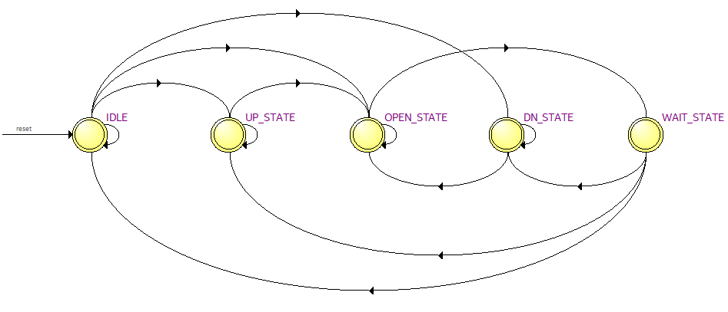

Figure 1: State diagram from Qartus tool

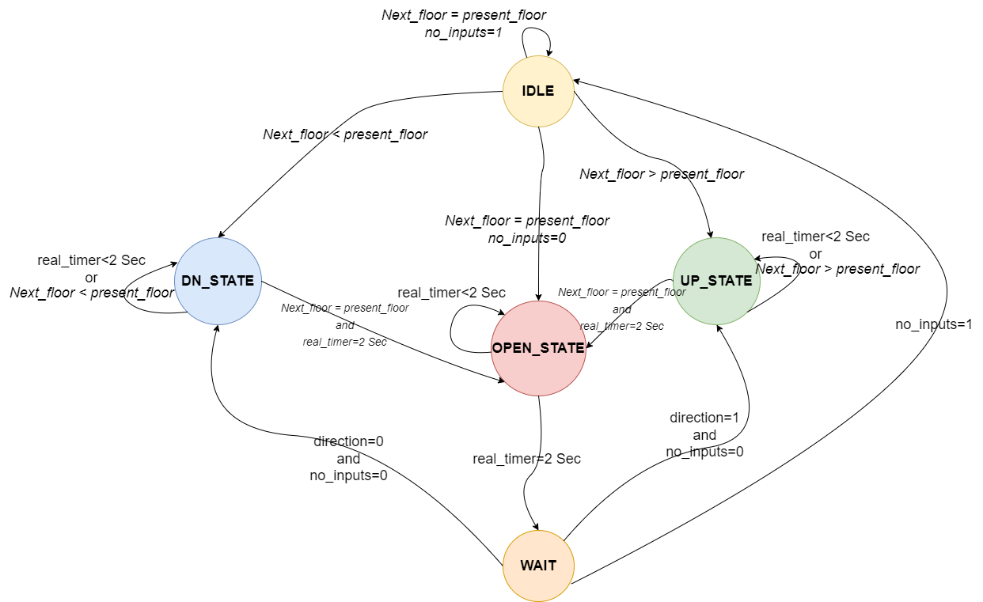

Figure 2: State diagram with states conditions

* **Output Signals:**

|  |  |  |  |
| --- | --- | --- | --- |
| **Output signals** | | | |
| **States** | **Open** | **Up** | **Down** | **Direction** |
| **IDLE** | 0 | 0 | 0 | Don’t care |
| **UP_STATE** | 0 | 1 | 0 | 1 |
| **DOWN_STATE** | 0 | 0 | 1 | 0 |
| **OPEN_STATE** | 1 | 0 | 0 | Don’t care |
| **WAIT_STATE** | 0 | 0 | 0 | No change |