

**Faculty of engineering - Shoubra**

**Benha University**

**Research Article / Research Project / Literature Review**

in fulfillment of the requirements of

|  |  |
| --- | --- |
| **Department** | **Electrical** |
| **Division** | **Communication** |
| **Academic Year** | **1st** |
| **Course name** | **Computer Application 1** |
| **Course code** | **ECE 124C** |

# Title: -

**Research Project: Web Site HTML, CSS and JS**

By:

|  |  |  |  |
| --- | --- | --- | --- |
|  | Name | Edu mail | B.N |
| 1 | محمد عبد الغنى محمد حلمي | Mohamed180705@feng.bu.edu.eg | 141072 |

**Approved by:**

|  |  |
| --- | --- |
| Examiners committee | Signature |
| Dr. Rania Ramadan |  |

# Introduction

In this report, I will talk about my first website I have made. It's a site about sports and it consists of five pages.

The first page is a registration page and it leads you to the welcome page.

The second page is called " Balloon d'Or" and it is about Football and the golden ball winners in the last ten years.

The third page is called "Tennis ATP Rankings" and it is about Tennis and 2019 Men's Tennis ATP Rankings .

The fourth page is called "Top 10 Basketball Players" and it is about Basketball and Top 10 Basketball Players of All Time.

The fifth page is called "AIBA World Boxing" and it is about Boxing and AIBA World Boxing Championships.

**GitHub link :** <https://github.com/MuhamedAbdelghany/ECE124C>  
 **ID : MuhamedAbdelghany**

**Home Page: -**

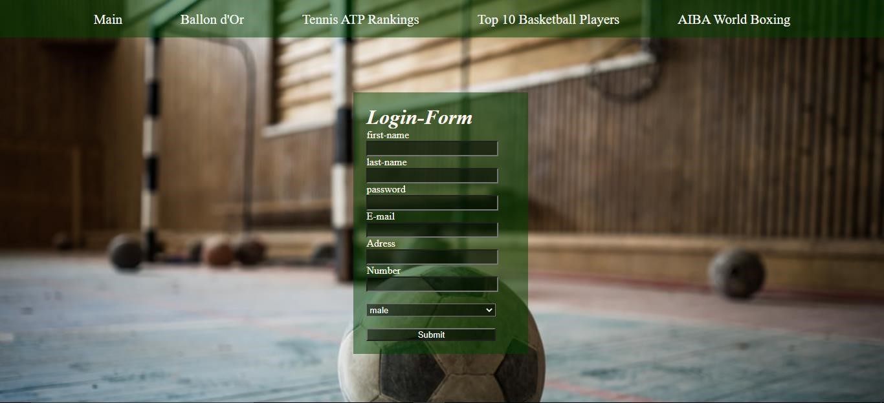

First, I made paragraph with class bar inside it welcome to our page with marquee to move from left to right with scroll amount="15 "then I made the form give it class login to control its position by margin-left:40% and width 230 px and padding 20 px and margin-top:85% and background:r g b a(0, 65, 0, 0.5) .

After that, I used java script to check if the input name, password, email address and number are correct or not if the user clicks to submit the message with blank using error alert will guide him if the user fills the form correctly and the welcome page appears to him.

# The Balloon d'Or Page:-

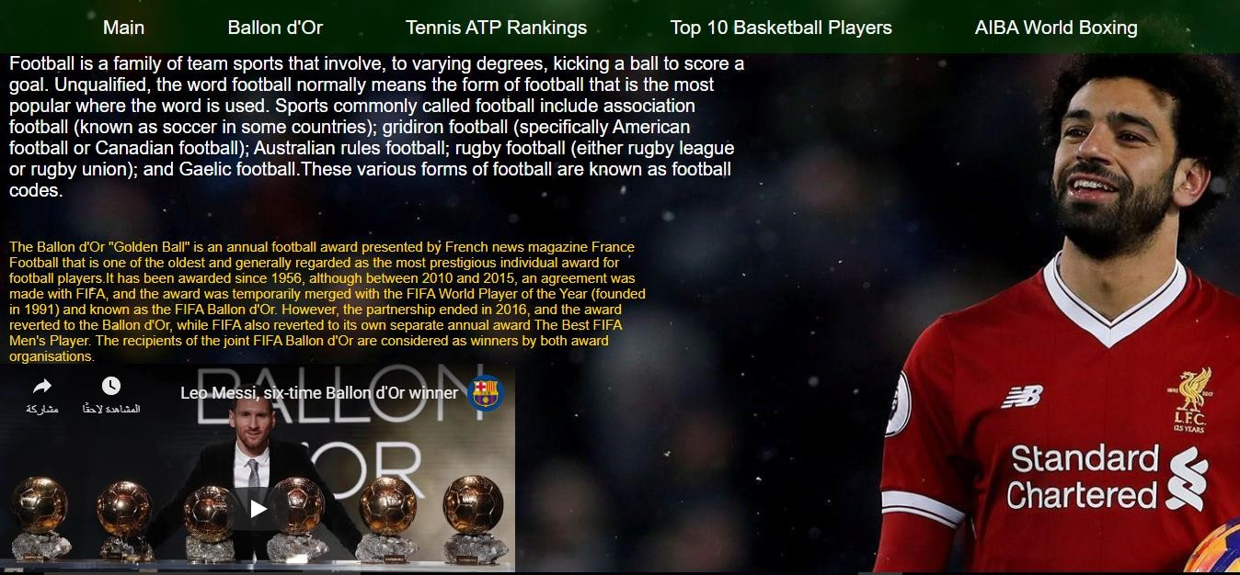

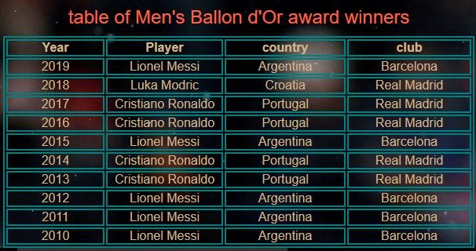

As you cee I used div with class foot to write the paragraph at the topleft page with **color: white; max-width: 800px; font-size: 20px; margin-left: 10px;** and by the same way I used div with class "balloon "to write the second paragraph below the first one **with color :gold; max-width: 700px; font-size: 15px; margin-left: 10px;** then I used an iframe with **width="560" height="315"** to show Video . then I used table with class table and I made caption called table of Men's Balloon d'Or award winners with **font-size: x-large; padding: 10px; color: tomato;** and the table with **margin-left: 30px;** and the words inside table with **color: tan; width: 600px; text-align:**

**center;**

----------------------------------------------------------------------------------------------------

# Tennis ATP Rankings Page :-

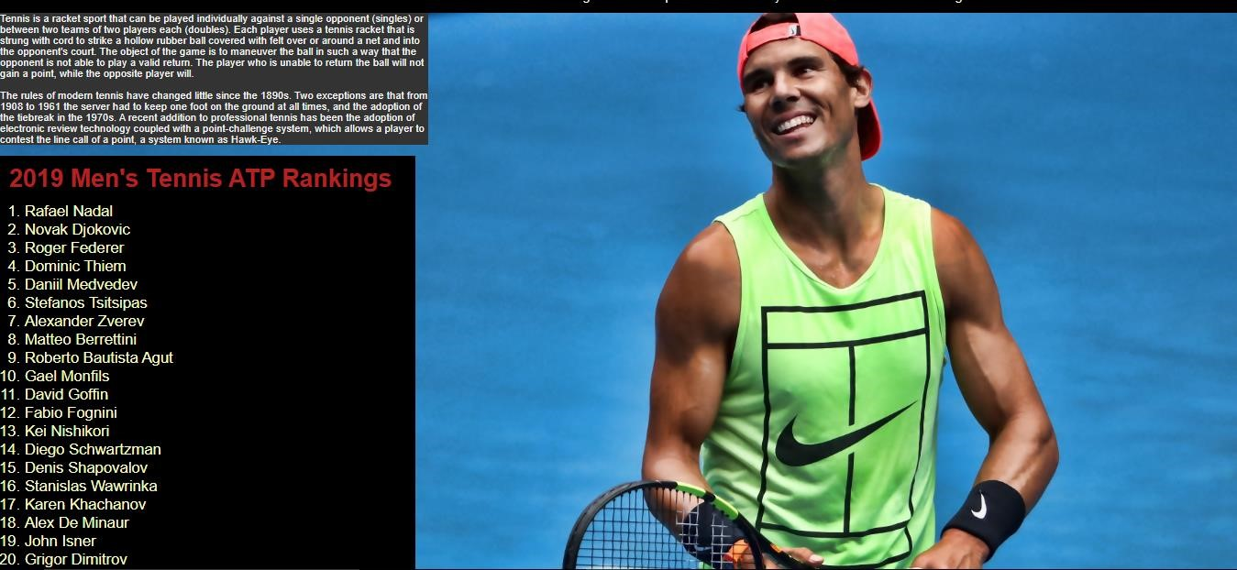

I used the same steps of the previous page to write a paragraph of this page . But in this page, I made a list of **2019 Men's Tennis ATP Rankings** by using the order list (<o l> </ o l >) and inside this order list I made a div with class called **list** with these properties **font-size: 25px; background-color:#000000; color: #f5fcc1; width: 680px;** and this order list is decimal and it take **margin-left: 40px;**

# Top 10 Basketball Players Page :-

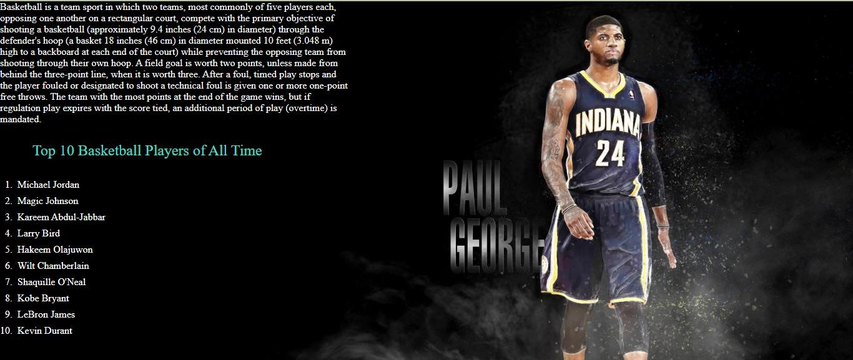

I made div to write the top-left paragraph in this page with these properties **color: #f7f7f7; max-width:700px ; font-size: 20px;** and I made a list and inside this list I made a div with class called cap and inside this div I made a caption called Top 10 Basketball Players of All Time with these properties **color: turquoise; font-size:**

**30px; padding: 35px;** and the list take these properties **list-style:**

**decimal; margin-left: 30px;** and the words in the list take these properties **color: white; font-size: 20px;padding: 5px;**

# AIBA World Boxing Page :-

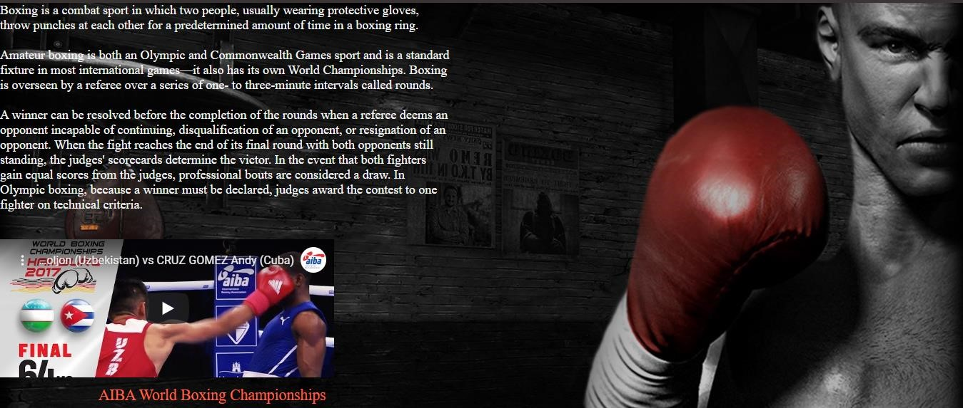

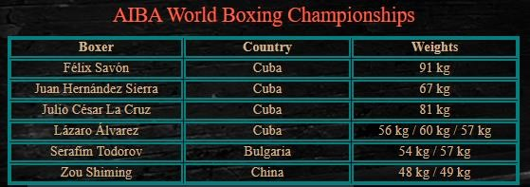

As you cee I used div with class called " b o " and inside this div I used three div each one is to write one of three paragraphs in this page then, I used iframe to show a video with these properties **width="520" height="215"** then I made a table with a class called table and inside it I made a caption called AIBA World Boxing Championships with these properties **font-size: x-large; padding: 10px; color: tomato;** and table take this property **margin-left: 30px; border: 2px solid teal;** and the word inside the table take these properties **color: tan; width: 600px; text-align: center;**