What the Plots Show
Results & interpretation — GLP-1R agonist CNS meta-analysis
A plot-by-plot reading of what the data suggest

1. Headline finding
Across 34 GLP-1R-agonist / multi-agonist CNS comparisons, the recurring transcriptional response is a coordinated metabolic-neurotrophic program: up-regulation of protein-synthesis machinery (ribosome / translation) and mitochondrial oxidative phosphorylation, alongside a stress-hormone and lipid-handling signature (Fkbp5, Plin4) and a pro-survival, anti-inflammatory tilt. The same leaders appear whether the fold-change cut is loose or strict, which argues the signal is robust rather than threshold-dependent.

2. Enrichment plots — which pathways move
The dot plots and bar plots tell a consistent story across all five databases. Three themes dominate the LFC0.2 consensus (4,769 genes):
- Translation / ribosome. GO 'Translation' (padj 4e-20, 127 genes), 'Cytoplasmic Translation', KEGG 'Ribosome' (padj 6e-20, 95 genes), and the Reactome elongation / SRP-targeting terms are the single strongest block. Note the Reactome 'Influenza / Viral mRNA Translation' labels are ribosomal-protein gene sets — they flag protein-synthesis genes, not literal infection.
- Mitochondrial energy metabolism. GO 'Mitochondrial Inner Membrane' and 'Respiratory Chain Complex I', GO-MF 'NADH Dehydrogenase activity', and KEGG 'Thermogenesis' indicate up-regulated oxidative phosphorylation / electron transport.
- Neurodegeneration pathways. KEGG 'Parkinson', 'Huntington' and 'Alzheimer disease' co-enrich — expected because those KEGG maps are built largely from the same mitochondrial and proteostasis genes, suggesting the GLP-1R metabolic program is relevant to neurodegenerative models.
Interpretation: GLP-1R agonists push CNS cells toward higher biosynthetic and bioenergetic capacity — a classic neurotrophic/neuroprotective metabolic shift.
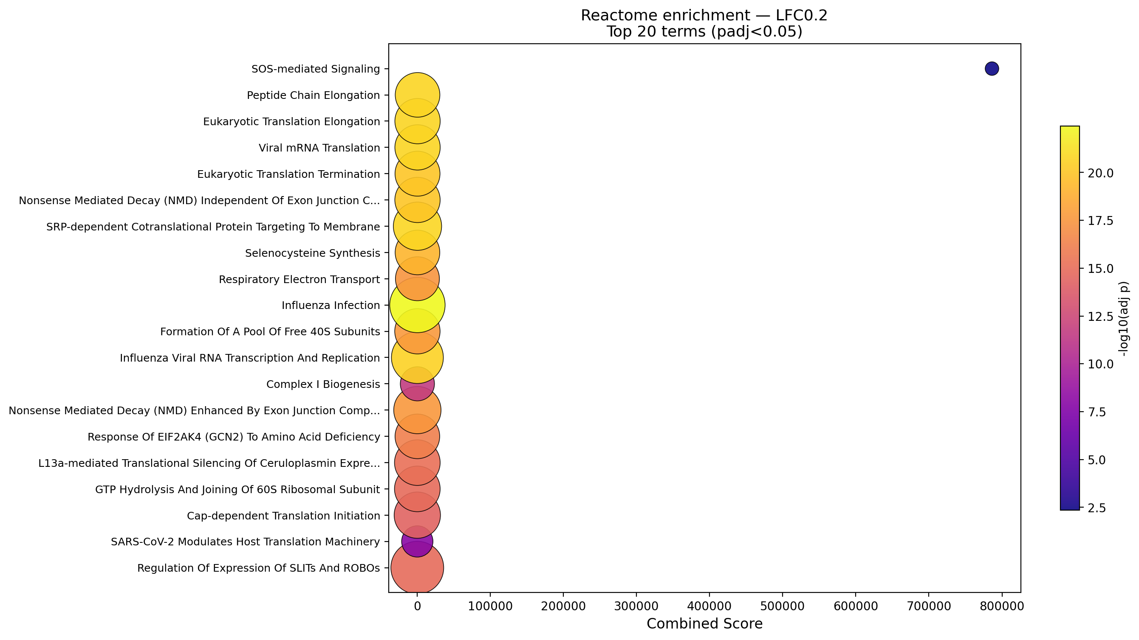
Reactome dot plot (LFC0.2) — translation/ribosome terms carry the strongest combined scores and significance.
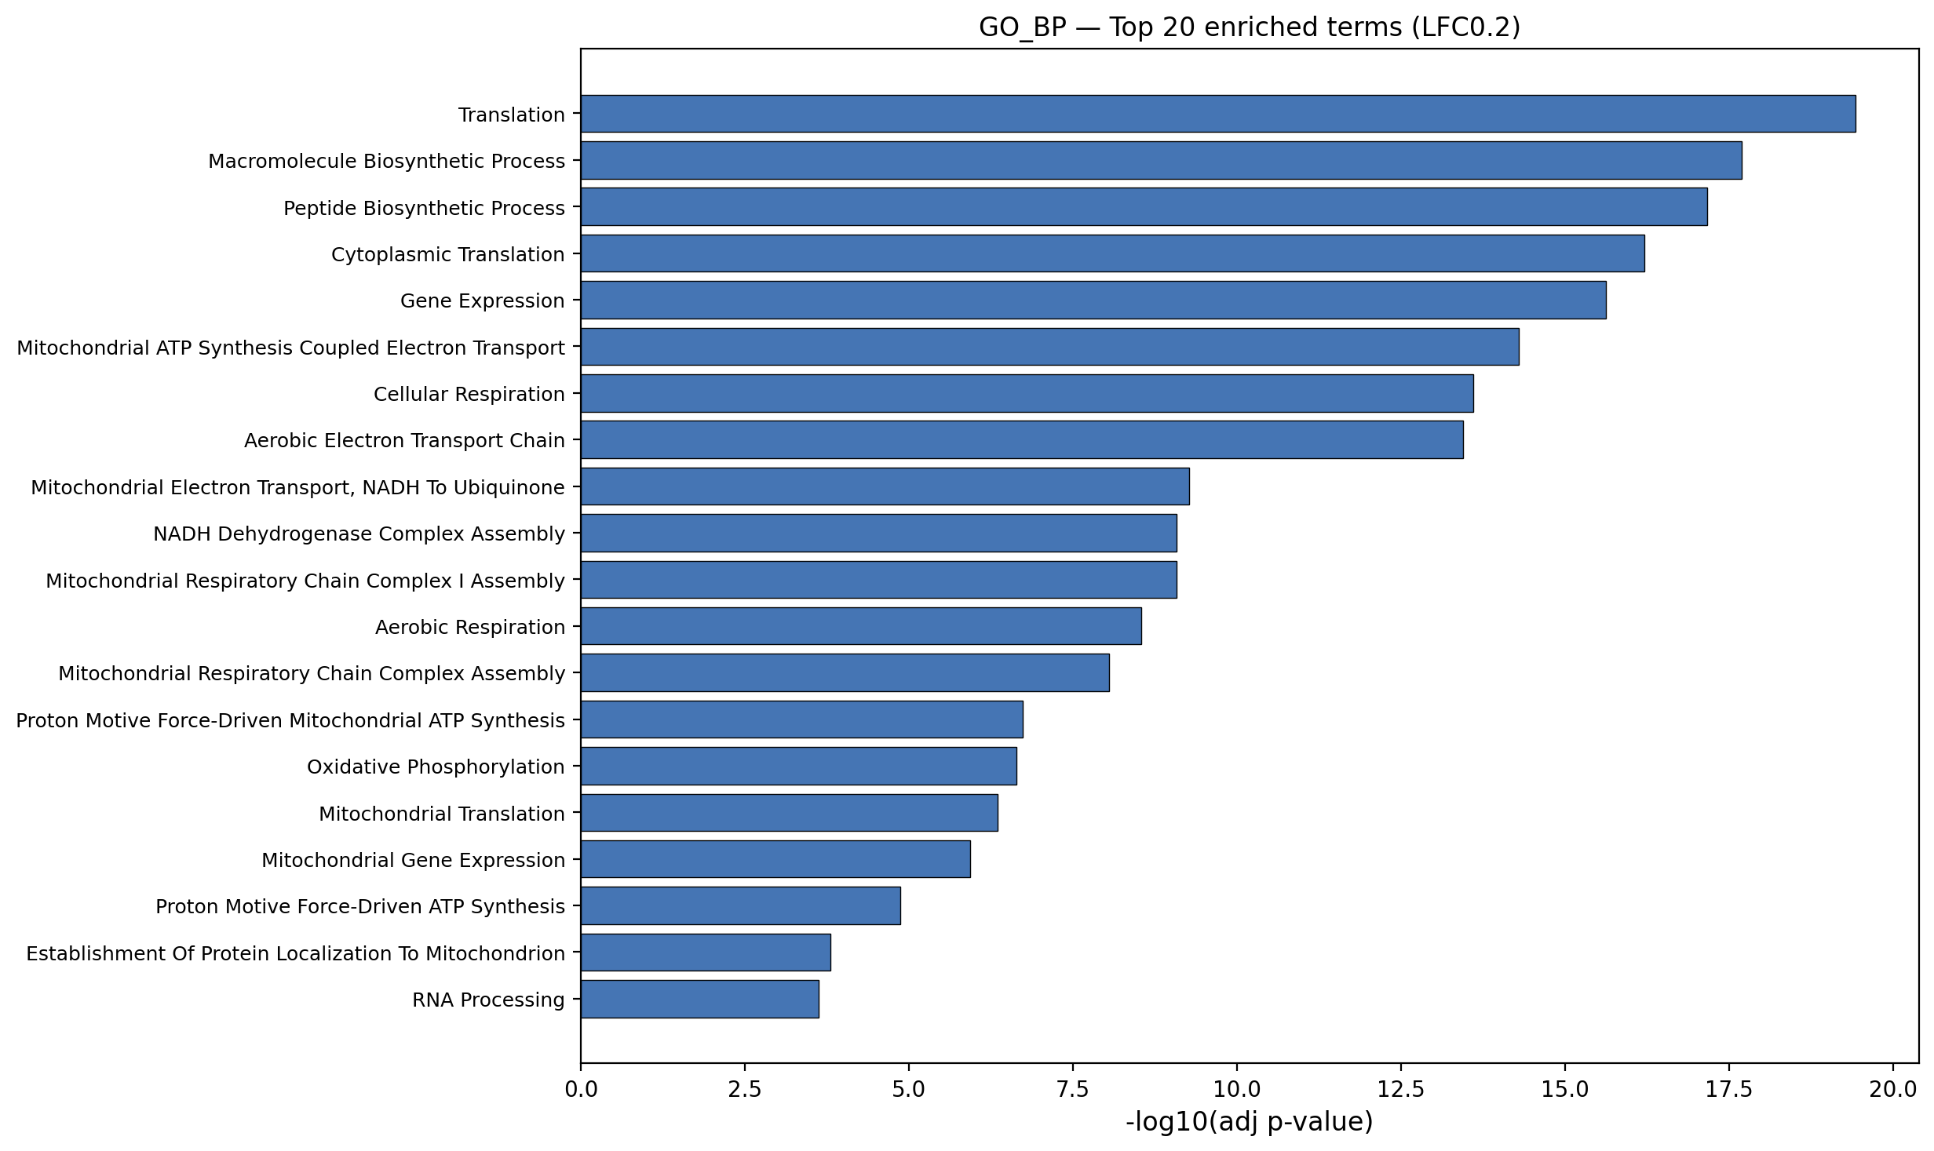
GO Biological Process (LFC0.2) — translation and mitochondrial ATP-synthesis / electron-transport terms lead.

3. Top consensus genes — the most reproducible hits
Ranked by how many of the 34 groups each gene reaches, the leaders are strikingly directional:
Gene | Groups | Direction | Reading
Fkbp5 | 12 | UP (12/12) | Glucocorticoid/HPA-axis effector — the single most pan-regional hit (4 datasets, 8 regions)
Plin4 | 9 | UP (9/9) | Perilipin-4 — lipid-droplet / lipid handling
Hif3a | 9 | UP (9/9) | Hypoxia-inducible factor 3a — hypoxia/metabolic adaptation
Xdh | 8 | UP (8/8) | Xanthine dehydrogenase — purine / oxidative metabolism
Cdkn1a | 8 | UP (5/3) | p21 — cell-cycle arrest / senescence / stress response
Mertk | 7 | UP (7/7) | Microglial phagocytic receptor — debris clearance / neuroprotection
Mpp5 | 9 | DOWN (8/1) | Polarity scaffold — consistently down
Ednrb | 8 | DOWN (8/0) | Endothelin receptor B — vascular/astrocyte, consistently down
The uniform direction (e.g. Fkbp5 up in all 12 groups, Ednrb down in all 8) is the key point: these are not averaged-out signals but consistent shifts across independent datasets and brain regions.
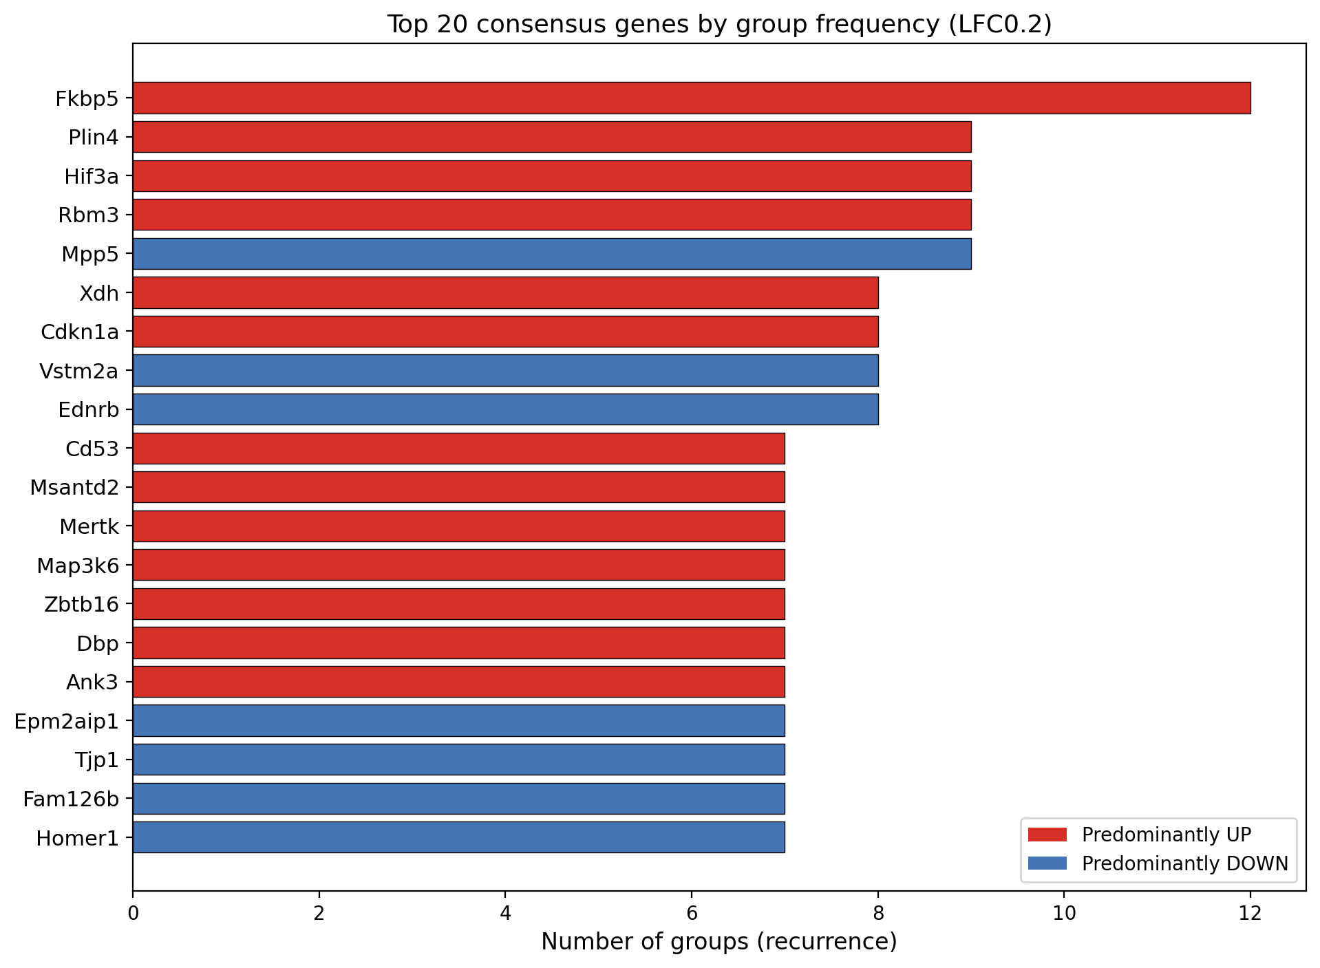
Recurrence of the top consensus genes (LFC0.2); red = predominantly up, blue = down.

4. Consensus heatmap — direction and regional breadth
The heatmap shows the top-20 genes across all 34 groups. Two things stand out:
- Row coherence. Fkbp5, Plin4, Hif3a, Xdh and Mertk are red (up) across most groups they touch; Mpp5, Vstm2a and Ednrb are blue (down). The response is directionally consistent, not noisy.
- Sparsity is informative. Blank cells mean the gene was not a significant DEG in that group. Most genes are significant in only a subset of groups, so the consensus is built from partial but agreeing overlap rather than universal change.
Caveat visible in the heatmap: a few genes (e.g. Cd53) show very large values concentrated in the Accession-6 medial-basal-hypothalamus groups (+~10 log2FC). These extreme fold-changes come from one dataset and one region and should be read as dataset-specific rather than pan-CNS; the colour scale is capped so they do not dominate the rest.
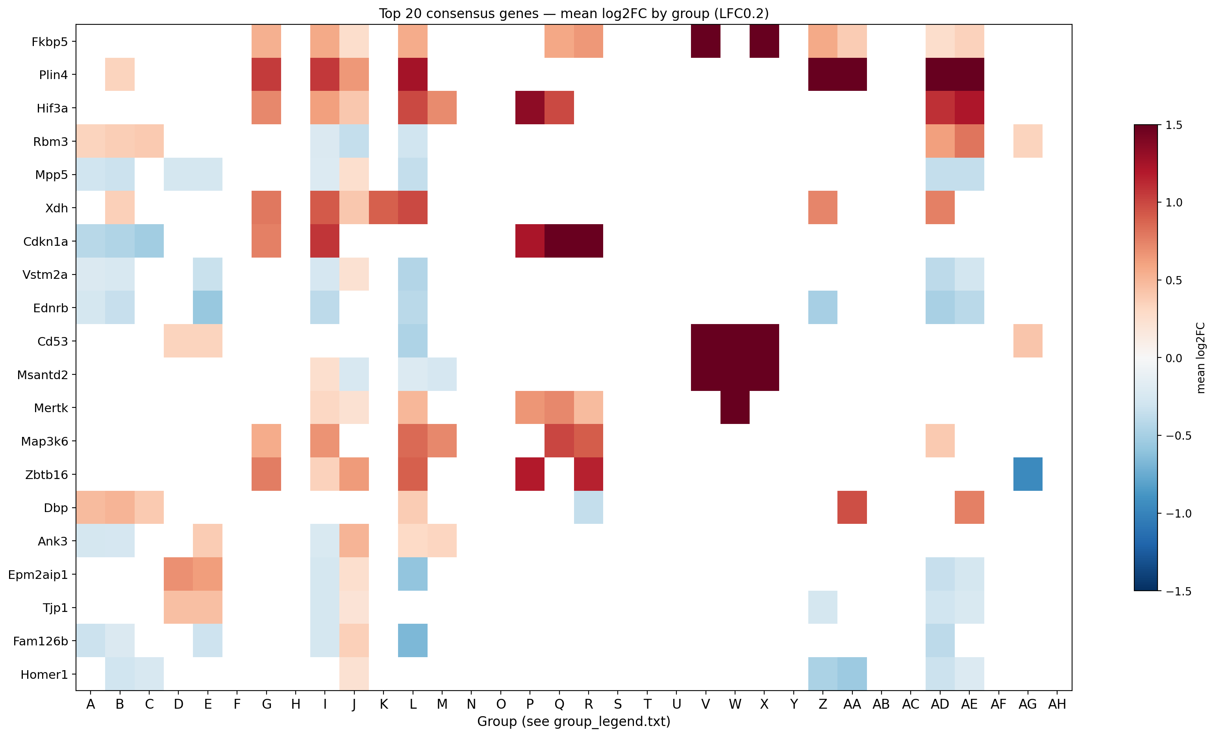
Top-20 consensus genes x 34 groups (LFC0.2).

5. Mechanism heatmaps — directional pathway reading

5.1 Blood-Brain Barrier
The BBB genes that recur are mostly DOWN-regulated: Cav1 (caveolin-1, 6/6 down), Aqp4 (aquaporin-4, 5/5 down), Jam2, Slc16a1 and Hif1a all trend down, while the glucose transporter Slc2a1 (Glut1, 4/4 up) and Lrp1 (4/4 up) go up. Read together this suggests reduced caveolar transcytosis and aquaporin-4 (less vascular leak / oedema potential) with increased glucose uptake and LRP1-mediated clearance — i.e. a barrier-stabilising, metabolically-supportive shift. The MMP proteases are not recurrent (they appear only in the presence/>=1 view), so matrix remodelling is sporadic rather than a core consensus effect.
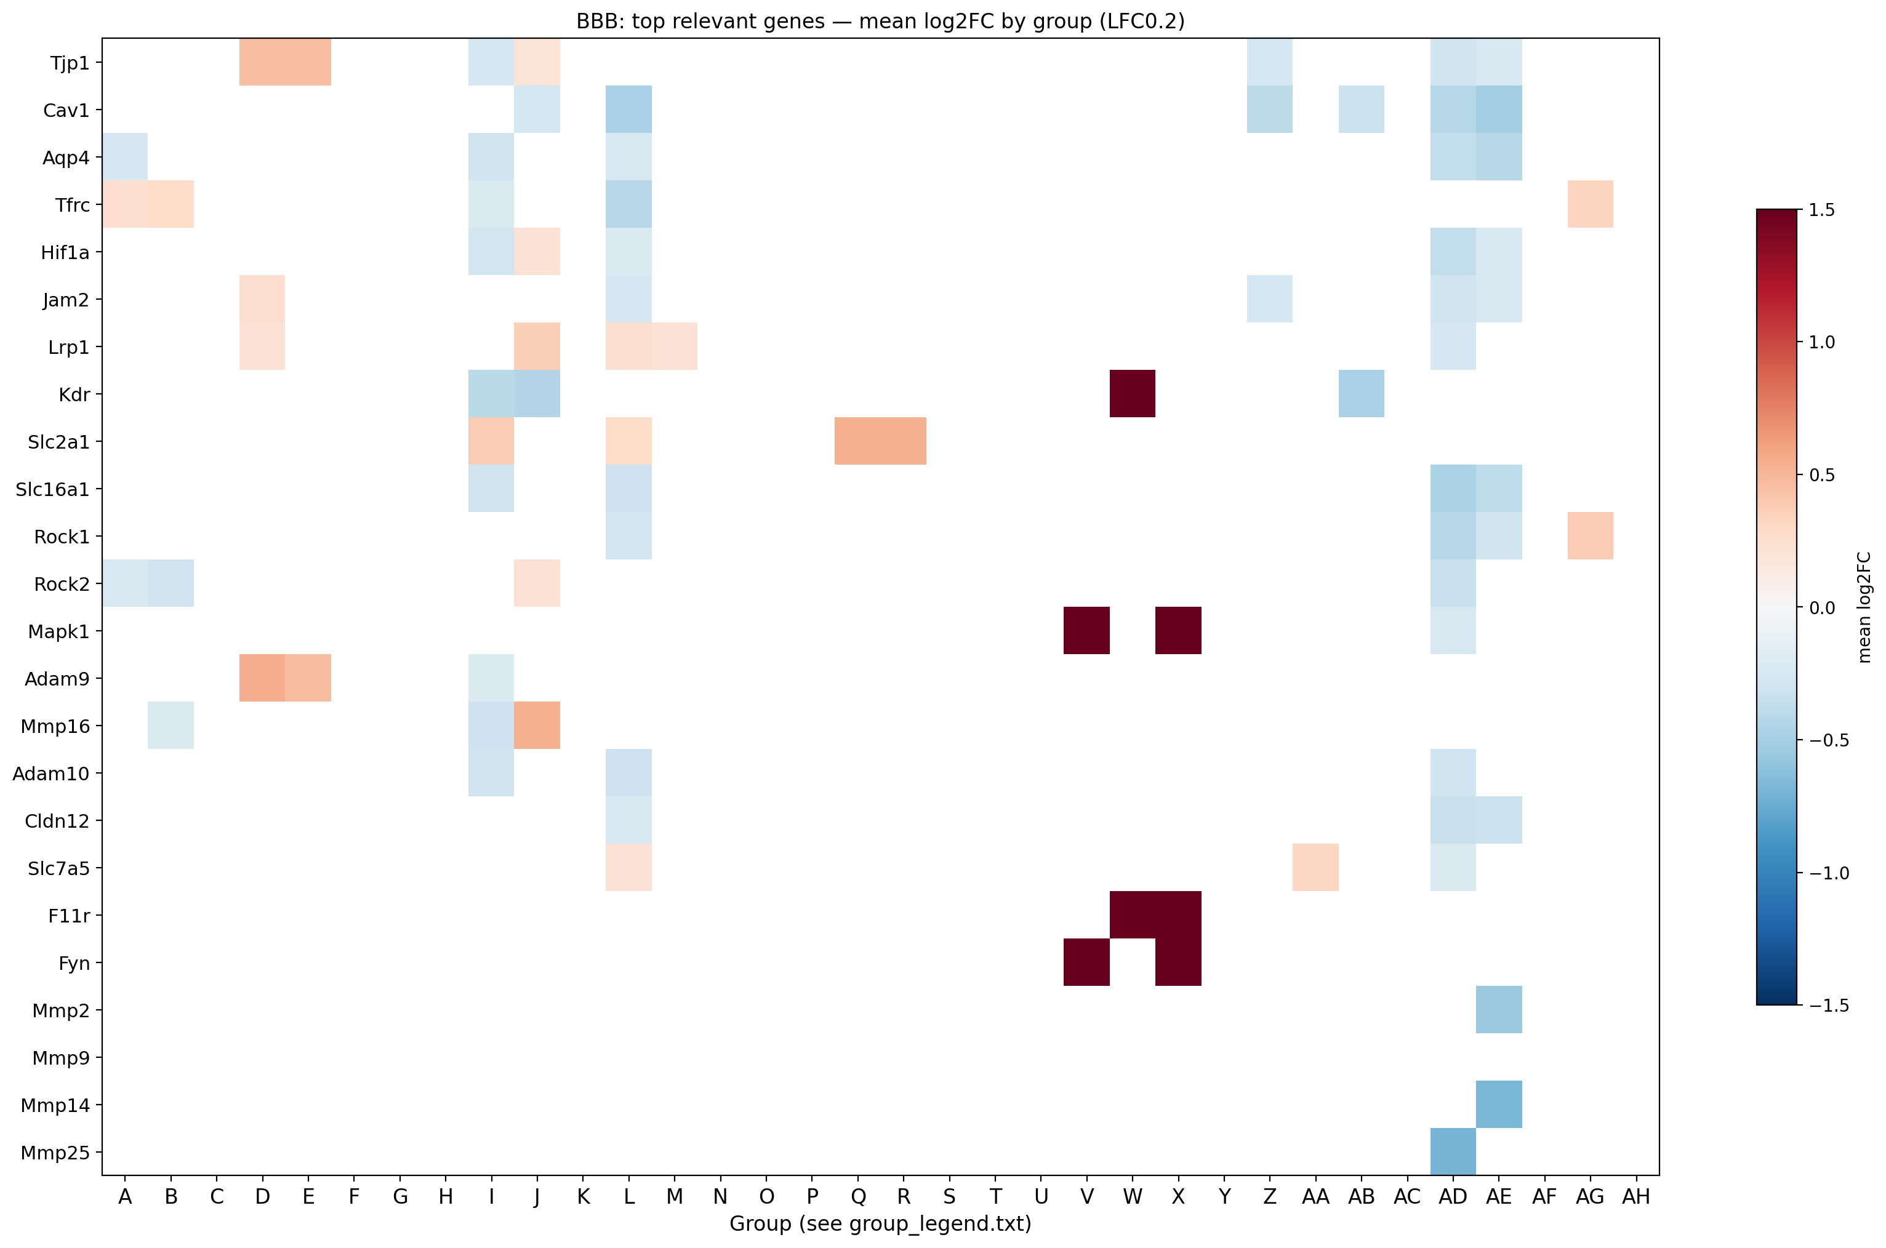
BBB mechanism heatmap (LFC0.2): caveolin/aquaporin down, glucose transporter up; full MMP family shown for presence.

5.2 Inflammatory (JAK-STAT3) and 5.3 Survival (PI3K/Akt)
Inflammatory: Stat1 (3/3 down), Il6st and Socs4 down, with Bcl2l1 (pro-survival) up — a net dampening of cytokine/STAT inflammatory signalling. Survival: Gsk3b is consistently DOWN (5/6) and the autophagy marker Map1lc3a is UP (4/4), with Bcl2l1 up — GSK3-beta inhibition plus autophagy/anti-apoptotic engagement is a recognised neuroprotective signature. Together the two mechanism panels point the same way: less inflammation, more survival signalling.

6. Concept-network plots — what wires together
The consensus Cnet makes the translation theme visual: the hub genes are ribosomal proteins (Rpl/Rps families) and RNA-binding factors converging on the translation/elongation terms — the same block that tops the enrichment plots. In the BBB Cnet the connective hubs are signalling nodes (Mapk1, Fyn, Akt1) bridging junction, vascular-permeability and matrix terms, consistent with GLP-1R acting through canonical kinase signalling onto barrier biology.
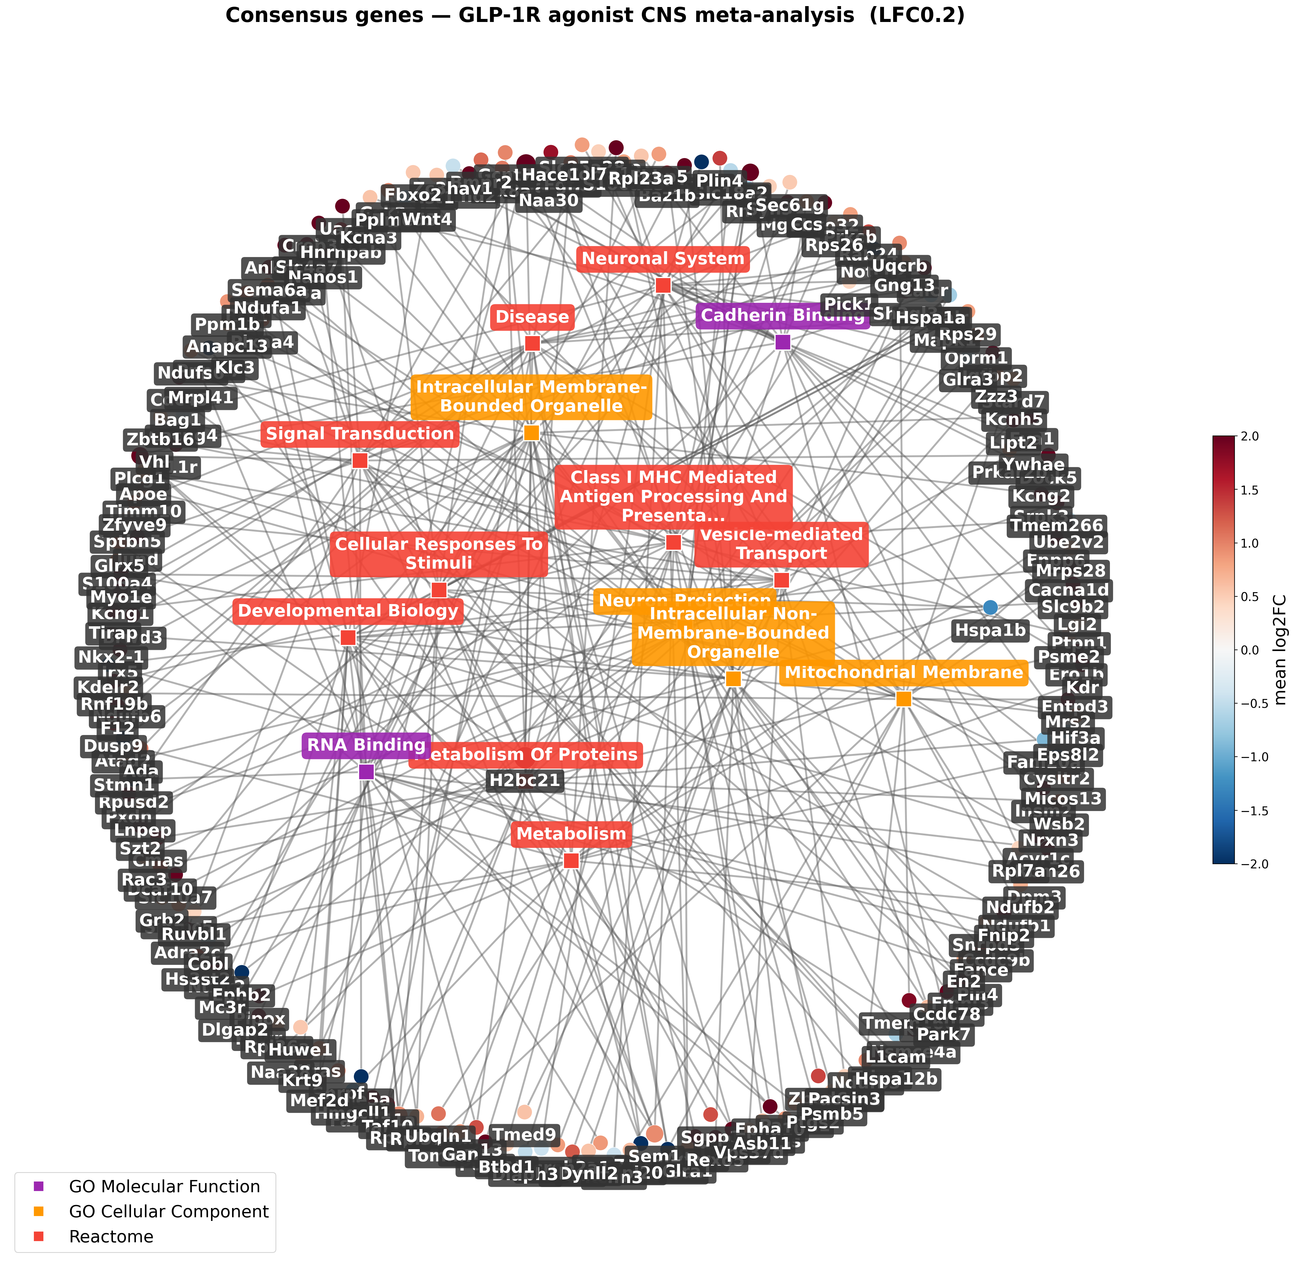
Consensus Cnet (LFC0.2): ribosomal/translation hub dominates.
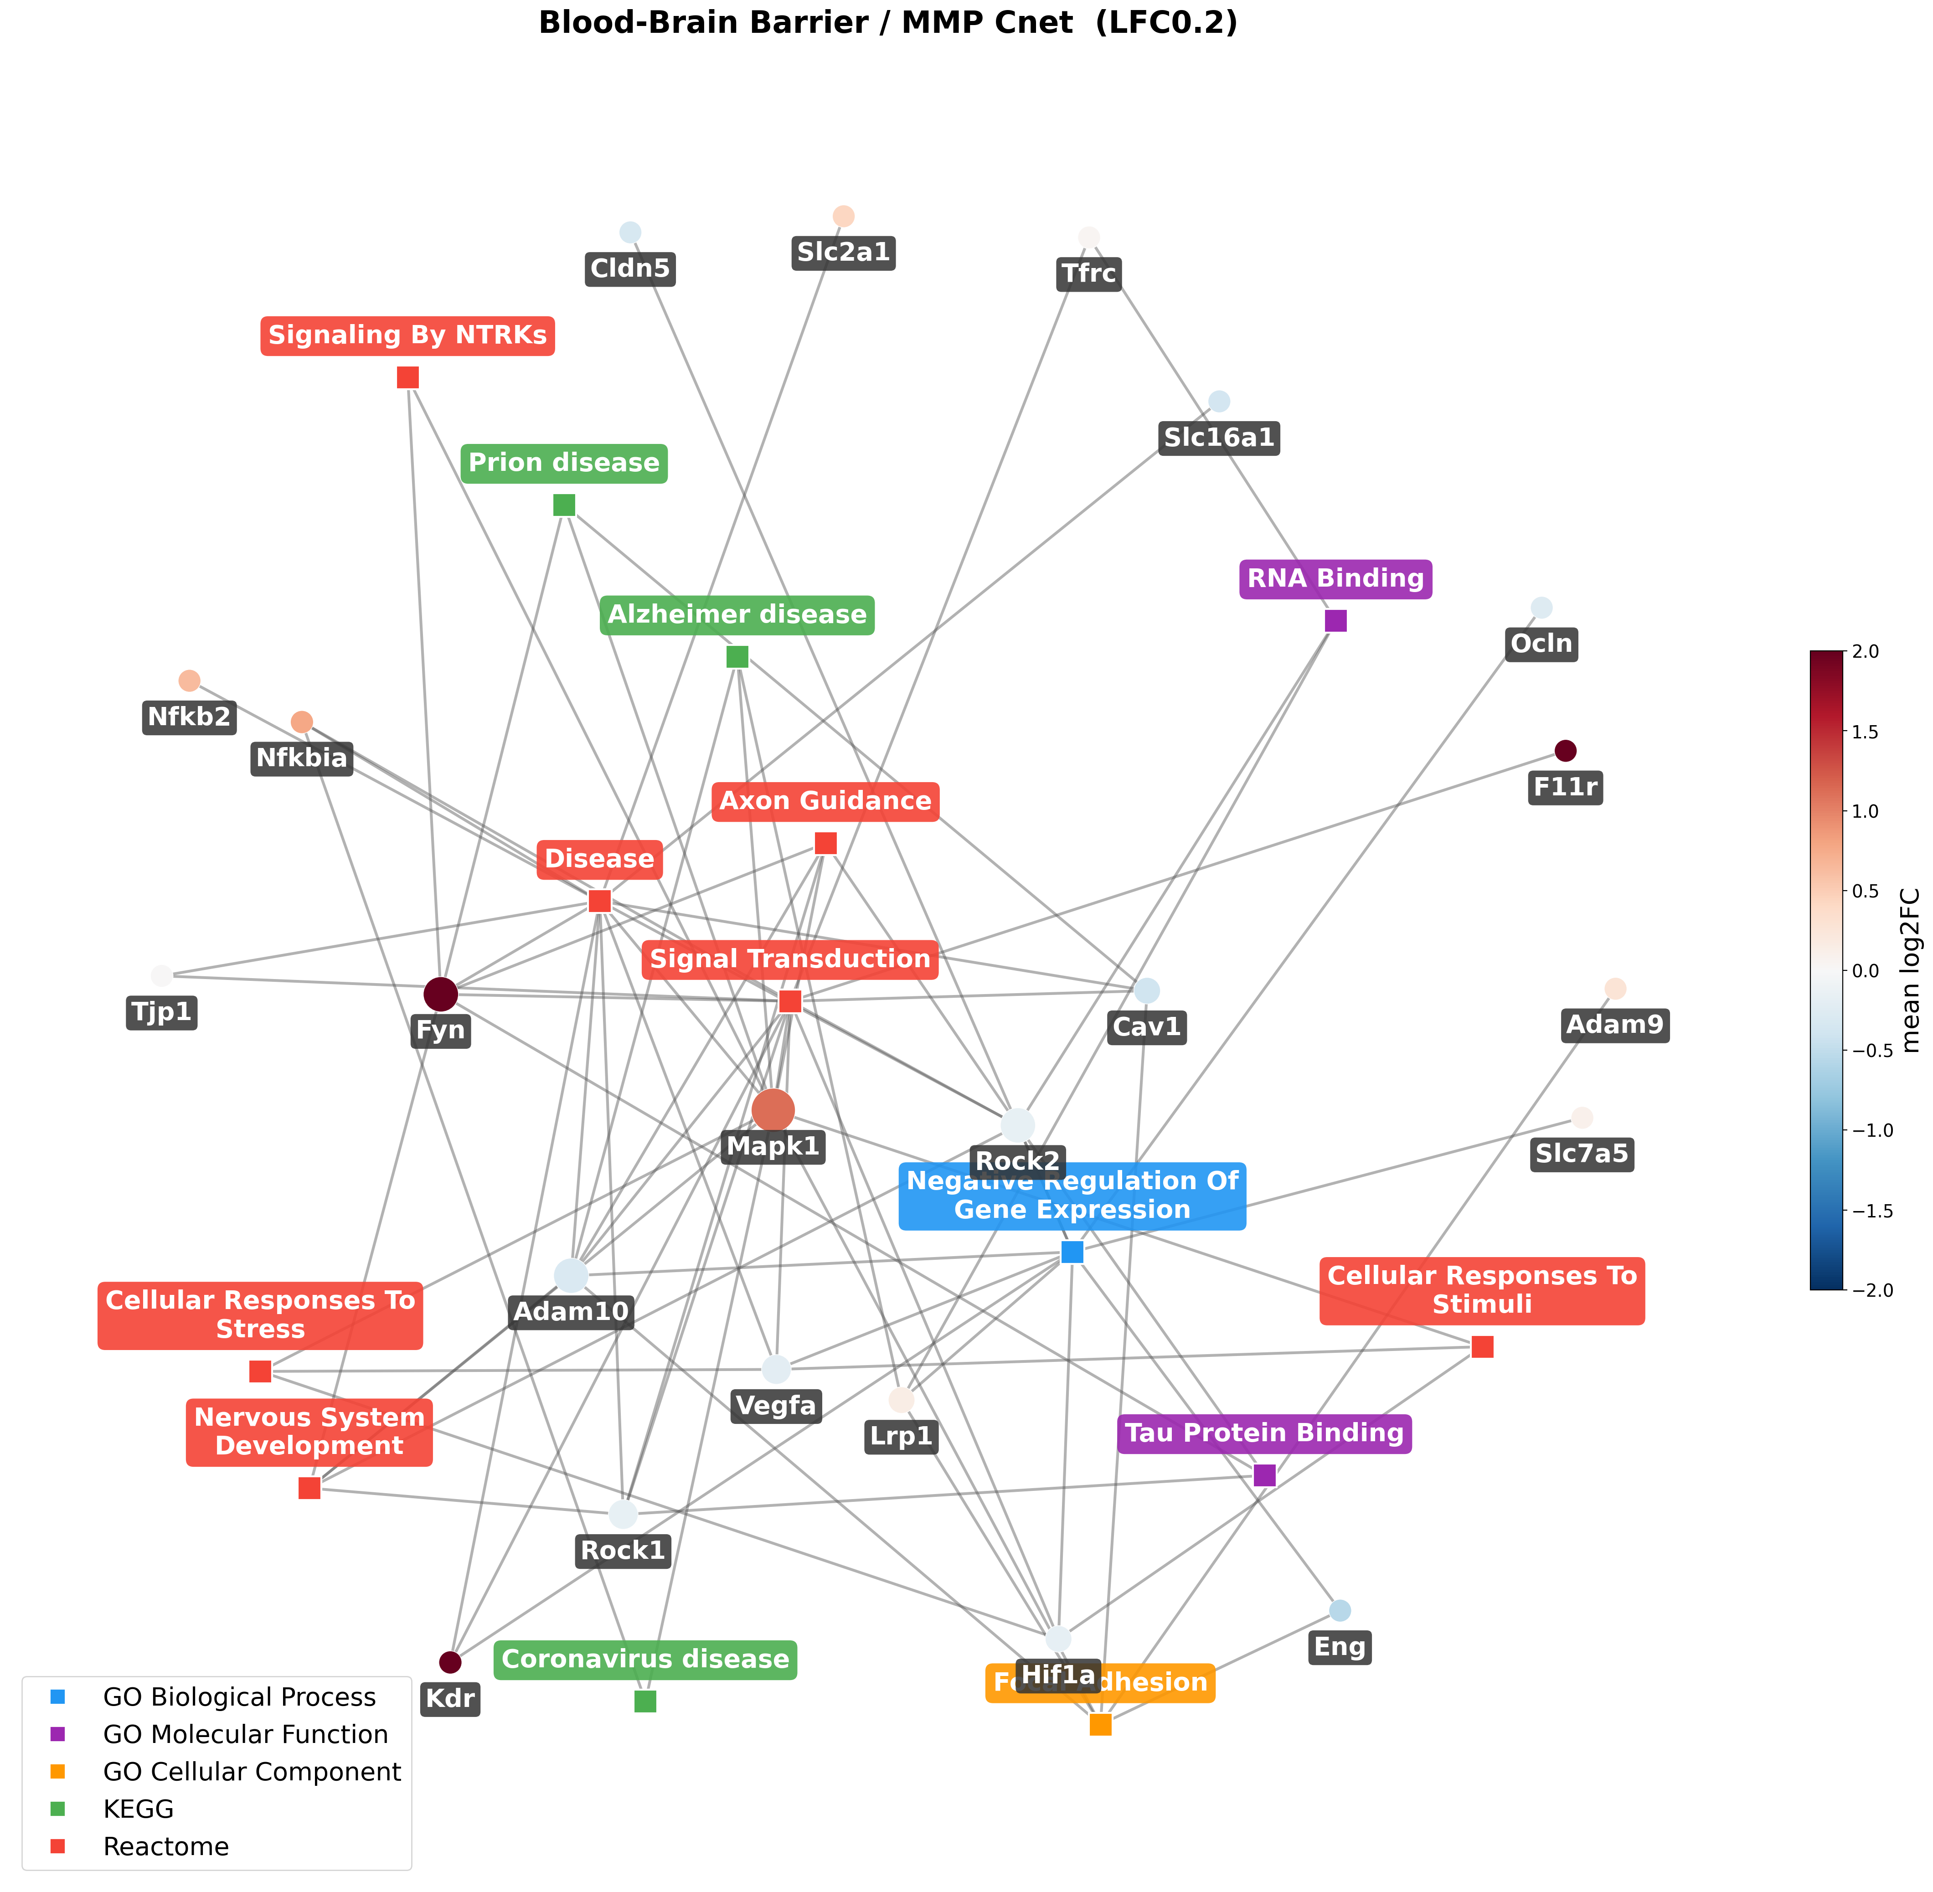
BBB Cnet (LFC0.2): Mapk1/Fyn/Akt1 bridge barrier and matrix terms.

7. Threshold comparison — how robust is the signal?
Reading the same plots across LFC0.2 / 0.5 / 1 is itself informative:
- LFC0.2 (4,769 genes): the full metabolic-translation program described above.
- LFC0.5 (901 genes): the same leaders survive (Plin4, Fkbp5, Hif3a, Cdkn1a), so the headline genes are genuinely large-effect, not marginal.
- LFC1 (297 genes): becomes dominated by a handful of very-high fold-change genes (Echdc2, Nwd2, Zfp41 at +8 to +13 log2FC) that originate almost entirely from the Accession-6 medial-basal-hypothalamus arms. At the strict cut the 'consensus' therefore reflects one dataset's large effects more than cross-dataset agreement — which is why the LFC1 enrichment and Cnets are sparse. Treat LFC0.2/0.5 as the meta-analytic signal and LFC1 as a strong-effect shortlist.

8. The special Cnet variants
Top-5-term consensus Cnet: restricting to the five most-significant terms confirms that the most enriched biology is overwhelmingly translation/RNA — all five terms share the same ribosomal-protein genes, so they collapse onto one tight cluster.
BBB presence (>=1 group) Cnet: relaxing from >=2 to >=1 group raises the BBB gene count from 22 to 36, pulling in the MMP proteases (Mmp2/14/16/25) and endothelial markers (Cdh5, Pecam1, Vwf, Nos3). The message: the wider BBB/matrix machinery IS touched somewhere in the data, but only sporadically (single groups), whereas the junction/transporter core (Cav1, Aqp4, Slc2a1, Tjp1) is what recurs.
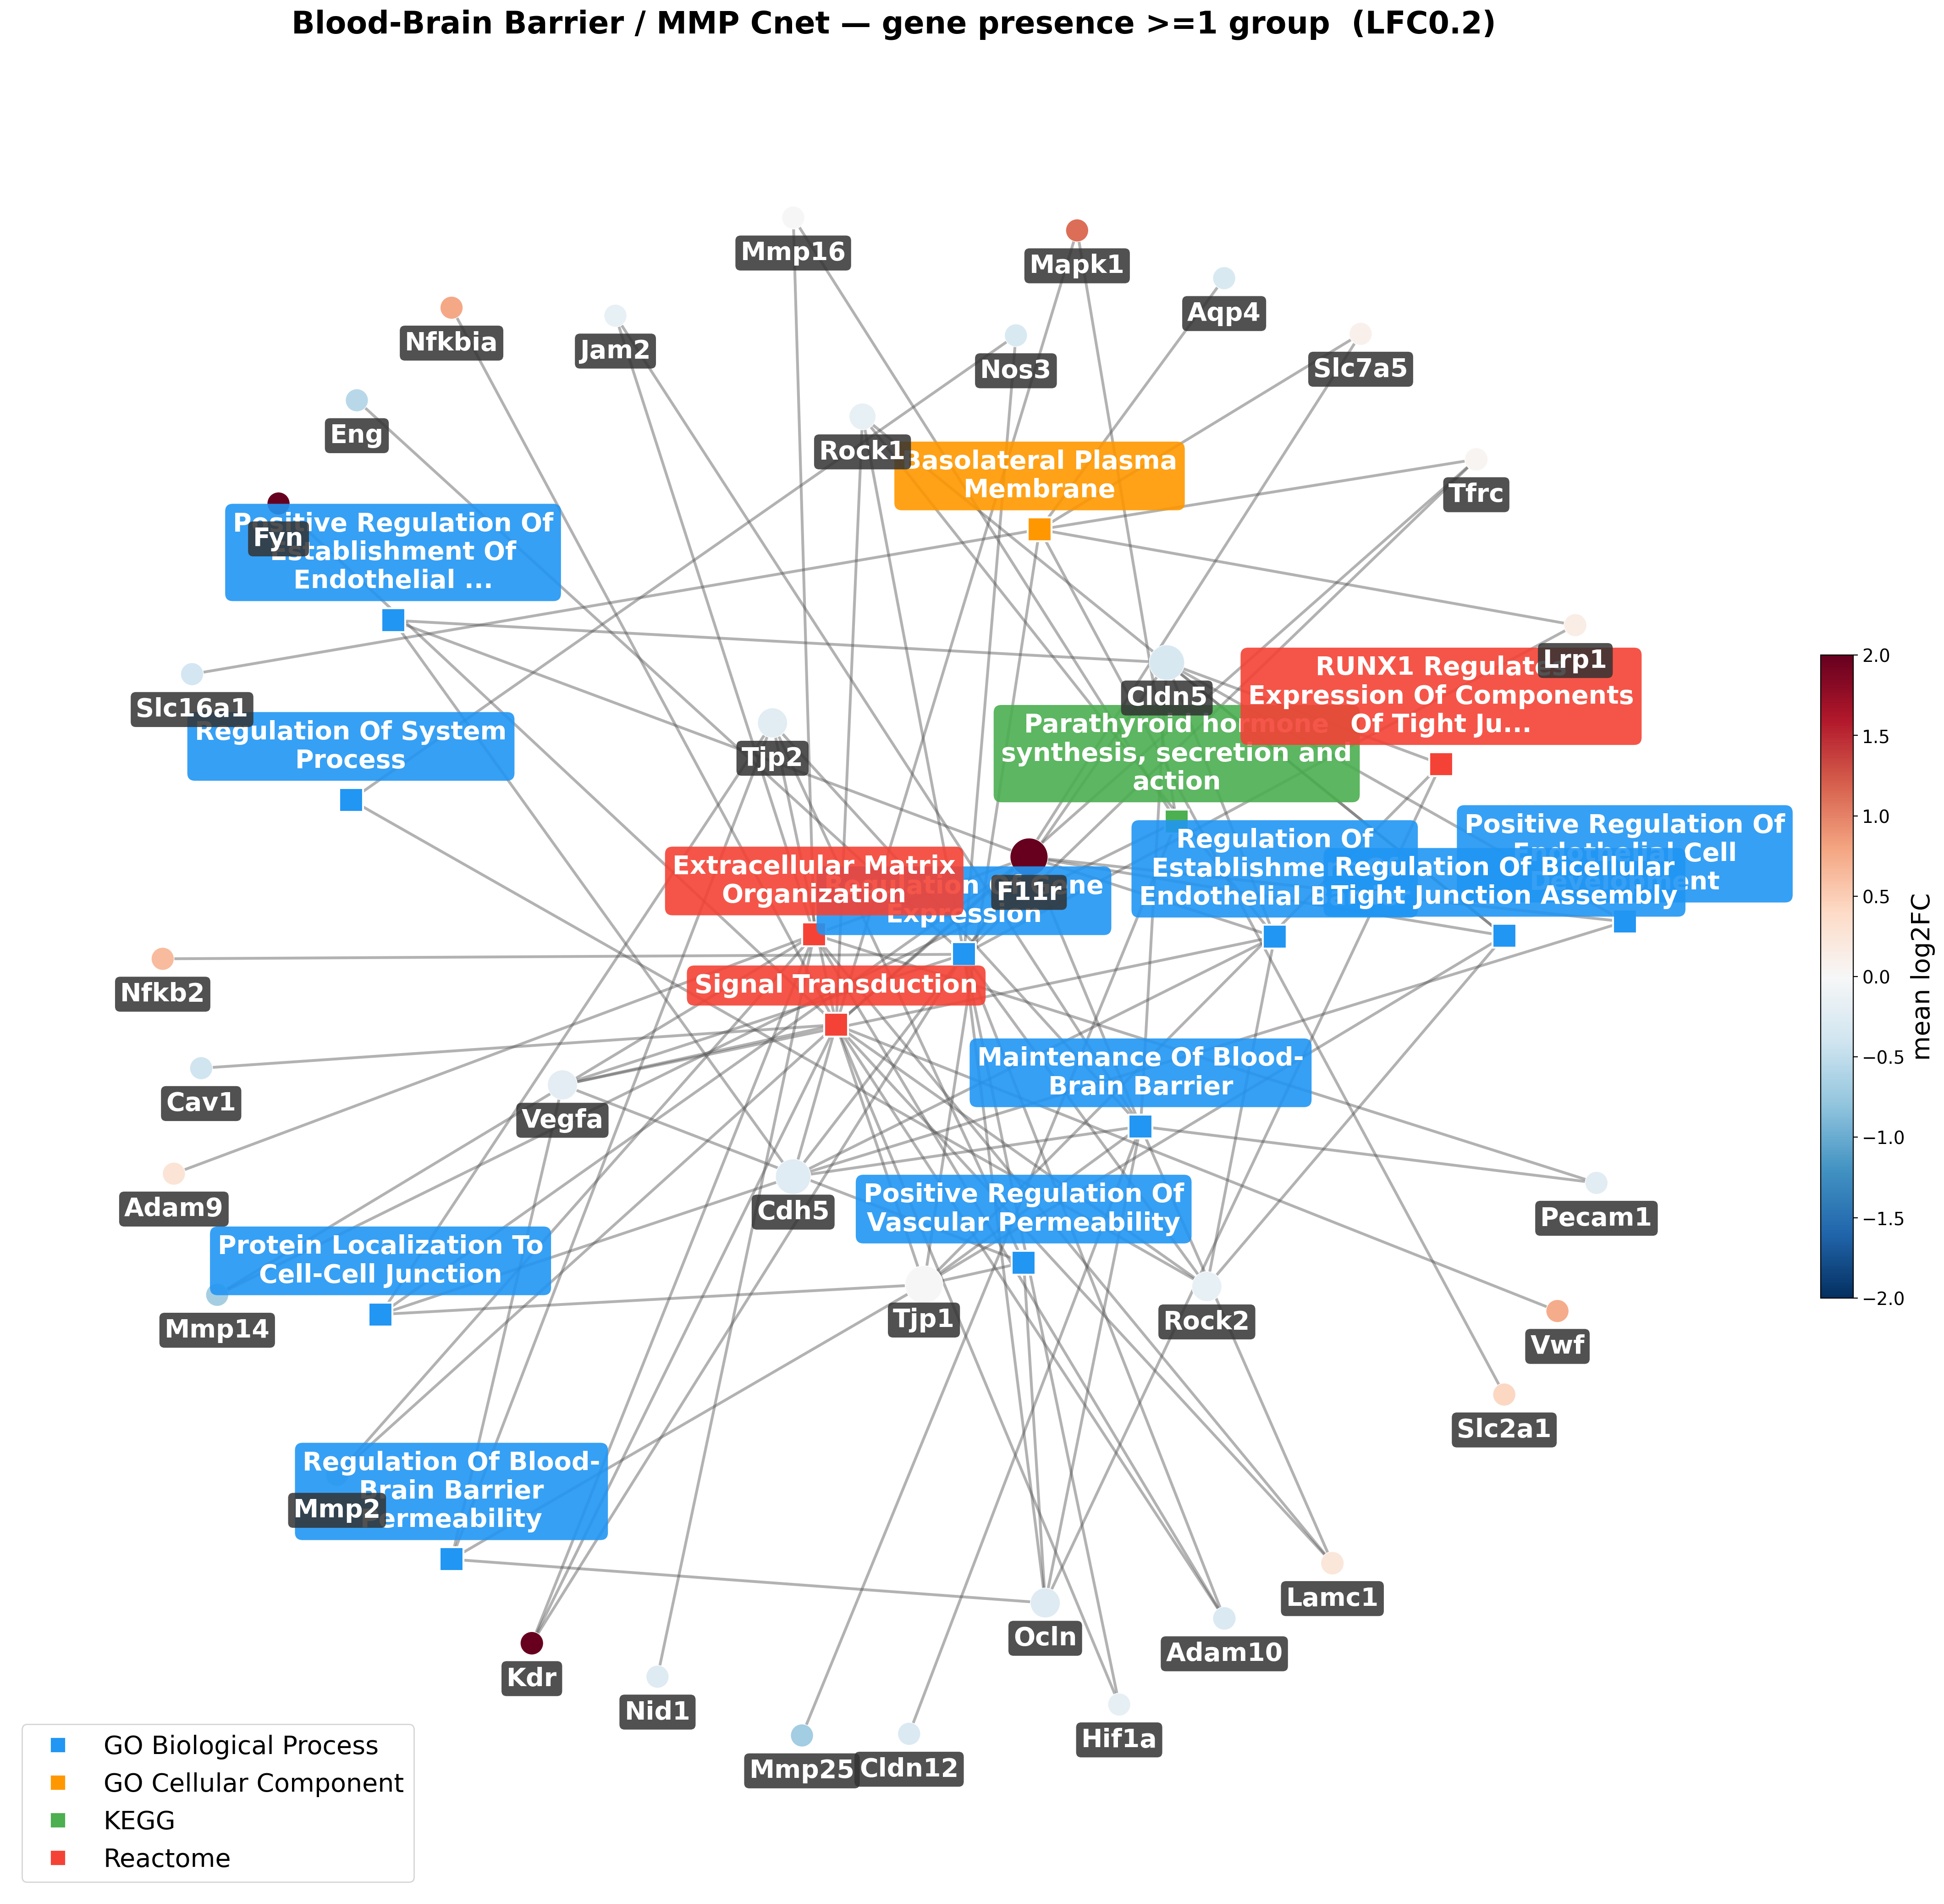
BBB presence Cnet (>=1 group, LFC0.2): the broader matrix/endothelial set appears, but as single-group occurrences.

9. What the data suggest — and caveats
Suggested biology: GLP-1R / multi-agonist exposure drives a reproducible CNS program of increased translation and mitochondrial energy metabolism, a glucocorticoid/lipid stress-response (Fkbp5, Plin4, Hif3a), microglial clearance (Mertk), and a neuroprotective tilt (GSK3-beta down, autophagy and Bcl2l1 up, STAT1/inflammatory signalling down), with barrier stabilisation (Cav1/Aqp4 down, Glut1 up). The overlap with Parkinson/Huntington/Alzheimer KEGG maps positions this program as relevant to neurodegeneration.
Caveats for honest reading:
- Effect-size inflation in some arms (notably Accession-6 mbh) produces +10-13 log2FC values that drive the strict-threshold lists; these are dataset-specific.
- Enrichment uses human-orthology gene-set libraries (KEGG/Reactome) on mouse symbols, and the 'viral/influenza' Reactome labels are ribosomal-gene sets, not infection per se.
- Accession 1 was excluded and Accession 7 (spinal cord) remained locked at run time, so the consensus reflects the 34 included groups; folding Acc7 in later may add CNS-injury context.

