Cross-Accession Pathway Analysis
Summary Report & Figure Interpretations
GLP-1R Agonist DEGs — CNS Biology Across Disease Conditions

Study Overview
This report summarises a cross-accession pathway analysis integrating bulk RNA-sequencing differential expression data from nine independent GEO accessions. All accessions involve GLP-1R agonist treatment, CNS-associated tissues, or both. Genes are standardised to mouse symbols before analysis, with Illumina probe IDs mapped via GPL6885 annotation and Ensembl IDs converted via the Ensembl REST API.

Accession | Biological Model | Condition | CNS Tissue(s) | Sig. DEGs
Acc3 | GLP-1R Agonist (GLP-1, MK-801 conjugate) | Obesity/GLP-1R | Hypothalamus, Brainstem, Accumbens | 3,316
Acc4 | Obesity / RYGB Surgery ± Liraglutide | Obesity/GLP-1R | Hypothalamus | 567
Acc5 | PYY + GLP-1 dual agonist | Obesity/GLP-1R | ARC, NTS, PVN | 271
Acc6 | GLP-1R agonists (AC3174, AC710222, COMBO) | Obesity/GLP-1R | DVC, MBH | 352
Acc7 | EAE/MS model + Liraglutide | Neuroinflammation | Lumbar Spinal Cord | 0*
Acc8 | Aging + Exendin-4 (CNS tissues only) | Aging | Frontal Cortex, Hippocampus, Hypothalamus | 6,290
Acc10 | Blast TBI + Exendin-4 | TBI | Hippocampus | 6,938
Acc11 | mTBI + Exendin-4 | TBI | Hippocampus | 1,206
Acc12 | Huntington Disease + GLP-1/Exendin-4 | Neurodegeneration | Hypothalamus | 75

*Acc7 had 0 significant DEGs at padj<0.05, |LFC|>0.2, consistent with a relatively subtle transcriptional response to Liraglutide in the EAE spinal cord model at the thresholds applied. The full ranked gene list (14,831 genes) was retained for GSEA.

Analytical Methods
Significance thresholds: padj < 0.05 and |log₂ fold-change| > 0.2 for all DEG-based analyses. Two complementary enrichment strategies were applied:
- GSEA (Gene Set Enrichment Analysis): gseapy prerank, 100 permutations, seed 42. Genes ranked by maximum absolute LFC per gene across groups within each accession. Gene sets: MSigDB mouse Hallmarks (mh.all.v2023.2.Mm.symbols.gmt) and KEGG_2019_Mouse (via Enrichr).
- ORA (Over-Representation Analysis): local hypergeometric test with Benjamini-Hochberg FDR correction. Input: union of significant DEGs per accession against the full background of expressed genes.

Figure 01 — Venn Diagram & DEG Counts
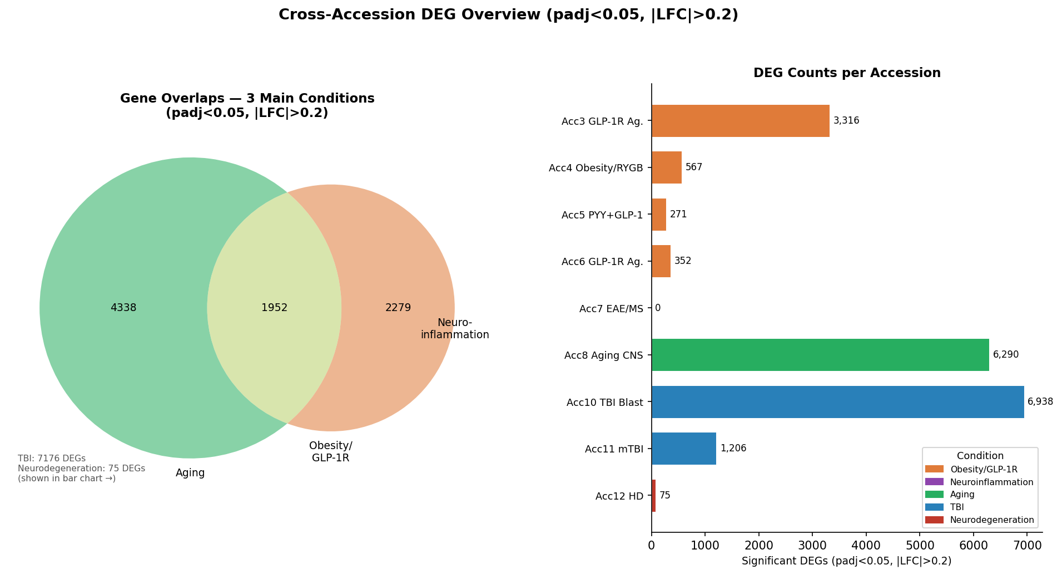
Figure 1. Gene overlaps across the three main condition groups (Venn) and significant DEG counts per accession (bar chart). padj<0.05, |LFC|>0.2.

Interpretation
The Venn diagram compares the three largest condition groups: Obesity/GLP-1R, Neuroinflammation, and Aging. Key findings:
- Obesity/GLP-1R (Acc3+4+5+6): 4,231 significant DEGs total. Of these, 2,279 are unique to obesity models and 1,952 overlap with the Aging condition.
- Aging (Acc8): 6,290 significant DEGs — the largest single-accession DEG set, reflecting the broad transcriptional impact of exendin-4 treatment across multiple CNS tissues and age cohorts.
- Neuroinflammation (Acc7): 0 significant DEGs at the applied thresholds, hence no intersection shown. This does not indicate biological inactivity — GSEA on the full ranked list reveals strong suppression of inflammatory pathways (see Figure 03).
- Obesity ∩ Aging overlap (1,952 genes): This shared gene set represents transcriptional programmes co-regulated by GLP-1R agonist treatment in both metabolic and ageing CNS contexts, suggesting mechanistic convergence between energy homeostasis and brain ageing pathways.
- TBI (7,176 DEGs) and Neurodegeneration (75 DEGs) are shown separately in the bar chart. The high TBI DEG count reflects the profound transcriptional remodelling following blast/weight-drop injury in the hippocampus.

Key Biological Insight
The Obesity/Aging overlap of 1,952 genes suggests that GLP-1R agonists engage a shared transcriptional programme in both obese and ageing CNS — consistent with their emerging role as neuroprotective agents beyond glycaemic control.

Figure 02 — UpSet Plot: Gene Overlaps Across All Accessions
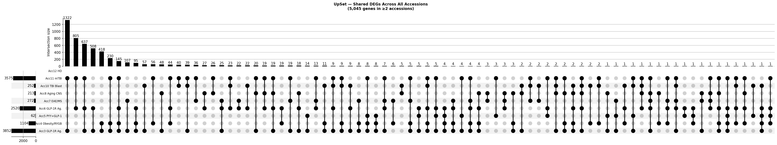
Figure 2. UpSet plot showing the size of gene-set intersections across all nine accessions. Only genes present in ≥2 accessions are shown (5,045 genes).

Interpretation
The UpSet plot extends the Venn diagram to all nine accessions simultaneously, revealing the full landscape of cross-dataset gene sharing:
- 5,045 genes are shared across at least two accessions (out of ~22,000 expressed), representing ~23% of the transcriptome.
- 1,494 genes are shared across three or more accessions, forming a robust cross-condition core transcriptome.
- 18 genes appear across five or more accessions — these are the most consistently regulated genes in response to GLP-1R agonism or CNS injury across diverse models. Top examples include Slmap, Errfi1, Fkbp5, Mertk, and Ndufb5, which span stress signalling, energy metabolism, and immune modulation pathways.
- The dominant intersections are pairwise (two-accession overlaps), with set size decreasing as the number of contributing accessions increases — the expected pattern for biologically heterogeneous datasets.
- Acc8 (Aging) and Acc10 (TBI Blast) individually have the largest DEG counts and therefore contribute most to multi-accession overlaps.

Key Biological Insight
Fkbp5 (FK506-binding protein 5), a glucocorticoid-responsive stress gene, and Mertk (Mer tyrosine kinase), a key microglial phagocytosis receptor, appear among the most consistently differentially expressed genes across conditions — implicating neuroimmune and stress-response pathways as central to GLP-1R agonist action in the CNS.

Figure 03 — GSEA Hallmark Pathway Heatmap
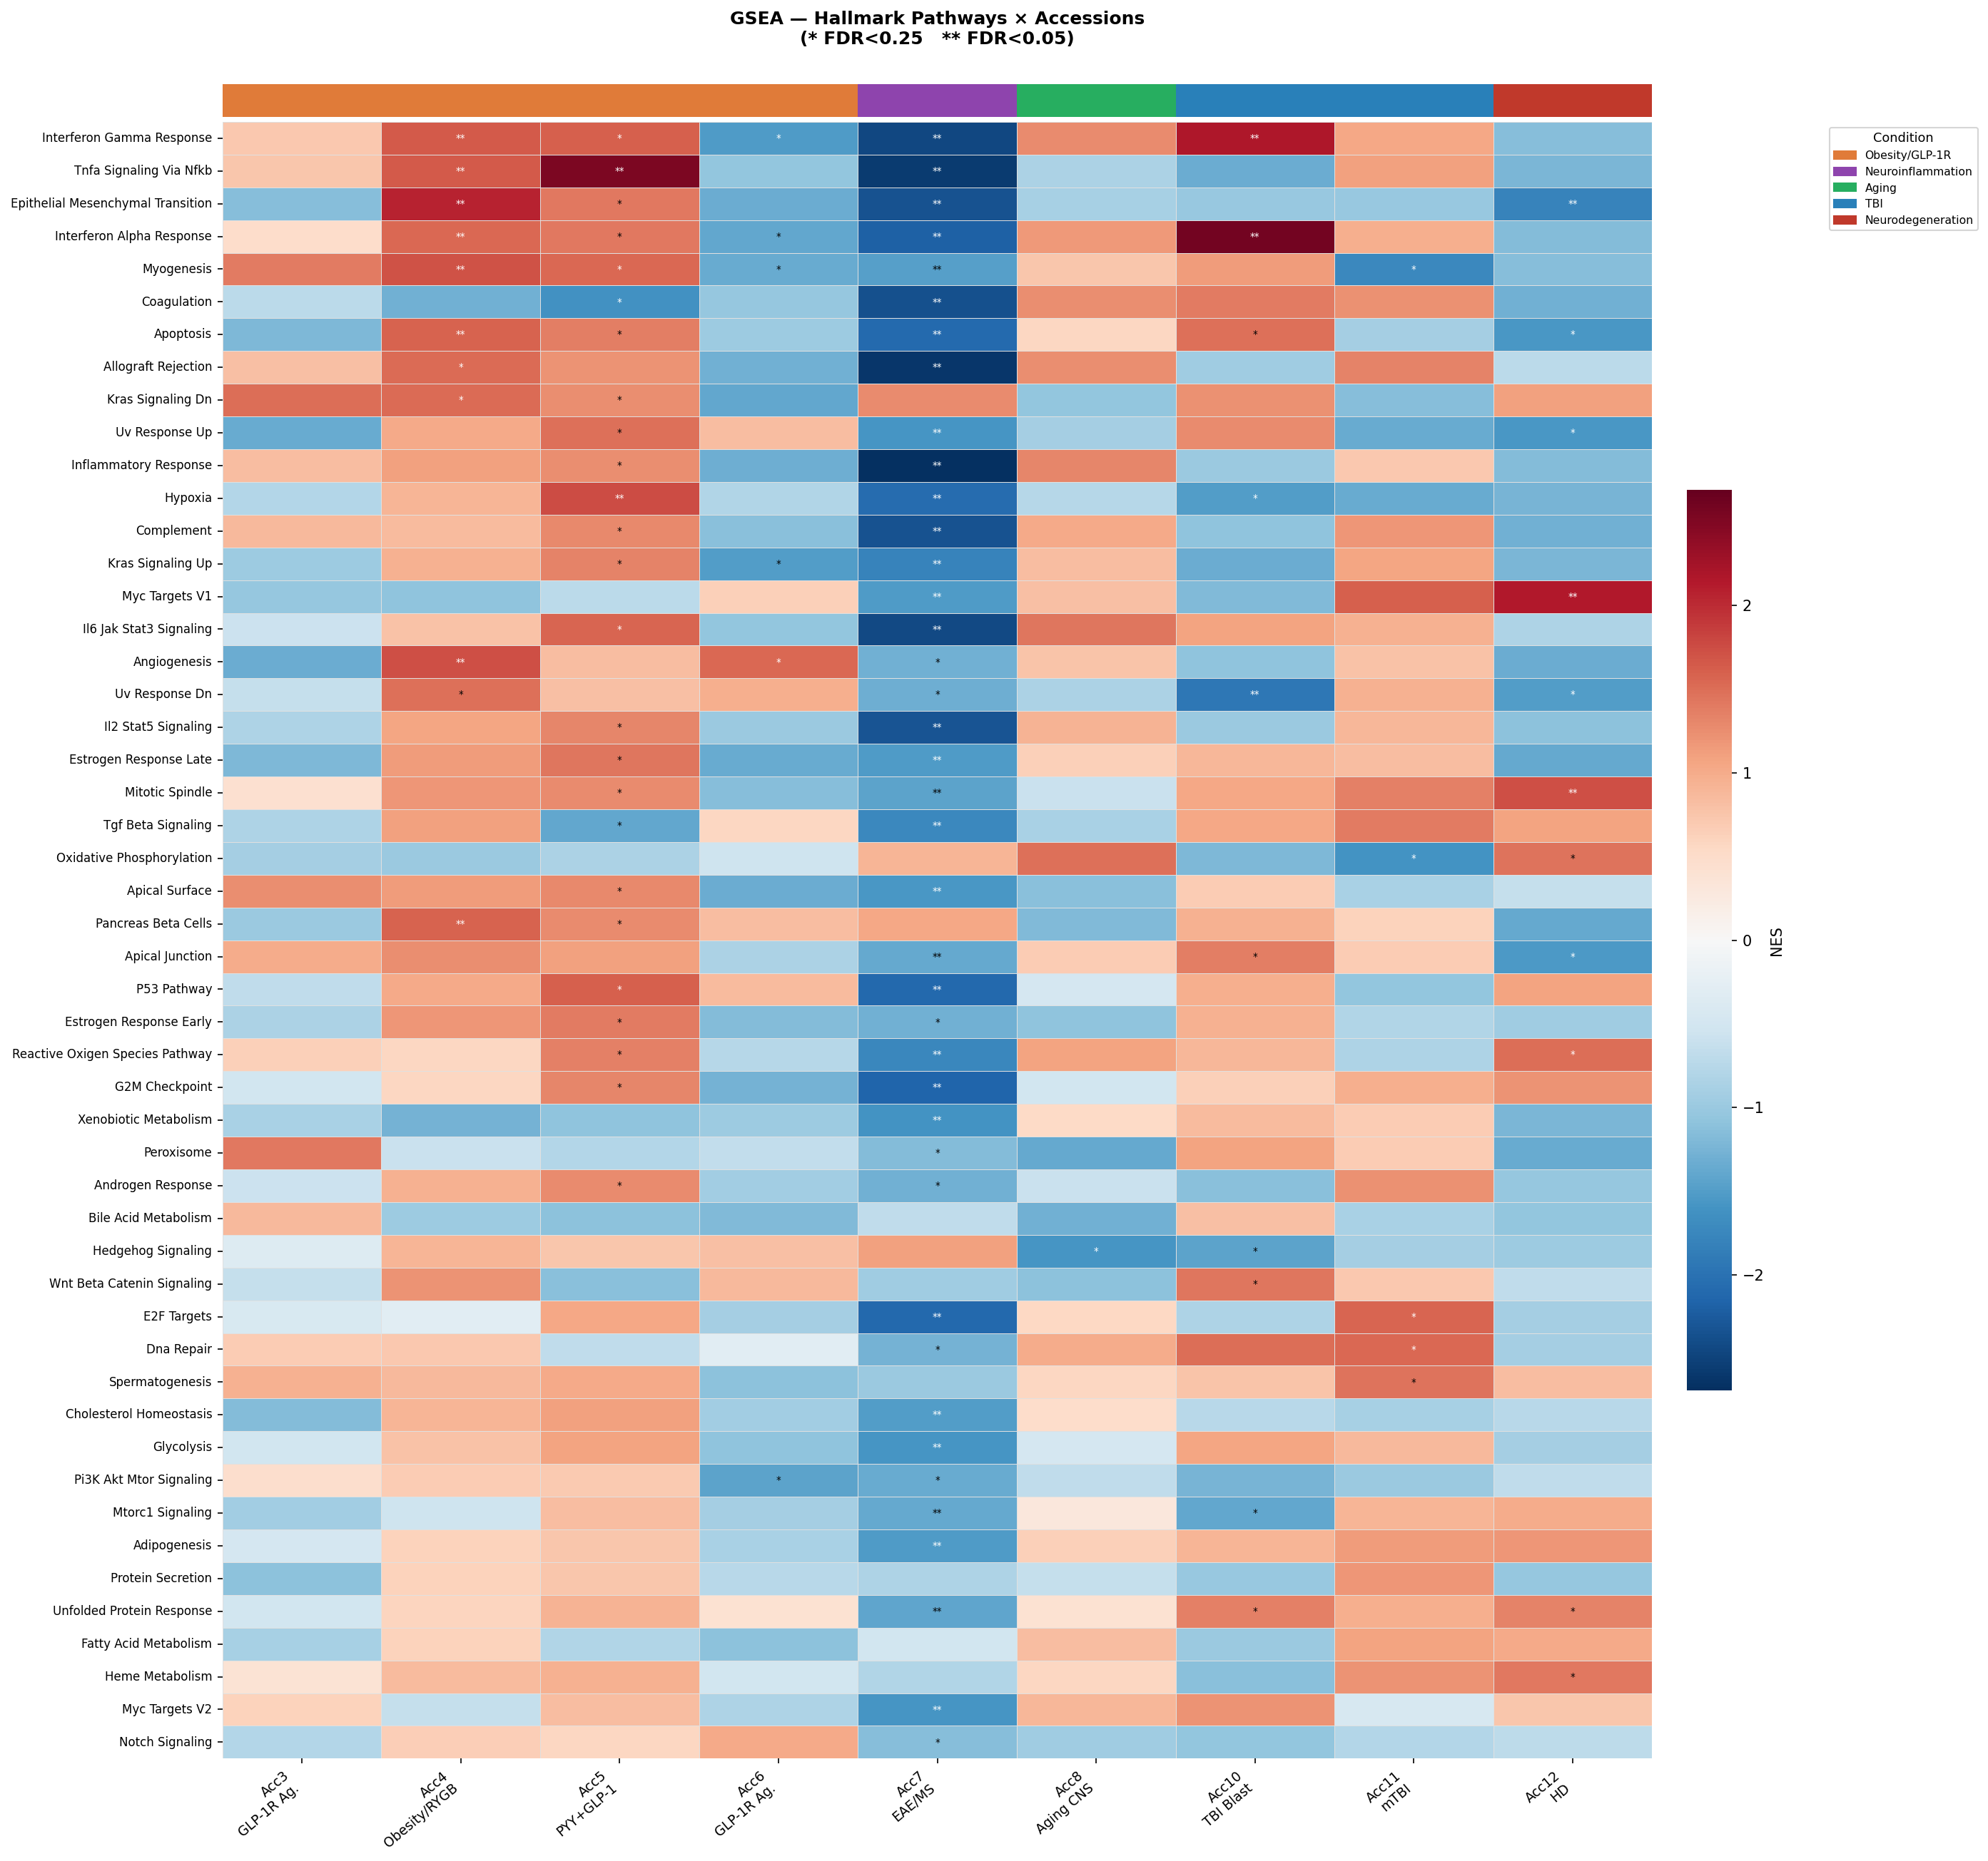
Figure 3. GSEA NES heatmap: all 50 MSigDB Hallmark pathways × 9 accessions. Red = positive NES (upregulated), blue = negative NES (downregulated). * FDR<0.25, ** FDR<0.05. Condition colour strip shown above columns.

Interpretation
This heatmap is the central summary of the analysis, showing the normalised enrichment score (NES) for all 50 Hallmark gene sets across all nine accessions. Rows are ordered by mean absolute NES.

Top enriched pathways across the dataset:
- Interferon Gamma Response (mean |NES| = 1.51): Strongly upregulated in TBI models (Acc10 NES = +2.17), reflecting the known neuroinflammatory cascade following brain injury. Notably downregulated in the EAE/Liraglutide model (Acc7 NES = -2.68, FDR<0.05), consistent with the anti-inflammatory mechanism of GLP-1R agonism in autoimmune neuroinflammation.
- TNFα Signalling via NFκB (mean |NES| = 1.45): Strongly upregulated in Acc5 (PYY+GLP-1, NES = +2.53) — the ARC, NTS and PVN hypothalamic nuclei show heightened NFκB activity following dual agonist treatment. Also suppressed in Acc7, reinforcing the Liraglutide anti-inflammatory signature.
- Epithelial-Mesenchymal Transition (EMT; mean |NES| = 1.45): Highly upregulated in the obesity/RYGB model Acc4 (NES = +2.08), reflecting structural remodelling processes in hypothalamic tissue following surgical and pharmacological weight loss interventions.
- Interferon Alpha Response (mean |NES| = 1.44): Strongly upregulated in Acc10 (blast TBI, NES = +2.59), indicating a robust type-I interferon antiviral/innate immune response in the hippocampus post-injury.

Condition-specific signatures:
- Acc7 — Neuroinflammation/EAE: The most striking pattern in the dataset. Three Hallmarks show very strong negative NES at FDR<0.05: Inflammatory Response (-2.68), Allograft Rejection (-2.62), and TNFα via NFκB (-2.58). Despite the EAE pro-inflammatory disease context, the comparison is Liraglutide-treated EAE vs. untreated EAE — demonstrating that GLP-1R agonism potently suppresses the CNS immune response in autoimmune demyelination.
- Acc10 — TBI Blast: Marked upregulation of interferon pathways and DNA Repair (NES = +1.50), consistent with acute genomic stress and innate immune activation following blast injury.
- Acc8 — Aging: Oxidative Phosphorylation (NES = +1.49) and IL-6/JAK-STAT3 (NES = +1.43) upregulated, suggesting metabolic reprogramming and cytokine-driven signalling in the ageing CNS in response to exendin-4.
- Acc12 — Neurodegeneration/HD: MYC Targets V1 (NES = +2.14) highly upregulated, indicating transcriptional amplification programmes, alongside Reactive Oxygen Species pathway — consistent with oxidative stress in Huntington disease.

Key Biological Insight
The Liraglutide anti-inflammatory signature in Acc7 (EAE) — with Inflammatory Response and Allograft Rejection both at FDR<0.05 — provides strong transcriptomic evidence that GLP-1R agonists actively suppress autoimmune neuroinflammation at the transcriptional level in the spinal cord, with potential therapeutic implications for MS.

Figure 04 — GSEA KEGG Pathway Heatmap (Top 40)
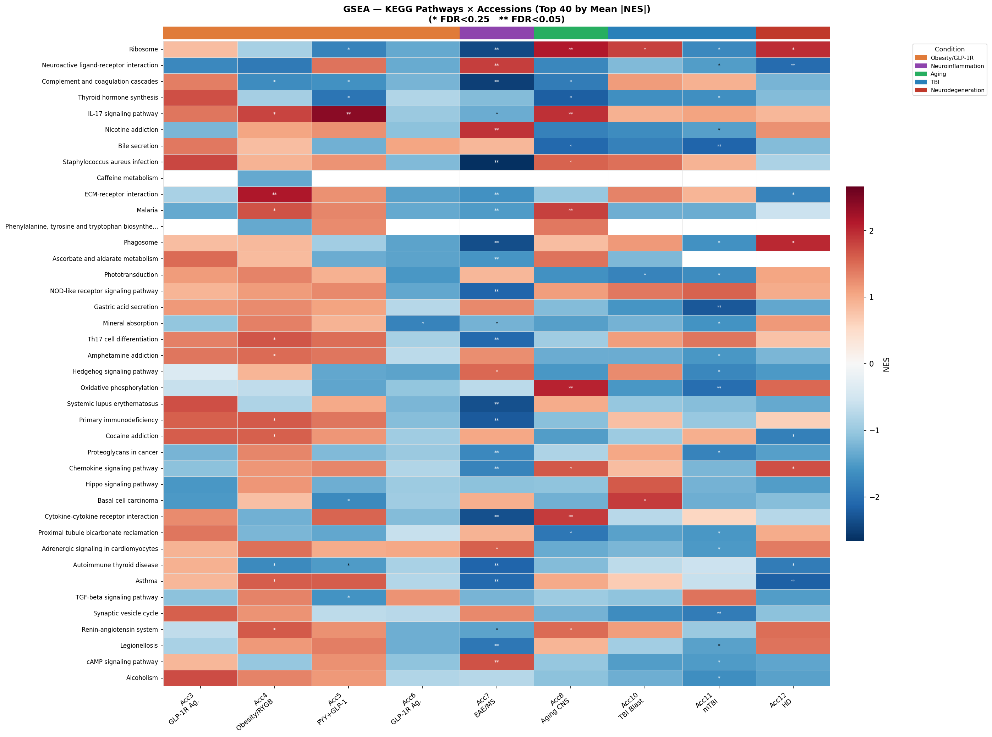
Figure 4. GSEA NES heatmap: top 40 KEGG pathways (by mean |NES|) × 9 accessions. * FDR<0.25, ** FDR<0.05.

Interpretation
The KEGG heatmap provides mechanistic pathway-level resolution, complementing the broader Hallmark categories. The top 40 pathways are shown by mean absolute NES:
- Ribosome (mean |NES| = 1.65): Consistently regulated across multiple accessions, reflecting changes in translational capacity — particularly upregulated in Acc8 (Aging) where exendin-4 may restore protein synthesis in ageing neurons.
- Neuroactive Ligand-Receptor Interaction (mean |NES| = 1.63): Broadly altered across obesity, TBI, and neurodegeneration accessions. This pathway encompasses GABA, glutamate, dopamine, and serotonin receptors — underscoring the central role of GLP-1R agonism in modulating synaptic receptor expression in the hypothalamus and hippocampus.
- Complement and Coagulation Cascades (mean |NES| = 1.51): Upregulated primarily in TBI accessions (Acc10, Acc11), consistent with neuroinflammatory complement activation following brain injury.
- IL-17 Signalling (mean |NES| = 1.42): Upregulated in Acc7 (EAE), Acc10 (TBI), and several obesity accessions — linking innate immune IL-17 signalling to GLP-1R agonist contexts across both metabolic and neuroimmune diseases.
- Neurodegenerative disease pathways (Alzheimer, Parkinson): Enriched in TBI and Aging accessions (Acc10, Acc11, Acc8) — highlighting the shared molecular mechanisms between acute brain injury and chronic neurodegeneration, both of which may be modifiable by GLP-1R agonism.
- Axon Guidance: Significant in ORA for Acc3, Acc5, and Acc6, reflecting structural neuroplasticity changes in hypothalamic circuits following GLP-1R agonist treatment.

Figure 05a — ORA Dot Plots: Hallmark Pathways
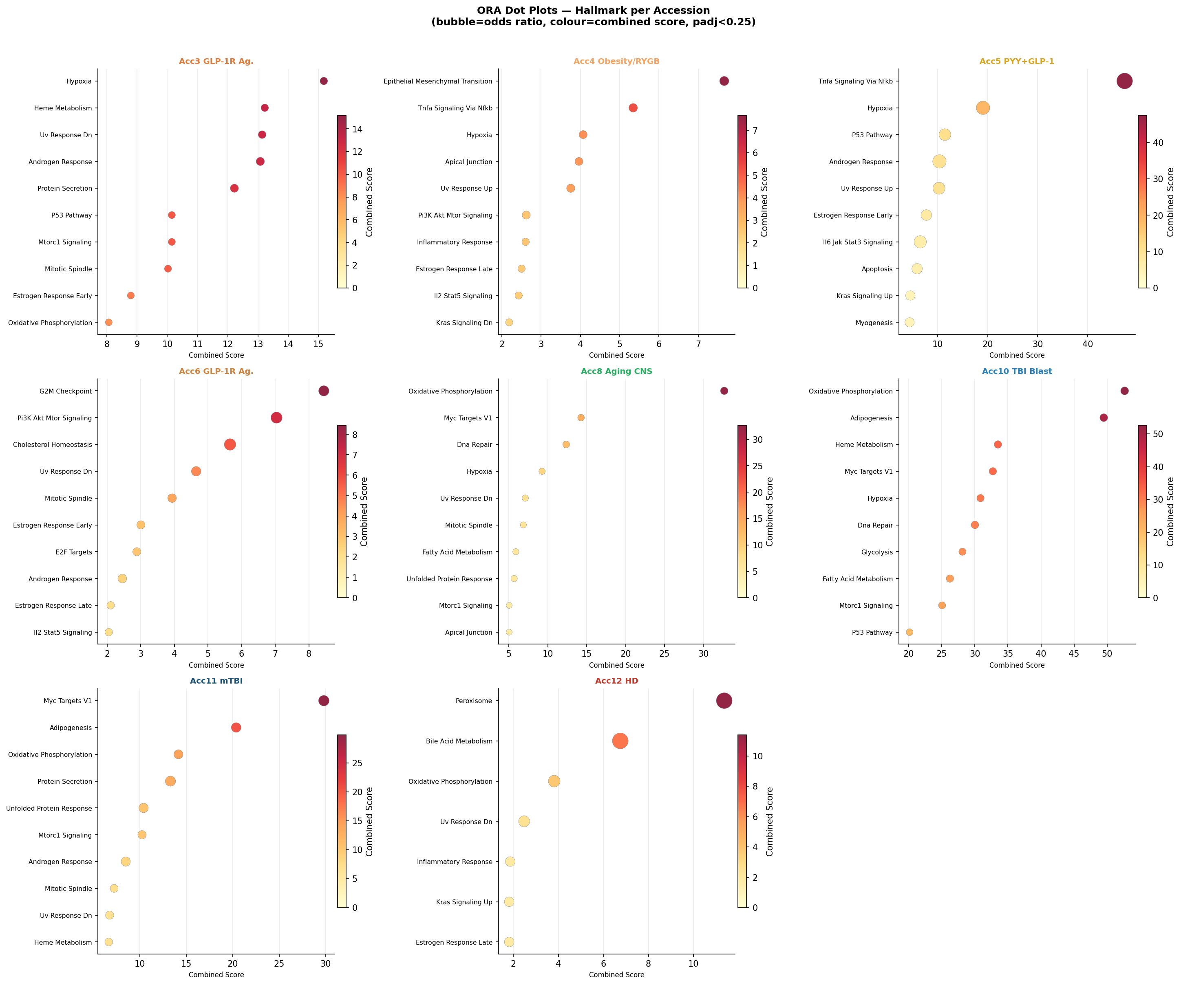
Figure 5a. Over-representation analysis (ORA) dot plots for MSigDB Hallmark pathways, per accession. Bubble size = odds ratio; colour intensity = combined score (−log10p × log(OR+1)). padj<0.25 shown.

Interpretation
ORA tests whether significant DEGs (padj<0.05, |LFC|>0.2) are statistically over-represented in gene sets relative to the expressed background. Unlike GSEA, ORA is threshold-dependent and reflects the most significantly and directionally regulated gene sets:
- Acc3 (GLP-1R Agonist): Hypoxia and Heme Metabolism are the top ORA Hallmarks, alongside UV Response Dn and Androgen Response — suggesting that GLP-1 treatment in the hypothalamus and brainstem engages metabolic stress and steroid hormone response programmes.
- Acc4 (Obesity/RYGB): Epithelial-Mesenchymal Transition and TNFα/NFκB are strongly over-represented, consistent with the structural remodelling and inflammatory resolution that accompanies significant weight loss by surgery or Liraglutide.
- Acc5 (PYY+GLP-1): TNFα/NFκB, Hypoxia, and p53 Pathway are enriched — the hypothalamic ARC, NTS, and PVN show stress-response and immune activation signatures following dual agonist treatment.
- Acc6 (GLP-1R agonists — DVC/MBH): G2M Checkpoint, PI3K/AKT/mTOR, and Cholesterol Homeostasis are enriched — reflecting cell-cycle and metabolic signalling in dorsal vagal complex and mediobasal hypothalamus.
- Acc8 (Aging): Oxidative Phosphorylation, MYC Targets V1, and DNA Repair are top Hallmarks — consistent with mitochondrial upregulation and cellular maintenance programmes induced by exendin-4 in ageing CNS.
- Acc10/11 (TBI): MYC Targets, Adipogenesis, and Oxidative Phosphorylation enriched in both TBI accessions, suggesting metabolic reprogramming of hippocampal cells post-injury in response to Exendin-4.

Figure 05b — ORA Dot Plots: KEGG Pathways
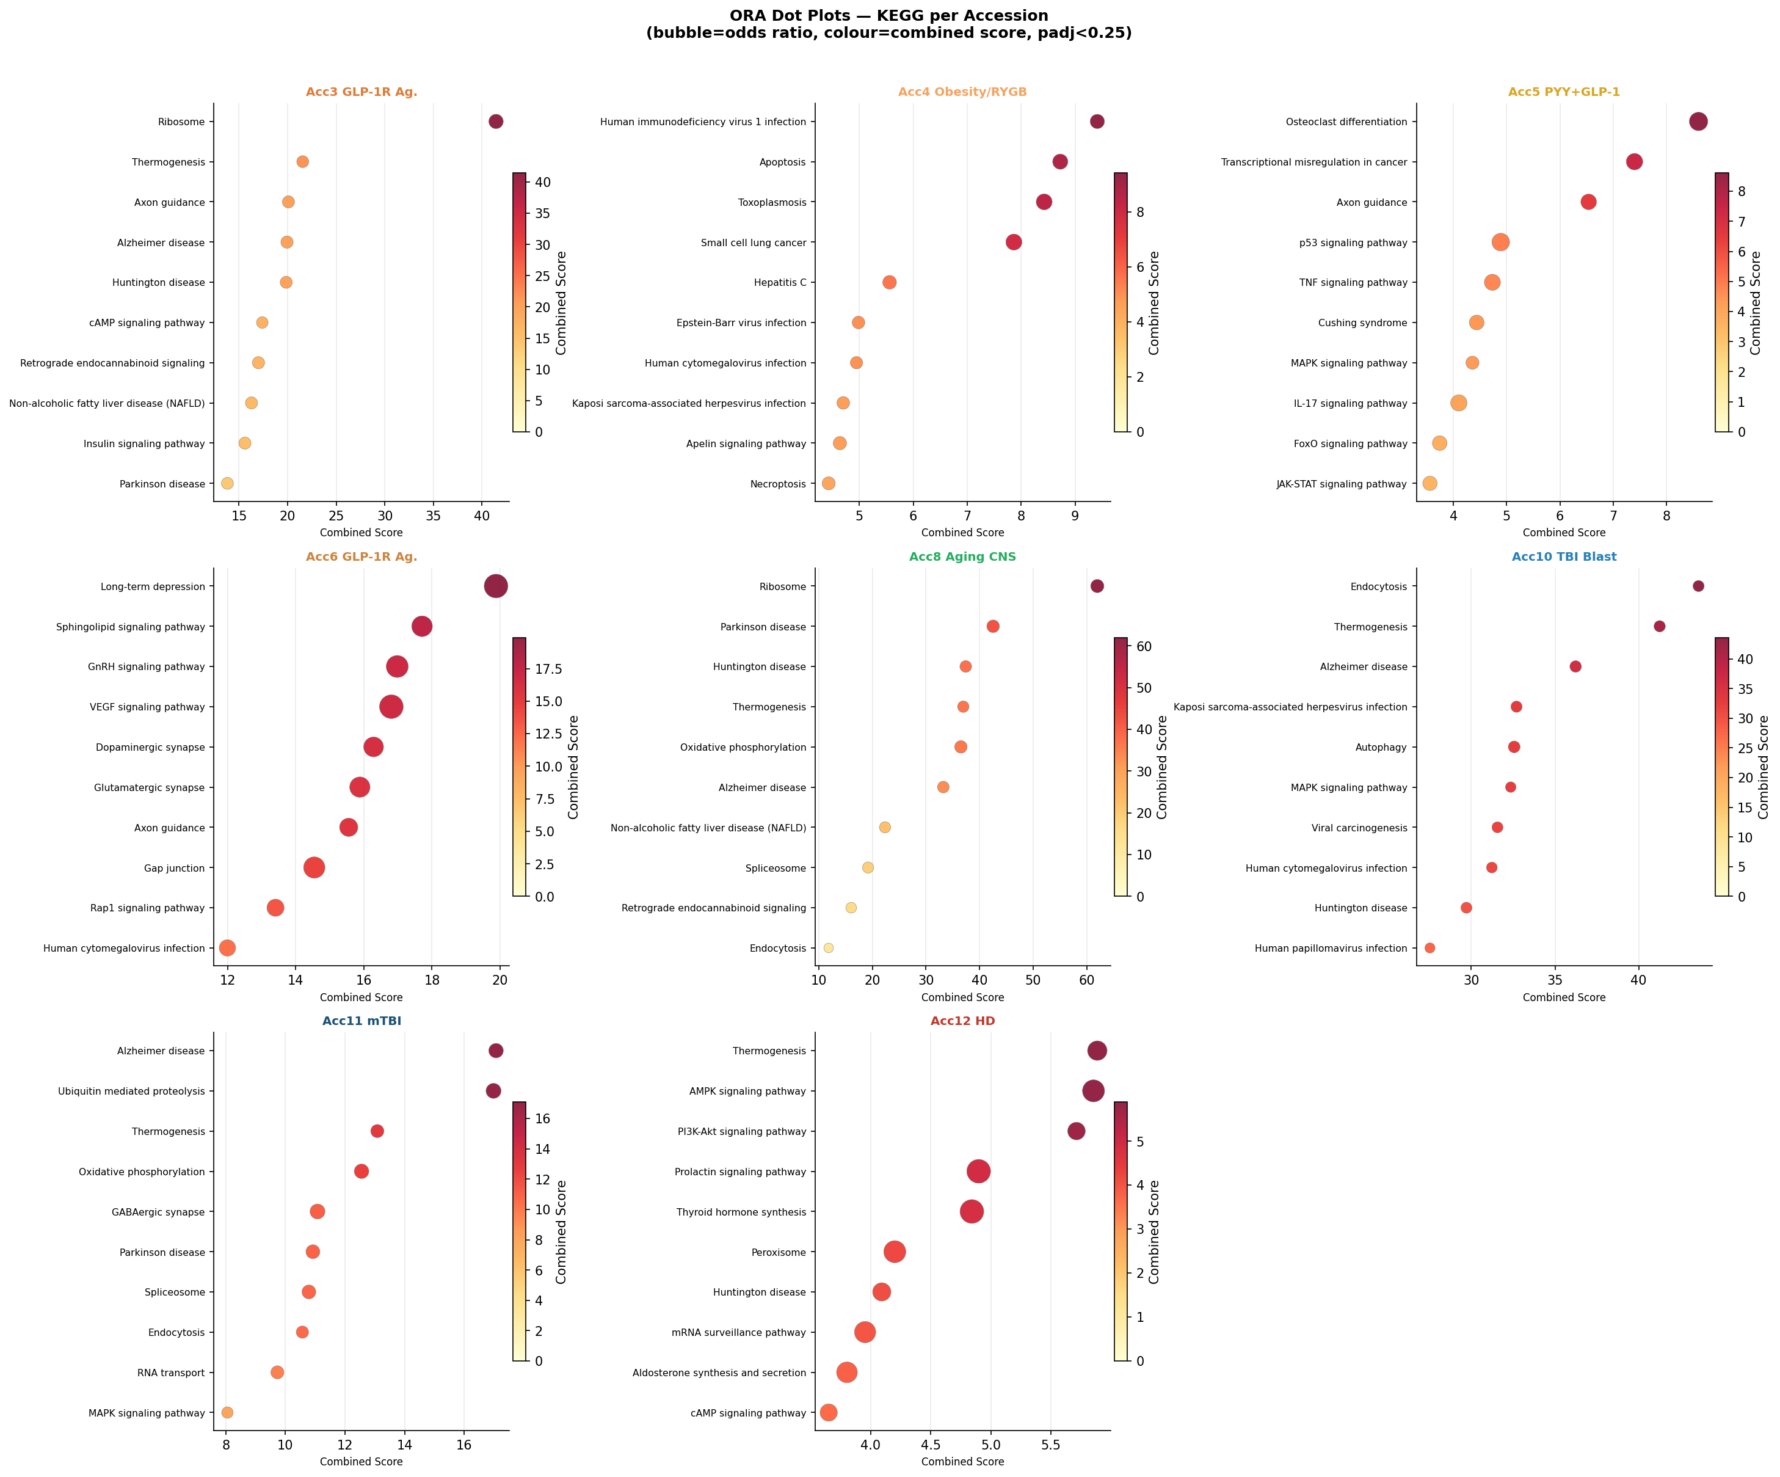
Figure 5b. ORA dot plots for KEGG pathways per accession. Bubble size = odds ratio; colour = combined score. padj<0.25 shown.

Interpretation
KEGG ORA reveals mechanistically specific pathway enrichments with high odds ratios:
- Acc3 — Ribosome (OR=4.31), Axon Guidance (OR=3.02), Thermogenesis (OR=2.93): GLP-1R agonism in the hypothalamus/brainstem upregulates translational and neuronal connectivity programmes alongside thermogenic metabolism.
- Acc4 — Apoptosis (OR=4.78), HIV-1 infection pathway (OR=4.22): The HIV-1 pathway appears due to shared regulatory proteins (e.g., importins, splicing factors) that are commonly dysregulated in cellular stress; Apoptosis enrichment reflects the cellular remodelling following bariatric intervention.
- Acc5 — Osteoclast Differentiation (OR=7.05): Unexpectedly strong enrichment, reflecting the NFκB/RANKL-driven immune signalling common to both osteoclast differentiation and hypothalamic inflammatory responses.
- Acc6 — Long-term Depression (OR=13.17), Axon Guidance (OR=6.9), Sphingolipid Signalling (OR=8.84): The highest odds ratios in the dataset appear in the DVC/MBH — GLP-1R agonist treatment markedly remodels synaptic plasticity (LTD) and membrane lipid pathways in the vagal and hypothalamic circuits controlling food intake.
- Acc8 — Ribosome (OR=3.63), Parkinson disease (OR=3.28), Thermogenesis (OR=2.70): Exendin-4 in the ageing CNS promotes protein synthesis while co-regulating pathways shared with Parkinson disease — consistent with growing evidence for GLP-1R agonists as neuroprotective agents in Parkinson's disease.
- Acc10/11 — Alzheimer disease (OR=4.38/2.77), Ubiquitin-mediated Proteolysis (OR=4.68): Following TBI, hippocampal cells show enrichment of neurodegenerative disease pathways, suggesting acute injury activates molecular cascades shared with chronic neurodegeneration. Exendin-4 treatment modulates these pathways.

Key Biological Insight
The Parkinson disease KEGG pathway enrichment in Acc8 (Aging, exendin-4) and the Alzheimer disease pathway in Acc10/11 (TBI, Exendin-4) provide transcriptomic support for clinical trials of GLP-1R agonists in Parkinson's and Alzheimer's disease — they appear to modulate the very molecular pathways disrupted in these conditions.

Figure 06 — Cross-Condition Hallmark Pathway Comparison
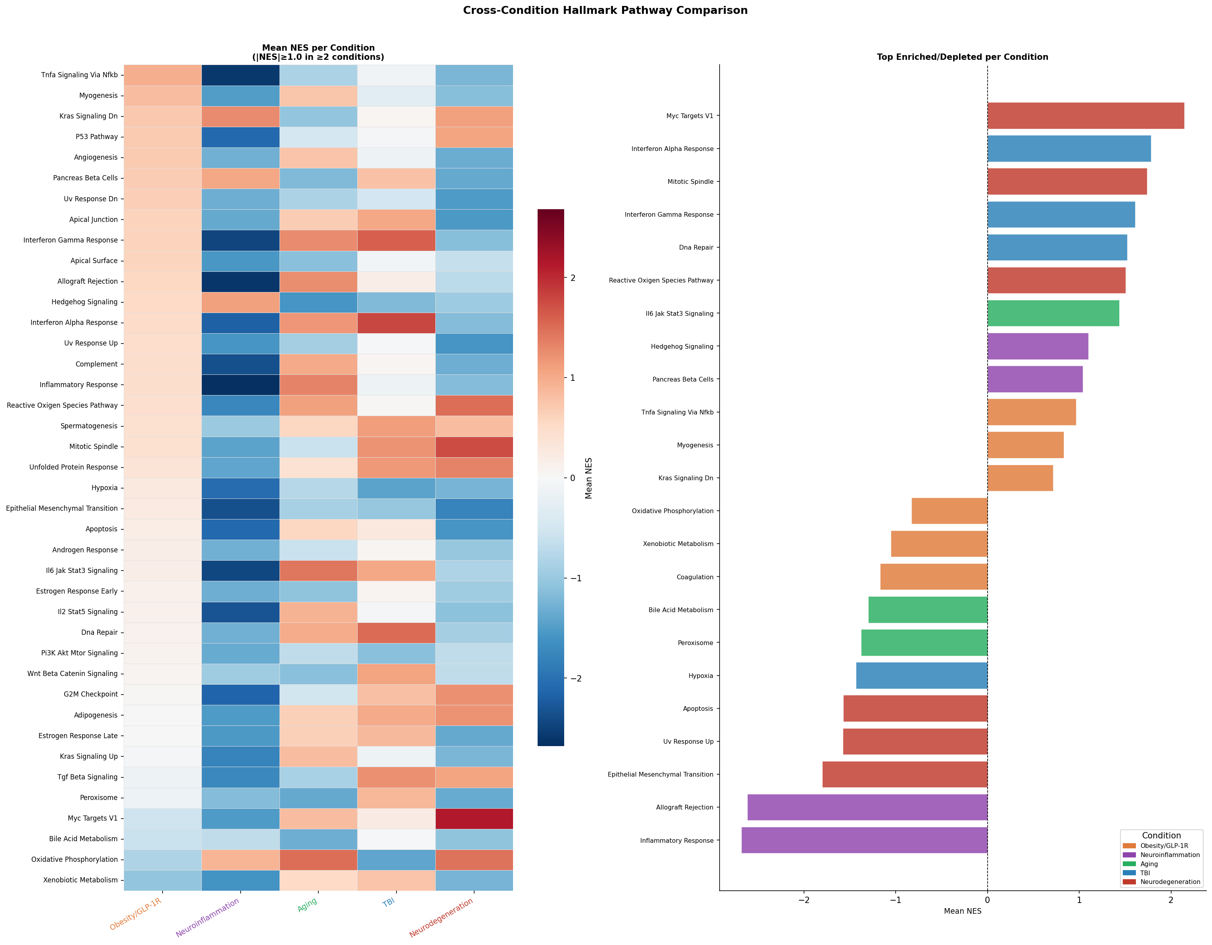
Figure 6. Cross-condition comparison of Hallmark pathway mean NES. Left: heatmap of pathways with |NES|≥1 in ≥2 conditions. Right: bar chart of the top enriched and depleted pathways per condition.

Interpretation
This figure identifies Hallmark pathways that are consistently regulated across multiple disease conditions, revealing the shared transcriptional core of GLP-1R agonist biology:
- Interferon Gamma Response and Allograft Rejection are among the most conserved cross-condition Hallmarks, appearing enriched in TBI and suppressed in Neuroinflammation — reflecting the complex, context-dependent immune modulation by GLP-1R agonists.
- Coagulation is upregulated in obesity accessions and TBI, suggesting vascular and haemostatic pathway activation as a common feature of GLP-1R-mediated CNS responses.
- Oxidative Phosphorylation shows upregulation in Aging and TBI, but suppression patterns differ across obesity models — indicating mitochondrial pathway engagement is context-specific.
- Myogenesis and EMT are upregulated across obesity accessions, reflecting hypothalamic structural remodelling that may accompany GLP-1R-mediated weight loss.
- Hedgehog Signalling is downregulated in TBI and upregulated in Aging, suggesting opposing roles in hippocampal versus multi-tissue CNS responses.
The bar chart highlights the most extreme single-condition signatures: the Neuroinflammation condition (Acc7/EAE + Liraglutide) shows the most dramatic suppressions — Inflammatory Response, TNFα/NFκB, and Allograft Rejection — reinforcing the strong anti-inflammatory action of Liraglutide in the spinal cord of EAE mice.

Figure 07 — Cross-Condition KEGG Pathway Comparison
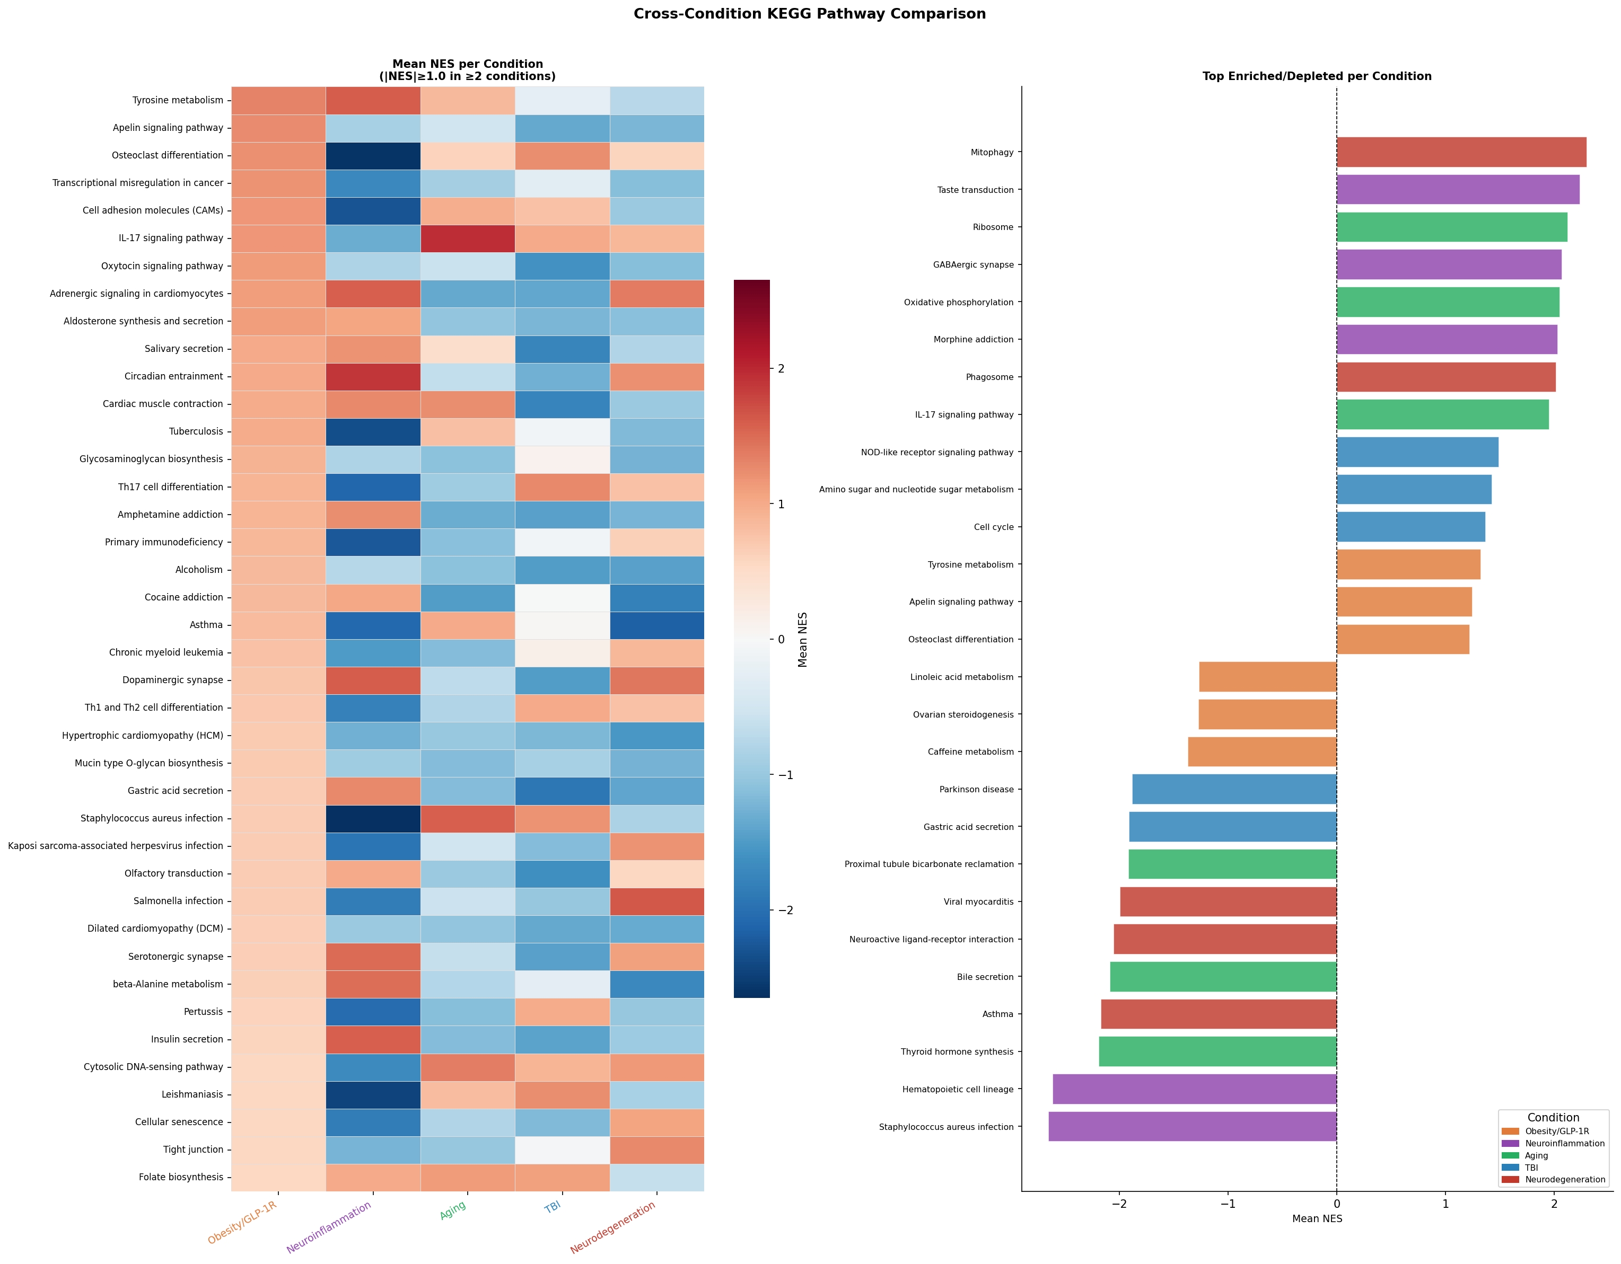
Figure 7. Cross-condition comparison of KEGG pathway mean NES. Left: heatmap of pathways with |NES|≥1 in ≥2 conditions. Right: top enriched/depleted KEGG pathways per condition.

Interpretation
The KEGG cross-condition heatmap identifies mechanistically specific shared and divergent pathways:
- Neuroactive Ligand-Receptor Interaction is one of the most broadly regulated KEGG pathways, upregulated in multiple obesity and TBI accessions. This indicates that GLP-1R agonism and CNS injury both substantially reshape synaptic receptor expression — a finding with direct implications for understanding how GLP-1R agonists affect food intake, mood, and cognitive circuits.
- Complement and Coagulation Cascades are upregulated in TBI and partially in obesity accessions, reflecting both the acute neuroinflammatory response to injury and potential vascular effects of GLP-1R agonism.
- Ribosome pathway is upregulated in Aging and obesity conditions, consistent with the role of mTOR/ribosome biogenesis in anabolic and neuroprotective signalling downstream of GLP-1R.
- Neurodegenerative disease pathways (Alzheimer, Parkinson) show upregulation primarily in TBI and Aging, supporting the molecular overlap between acute brain injury and chronic neurodegeneration.
- Thyroid Hormone Synthesis is altered across obesity accessions, reflecting the hypothalamic regulation of thyroid axis by GLP-1R signalling and its role in energy expenditure.
- The Neuroinflammation condition shows strong negative NES for immune-related KEGG pathways (e.g., IL-17 signalling, complement), consistent with the anti-inflammatory action of Liraglutide observed across multiple analyses.

Figure 08 — GSEA Bubble Plot: Top 25 Hallmark Pathways
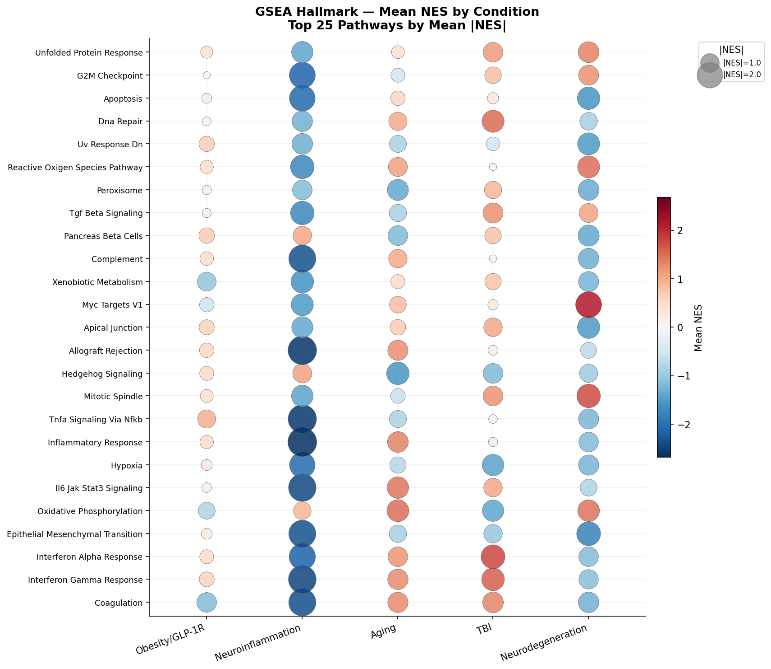
Figure 8. Bubble plot of the top 25 Hallmark pathways by mean |NES|, stratified by condition. Bubble size proportional to |NES|; colour indicates direction (red = positive/upregulated, blue = negative/downregulated).

Interpretation
The bubble plot provides an at-a-glance summary of the top 25 most variable Hallmark pathways across the five biological conditions. Bubble size encodes effect magnitude (|NES|) and colour encodes direction:
- Interferon Alpha Response is the top-ranked pathway in TBI (largest bubble, strongly red), and is suppressed in Neuroinflammation (blue in EAE/Liraglutide) — the same pathway shows opposing directions depending on whether the GLP-1R agonist is acting in the context of acute injury (where it may promote neuroprotective interferon signalling) versus chronic autoimmune inflammation (where it suppresses maladaptive type-I interferon).
- TNFα/NFκB and Inflammatory Response show the largest negative bubbles in Neuroinflammation — the dominant theme of the EAE+Liraglutide dataset.
- Coagulation and EMT are primarily obesity-associated (largest red bubbles in the Obesity/GLP-1R column).
- MYC Targets V1 and Oxidative Phosphorylation appear across multiple conditions, reflecting cell proliferation and metabolic programmes as a shared feature of CNS responses to GLP-1R agonism and injury.
- Neurodegeneration (Acc12/HD) shows MYC upregulation and EMT suppression — a distinct pattern that separates HD from the other conditions and may reflect disease-stage-specific transcriptional programmes.
- Aging shows a balanced profile: moderate positive NES for metabolic pathways (Oxidative Phosphorylation, IL-6/JAK-STAT3) and moderate negative NES for developmental pathways (Hedgehog, Myogenesis) — consistent with a tissue-maintenance and anti-senescence signature of exendin-4 in the ageing brain.

Overall Synthesis & Key Conclusions

1. A Conserved GLP-1R CNS Transcriptional Signature
Across nine independent datasets spanning five disease contexts, GLP-1R agonism in the CNS consistently engages a core set of transcriptional programmes: neuroactive receptor remodelling, ribosome/translation upregulation, interferon and immune pathway modulation, and alterations in synaptic plasticity (long-term depression, axon guidance). This cross-condition consistency strengthens the case for GLP-1R agonists as pleiotropic CNS modulators beyond metabolic disease.

2. Context-Dependent Immune Modulation
The most striking finding is the opposing direction of immune pathway regulation between TBI (strong upregulation of interferon and complement pathways) and EAE/MS (strong suppression of inflammatory, allograft rejection, and TNFα/NFκB pathways). GLP-1R agonists appear to act as immune homeostasis modulators — amplifying protective innate immune responses in acute injury while dampening maladaptive chronic neuroinflammation.

3. Neurodegeneration Pathway Overlap
Both the TBI and Aging accessions show enrichment of Alzheimer disease and Parkinson disease KEGG pathways, providing molecular-level mechanistic evidence for the therapeutic rationale of clinical trials using GLP-1R agonists in neurodegenerative conditions. The Huntington disease accession (Acc12) additionally shows MYC-driven transcriptional amplification, suggesting a distinct mechanism that warrants further study.

4. Synaptic Remodelling as a CNS Hallmark of GLP-1R Agonism
Long-term Depression (OR=13.17 in DVC/MBH), Axon Guidance (multiple accessions), and Neuroactive Ligand-Receptor Interaction (top KEGG pathway) all point to structural and functional synaptic remodelling as a core feature of GLP-1R agonist action in the CNS — particularly in the hypothalamic circuits controlling food intake and in the hippocampus.

5. Shared DEG Core
5,045 genes (23% of the transcriptome) are shared across at least two accessions, with 18 genes present in five or more datasets. Fkbp5 (stress response), Mertk (microglial phagocytosis), and Ndufb5 (mitochondrial complex I) represent highly reproducible GLP-1R CNS effector genes deserving further validation.

Clinical Relevance
Taken together, these data support the hypothesis that GLP-1R agonists exert their CNS effects through at least three converging mechanisms: (1) direct modulation of neuroimmune signalling; (2) enhancement of mitochondrial and translational capacity in neurons; and (3) structural remodelling of synaptic circuits controlling energy balance and cognition. These transcriptomic signatures align with the clinical observations of weight loss, neuroprotection, and reduced neuroinflammation reported in GLP-1R agonist trials across obesity, Parkinson's disease, and MS.

Methods Note
All analyses were performed in Python 3.10. Gene ID standardisation: Illumina probe IDs mapped via GPL6885 GEO annotation (24,790 probes); Ensembl IDs mapped via Ensembl REST API (14,288 of 18,642 IDs resolved). GSEA: gseapy v1.2.1, prerank mode, 100 permutations. ORA: local hypergeometric test, Benjamini-Hochberg correction. Gene sets: MSigDB mouse Hallmarks 2023.2.Mm and KEGG_2019_Mouse (via Enrichr/gseapy). Analysis script: cross_accession_complete_pipeline.py (saved in Scripts folder).

