GLP-1R Agonist CNS Bulk-RNA Meta-Analysis
Consensus Differential Expression, Functional Enrichment & Concept-Network Analysis
Finalized Bioinformatics Workflow

1. Executive Summary
This report summarizes a consensus meta-analysis of GLP-1R-agonist and multi-agonist (dual / conjugate / combination) effects on the central nervous system, assembled from 34 distinct treatment-vs-control comparisons ("groups") spanning nine GEO accessions and ten CNS regions. Each group was analyzed as a separate, un-merged comparison; genes were standardized to mouse symbols; and consensus genes were defined as those significantly differentially expressed in two or more groups.
At the |log2FC| >= 0.2, padj < 0.05 threshold, 4,769 consensus genes were identified; at the strict |log2FC| >= 1.0 threshold, 297 consensus genes remained. Functional enrichment converged on mitochondrial oxidative phosphorylation / electron transport, cytoplasmic translation (ribosome), and neurodegeneration-associated pathways - a coherent metabolic-neuroprotective signature for GLP-1R agonism in the CNS.

2. Datasets & Methods

2.1 Scope and group definition
Included: GLP-1R-agonist monotherapies (e.g. liraglutide, exendin-4, GLP-1, AC3174, semaglutide) and multi-agonists containing a GLP-1R-agonist component (e.g. GLP-1+MK-801 conjugate, PYY+liraglutide, AC710222, IP118/PY115, COMBO). Restricted to CNS tissue; peripheral tissues and non-GLP arms were excluded. Each treatment-vs-control comparison within a region is its own group; groups are never merged.

2.2 Gene standardization
- Ensembl mouse IDs (ENSMUSG; Acc 5, 6) -> symbols via mygene.info.
- Rat / mouse symbol tables (Acc 3, 4, 7, 8) -> mouse title-case.
- Illumina GPL6885 arrays (Acc 10, 11, 12) -> symbols via the GPL6885 AnnotGPL annotation.

2.3 Array re-analysis (GEO2R / limma)
The three Illumina GPL6885 microarray datasets were re-derived using the GEO2R limma workflow in R 4.5.3 + Bioconductor limma 3.66.0: log2 auto-transform -> lmFit(~0+group) -> makeContrasts -> eBayes(0.01) -> topTable(adjust=fdr). Contrasts: GSE71850 (Exendin4, Ex4-Pre-TBI, Ex4-Post-TBI vs Control); GSE41345 (Ex4, Ex4/mTBI vs sham); GSE39586 (glp vs nORM, using the supplied sample grouping).

2.4 Consensus, enrichment & thresholds
Consensus = significant DEG in >= 2 groups, computed per threshold (LFC0.2 and LFC1, both padj < 0.05). Enrichment used Enrichr (gseapy, organism = mouse) across GO Biological Process, GO Molecular Function, GO Cellular Component (GO:All), KEGG, and Reactome.

3. Datasets and Groups
34 groups were analyzed (source breakdown: 19 gene_name, 9 ensembl, 6 array). Summary by accession:
Acc | GEO | Groups | Regions | GLP-1R / multi-agonist arms
3 | GSE244607 | 7 | accumbens, brainstem, hypothalamus | GLP_1, GLP_1_MK_801, conjugate_2
4 | GSE190218 | 2 | hypothalamus | Lira, PYY_Lira
5 | GSE160802 | 3 | arc, nts, pvn | IP118_PY115
6 | GSE135862 | 6 | dvc, mbh | AC3174, AC710222, COMBO
8 | GSE280382 | 10 | frontalcortex, hippocampus, hypothalamus | LT_A_Ex, ST_A_Ex, ST_A_Ex_KD, YA_Ex
10 | GSE71850 | 3 | hippocampus | Ex4_Po_t_TBI, Ex4_Pre_TBI, Exendin4
11 | GSE41345 | 2 | hippocampus | Ex4, Ex4_mTBI
12 | GSE39586 | 1 | hypothalamus | GLP

4. Consensus Genes
Top recurring consensus genes (ranked by number of groups) at |log2FC| >= 0.2, padj < 0.05 (4,769 total):
Gene | # Groups | Direction | Mean log2FC
Fkbp5 | 12 | UP | 0.83
Plin4 | 9 | UP | 1.38
Hif3a | 9 | UP | 0.9
Rbm3 | 9 | UP | 0.22
Mpp5 | 9 | DOWN | -0.24
Xdh | 8 | UP | 0.73
Cdkn1a | 8 | UP | 0.58
Vstm2a | 8 | DOWN | -0.24
Ednrb | 8 | DOWN | -0.42
Cd53 | 7 | UP | 4.34
Msantd2 | 7 | UP | 2.16
Mertk | 7 | UP | 1.43
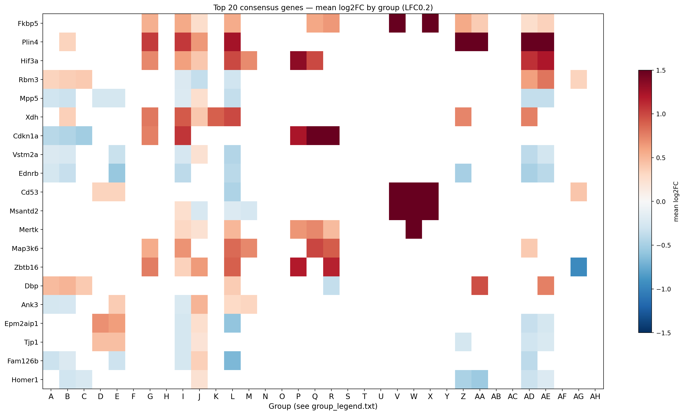
Figure 1. Top-20 consensus genes (by group frequency) - mean log2FC across groups (LFC0.2). Groups are lettered; see each plot's group_legend.txt.
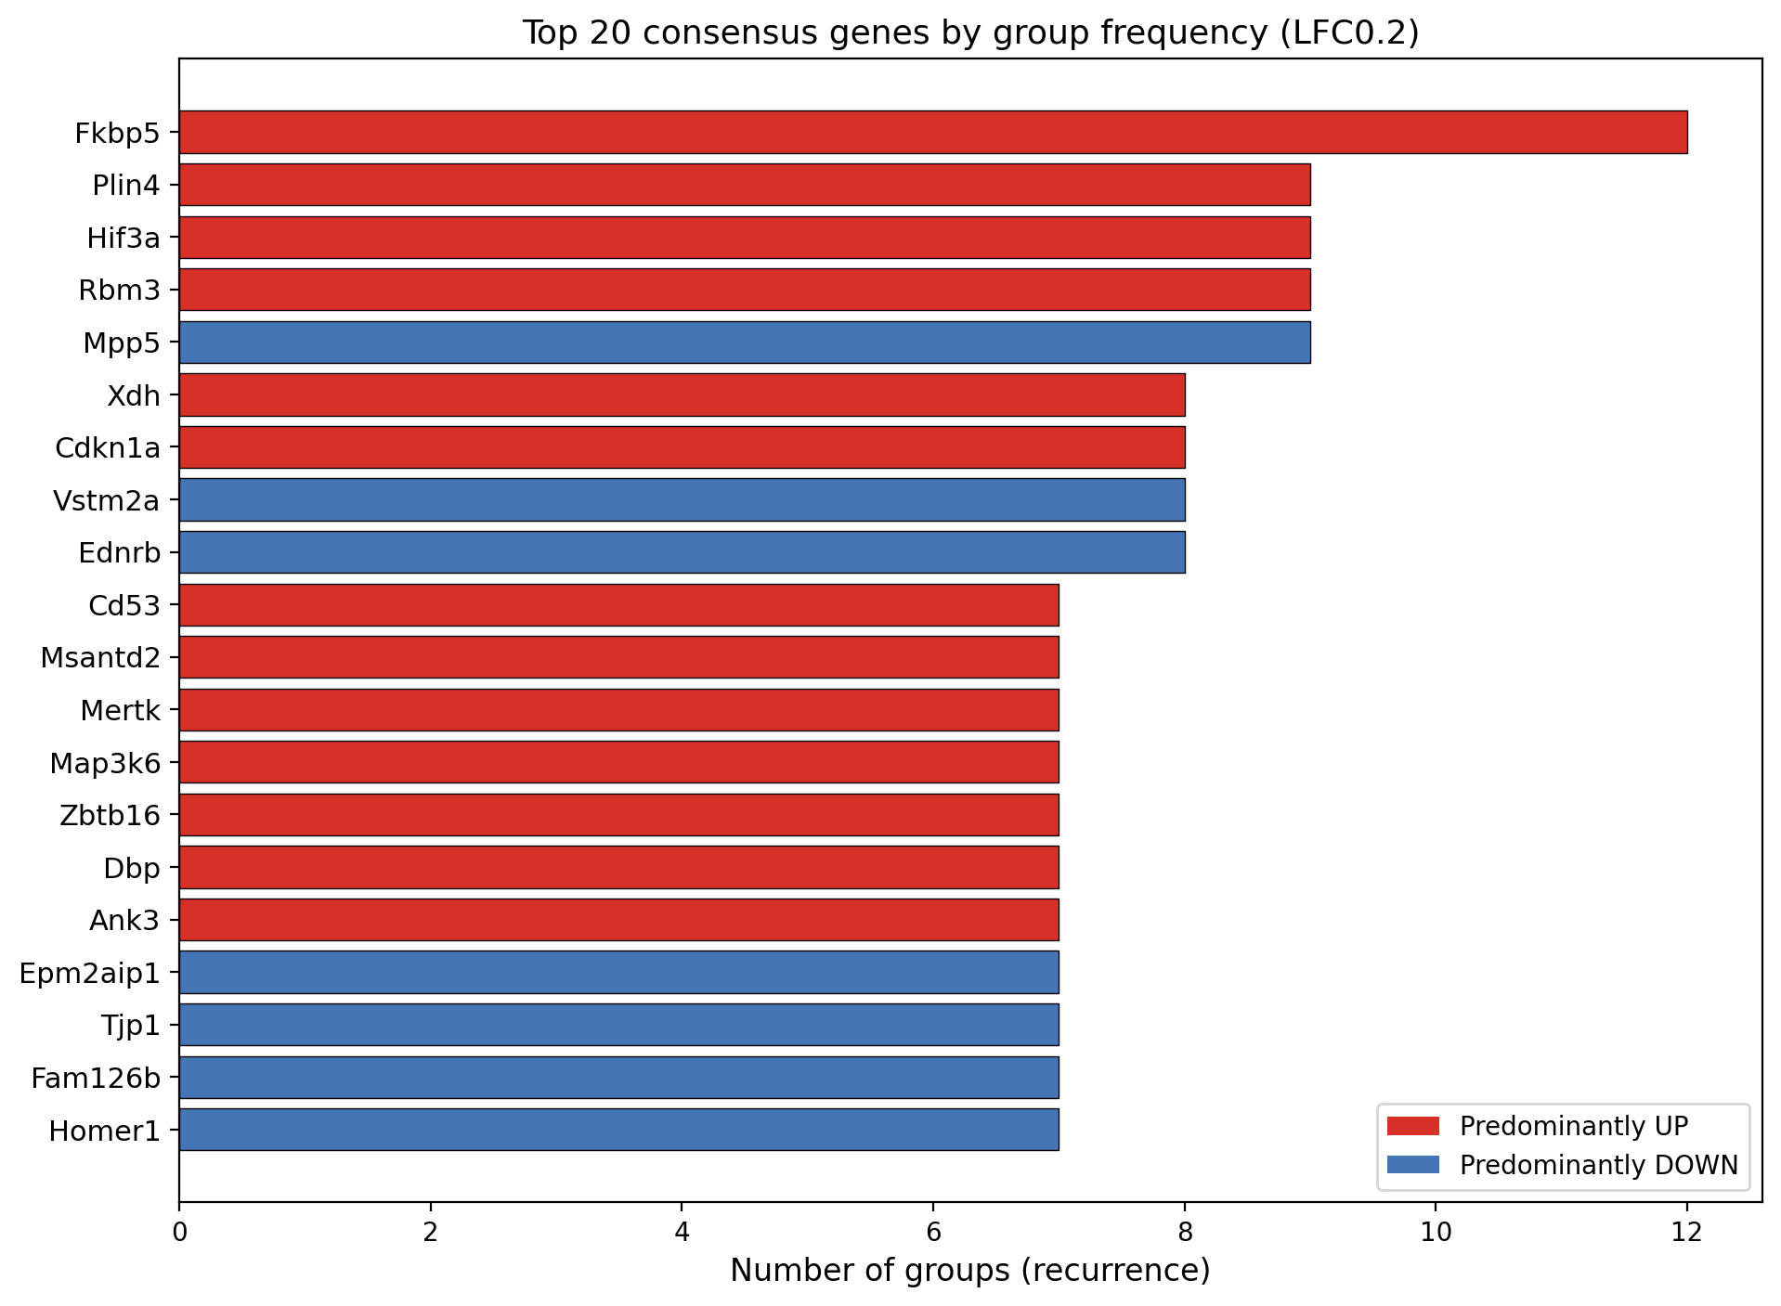
Figure 2. Top-20 consensus genes by recurrence, coloured by predominant direction (LFC0.2).
At the strict |log2FC| >= 1.0 threshold, 297 consensus genes remained; the most recurrent were Plin4, Nwd2, Cdkn1a, Zfp41, Myo1e, Szt2. Plin4 and Cdkn1a are consensus at both thresholds.

5. Functional Enrichment
Significant terms (padj < 0.05) at LFC0.2: GO BP 57, GO CC 48, GO MF 12, KEGG 43, Reactome 138. Leading terms per database:
Database | Enriched term | padj
GO BP | Translation | 3.8e-20
 | Macromolecule Biosynthetic Process | 2.1e-18
 | Peptide Biosynthetic Process | 6.9e-18
GO CC | Organelle Inner Membrane | 7.5e-17
 | Mitochondrial Inner Membrane | 4.9e-16
 | Mitochondrial Respiratory Chain Complex I | 3.4e-12
GO MF | RNA Binding | 9.4e-25
 | Oxidoreduction-Driven Active Transmembrane Transporter | 4.6e-12
 | NADH Dehydrogenase (Ubiquinone) Activity | 7.7e-11
KEGG | Ribosome | 5.7e-20
 | Parkinson disease | 1.2e-9
 | Huntington disease | 1.2e-9
Reactome | Influenza Infection | 3.7e-23
 | SRP-dependent Cotranslational Protein Targeting To Memb | 1.5e-21
 | Eukaryotic Translation Elongation | 1.8e-21
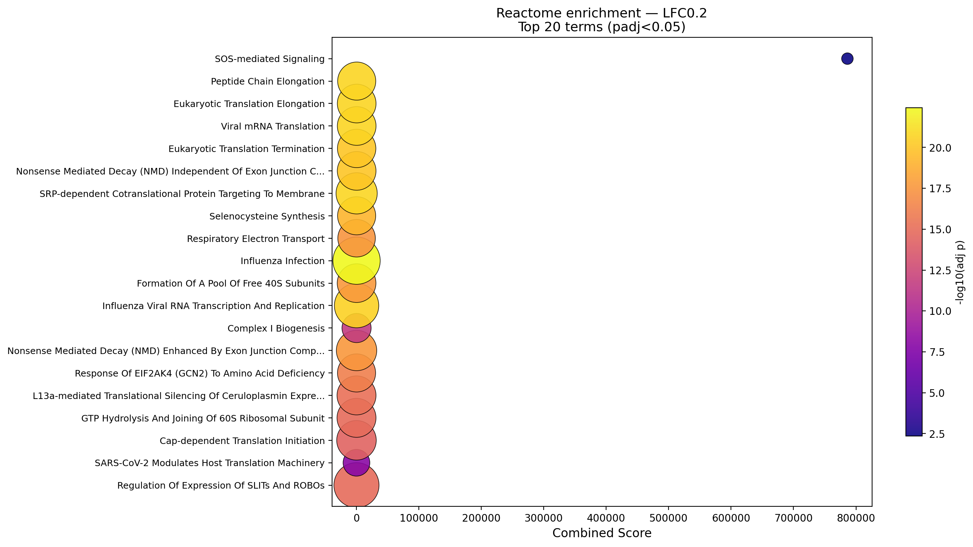
Figure 3. Reactome enrichment dot plot (LFC0.2): dot size = gene overlap, colour = -log10(padj). Top 20 terms.
Biological interpretation: the consensus signature is dominated by mitochondrial electron transport / oxidative phosphorylation (NADH dehydrogenase, respiratory chain complex I), cytoplasmic translation / ribosome, and neurodegeneration pathways (Parkinson, Huntington), consistent with GLP-1R agonists enhancing neuronal bioenergetics and proteostasis while modulating neuroinflammatory and survival signalling.

6. Concept-Network (Cnet) Analysis
Concept-network plots link consensus genes to their enriched terms (gene nodes coloured by mean log2FC; term squares coloured by database). A global consensus cnet and three mechanism-restricted cnets (Blood-Brain Barrier/MMP, JAK-STAT3 inflammatory, PI3K/Akt pro-survival) were generated at both thresholds, with enlarged gene nodes and thickened edges.
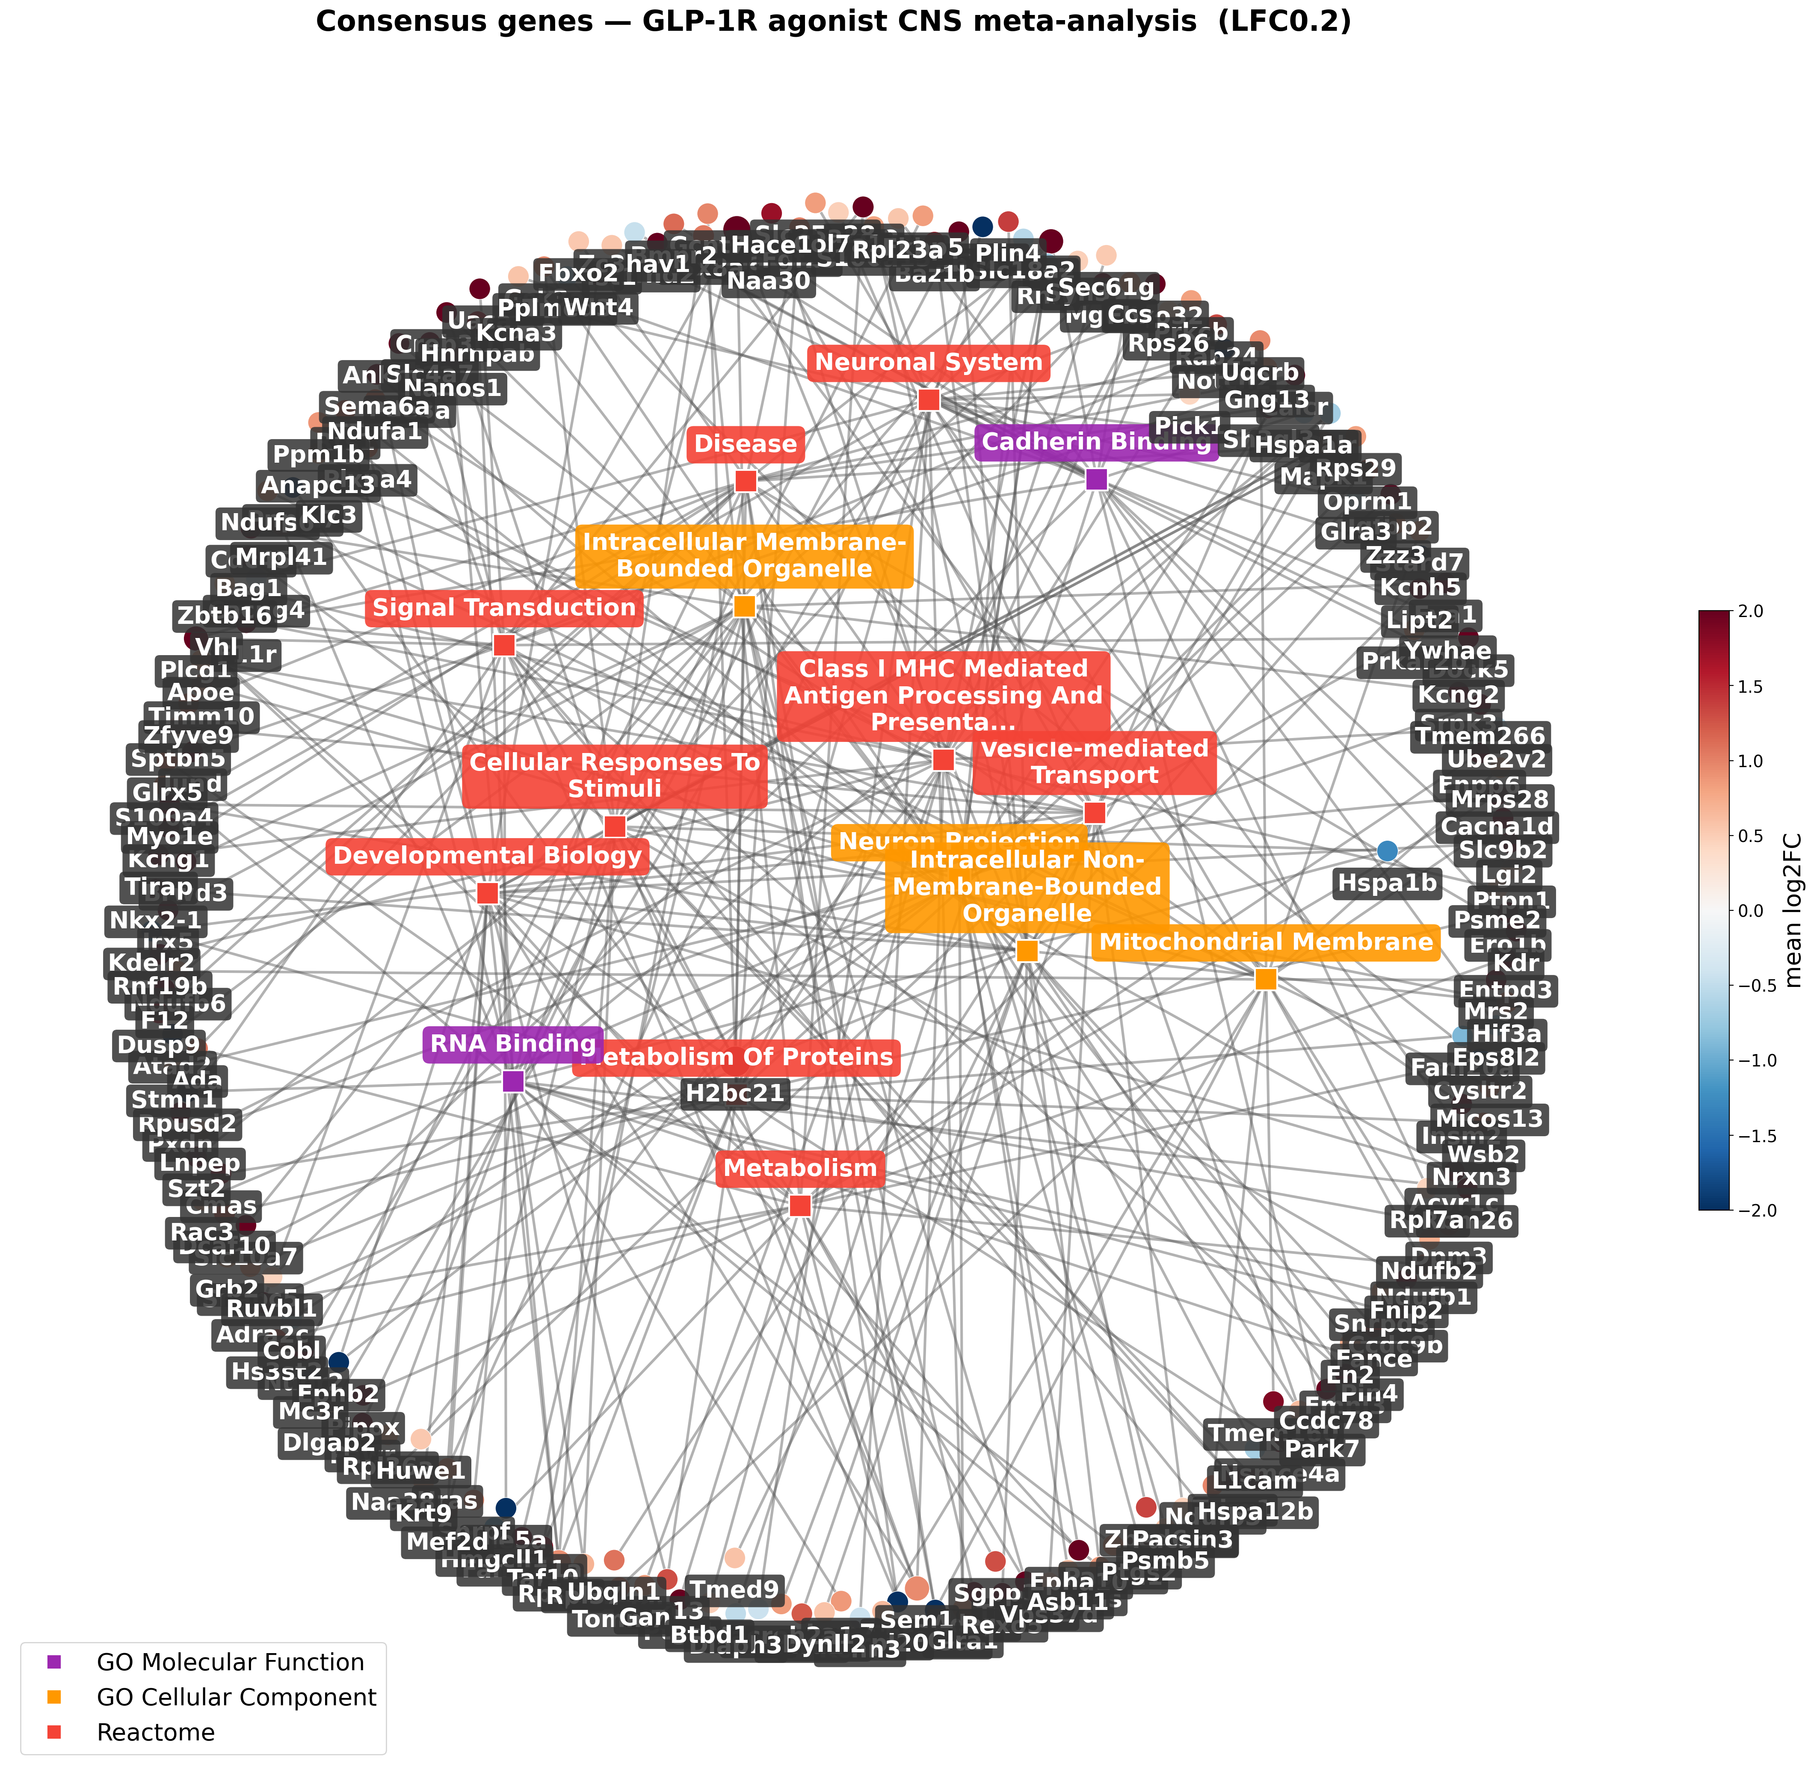
Figure 4. Consensus concept-network (LFC0.2): all consensus genes vs all enriched terms.
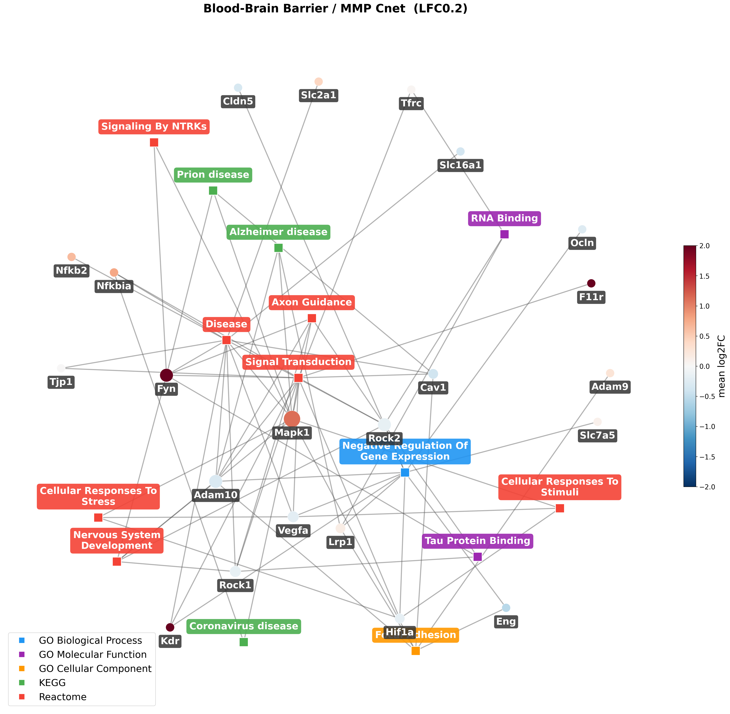
Figure 5. Blood-Brain-Barrier / MMP concept-network (LFC0.2).
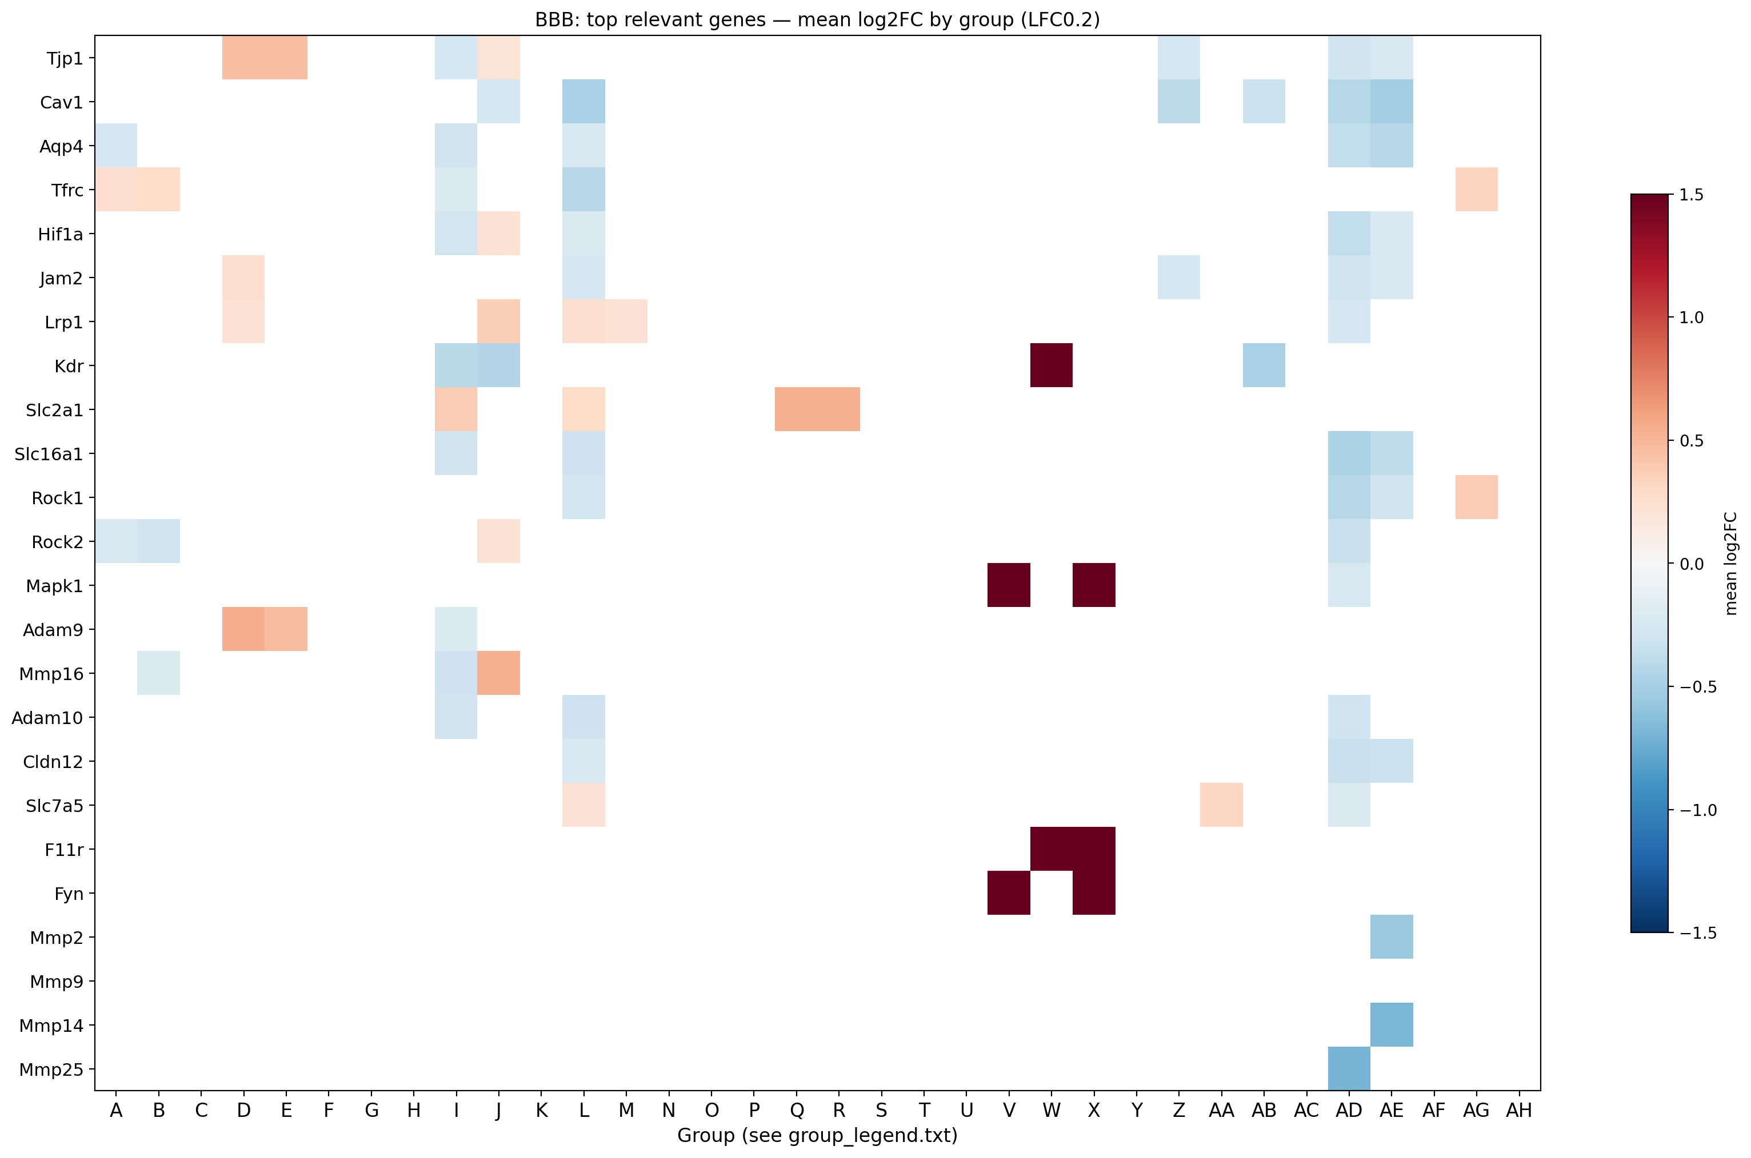
Figure 6. BBB mechanism heatmap (LFC0.2): top relevant genes plus the full MMP family (incl. Mmp9, shown explicitly).

7. Deliverables & Folder Map
All outputs are in 'Finalized Bioinformatics Workflow/': scripts/ (Python + R pipeline), Data/ (master DEG tables, consensus lists, enrichment, group legends), and Plots/ organized as Plots / [plot type] / [LFC0.2 | LFC1] / [PDF | PNG]. Every heatmap folder includes a group_legend.txt mapping the A/B/C... axis letters to groups. All plots are provided as transparent PNG and PDF.

8. Limitations & Notes
- Seven RNA-seq DEG files (4 from Accession 1, 1 from Accession 3, plus Accession 4 liraglutide and Accession 7) were locked (open in Excel / mid-sync) at run time and were excluded; re-running steps 02-07 folds them in automatically once released.
- The strict |log2FC| >= 1.0 threshold combined with the >=2-group recurrence filter leaves few significant enriched terms, so LFC1 dot/bar/cnet plots are intentionally sparse.
- Rat->mouse orthology uses symbol case-normalization (the reference-pipeline convention); array fold-changes can be large for low-expression probes and are robustly capped in heatmap colour scales (exact values annotated).

