GSEA Analysis — Interpretation
GLP-1R agonist CNS meta-analysis — figure-by-figure reading
What each GSEA graph shows and what it suggests

Background
Gene Set Enrichment Analysis (GSEA) was run across the 31 treatment-vs-control groups that have differentially expressed genes (the two empty groups - Accession 7 spinal cord and Accession 8 hippocampus LT_A_Ex - and AC710222, the Accession-6 CCK1R agonist that is NOT a GLP-1R agonist, are excluded). Unlike over-representation analysis, GSEA prerank uses the FULL ranked gene list per group, so it captures coordinated shifts even when few single genes pass significance. Two gene-set libraries were used: MSigDB Hallmark (50 well-curated pathways) and KEGG. Groups belong to four condition classes: Obesity (Acc 3-6, 16 groups), Aging (Acc 8, 9 groups), TBI (Acc 10-11, 5 groups) and Neurodegeneration (Acc 12, 1 group). The figures move from gene-level overlap, through per-group and per-condition pathway activity, to a single consolidated Hallmark summary.

Figure 1 - DEG overlap across conditions (Venn)
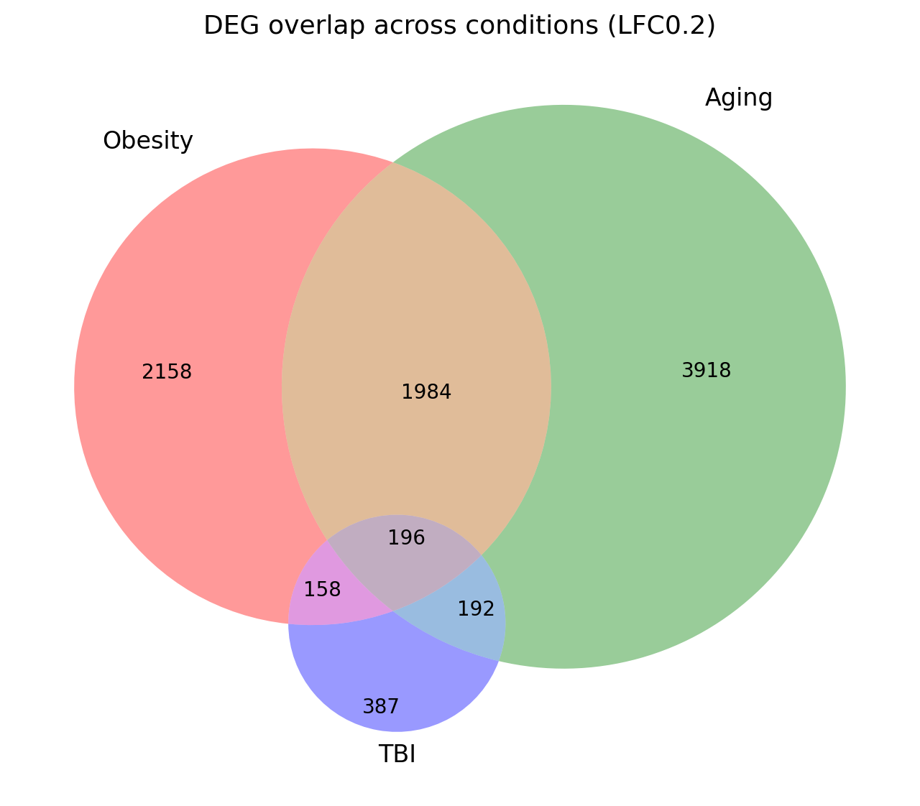
01_venn_gene_overlaps.png
What it shows
The union of significant DEGs in each condition class and their overlaps: Obesity 4,496 genes, Aging 6,290, TBI 933.
Interpretation
Obesity and Aging share a large common response - 1,984 genes are differentially expressed in both - indicating that GLP-1R agonism engages a substantial shared transcriptional program across metabolic and aging CNS models. TBI is smaller and more distinct (only 386 TBI-private genes), consistent with its acute-injury biology and fewer datasets. Critically, only 196 genes are shared by all three conditions: this small, condition-independent core represents the most generalisable GLP-1R-agonist CNS response, while the bulk of each condition's signature is context-specific. This is the rationale for the consensus (>=2 group) filtering used elsewhere in the project.

Figure 2 - DEG set intersections across accessions (UpSet)
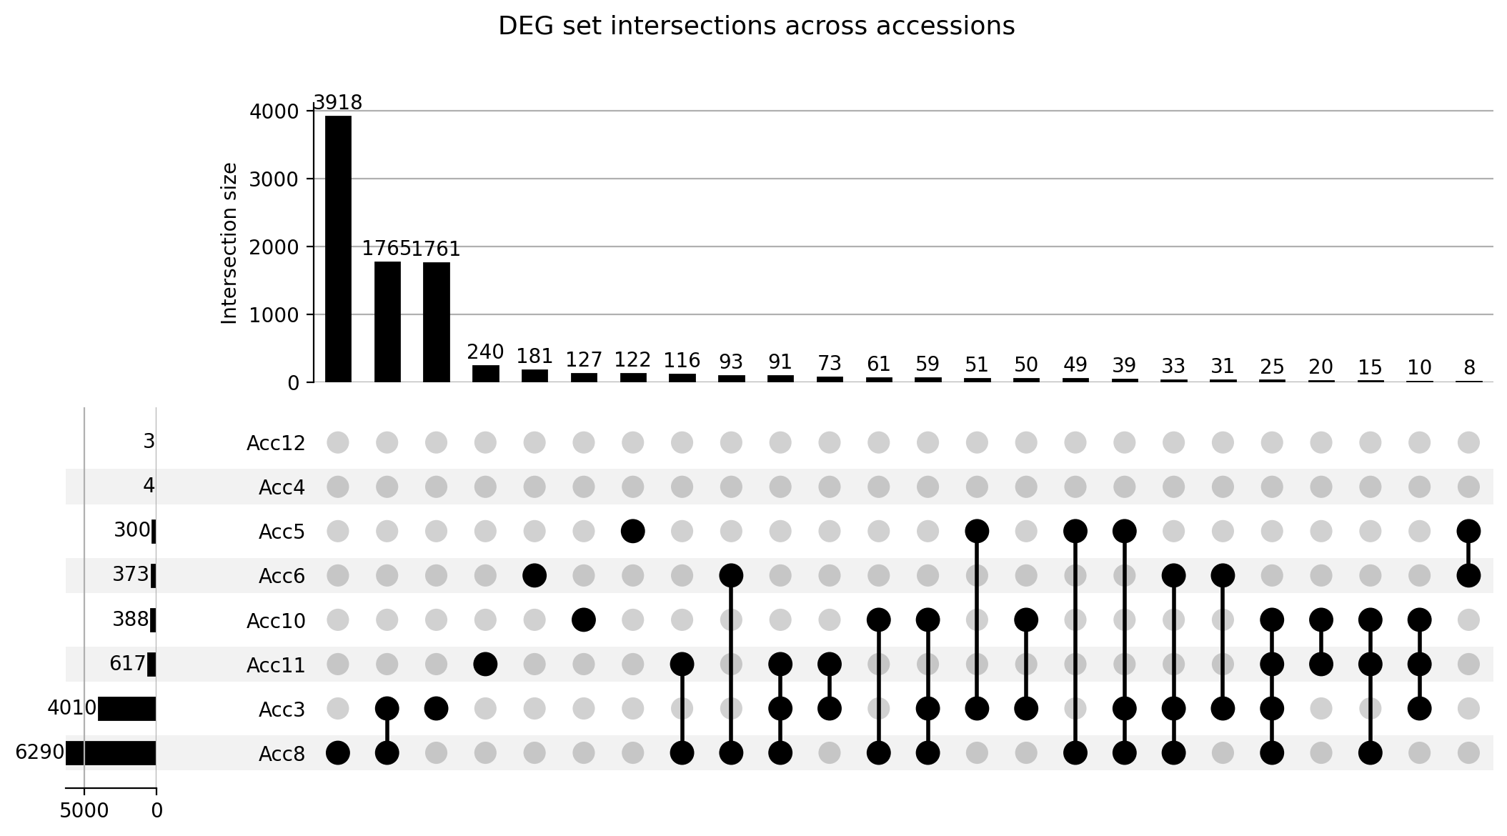
02_upset_all_accessions.png
What it shows
Per-accession DEG sets and the size of every intersection. DEG counts: Acc8 6,290, Acc3 4,010, Acc11 617, Acc6 373, Acc10 388, Acc5 300, Acc4 4, Acc12 3.
Interpretation
The signal is dominated by two deeply-powered datasets - Acc8 (aging) and Acc3 (obesity) - and most DEGs are accession-private (the single largest bar, 3,918 genes, is unique to Acc8). Pairwise and higher-order intersections fall off steeply, confirming that no single gene list generalises on its own and that cross-dataset agreement is the exception, not the rule. Two microarray-derived sets (Acc4, Acc12) contribute almost nothing at this threshold and should be read with caution. The practical message: meta-analytic conclusions must come from recurrent genes/pathways, not from any one accession.

Figure 3 - GSEA NES heatmap, Hallmark
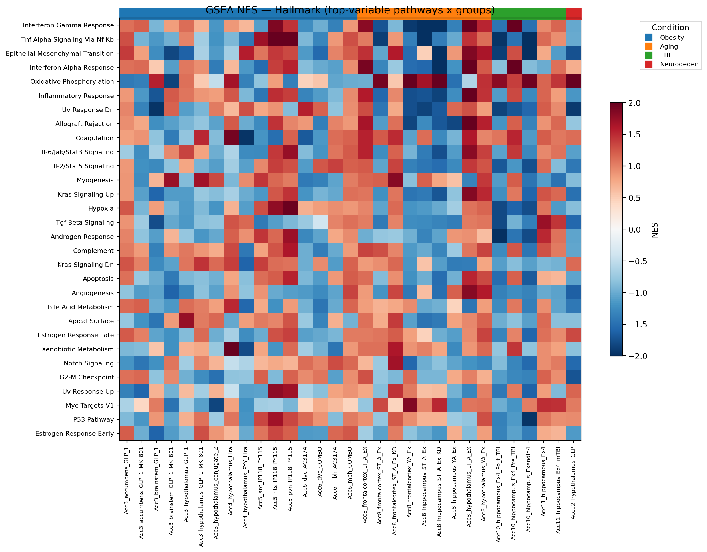
03_pathway_heatmap_hallmark.png
What it shows
Normalised Enrichment Score (NES) for the most variable Hallmark pathways (rows) in every group (columns; red = up, blue = down). The coloured bar above the columns marks the condition class.
Interpretation
Pathway activity is genuinely heterogeneous across groups and brain regions - there is no single uniform response - but coherent blocks are visible: a recurring band of oxidative-phosphorylation / metabolic up-regulation, and a band of inflammatory (TNF-alpha/NF-kB, interferon) and angiogenesis down-regulation that appears across many groups. The condition bar helps see that some blocks track condition (e.g. the neurodegeneration column behaves distinctly), which is quantified in Figures 6-7. The heterogeneity is a reminder that group-level GSEA, not a single pooled list, is what reveals these patterns.

Figure 4 - GSEA NES heatmap, KEGG
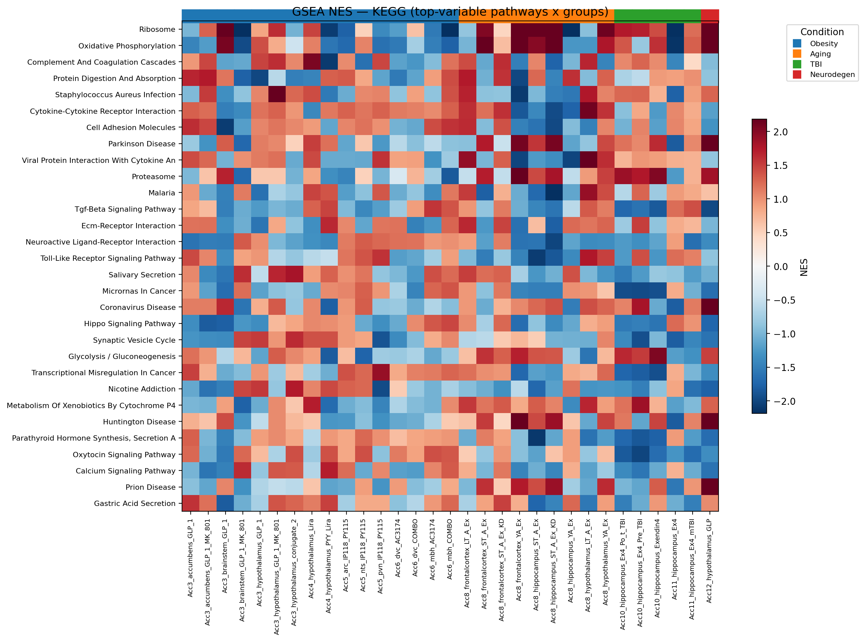
04_pathway_heatmap_kegg.png
What it shows
The same per-group NES heatmap for the most variable KEGG pathways.
Interpretation
KEGG echoes the Hallmark picture at finer granularity: metabolic and oxidative-phosphorylation pathways trend up in a subset of groups while immune/signalling pathways trend down, again with strong group-to-group variation. Because KEGG includes broad disease maps (neurodegeneration, infection) built largely from mitochondrial and proteostasis genes, those rows tend to move together with the energy-metabolism rows - useful context for the ORA results in Figure 6.

Figure 5 - ORA dot plot, Hallmark
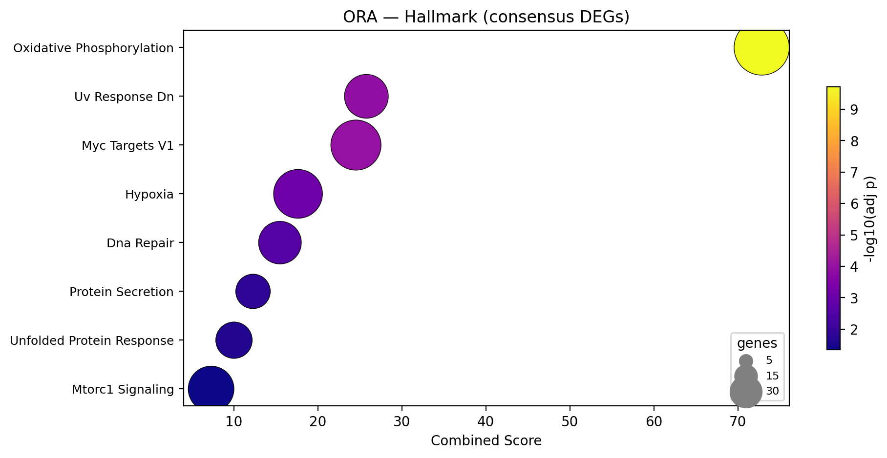
05_ora_dotplot_hallmark.png
What it shows
Over-representation of Hallmark pathways among the consensus DEGs (genes significant in >=2 groups). Dot size = number of overlapping genes, colour = -log10(adjusted p).
Interpretation
Oxidative Phosphorylation is overwhelmingly the top hit (92 of 200 pathway genes overlap, adj p = 2.5e-10) - the consensus DEGs are strongly enriched for mitochondrial energy machinery. The remaining significant terms (Myc Targets, Hypoxia, DNA Repair, UV-response-down, Protein Secretion, Unfolded Protein Response) point to coordinated biosynthesis, genome maintenance and proteostatic stress handling. This is a complementary, DEG-based confirmation of the GSEA signal: the recurrent genes are mitochondrial/metabolic and stress-adaptive.

Figure 6 - ORA dot plot, KEGG
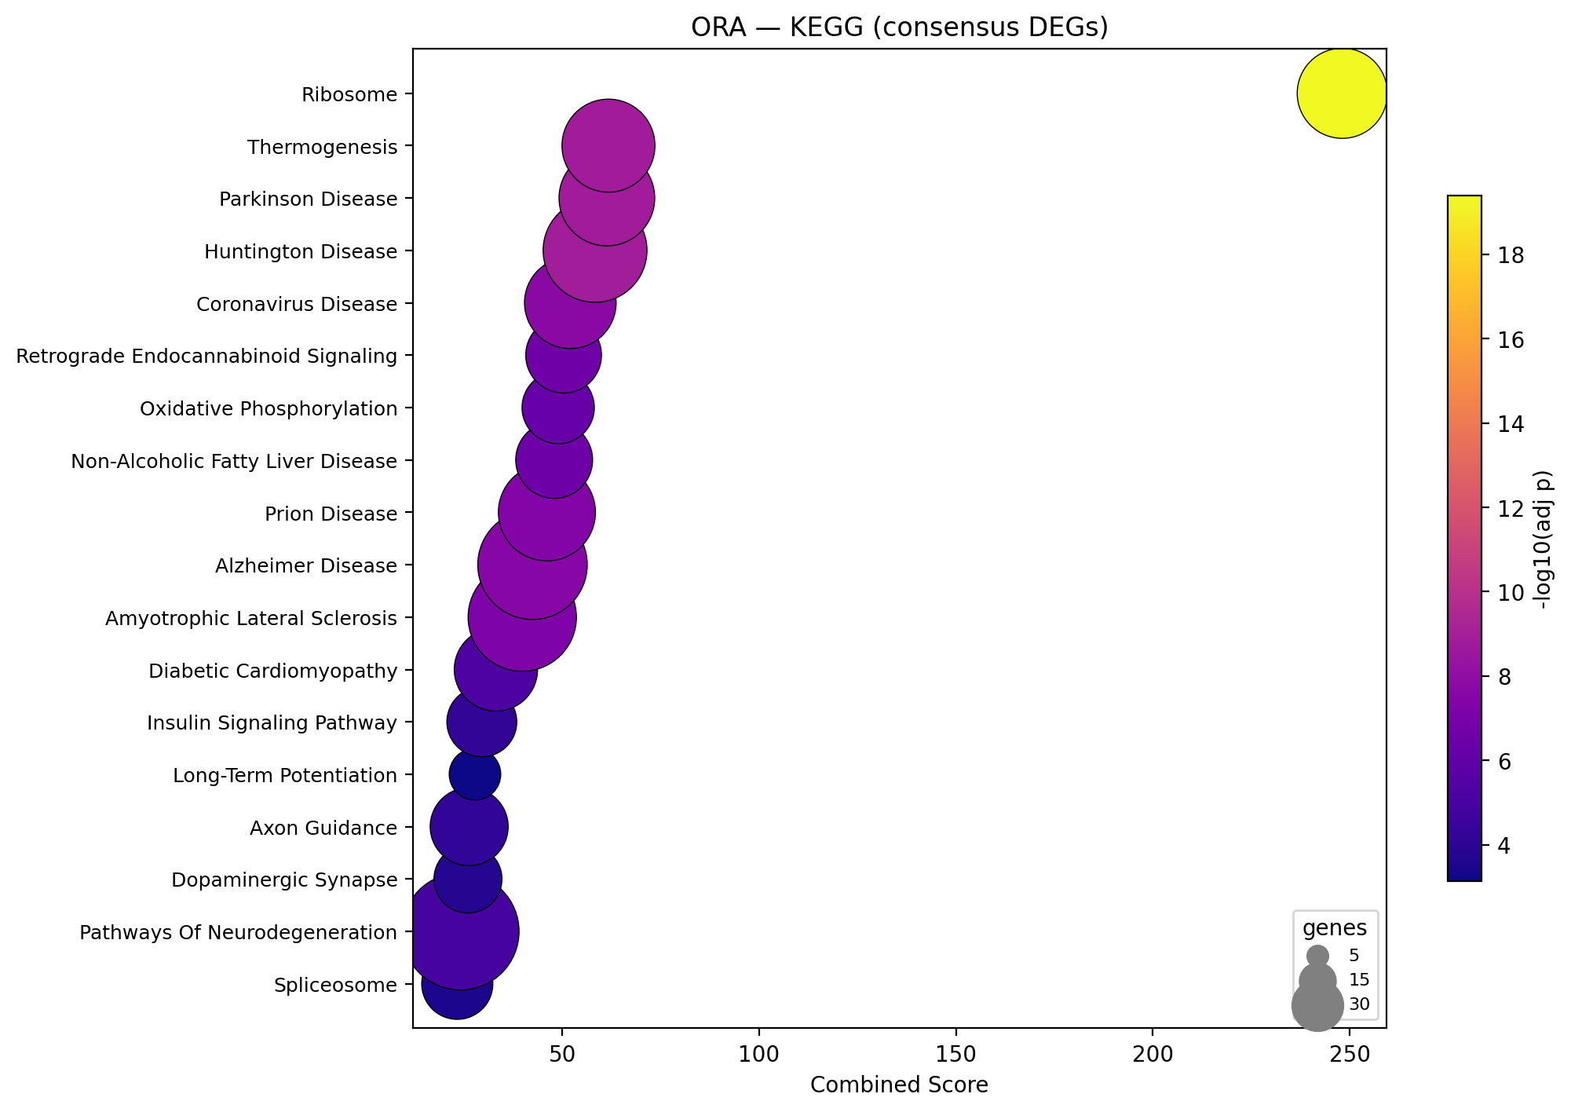
05b_ora_dotplot_kegg.png
What it shows
Over-representation of KEGG pathways among the consensus DEGs.
Interpretation
KEGG is led by Ribosome (95/158 genes, adj p = 5.7e-20) and Oxidative Phosphorylation/Thermogenesis, i.e. translation plus mitochondrial energy - the same axis seen throughout the project. The prominent neurodegeneration maps (Parkinson, Huntington, Prion disease) and Retrograde Endocannabinoid Signaling are largely composed of these mitochondrial and synaptic genes, so their enrichment reflects the shared bioenergetic machinery and positions the GLP-1R-agonist program as relevant to neurodegenerative contexts rather than implying those diseases per se.

Figure 7 - Cross-condition mean NES, Hallmark
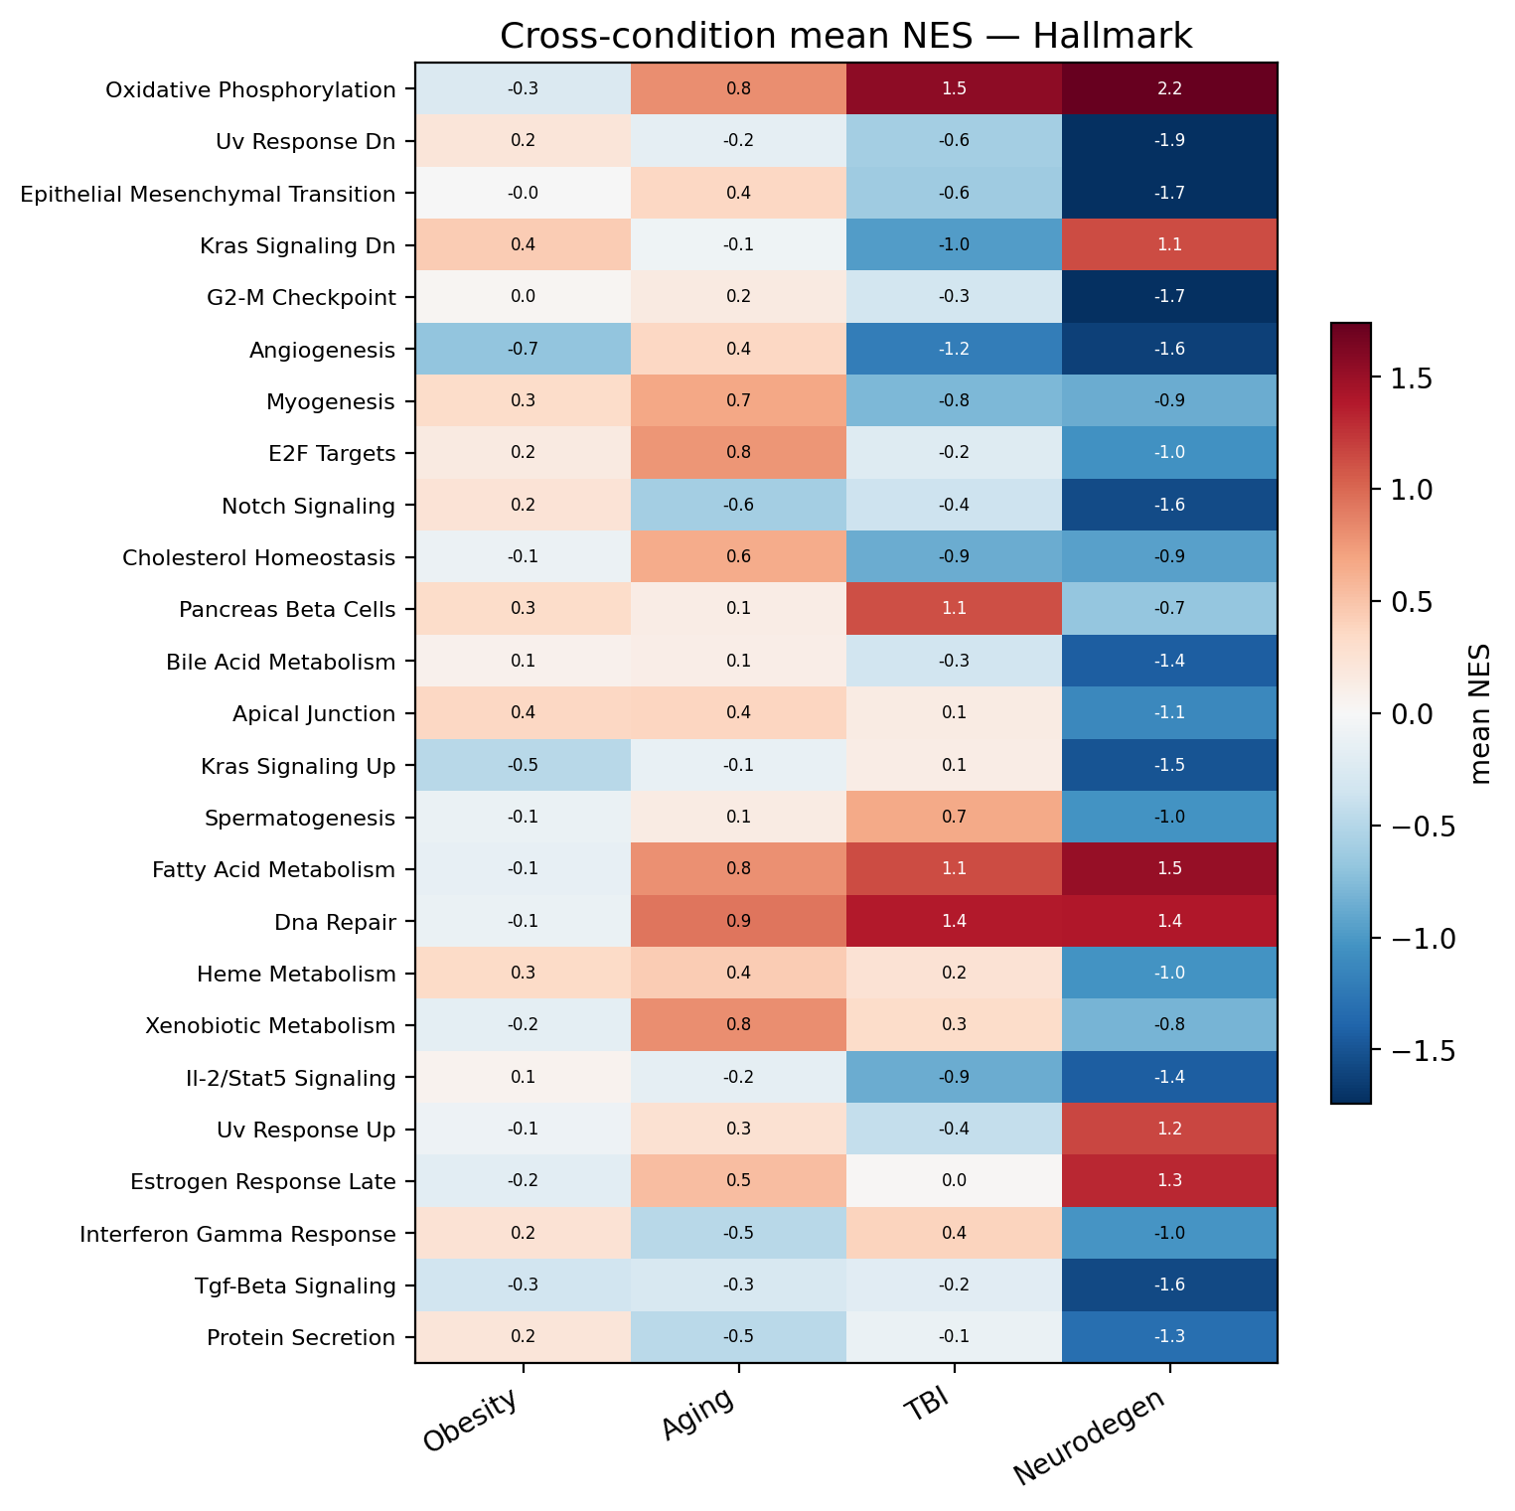
06_cross_condition_hallmark.png
What it shows
Mean Hallmark NES within each condition class (Obesity, Aging, TBI, Neurodegeneration) for the most divergent pathways, with the value printed in each cell.
Interpretation
This is where context-dependence becomes explicit. Oxidative Phosphorylation shows a clear gradient - roughly neutral in Obesity (-0.3), positive in Aging (+0.8), and strongly induced in TBI (+1.5) and Neurodegeneration (+2.2) - i.e. the mitochondrial boost is largest exactly where energy failure is central to the pathology. Angiogenesis is suppressed most in TBI and Neurodegeneration; and cell-cycle/proliferation programs (E2F targets, G2-M checkpoint) plus Notch signalling are markedly down in the Huntington (Neurodegeneration) model. The takeaway: GLP-1R agonists do not act identically everywhere - they appear to up-regulate bioenergetics and damp vascular/proliferative signalling most in injury and neurodegeneration.

Figure 8 - Cross-condition mean NES, KEGG
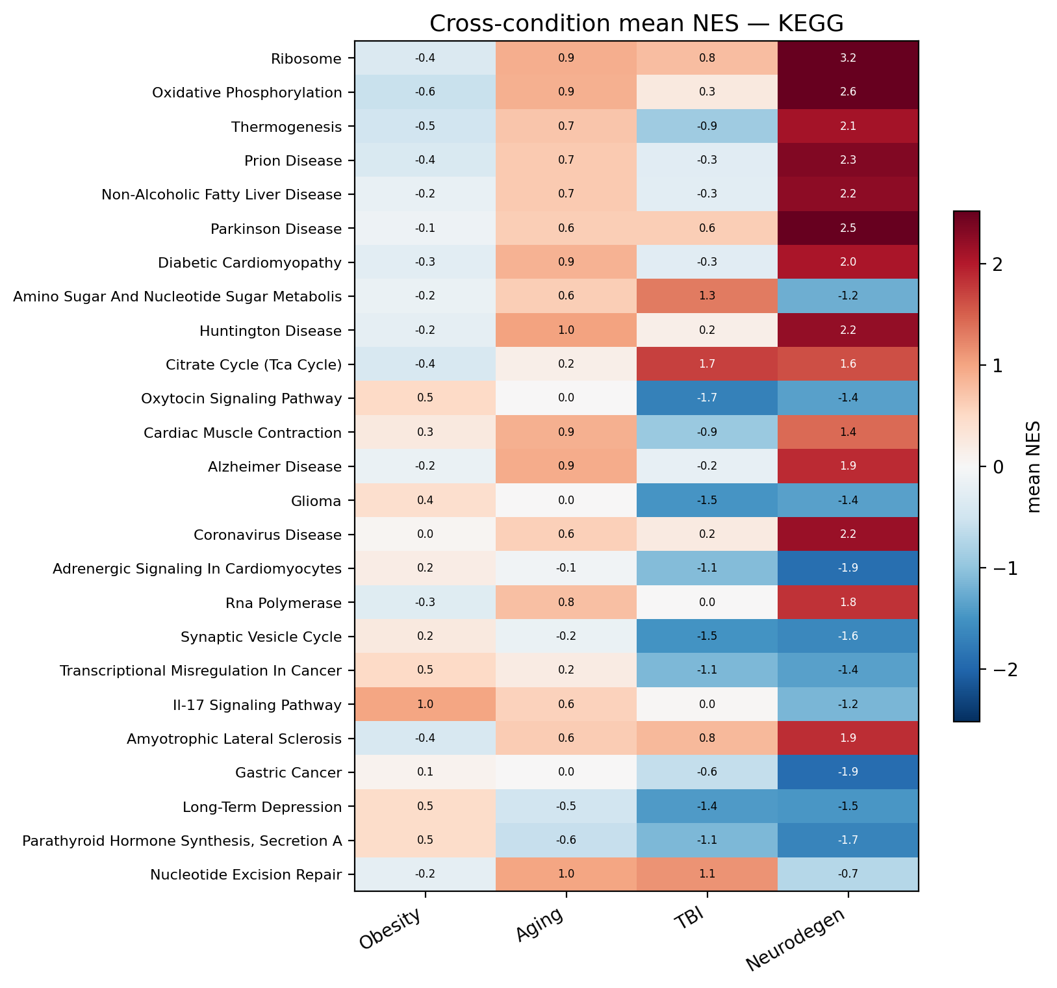
07_cross_condition_kegg.png
What it shows
The same per-condition mean-NES view for KEGG pathways.
Interpretation
KEGG reinforces the condition-specific reading: amino-acid and fatty-acid metabolism pathways tend to be induced (strongest in the injury/neurodegeneration classes), while growth-factor, Wnt and Hedgehog signalling and antigen processing trend down. The consistency between the Hallmark and KEGG cross-condition views increases confidence that the condition gradients are real biology rather than library artefacts.

Figure 9 - GSEA summary bubble, Hallmark
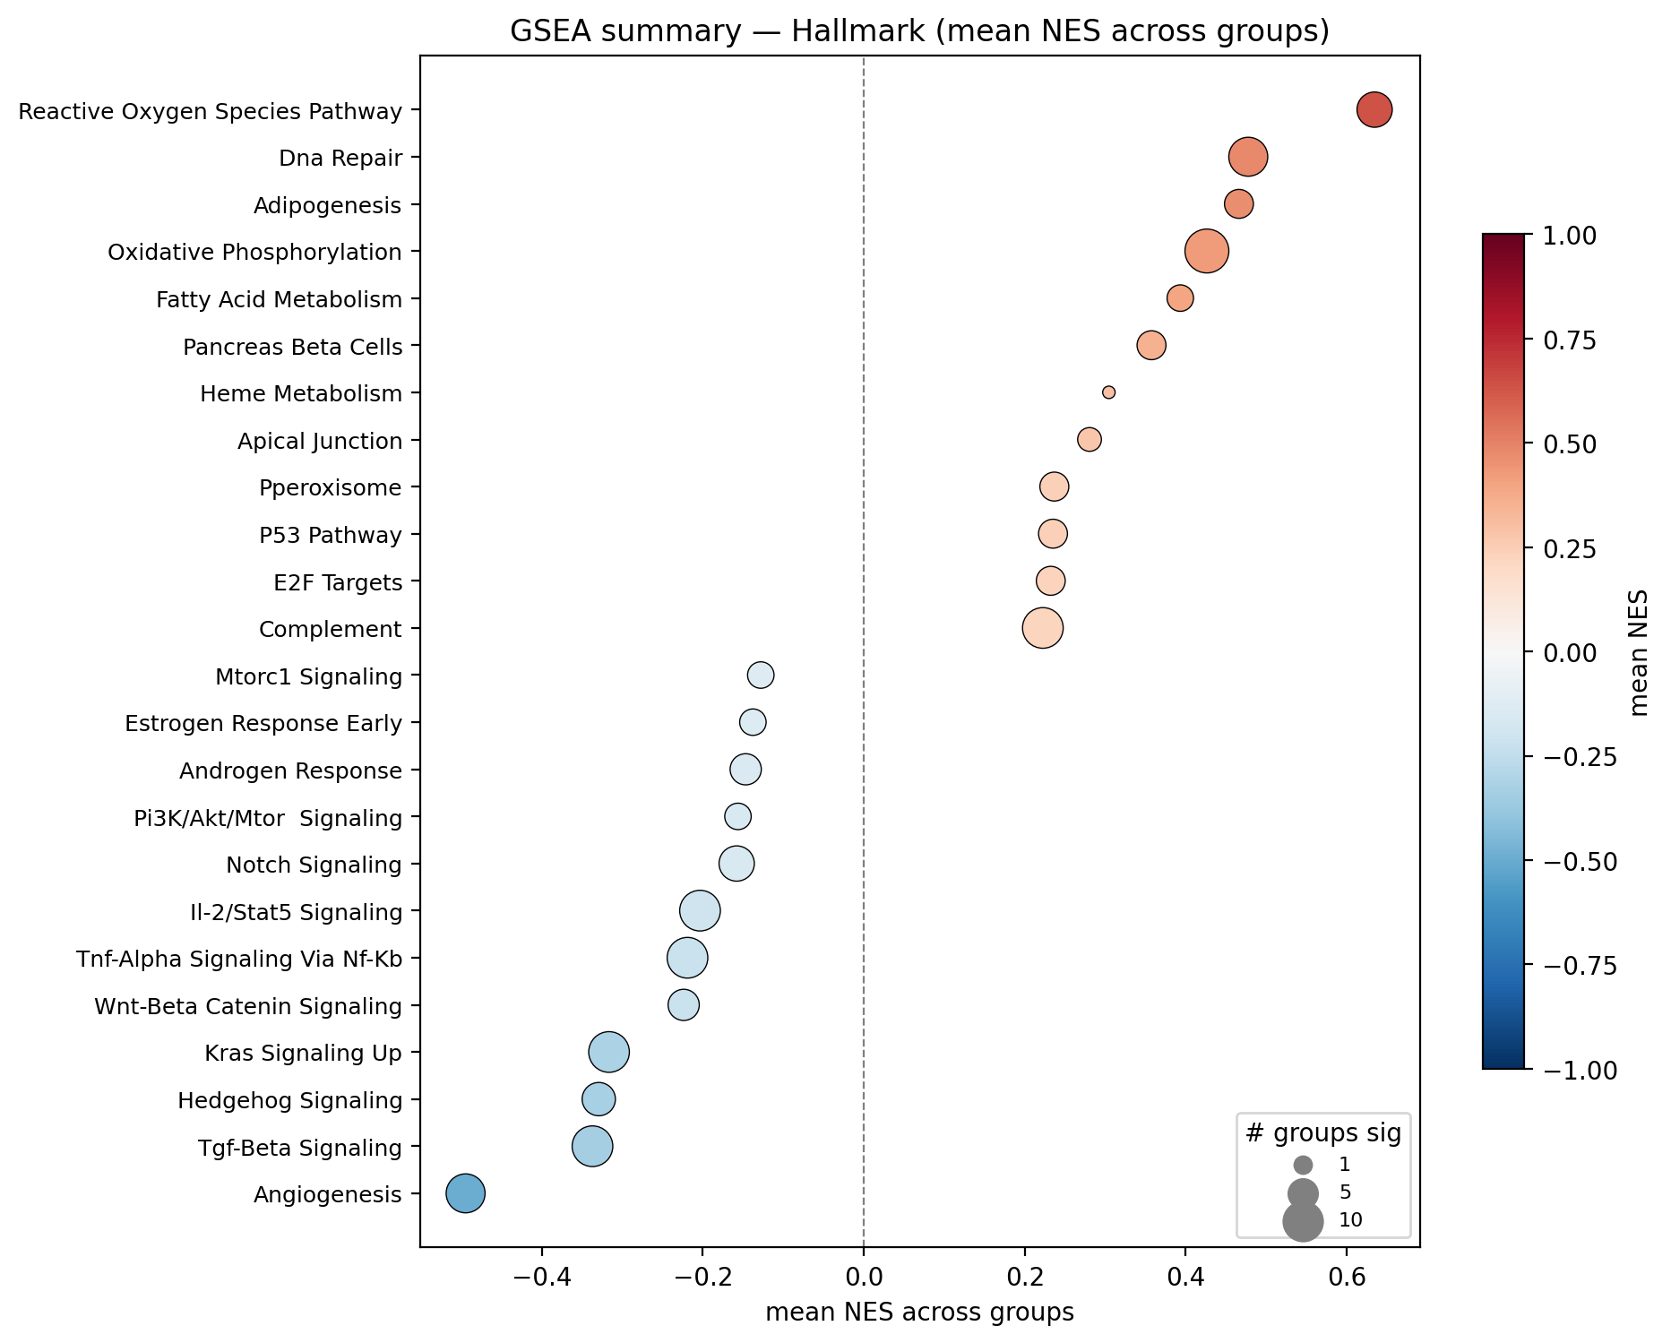
08_gsea_bubble_hallmark.png
What it shows
The consolidated signature: each Hallmark pathway's mean NES across all 33 groups (x-axis and colour), with bubble size = the number of groups in which it is individually significant.
Interpretation
Read left-to-right this is the single best summary of the GLP-1R-agonist CNS effect. Consistently UP: Reactive Oxygen Species pathway, Adipogenesis, DNA Repair (significant in 10/31 groups), Oxidative Phosphorylation (the most broadly significant, 13/31 groups), Fatty-Acid Metabolism, Pancreas Beta Cells and P53 - a pro-oxidative-metabolism and genome-maintenance program. Consistently DOWN: Angiogenesis (10/31), KRAS-up (11/31), TGF-beta (11/31), Hedgehog, Wnt/beta-catenin, PI3K/Akt/mTOR, Glycolysis and TNF-alpha/NF-kB (11/31) - i.e. reduced growth-factor, developmental and inflammatory signalling and a shift away from glycolysis toward oxidative metabolism. Together these define a coherent metabolic-rejuvenation, anti-inflammatory phenotype that matches the consensus DEG, c-net and GOplot findings.

Overall synthesis & caveats
Across all nine figures one signal dominates: GLP-1R / multi-agonist exposure shifts CNS cells toward oxidative (mitochondrial) metabolism and fatty-acid oxidation with active genome maintenance, while down-regulating inflammatory (TNF-alpha/NF-kB), angiogenic, and growth-factor (PI3K/Akt/mTOR, Wnt, TGF-beta, Hedgehog) signalling. The effect is strongest in injury and neurodegeneration contexts (Figs 7-8), and only a small gene core is truly condition-independent (Fig 1).
Caveats
- GSEA prerank used 100 permutations for speed: NES and rankings are robust, but FDR q-values are approximate - raise the permutation count for publication-grade statistics.
- Hallmark and KEGG are human libraries; mouse genes were matched by upper-casing the symbol (ortholog-by-name), a standard but imperfect approximation.
- Dataset power is uneven (Acc8 and Acc3 dominate; Acc4 and Acc12 contribute few DEGs), so per-condition means for the smaller classes - especially Neurodegeneration (a single dataset) - should be treated as indicative.

