***LAB-01***

***DATA STRUCTURES & ALGORITHM***

**TASKS:**

1. package lab;

public class Lab {

public static void main(String[] args) {

String str1 = "Hello";

String str2 = new String("World");

String str3 = new String("Java").intern();

String str4 = "Programming" + " Language";

String str5 = "DSA-Labs";

str1 = str1.concat("!");

str2 = str2.concat("!");

str3 = str3.concat("!");

str4 = str4.concat("!");

str5 = str5.concat("!");

System.out.println(str1);

System.out.println(str2);

System.out.println(str3);

System.out.println(str4);

System.out.println(str5);

}

}

**Output:**

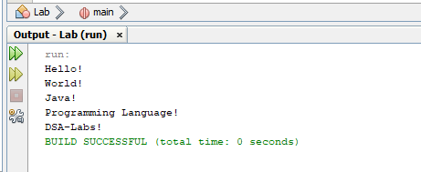

2. package lab;

public class DoubleToWrapper {

public static void main(String[] args) {

double primitiveDouble = 10.5;

Double wrapperDouble = Double.valueOf(primitiveDouble);

System.out.println("Primitive Double: " + primitiveDouble);

System.out.println("Wrapper Double: " + wrapperDouble);

}

}

Output:

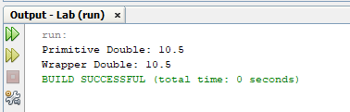

**HOME-TASKS:**

1. package lab;

import java.util.ArrayList;

public class AutoBoxing {

public static void main(String[] args) {

// Autoboxing

ArrayList<Integer> numbers = new ArrayList<>();

for (int i = 0; i < 10; i++) {

numbers.add(i); // int to Integer

}

// Displaying the numbers

for (Integer number : numbers) {

System.out.println("Number: " + number);

}

// Using wrapper class methods

Integer num1 = Integer.valueOf(10);

Integer num2 = Integer.valueOf("20");

// Performing operations

int sum = num1.intValue() + num2.intValue();

System.out.println("Sum: " + sum);

// Comparing two Integer objects

if (num1.equals(num2)) {

System.out.println("Numbers are equal.");

}

else {

System.out.println("Numbers are not equal.");

}

// Converting Integer to String

String numString = num1.toString();

System.out.println("Integer as String: " + numString);

}

}

Output:

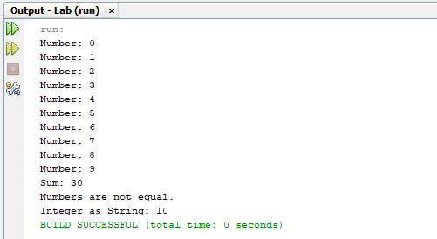

2. package lab;

import java.util.Scanner;

public class EvenOddCounter {

public static void main(String[] args) {

Scanner scanner = new Scanner(System.in);

System.out.print("Enter an integer: ");

int number = scanner.nextInt();

Integer num = number; // Autoboxing

int evenCount = 0;

int oddCount = 0;

while (num != 0) {

int digit = num % 10; // Unboxing

if (digit % 2 == 0) {

evenCount++;

} else {

oddCount++;

}

num /= 10; // Unboxing

}

System.out.println("Even digits count: " + evenCount);

System.out.println("Odd digits count: " + oddCount);

}

}

Output:

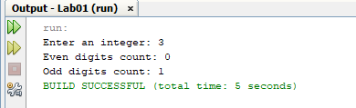

3. package lab;

import java.util.Scanner;

public class MathOperations {

public static void main(String[] args) {

Scanner scanner = new Scanner(System.in);

System.out.print("Enter a number: ");

Double number = scanner.nextDouble(); // Autoboxing

Double absoluteValue = Math.abs(number);

Double squareRoot = Math.sqrt(number);

Double power = Math.pow(number, 2); // Power of 2

System.out.println("Absolute Value: " + absoluteValue);

System.out.println("Square Root: " + squareRoot);

System.out.println("Power (number^2): " + power);

scanner.close();

}

}

Output:

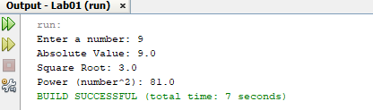

4. package lab;

import java.util.Scanner;

public class ReverseVowels {

public static void main(String[] args) {

Scanner scanner = new Scanner(System.in);

System.out.print("Enter a string: ");

String input = scanner.nextLine();

System.out.println("Reversed Vowels: " + reverseVowels(input));

}

public static String reverseVowels(String s) {

char[] chars = s.toCharArray();

int left = 0, right = s.length() - 1;

String vowels = "aeiouAEIOU";

while (left < right) {

if (vowels.indexOf(chars[left]) == -1) {

left++;

}

else if (vowels.indexOf(chars[right]) == -1) {

right--;

}

else {

char temp = chars[left];

chars[left] = chars[right];

chars[right] = temp;

left++;

right--;

}

}

return new String(chars);

}

}

Output:

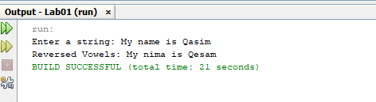

5. package lab;

import java.util.Scanner;

public class LongestWordFinder {

public static void main(String[] args) {

Scanner scanner = new Scanner(System.in);

System.out.println("Enter a sentence:");

String sentence = scanner.nextLine();

String[] words = sentence.split(" ");

String longestWord = "";

for (String word : words) {

if (word.length() > longestWord.length()) {

longestWord = word;

}

}

System.out.println("The longest word is: " + longestWord);

scanner.close();

}

}

Output:

