***LAB-03***

***DATA STRUCTURES & ALGORITHM***

**TASKS:**

1. package lab03;

import java.util.Scanner;

public class DescendingSequence {

public static void main(String[] args) {

Scanner scanner = new Scanner(System.in);

System.out.print("Enter an integer value (K): ");

int K = scanner.nextInt();

// Call the recursive method

printDescending(K);

}

// Recursive method to print integers from K down to 0

public static void printDescending(int n) {

// Base case: when n is less than 0, stop recursion

if (n < 0) {

return;

}

// Print the current number

System.out.print(n + " ");

// Recursive call with n decremented by 1

printDescending(n - 1);

}

}

**Output:**

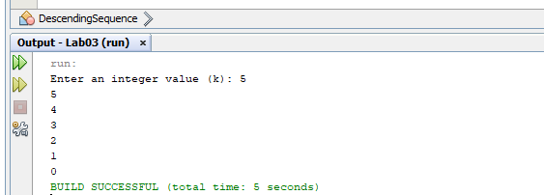

2. package lab03;

public class ReverseName {

public static void main(String[] args) {

String fullName = "Qasim Raza";

String reversedName = reverse(fullName);

System.out.println("Name: "+Name);

System.out.println("Reversed Name: " + reversedName);

}

// Recursive method to reverse a string

public static String reverse(String name) {

// Base case: if the string is empty or has one character

if (name.isEmpty()) {

return name;

}

// Recursive case: return last character + reverse of the remaining string

return name.charAt(name.length() - 1) + reverse(name.substring(0, name.length() - 1));

}

}

**Output:**

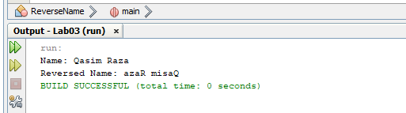

3. package lab03;

import java.util.Scanner;

public class SumRecurrsion {

// Method to calculate the sum of numbers from 1 to N

public static int sum(int n) {

// Base case: if N is 0, return 0

if (n == 0) {

return 0;

}

// Recursive case: N + sum of numbers from 1 to N-1

return n + sum(n - 1);

}

public static void main(String[] args) {

Scanner scanner = new Scanner(System.in);

// Prompt user for input20

System.out.print("Enter a positive integer N: ");

int N = scanner.nextInt();

// Calculate the sum and display the result

int result = sum(N);

System.out.println("The sum of numbers from 1 to " + N + " is: " + result);

scanner.close();

}

}

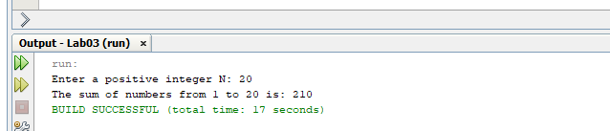**Output:**

4. public class ArraySum {

public static void main(String[] args) {

int[] array = {1, 2, 3, 4, 5};

int sum = calculateSum(array, array.length);

System.out.println("Sum of array elements: " + sum);

}

public static int calculateSum(int[] array, int n) {

if (n <= 0) {

return 0;

}

return calculateSum(array, n - 1) + array[n - 1];

}

}

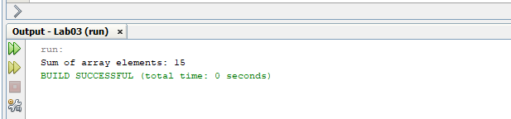**Output:**

5. package lab03;

import java.util.Scanner;

public class Factorial {

public static void main(String[] args) {

Scanner scanner = new Scanner(System.in);

System.out.print("Enter a positive integer: ");

int n = scanner.nextInt();

System.out.println("Factorial of " + n + " is: " + factorial(n));

scanner.close();

}

public static int factorial(int n) {

if (n == 0) {

return 1;

} else {

return n * factorial(n - 1);

}

}

}

**Output:**

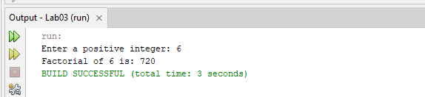

6. package lab03;

import java.util.Scanner;

public class CountDigits {

public static void main(String[] args) {

Scanner scanner = new Scanner(System.in);

System.out.print("Enter a number: ");

int number = scanner.nextInt();

int count = countDigits(number);

System.out.println("Number of digits: " + count);

}

public static int countDigits(int number) {

if (number < 10) {

return 1;

}

return 1 + countDigits(number / 10);

}

}

**Output:**

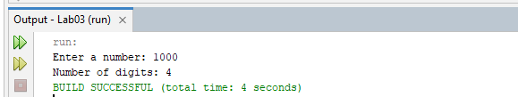

**HOME-TASKS:**

1. package lab03;

import java.util.HashMap;

public class Fibonacci {

private static HashMap<Integer, Long> memo = new HashMap<>();

public static void main(String[] args) {

int n = 10; // Change this value to find the N-th term

System.out.println("The " + n + "-th term in the Fibonacci series is: " + fibonacci(n));

}

public static long fibonacci(int n) {

if (n <= 1) {

return n;

}

if (memo.containsKey(n)) {

return memo.get(n);

}

long result = fibonacci(n - 1) + fibonacci(n - 2);

memo.put(n, result);

return result;

}

}

**Output:**

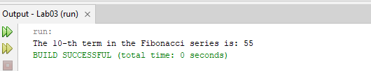

2. package lab03;

import java.util.Scanner;

public class countsdigits {

public static void main(String[] args) {

Scanner scanner = new Scanner(System.in);

System.out.print("Enter a number: ");

int number = scanner.nextInt();

int count = countDigits(number);

System.out.println("Number of digits: " + count);

}

public static int countDigits(int number) {

if (number < 10) {

return 1;

} else {

return 1 + countDigits(number / 10);

}

}

}

**Output:**

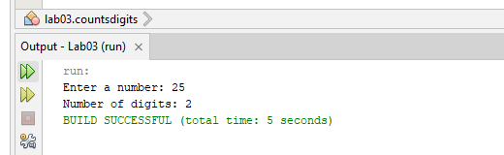

3. package lab03;

import java.util.Scanner;

public class PalindromeChecker {

public static void main(String[] args) {

Scanner scanner = new Scanner(System.in);

System.out.print("Enter a string: ");

String input = scanner.nextLine();

String reversed = new StringBuilder(input).reverse().toString();

if (input.equals(reversed)) {

System.out.println("YES");

} else {

System.out.println("NO");

}

scanner.close();

}

}

**Output:**

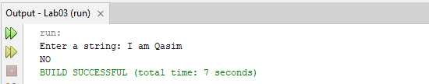

4. package lab03;

import java.util.Scanner;

public class GCD {

public static void main(String[] args) {

Scanner scanner = new Scanner(System.in);

System.out.print("Enter the first number: ");

int a = scanner.nextInt();

System.out.print("Enter the second number: ");

int b = scanner.nextInt();

int gcd = findGCD(a, b);

System.out.println("The GCD of " + a + " and " + b + " is: " + gcd);

}

public static int findGCD(int a, int b) {

if (b == 0) {

return a;

}

return findGCD(b, a % b);

}

}

**Output:**

