Name: Muhammad Daniyal
Class: CS-F
Roll No. 23i-0579

ANALYSIS Between AI generated Websites

Gemini Website:

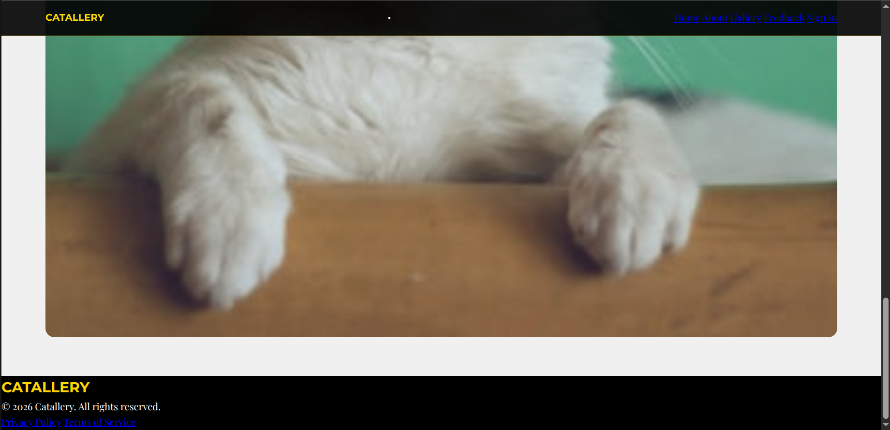
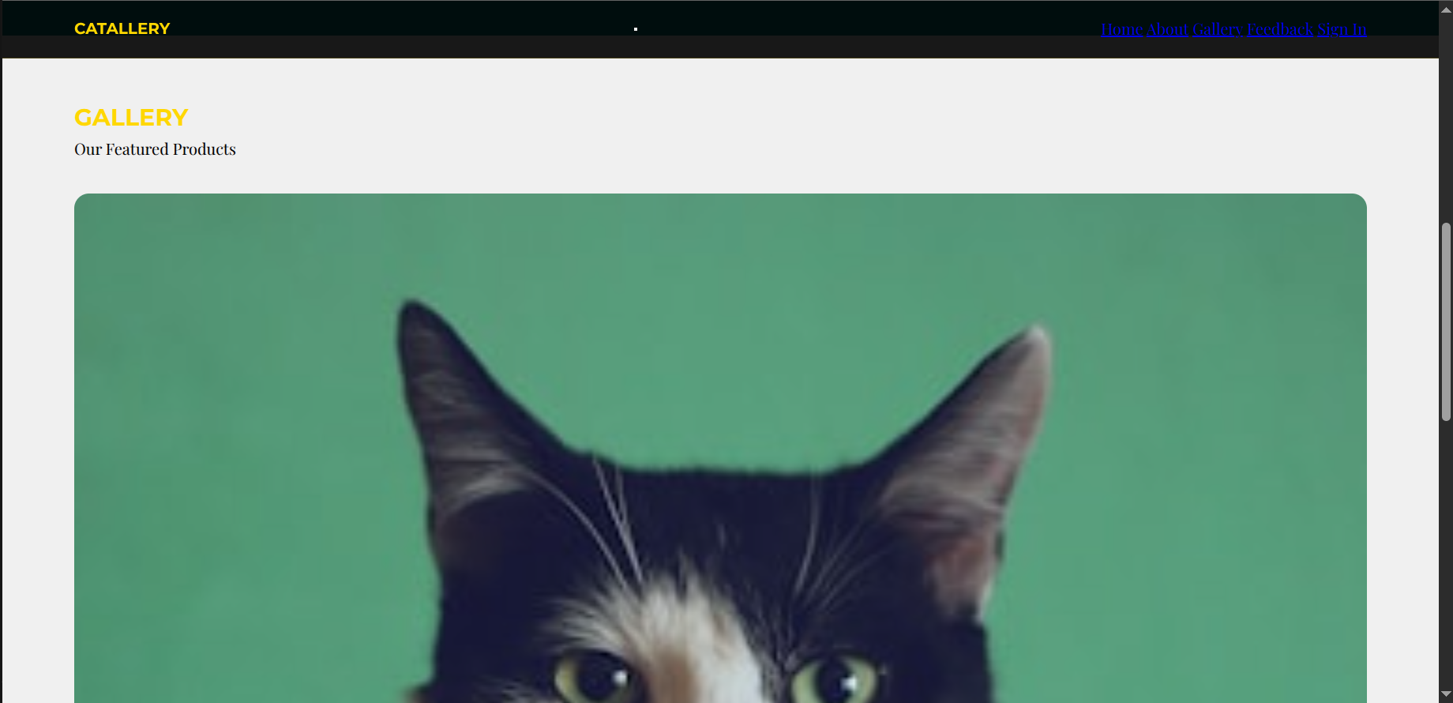
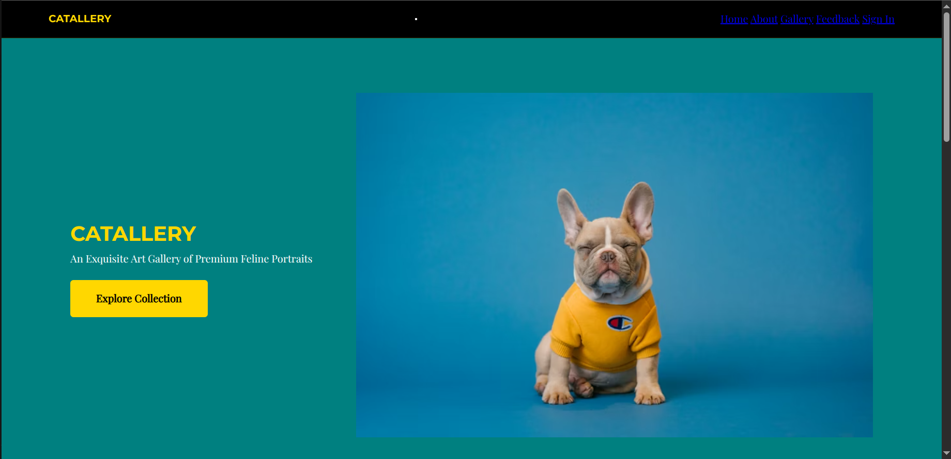

Grok Website:

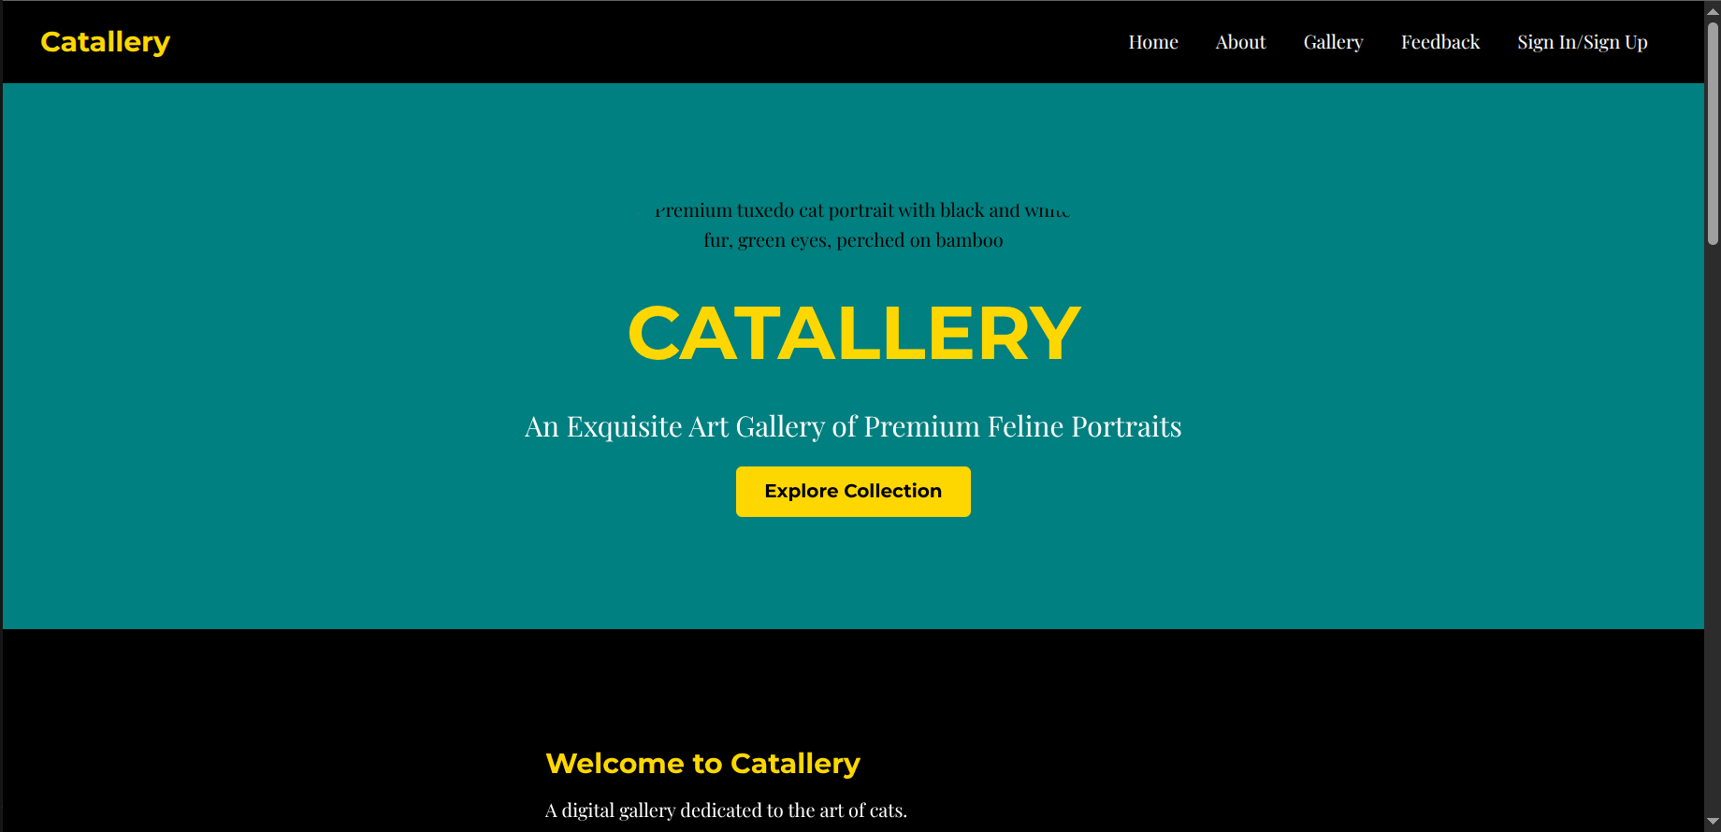
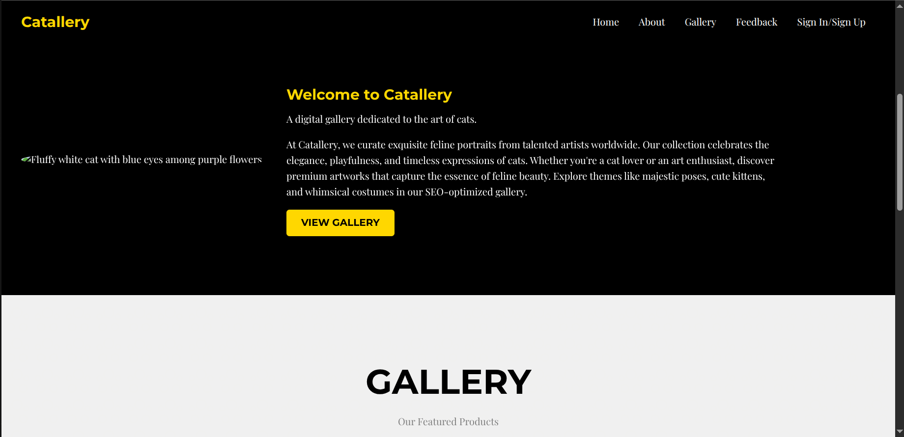

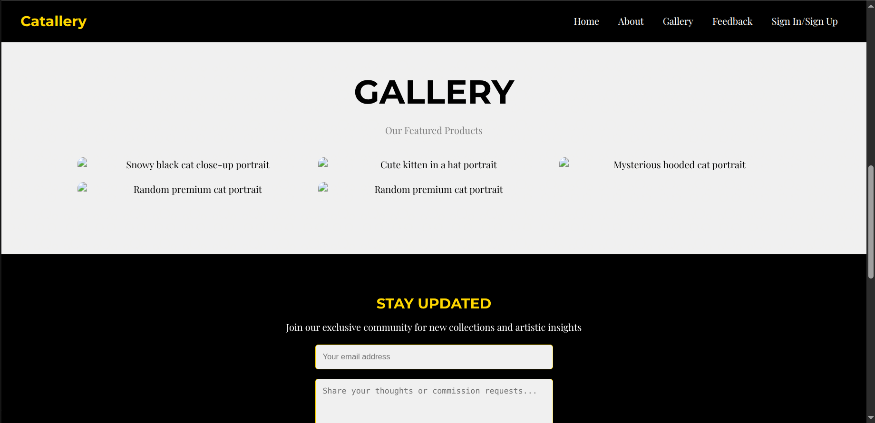
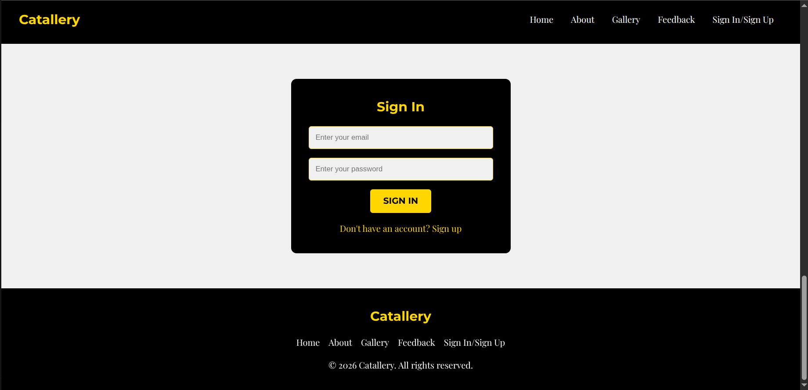

DeepSeek Website:

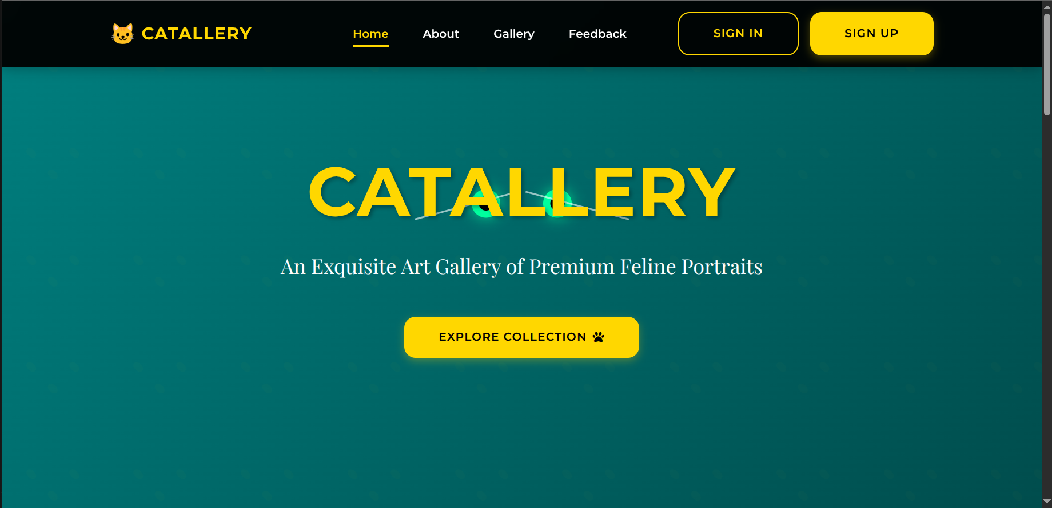

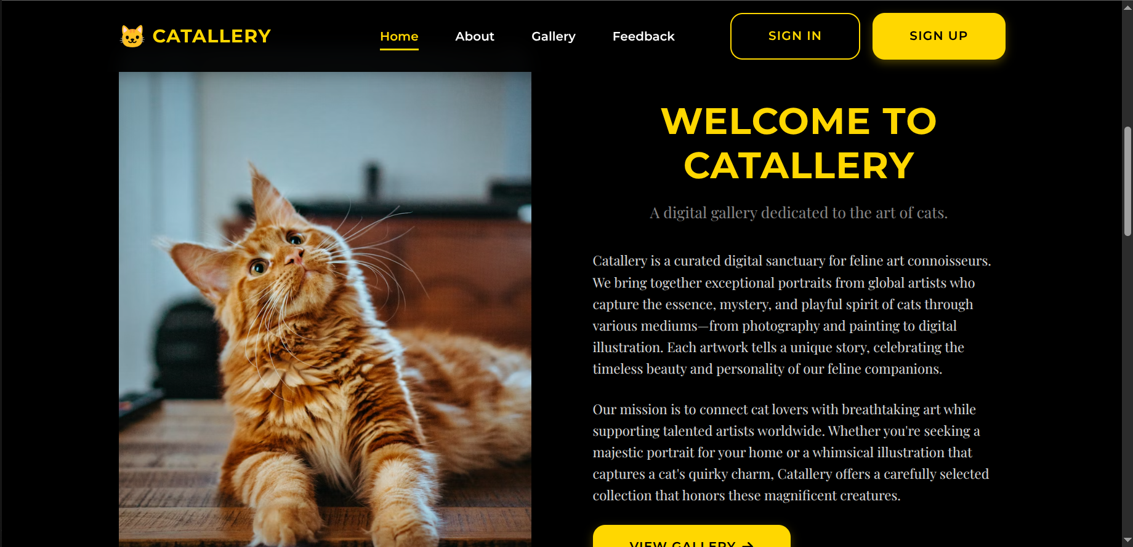

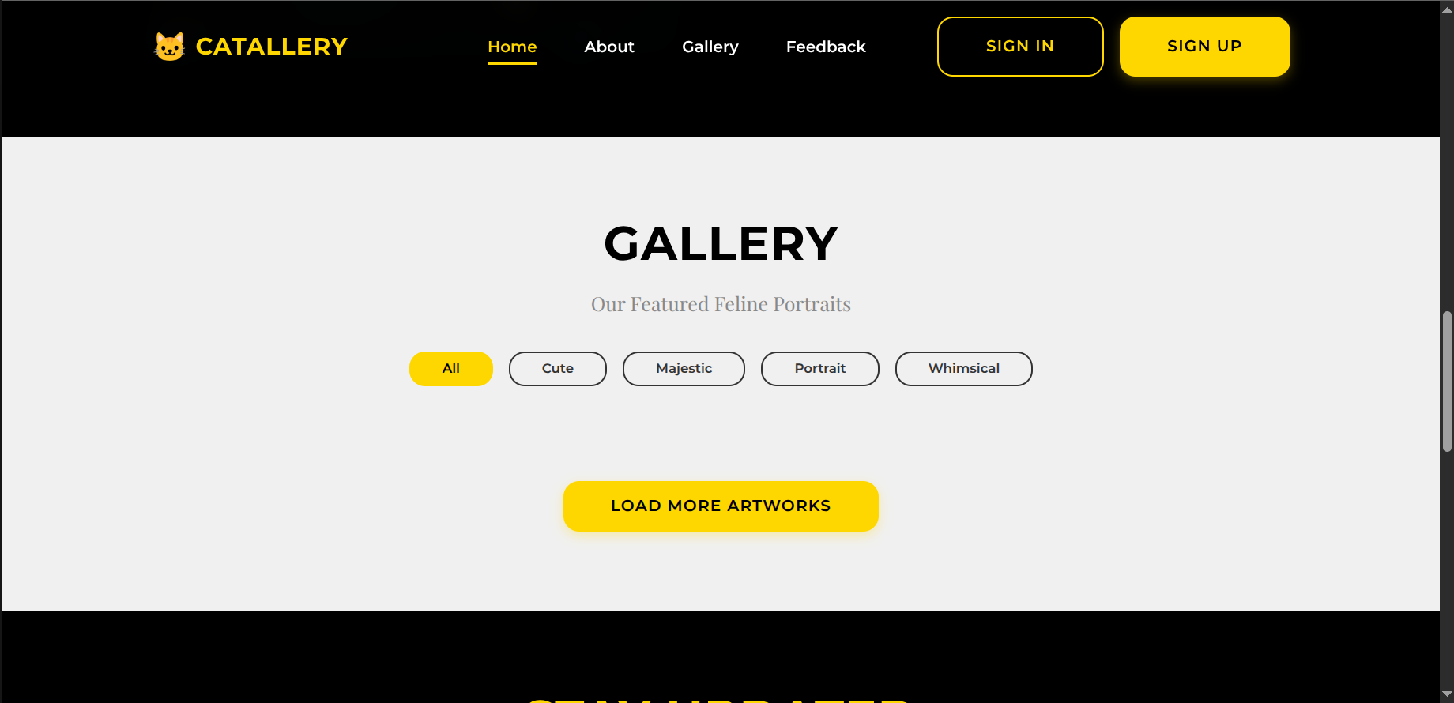
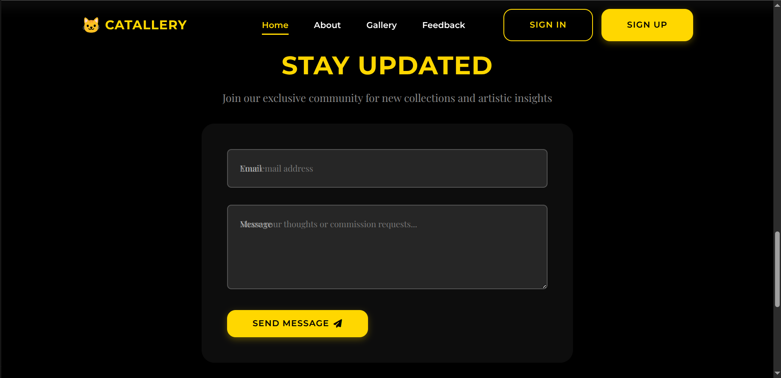
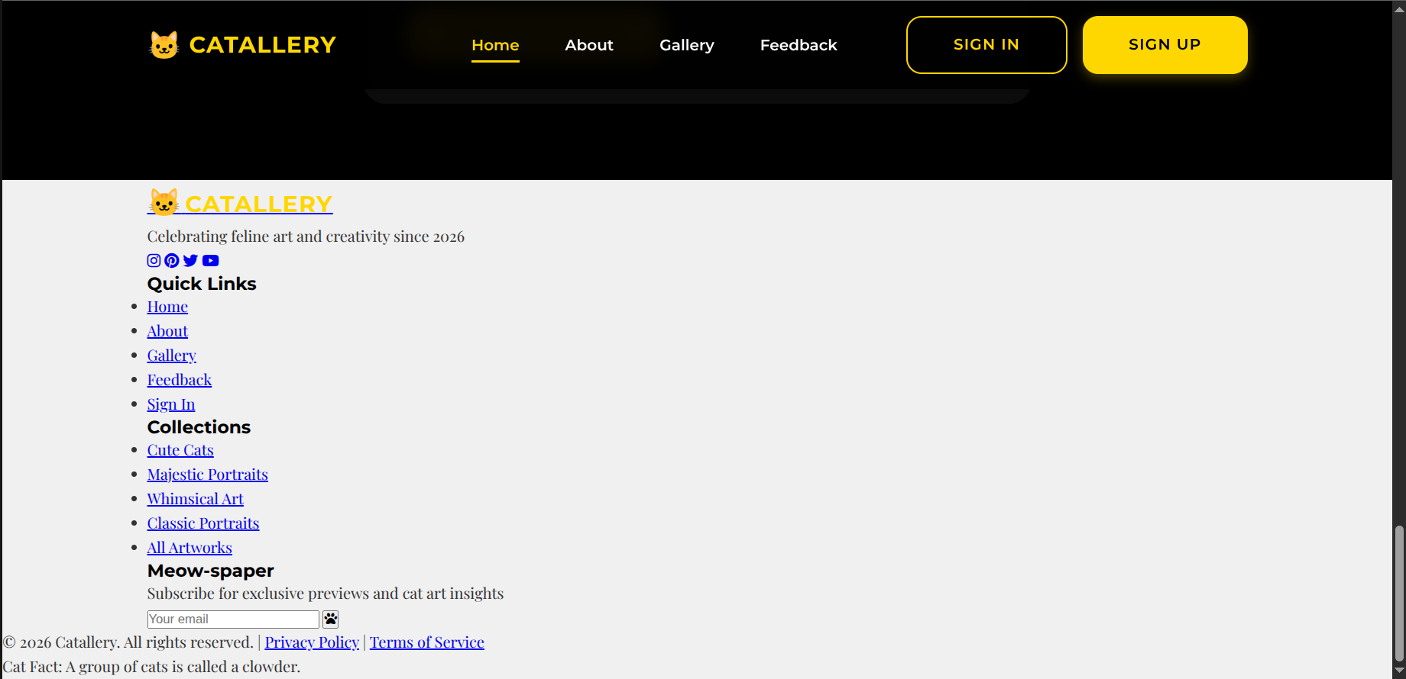

Claude:

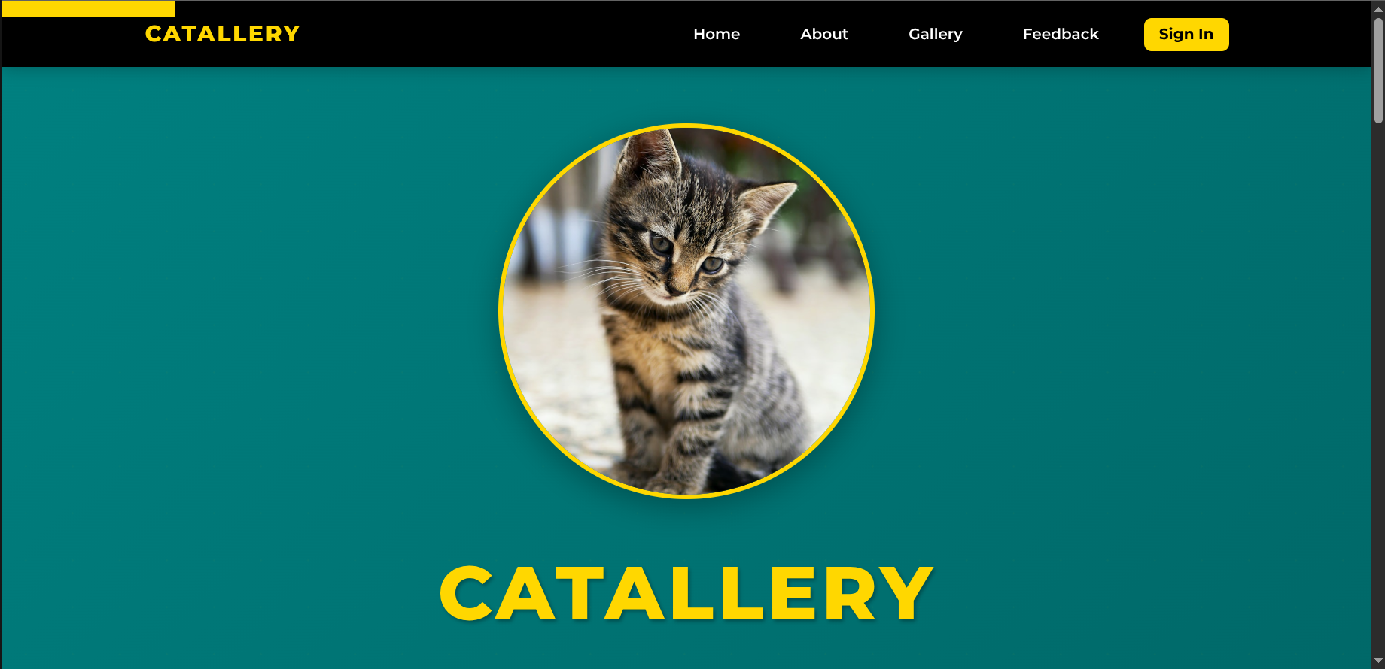
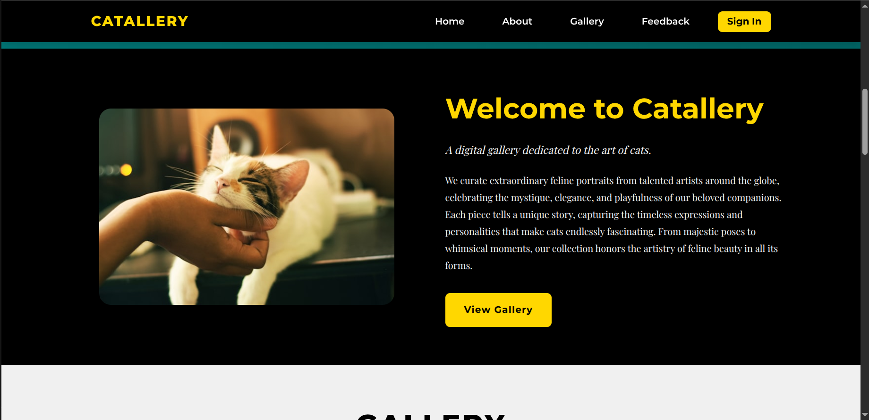
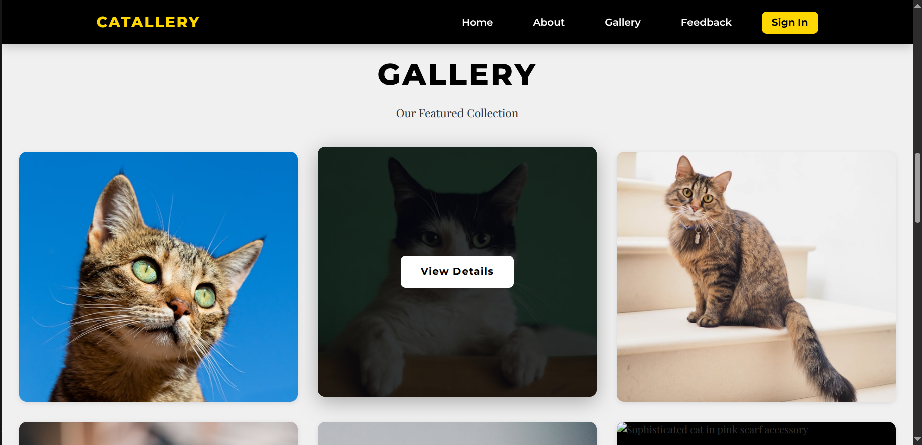

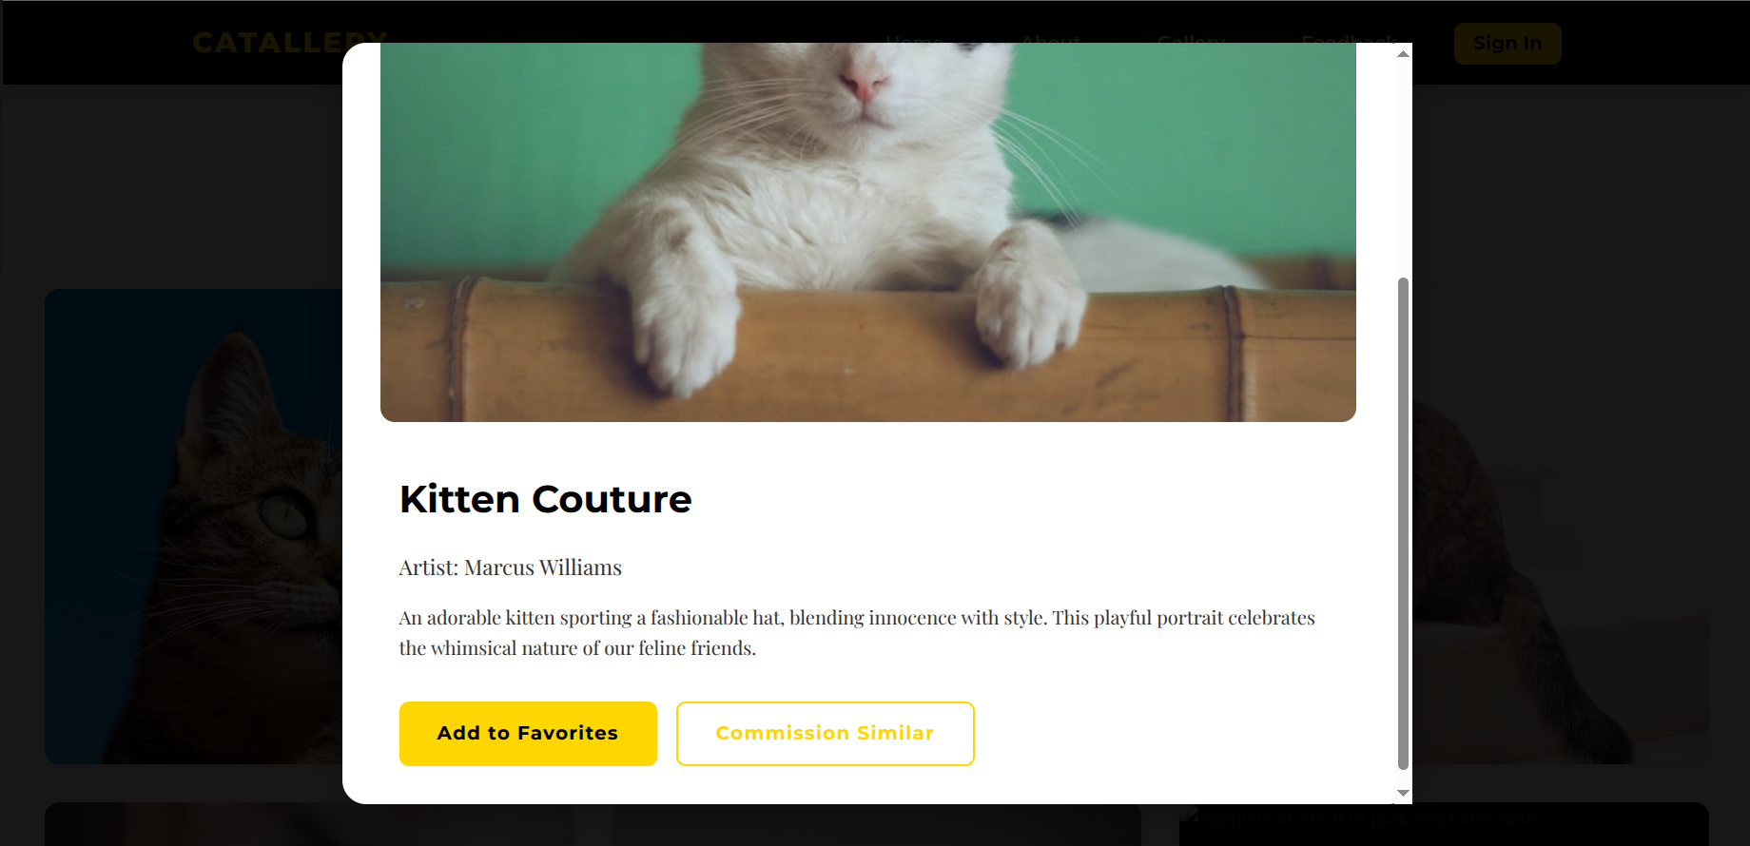
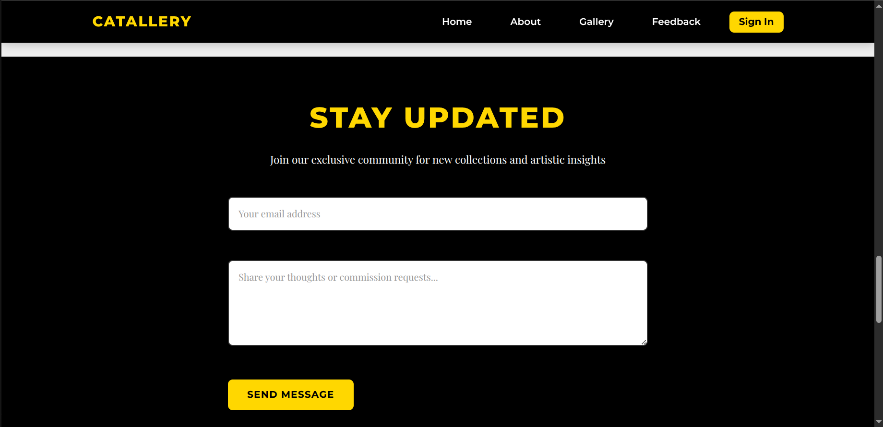

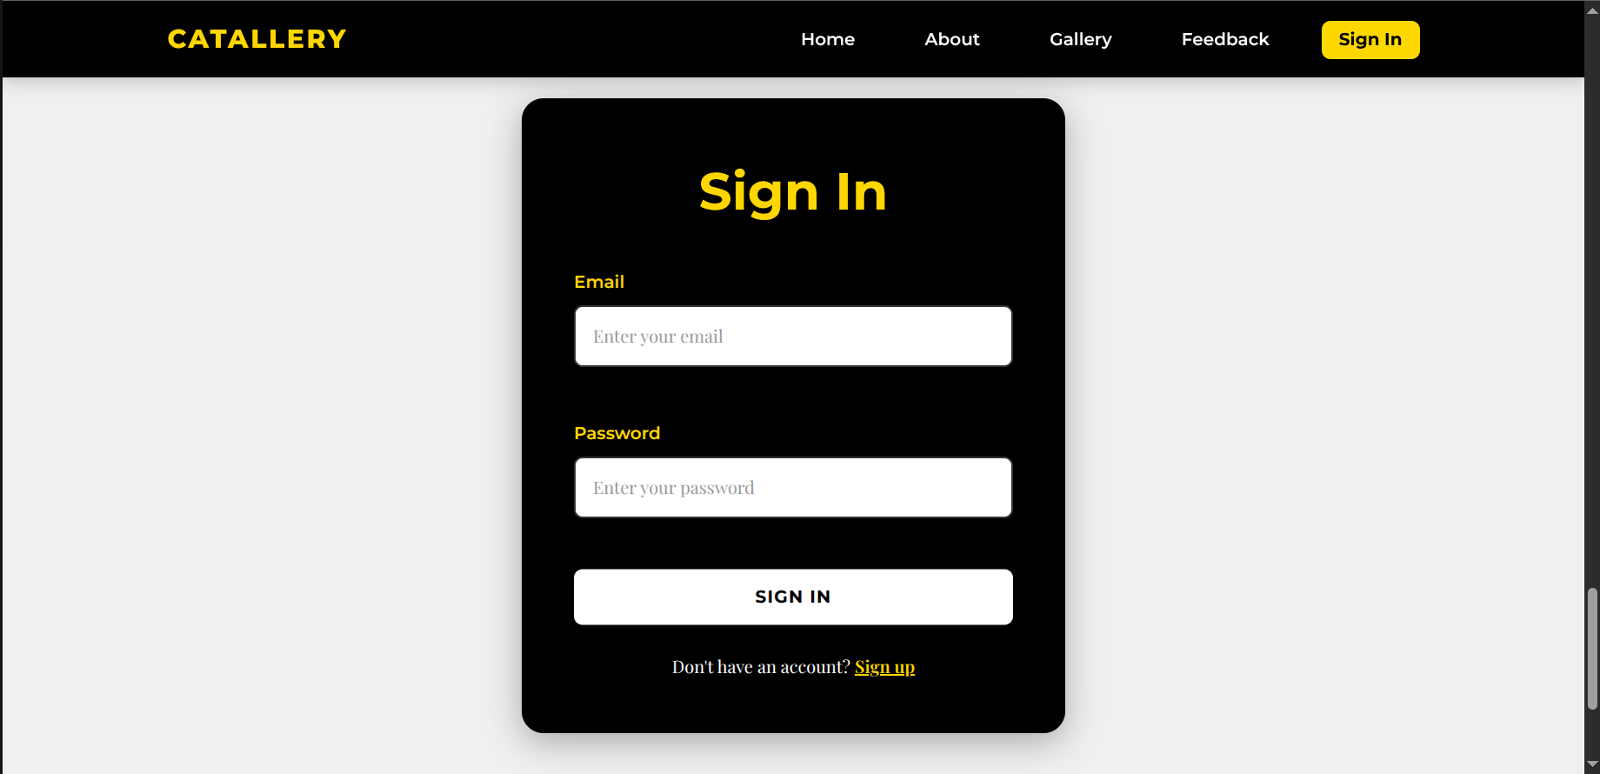
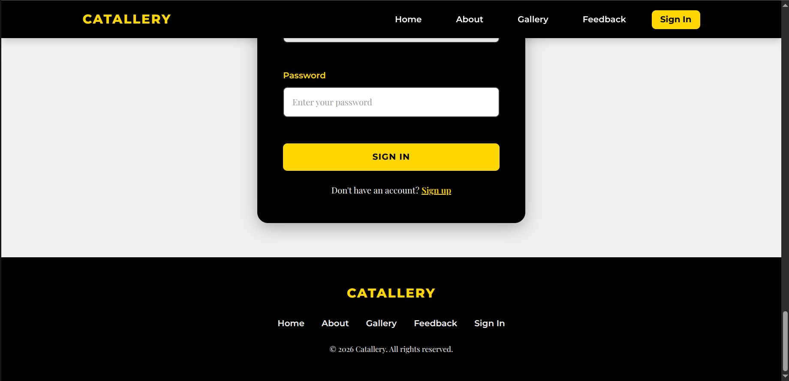

Chatgpt:

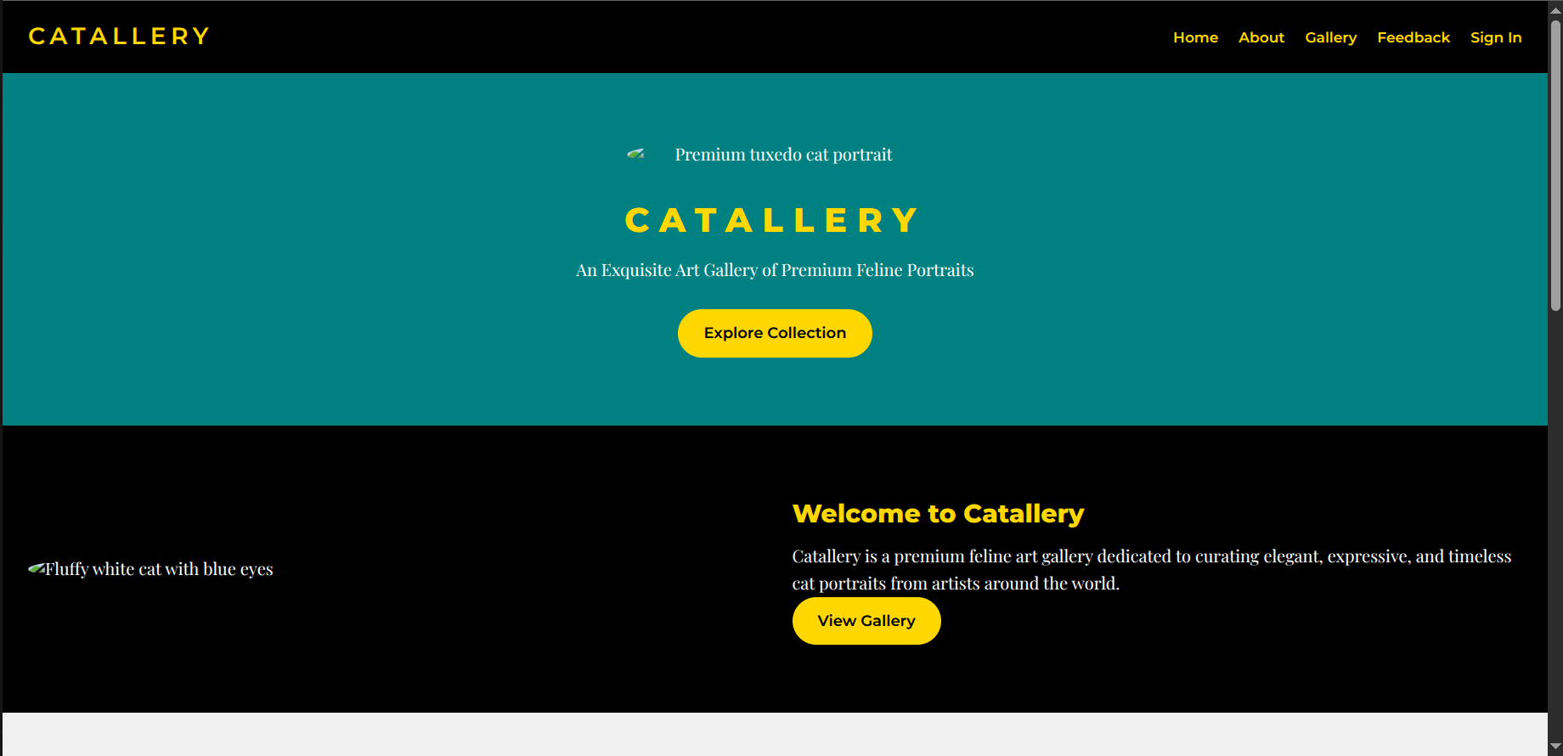

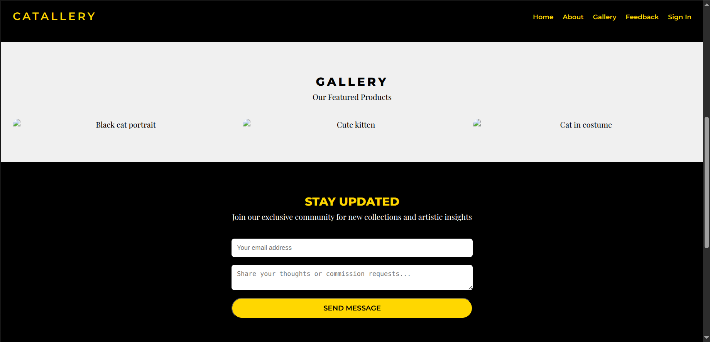

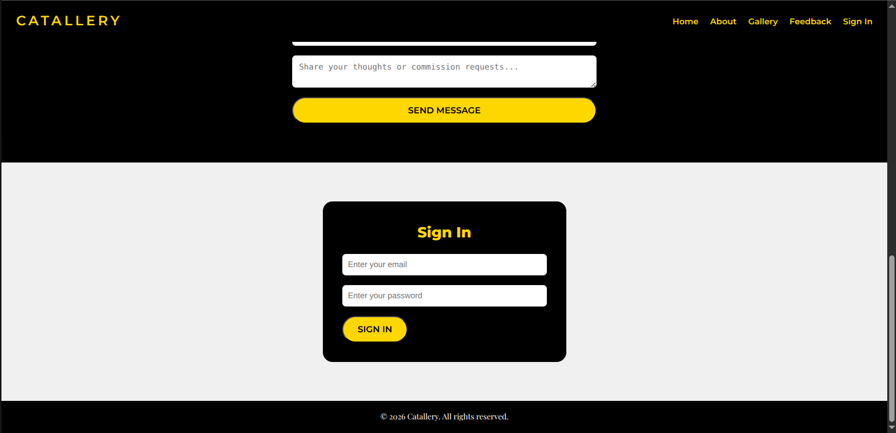

Above websites are the result of the prompt:

"Act as a Senior Frontend Developer and UI/UX Designer. I am building Catallery. I will provide detailed specs for each section. Your goal is to provide clean, semantic HTML5, modern CSS (using Flexbox/Grid), and vanilla JavaScript for interactions. All designs must be accessible (WCAG) and mobile-first. Do you understand the brand identity (Gold/Black/Teal-Green, Premium Feline Art)?"

"Create the best possible version of a website called 'Catallery,' an exquisite digital art gallery dedicated to premium feline portraits. The theme is elegant, playful, and cat-centric, celebrating art, creativity, and timeless cat expressions. Make it visually stunning, user-friendly, responsive for mobile/desktop, SEO-optimized, and accessible (follow WCAG guidelines). Incorporate modern web design best practices like fast loading, smooth animations, and secure forms. Enhance the design for maximum engagement, such as subtle cat-themed Easter eggs or hover effects on images.
Overall Structure:

Use descriptive placeholder URLs from Unsplash or a similar service that match the cat descriptions (e.g., https://source.unsplash.com/featured/?tuxedo-cat).
You have to make :root for the fonts and colors which will be used for dynamic color changing.

Use a consistent color palette: Gold (#FFD700) for accents/buttons/text highlights, black (#000000) for dark sections/backgrounds, light gray/beige (#F0F0F0) for light backgrounds, teal-green (#008080) for hero sections.
Fonts: Bold sans-serif (e.g., Montserrat) for headings in gold, clean serif (e.g., Playfair Display) for body text in white/black.
Navigation: Sticky top bar with menu icon (three lines in gold circle), links to Home, About, Gallery, Feedback, Sign In/Sign Up.
Footer: Black background with 'Catallery' logo, copyright '© 2026 Catallery. All rights reserved.', and navigation links.

Key Pages/Sections Based on Provided Screenshots:

Homepage (Hero Section):
Full-width hero with teal-green background, centered tuxedo cat image (black and white fur, green eyes, perched on bamboo), large gold 'CATALLERY' title, subtitle 'An Exquisite Art Gallery of Premium Feline Portraits' in white.
Yellow-gold 'Explore Collection' button below, leading to Gallery.
Subtle animation: Cat eyes blink or whiskers twitch on hover.

Sign In/Sign Up Page:
Light gray background, centered black rounded box with gold 'Sign In' title.
Form fields: Email (placeholder 'Enter your email'), Password (placeholder 'Enter your password'), yellow-gold 'SIGN IN' button.
Link below: 'Don't have an account? Sign up' in gold.
Integrate secure authentication (suggest using email/password or OAuth).
Variant: Overlay on other pages if needed, with footer visible.

Stay Updated/Feedback Page:
Black background, gold 'STAY UPDATED' title, subtitle 'Join our exclusive community for new collections and artistic insights' in white.
Form: Email field (placeholder 'Your email address'), textarea (placeholder 'Share your thoughts or commission requests...'), yellow-gold 'SEND MESSAGE' button.
Add validation for email and success message on submit.

About Section:
Black background, rounded white cat image (fluffy white cat with blue eyes among purple flowers) on left.
Text on right: Gold 'Welcome to Catallery' heading, subtitle 'A digital gallery dedicated to the art of cats.', followed by lorem ipsum-style descriptive paragraph about curating artworks from global artists.
Yellow-gold 'VIEW GALLERY' button.
Make text engaging and SEO-friendly with keywords like 'feline art gallery'.

Gallery Page:
Light gray background, large black 'GALLERY' title, subtitle 'Our Featured Products' in gray.
Responsive grid (3-6 columns depending on screen size) of cat portrait images: Include examples like a snowy black cat close-up, kitten in hat, hooded cat, cats in costumes (pink scarf, black hood), fluffy white cat, blue-eyed white cat.
Each image: Rounded corners, hover zoom/overlay with 'View Details' button leading to modal with larger image, artist info, and purchase/download option.
Infinite scroll or pagination for more images; categorize by themes (e.g., 'Cute', 'Majestic').
The Gallery should use a CSS Grid with grid-template-columns: repeat(auto-fit, minmax(300px, 1fr)) to ensure it looks perfect on all screen sizes.

Enhancements to Make It the Best:

Add user features: After sign-in, allow favoriting images, commissioning custom cat art, or newsletter signup.
Performance: Optimize images for web (compress to <100KB), use lazy loading.
SEO: Include meta tags, alt text for all images (e.g., 'Premium tuxedo cat portrait'), and a sitemap.
Accessibility: High contrast ratios, keyboard navigation, screen reader-friendly labels.
Mobile Optimization: Stack sections vertically, touch-friendly buttons.
Creative Touches: Background cat paw prints fading in, or random cat fact pop-ups.

Output the full website design specs, including HTML structure outline, CSS styles, and any JS for interactivity. Suggest improvements like adding a search bar for cat breeds or e-commerce integration for selling prints. Ensure it's fun, immersive, and the ultimate cat art experience!"

For the Easter egg, include a JS function that plays a subtle 'purr' sound or shows a paw-print cursor when the user hovers over the Logo for more than 2 seconds."

Analysis:

Claude > Grok > DeepSeek > ChatGPT > Gemini

Web Dev AI Hierarchy — A Developer’s Perspective
Claude (1st Place)
Claude performed the strongest overall. It successfully implemented the required view-details feature and delivered a visually polished design. The layout, spacing, and overall UI quality were clearly superior compared to the other tools.
Grok (2nd Place)
Grok produced solid results and met most requirements. While its output was not at the same level of refinement as Claude’s, it was still comparable in functionality and can be considered a reliable tool for modern web development tasks.
DeepSeek (3rd Place)
DeepSeek showed some inconsistencies in frontend execution. In particular, the footer lacked proper CSS styling. However, the rest of the website structure and functionality were relatively well implemented.
ChatGPT (4th Place)
ChatGPT’s output was functionally correct and adhered to the given requirements. Although it did not include any images, it successfully structured all sections and maintained logical consistency throughout the page.
Gemini (5th Place)
Gemini’s results were the least satisfactory. The design lacked visual appeal and did not fully meet the requirements specified in the prompt.

