
CC-215-L: Database Systems Lab

Faculty of Computing & Information Technology

BS(SE) Afternoon - Fall 2023
LAB – 06
The objective of this lab is to:
- SQL JOINS
- SQL SUBQUERIES
- Previous Content
Course & Lab Instructor: Dr. Asif Sohail
Hope you are fine and feeling yourself comfortable and exciting to play with Structured Query Language (SQL) in this first lab.
You have been taught in the lecture about SQL and query writing. Why not to get all what you have learned with a hands-on experience? So, let’s Start!
Allowed time: 1 and 15 minutes hour
Note: Do follow these instructions while you are sitting in the lab and performing the tasks.
- Gossips are not allowed. So be gentle and do what you know. The lab is not to deduct your sessional marks but to prepare you to achieve good marks in quizzes, mids and finals and finally have good grades. So, try to perform all your tasks in time and at your own.
- Teacher assistants are for your help, so be nice with them. Respect them as they are teaching you. Raise your hands if you have some problem and need help from TA. Avoid calling them by raising your voice and disturbing the environment of Lab.
- You must revise the content of the past lectures before starting the lab, it will help you resolve most of your general queries and give you the confidence that you can do it.
- Evaluation will be considered final and you cannot debate for the marks. So, focus on performing the tasks when the time is given to you.
- TA may deduct your marks for any kind of ill-discipline or misconduct from your side.
- Finally, pray before you start. And, Best of Luck!

- Kindly paste the query as well as result table screenshot as a result of each task
Sample:
Display All the Employees from emp table
Solution:
Select * from emp
EMPNO | ENAME | JOB | MGR | HIREDATE | SAL | COMM | DEPTNO
7369 | SMITH | CLERK | 7902 | 12/17/1980 | 800 | - | 20
7499 | ALLEN | SALESMAN | 7698 | 02/20/1981 | 1600 | 300 | 30
7521 | WARD | SALESMAN | 7698 | 02/22/1981 | 1250 | 500 | 30
7566 | JONES | MANAGER | 7839 | 04/02/1981 | 2975 | - | 20
7654 | MARTIN | SALESMAN | 7698 | 09/28/1981 | 1250 | 1400 | 30

Write the queries using the following tables:
EMP (EMPNO, ENAME, JOB, SAL, HIREDATE, COMM, MGR, DEPTNO)
DEPT (DEPTNO, DNAME, LOC)
SALGRADE (GRADE, LOSAL, HISAL)
Task 01: [10 Marks]
- List EMPNO, ENAME, JOB, SAL, DEPTNO, DNAME using THREE different versions of join queries.
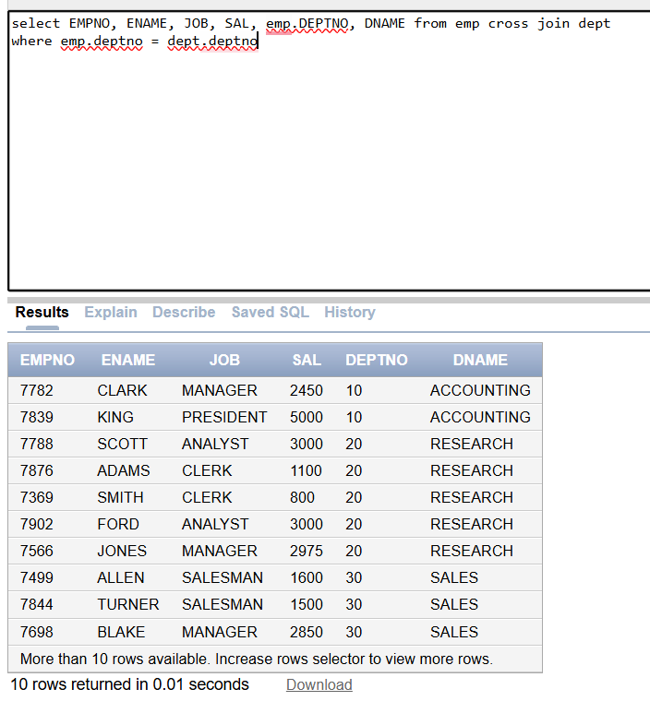
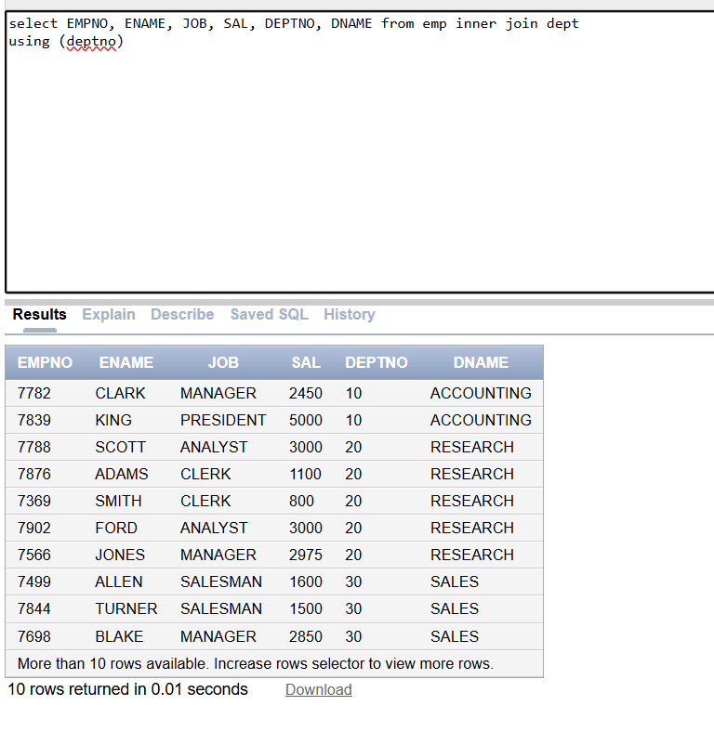
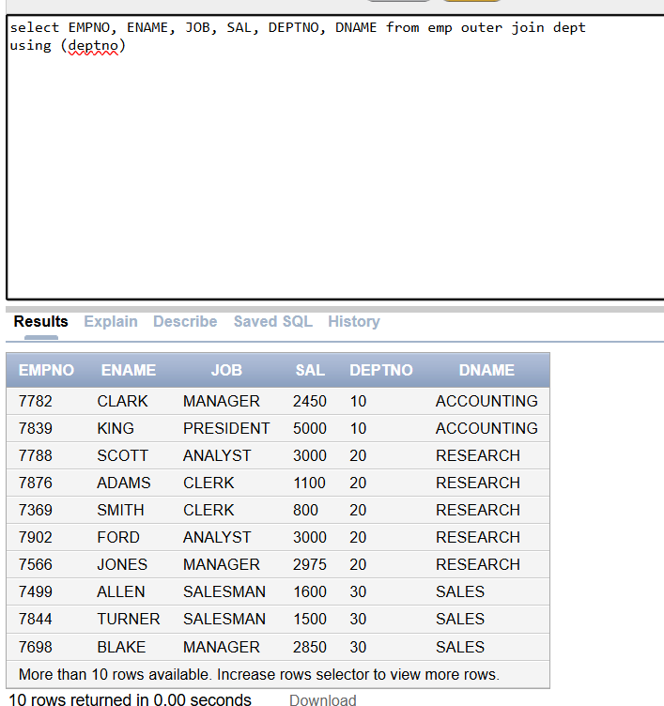
- Find the manager’s name of 'ALLEN'
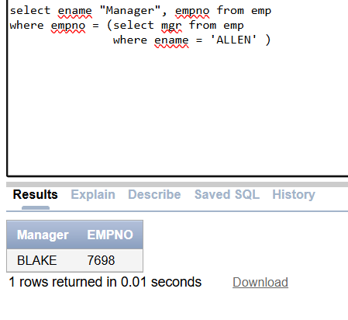
- Display the list of employees (employee name and job) along with their respective department names.
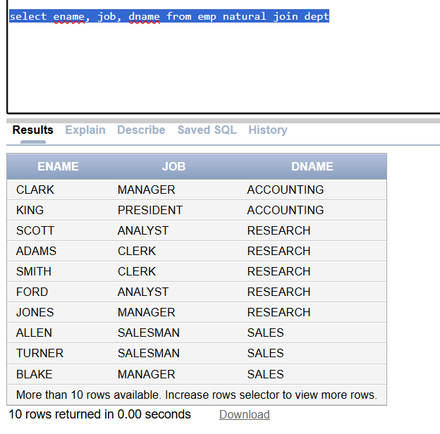
- Retrieve a list of salary grades and the number of employees in each grade.
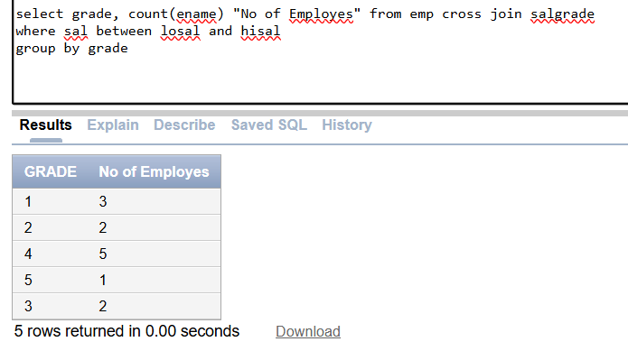
- Display The department numbers (deptno) and the corresponding department names (dname) from the "DEPT" table along with the total number of employees in each department from the "EMP" table. Include departments with zero employees.
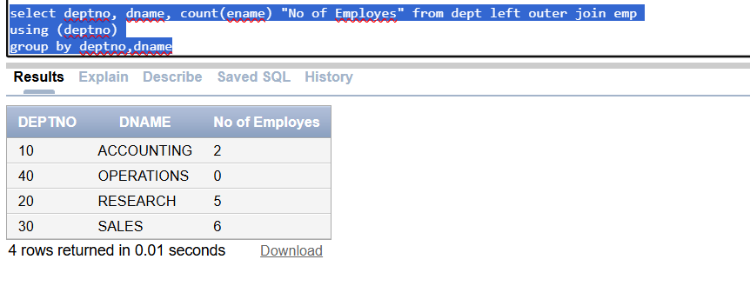
- Retrieve all employees and their respective departments, including employees without a
department.
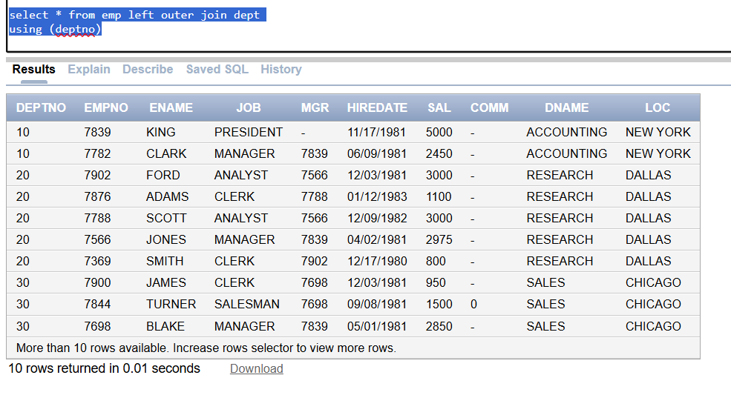
- Find the most Junior employee.
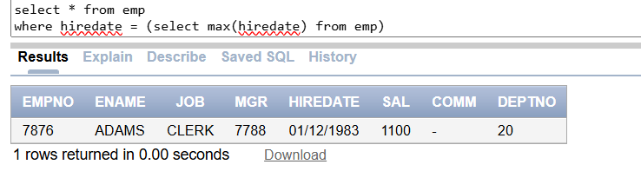
- Find the department name and the number of employees with the highest number of employees.
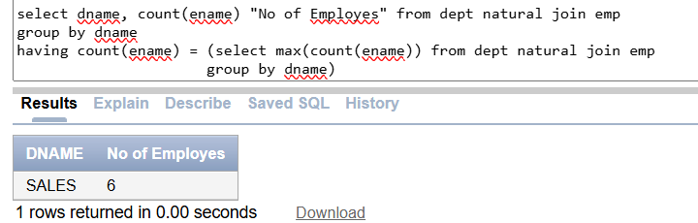
- List all employees whose salary is greater than the average salary of the employees working in department 20.
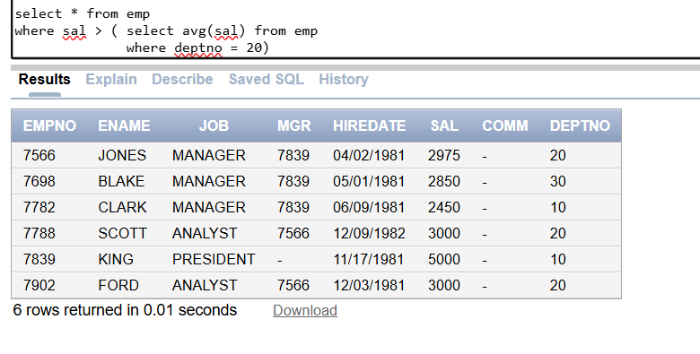

- Finds all employees whose salary is higher than the average salary of the employees in their departments.
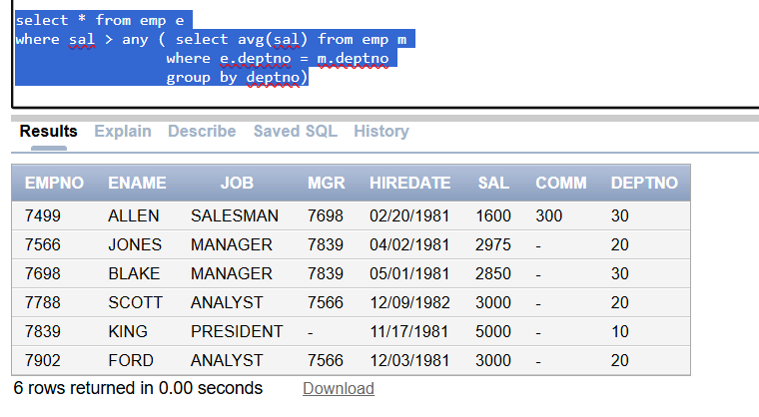

Task 02: [20 Marks]

- Retrieve a list of employees (employee name and manager's name) along with their respective managers. For an employee without manager, display “No Manger”
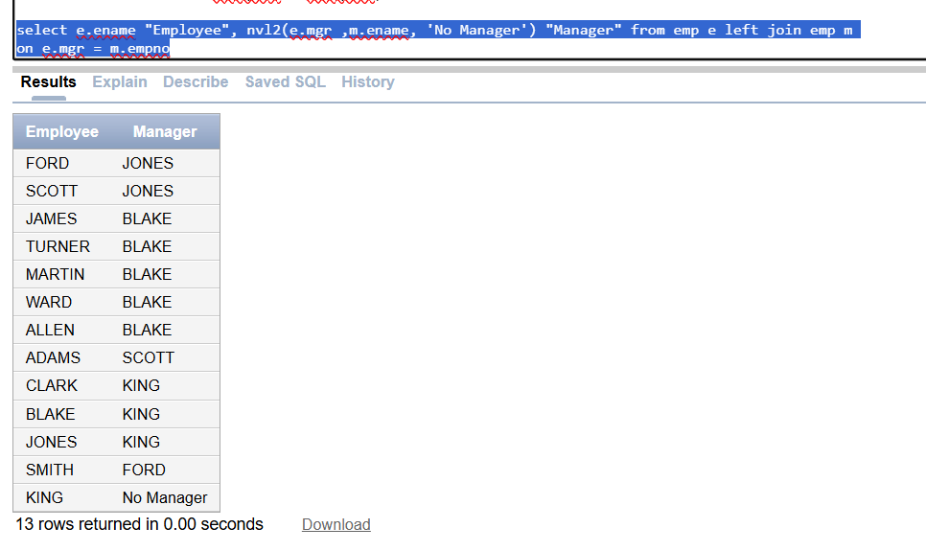
- Find employees who joined the company after their managers. Display their names, hire dates, and manager names.
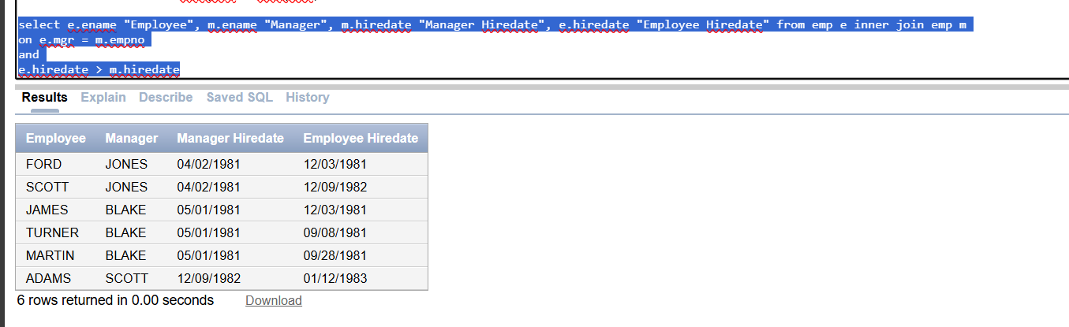
- Display the manager name, manager number and salary of the lowest paid employee for the manager. Exclude anyone whose manager is not known. Sort the output in descending order of the salary.

- Retrieve a list of employees who have the same salary grade as their managers
- List all employees in department 20 who have a manager in department 10.
(only to be solved by subquery)
- Find the department with the highest total salary.

- Find all employees whose salaries are greater than or equal to the highest salary of every department
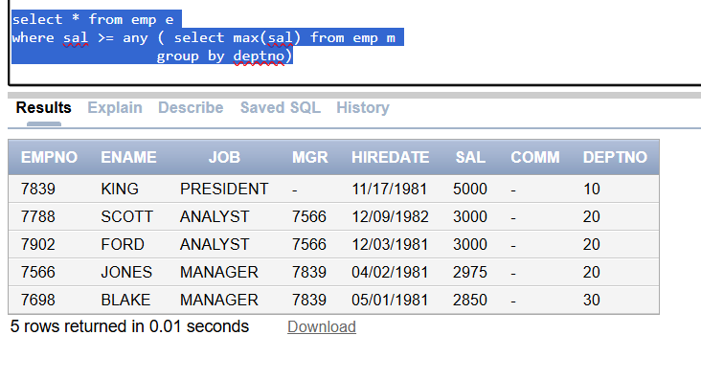
- List departments that have more than 3 employees
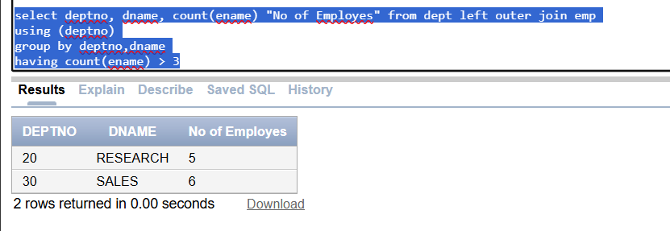

Task 03: [15 Marks]

- List the department names and the number of employees in each department, sorted by the number of employees in descending order. Display "High" for departments with more than 5 employees and "Low" for departments with 5 or fewer employees.
- List employee id,name,salary comm department name and average salary of that department and follow same output order

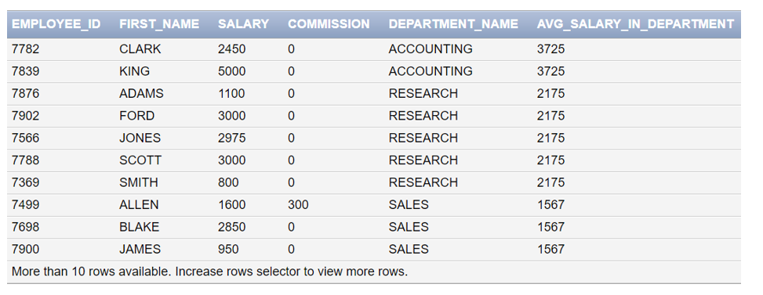

- List EMPNO, ENAME, JOB, SAL, DEPTNO, DNAME, GRADE, TAX, NET_SAL. Tax is a derived attribute computed on the basis of GRADE. All the employees rank 1 are exempted from tax. For the employees with GRADE 2,3, the tax rate is 10% of the salary. For the employees with GRADE above 3, the tax rate is 12% of the salary. NET_SAL is computed as SAL-TAX.
Task 04: [5 Marks]
1. Viva Question.(3+2)

