CC-215-L: Database Systems Lab

BS(SE) Morning - Fall 2023, Semester Spring 2025 LAB – 05
The objective of this lab is to:
- Previous Topics
- Joins

Course & Lab Instructor: Dr. Asif Sohail
Hope you are fine and feeling yourself comfortable and exciting to play with Structured Query
Language (SQL) in this first lab.
You have been taught in the lecture about SQL and query writing. Why not to get all what you have learned with a hands-on experience? So, let’s Start!
Allowed time: 1.5 hours
Note: Do follow these instructions while you are sitting in the lab and performing the tasks.



- Gossips are not allowed. So be gentle and do what you know. The lab is not to deduct your sessional marks but to prepare you to achieve good marks in quizzes, mids and finals and finally have good grades. So, try to perform all your tasks in time and at your own.

Faculty of Computing & Information Technology

- Teacher assistants are for your help, so be nice with them. Respect them as they are teaching you. Raise your hands if you have some problem and need help from TA. Avoid calling them by raising your voice and disturbing the environment of Lab.
- You must revise the content of the past lectures before starting the lab, it will help you resolve most of your general queries and give you the confidence that you can do it.
- Evaluation will be considered final and you cannot debate for the marks. So, focus on performing the tasks when the time is given to you.
- TA may deduct your marks for any kind of ill-discipline or misconduct from your side.
- Finally, pray before you start. And, Best of Luck!
● Kindly paste the query as well as result table screenshot as a result of each task Sample:
Display All the Employees from emp table
Solution:
Select * from emp
EMPNO | ENAME | JOB | MGR | HIREDATE | SAL | COMM | DEPTNO
7369 | SMITH | CLERK | 7902 | 12/17/1980 | 800 | - | 20
7499 | ALLEN | SALESMAN | 7698 | 02/20/1981 | 1600 | 300 | 30
7521 | WARD | SALESMAN | 7698 | 02/22/1981 | 1250 | 500 | 30
7566 | JONES | MANAGER | 7839 | 04/02/1981 | 2975 | - | 20
7654 | MARTIN | SALESMAN | 7698 | 09/28/1981 | 1250 | 1400 | 30

Total Lab Marks: 40

Task 01: [10 Marks]
- Find out the number of employees under each manager (DON’T USE JOINS)
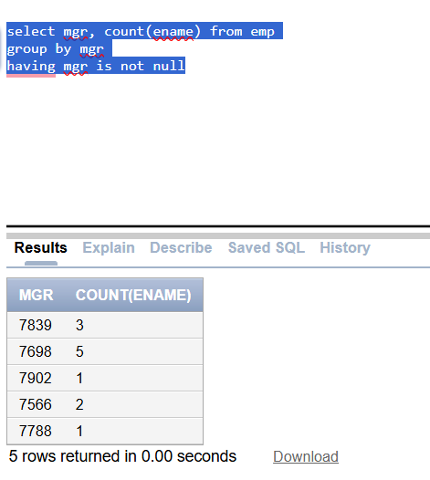
- Retrieve a list of salary grades and the number of employees in each grade.
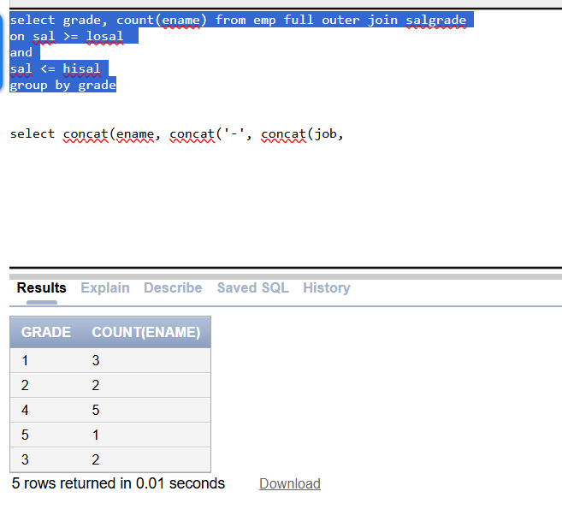
- List (dname) from the "DEPT" table along with the total number of employees in each department from the "EMP" table. Include departments with zero employees.
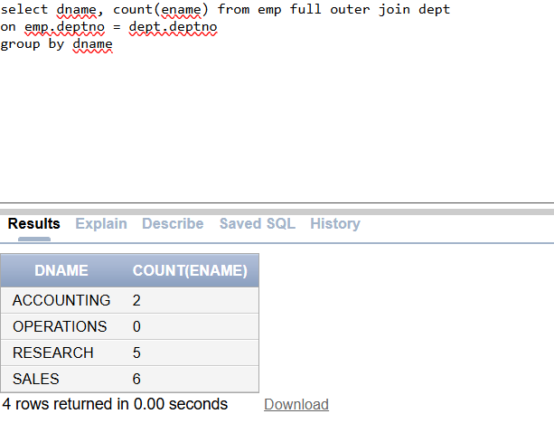
- Show enames with their job titles and department names as shown below.
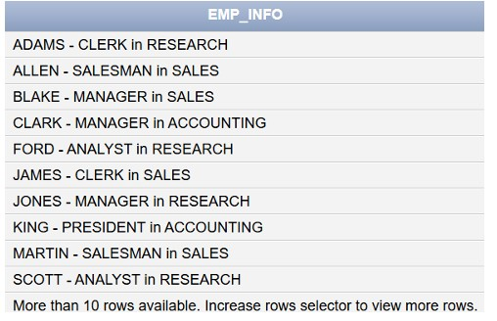
- Display a list of employees (employee JOB and their salary grades).
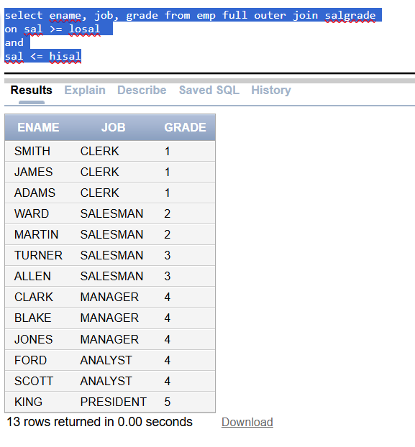

- Display The list of employees (employee name and job) along with their respective department names.
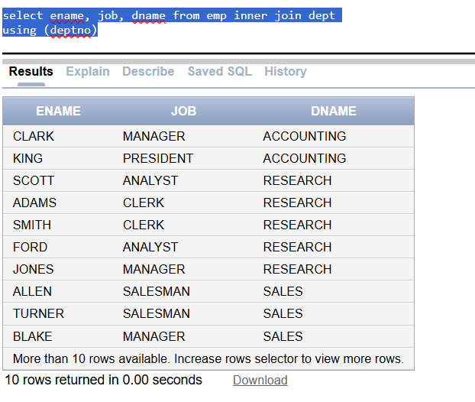
- List all employees whose location is 'dallas'.
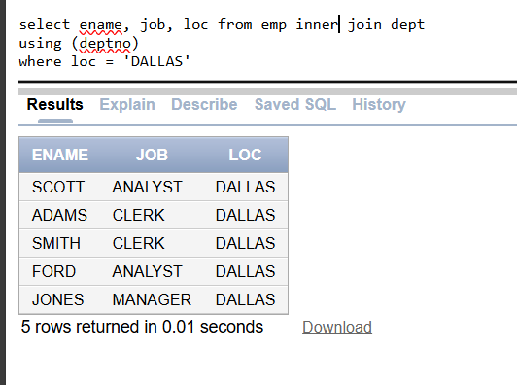

- Retrieve the count of employees whose salaries fall into each salary grade, as defined by the salary range in the SALGRADE table. This shows the employee distribution across various pay levels Output:

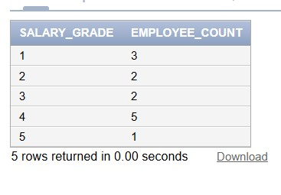
- List all unique job titles that are not 'CLERK' or 'SALESMAN'
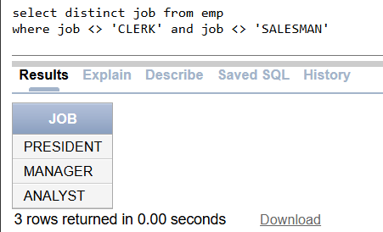
- Find out the number of employees under each manager (DON’T USE SELF JOIN)

Task 02: [10 Marks]
- Display the name of the department which has not employee.
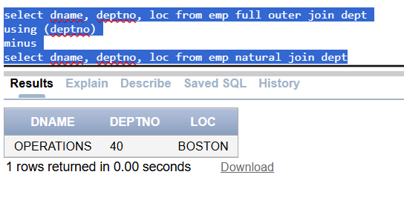
- Write a Query that display that either the Department has Even number of Employees or Odd number of Employees Show this in a derived column
- We want to assign a special code for each employee in emp table based on its salary. The sal is rounded it to its nearest thousand value. The special code is assigned on the basis of the following rules: a. A for 1000 b. B for 2000 c. C for 3000 d. D for 4000 e. E for 5000 f. S for 0 Note: You are not allowed to use decode or case for this question
Find departments where the total salary of employees is within a specific range (e.g., between $10,000 and $50,000):
- Find the department that spends the maximum percentage of its allocated budget (e.g., 15000/17000) on salaries
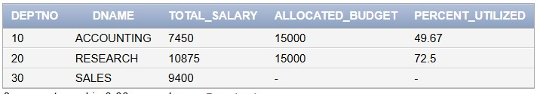
- Find departments with the most number of employees having the same job title
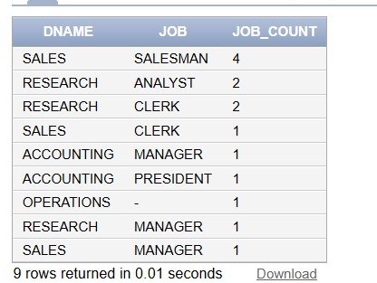
- Get a list of employees who work in departments with fewer than 5 employees.
- List the department names and the number of employees in each department, sorted by the number of employees in descending order. Display "High" for departments with more than 5 employees and "Low" for departments with 5 or fewer employees.
- Show the output like “Jones is a MANAGER of RESEARCH department”.
- List the departments that have at least one employee who is a 'MANAGER' or an 'ANALYST'
- List EMPNO, ENAME, JOB, SAL, DEPTNO, DNAME, RANK,TAX,NET_SAL. Tax is a derived attribute computed on the basis of GRADE. All the employees rank 1 are exempted from tax. For the employees with GRADE 2,3, the tax rate is 10% of the salary. For the employees with GRADE above 3, the tax rate is 12% of the salary. NET_SAL is computed as SAL-TAX.

Task 03: [15 Marks]
- Display how many employees fall into each salary grade per department (Matrix View).
- Generate an experience rank: count how many employees were hired before each employee (based on hiredate).
- Show Department-wise Unique Job Diversity Score
(Count of unique job titles per department — hints at talent diversity.)
Task 04: [5 Marks]
Viva

