
CC-215-L: Database Systems Lab

Faculty of Computing & Information Technology

BS(SE) Morning - Spring 2023
LAB – 01

The objective of this lab is to:
- Introduction to SQL language
- Basic SQL queries.

Course & Lab Instructor: Dr. Asif Sohail
Hope you are fine and feeling yourself comfortable and exciting to play with Structured Query Language (SQL) in this first lab.
You have been taught in the lecture about SQL and query writing. Why not to get all what you have learned with a hands-on experience? So, let’s Start!
Allowed time: 1 hour
Note: Do follow these instructions while you are sitting in the lab and performing the tasks.
- Gossips are not allowed. So be gentle and do what you know. The lab is not to deduct your sessional marks but to prepare you to achieve good marks in quizzes, mids and finals and finally have good grades. So, try to perform all your tasks in time and at your own.
- Teacher assistants are for your help, so be nice with them. Respect them as they are teaching you. Raise your hands if you have some problem and need help from TA. Avoid calling them by raising your voice and disturbing the environment of Lab.
- You must revise the content of the past lectures before starting the lab, it will help you resolve most of your general queries and give you the confidence that you can do it.
- Evaluation will be considered final and you cannot debate for the marks. So, focus on performing the tasks when the time is given to you.
- TA may deduct your marks for any kind of ill-discipline or misconduct from your side.
- Finally, pray before you start. And, Best of Luck!

- Kindly paste the query as well as result table screenshot as a result of each task
Sample:
Display All the Employees from emp table
Solution:
Select * from emp
EMPNO | ENAME | JOB | MGR | HIREDATE | SAL | COMM | DEPTNO
7369 | SMITH | CLERK | 7902 | 12/17/1980 | 800 | - | 20
7499 | ALLEN | SALESMAN | 7698 | 02/20/1981 | 1600 | 300 | 30
7521 | WARD | SALESMAN | 7698 | 02/22/1981 | 1250 | 500 | 30
7566 | JONES | MANAGER | 7839 | 04/02/1981 | 2975 | - | 20
7654 | MARTIN | SALESMAN | 7698 | 09/28/1981 | 1250 | 1400 | 30

Task 01: [15 Marks]
- Find employees with a job title of 'ANALYST' or 'CLERK' from department 30.
- List the employees having manager id=7698.
- Display the name and salary of employees earning more than 3000.
- Find all employees in department 10.
- Display all the departments from DEPT table.
- Display the employees who work as 'MANAGER'.
- Display the annual salary of each employee (12 months).
- Display employees who do not work as 'SALESMAN'.
- Display employees who earn less than 1500 or work as 'CLERK'.
- Display departments whose names start with the letter 'S'.

Task 02: [20 Marks]
- List all the employees hired after “4-10-1990”
- Show department number and location of accounting and sales department.
- List employees whose salaries are between 2000 and 5000, excluding managers
- Display employees who have not received any commission (i.e., COMM IS NULL) and their job titles.
- List the employees hired in 1980 or 1982.
- Display the employees who earn more than 2000 after adding their commission.
- Display the employees who receive a commission.
- List the employees who earn between 1000 and 3000.
- List the employees who do not have a manager (MGR is NULL).
- List employees earning more than 1000 per month.

Task 03: [15 Marks]
1. Federal Board of Revenue has asked the company to provide the total Income Tax returns filed by the employee since the hire date. The Income Tax Rate is 25% and is calculated annually.
2.Write an SQL query that calculates the total Income Tax returns filed by the employee in the following format. HINT: YOU CAN USE ROUND(“LOGIC TO CALCUALTE YEARS”) for precision
WRITE A QUERY TO DISPLAY EMPLOYEES WITH A TAKE-HOME SALARY BELOW AN AMOUNT OF 3000. THE TAKE-HOME SALARY IS THE SALARY WHICH EMPLOYEE TAKES AFTER PAYING TAX. THE RATE OF TAX IS 5%
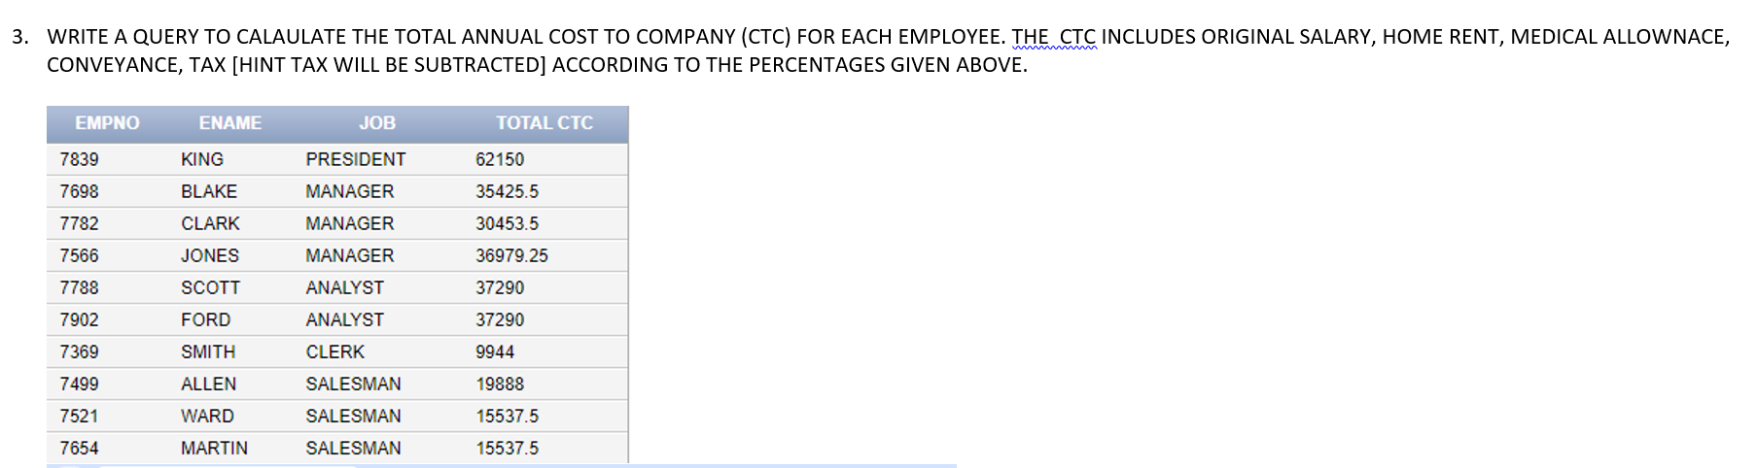
VIVA QUESTIONS 3marks

