

CC-215-L: Database Systems Lab
Faculty of Computing & Information Technology

BS(IT&CS) Morning - Fall 2023
LAB – 06
The objective of this lab is to:
- Revise Previous Content
- Practice Subqueries
Course & Lab Instructor: Dr. Asif Sohail
LAB TIMING : 60 MINS
TOTAL MARKS : 30
Task 01: [30 Marks]
- Display the total salary of the top 5 earning employees in emp table. (Use of Analytical or Ranking functions is not allowed)
SELECT SUM(e1.sal)
FROM emp e1
WHERE 5 > (
SELECT COUNT(DISTINCT e2.sal)
FROM emp e2
WHERE e2.sal > e1.sal
);

- Display the department name, employee name, job and salary grade for all the employees. (Use of Join is not allowed)

- Find employees who have the same job as their manager.
SELECT E1.ENAME
FROM EMP E1
JOIN EMP e2
ON E1.MGR = E2.EMPNO
WHERE E1.JOB = E2.JOB AND E1.MGR = E2.EMPNO;
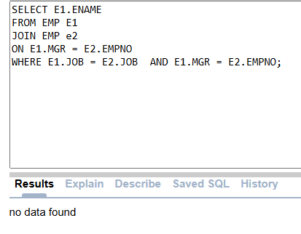
- Show the difference in salary between the highest and lowest paid employees in each department.
SELECT MAX(SAL) - MIN (SAL) SAL_DIFFERRCE
FROM EMP
GROUP BY DEPTNO
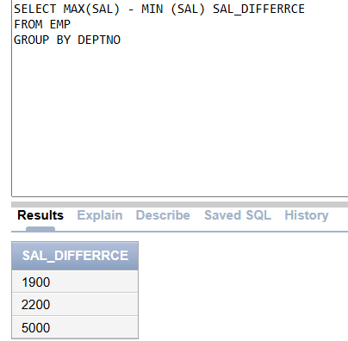
- Display the number of employees with a salary 'Less than', 'Equal to', and 'Above' the average salary of all employees. The output should be as follows.
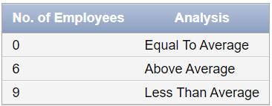
SELECT COUNT(*) "NO. OF EMPLOYEES",
(SUM(CASE WHEN SAL = (SELECT AVG(SAL) FROM EMP) THEN 1 ELSE 0 END)"EQUAL TO AVG",
SUM(CASE WHEN SAL > (SELECT AVG(SAL) FROM EMP) THEN 1 ELSE 0 END)"ABOVE AVG",
SUM(CASE WHEN SAL < (SELECT AVG(SAL) FROM EMP) THEN 1 ELSE 0 END)"LESS THAN AVG") ANALYSIS
FROM EMP;
- Retrieve the employees who work in the same department as the highest-paid employee with at least one subordinate, and who earn more than the average salary of that department.

SELECT E1.ENAME
FROM EMP E1
JOIN EMP E2
ON E1.MGR = E2.EMPNO
WHERE E1.DEPTNO = E2.DEPTNO AND E2.SAL = (SELECT MAX(SAL) FROM EMP )
AND E2.SAL > (SELECT AVG(SAL) FROM EMP);
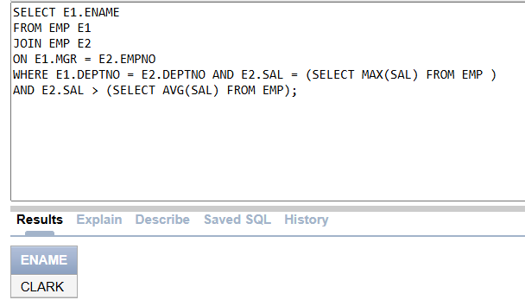
- List the three most senior employees along with the three most junior employees in chronological order. Display the absolute difference between the salaries of the corresponding employees. The output should be as follows.
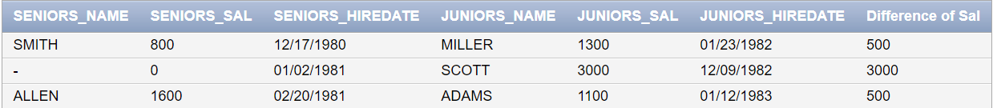

- Identify the departments with the highest concentration of employees in a specific job role. The target job role should be the one where the number of employees is closest to one-third of the maximum count (take the ceiling) for any job in the company. For each of these departments, display the department number and the number of employees in that job role.

- Find the subordinates who earn the smallest salary for each manager. Display the manager's name, the smallest salary, and the names of the employees earning that salary. (Use of Join is not allowed)

- List the departments where the total salary is above the average total salary paid by all departments.
SELECT DEPTNO
FROM EMP
GROUP BY DEPTNO
HAVING SUM(SAL) > (SELECT AVG(SAL) FROM EMP);
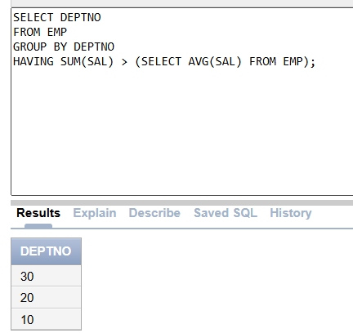
- Display the names of employees who have a salary greater than the average salary of managers.
SELECT ENAME
FROM EMP
WHERE SAL > (SELECT AVG(SAL) FROM EMP WHERE JOB = 'MANAGER');
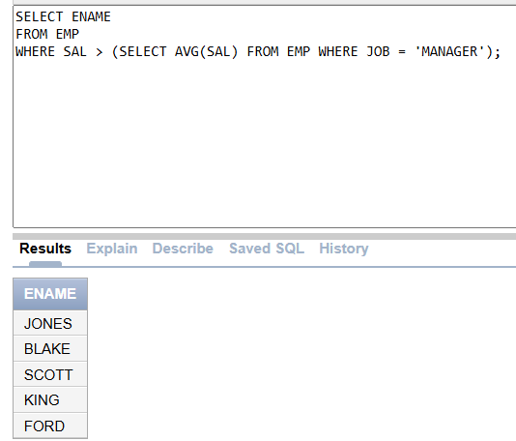
- Find the employee name, empno, department name and salary grade who have a salary grade greater than or equal to salary grade of highest paid employees in department 20
SELECT E.ENAME,E.EMPNO,D.DNAME,S.GRADE
FROM EMP E
JOIN DEPT D
ON E.DEPTNO = D.DEPTNO
JOIN SALGRADE S
ON SAL BAETWEEN HISAL AND LOSAL
WHERE D.DEPTNO = 20 AND S.GRADE >= ( SELECT MAX(GRADE) FROM EMP WHERE DEPTNO = 20);
- List employees who joined the company on the same month or year as at least one other employee but in different departments.

- Find the employees whose salary is equal to the second-highest salary in their department.
SELECT *
FROM EMP
WHERE SAL = (SELECT MAX(SAL) FROM EMP WHERE SAL < (SELECT MAX(SAL) FROM EMP))
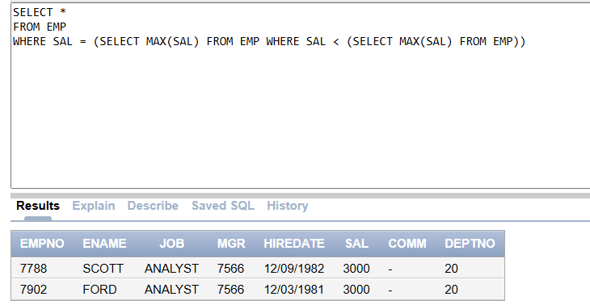
- Find the departments names and counts where the number of employees is less than the average number of employees in all departments.

SELECT DNAME,COUNT(*)
FROM EMP E
JOIN DEPT D
ON E.DEPTNO = D.DEPTNO
GROUP BY DNAME
HAVING COUNT(*) < (SELECT AVG(SUM(SAL)) FROM EMP GROUP BY DEPTNO);
