

Name: Muhammad Abdul Kareem
Roll No: BSEF23M014
Section: BS-SE(Morning)
Semester: 6th
Assignment: 1st
Subject: Operating System

Question 1
The following processes are being scheduled by the system. In addition to the processes listed below, the system also has an idle task (which consumes no CPU resources and is identified as idle). This task has priority 0 and is scheduled whenever the system has no other available processes to run.
- A pre-emptive round robin scheduling algorithm (ignore process priorities for this part). The length of a time quantum is 10 units.
- A pre-emptive priority scheduling algorithm. Each process is assigned a numerical priority, with a higher number indicating a higher priority.
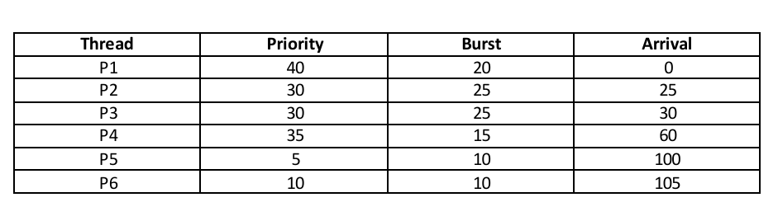
For both parts (part A and part B), do the following tasks:
- Show the scheduling order of the processes using a Gantt chart.
- What is the turnaround time for each process?
- What is the waiting time for each process?
- What is the CPU utilization rate?
- Compare both scheduling algorithms in terms of average turn-around time.
- Compare both scheduling algorithms in terms of average waiting time.

Solution 1 Part (A)

Task 1) Gantt Chart
Note:
When a process finishes its time quantum, newly arriving processes at that exact time are typically added to the ready queue before the preempted process is re-added.
| P1 | P1 | Idle | P2 | P3 | P2 | P3 | P2 | P4 | P3 | P4 | Idle | P5 | P6 |
0 10 20 25 35 45 55 65 70 80 85 90 100 110 120
Detailed:
- 0–10: P1 (remaining 10)
- 10–20: P1 (completes)
- 20–25: Idle (no ready process)
- 25–35: P2 (remaining 15)
- 35–45: P3 (remaining 15)
- 45–55: P2 (remaining 5)
- 55–65: P3 (remaining 5)
- 65–70: P2 (completes)
- 70–80: P4 (remaining 5)
- 80–85: P3 (completes)
- 85–90: P4 (completes)
- 90–100: Idle
- 100–110: P5 (completes)
- 110–120: P6 (completes)

Task 2) Turnaround Time (= Completion – Arrival)
Process | Arrival | Completion | Turnaround
P1 | 0 | 20 | 20
P2 | 25 | 70 | 45
P3 | 30 | 85 | 55
P4 | 60 | 90 | 30
P5 | 100 | 110 | 10
P6 | 105 | 120 | 15

Task 3) Waiting Time (= Turnaround – Burst)
Process | Burst | Turnaround | Waiting
P1 | 20 | 20 | 0
P2 | 25 | 45 | 20
P3 | 25 | 55 | 30
P4 | 15 | 30 | 15
P5 | 10 | 10 | 0
P6 | 10 | 15 | 5

Task 4) CPU Utilization
- Total Time: 120 units.
- Idle Time: 5 units (20-25) + 10 units (90-100) = 15 units.
- Active Time: 120 - 15 = 105 units.
- Utilization: (105/120)∗100 = 87.5%

Task 5) Average Turnaround
- (20 + 45 + 55 + 30 + 10 + 15) / 6 = 175 / 6 ≈ 29.17

Task 6) Average Waiting
- (0 + 20 + 30 + 15 + 0 + 5) / 6 = 70 / 6 ≈ 11.67

Solution 1 Part (B)

Task 1) Gantt Chart
| P1 | Idle | P2 | P3 | P4 | P3 | Idle | P5 | P6 | P5 |
0 20 25 50 60 75 90 100 105 115 120
Detailed:
- 0–20: P1 (priority 40)
- 20–25: Idle
- 25–50: P2 (priority 30, completes; P3 arrives at 30 with same priority, waits)
- 50–60: P3 (priority 30)
- 60–75: P4 (priority 35, preempts P3)
- 75–90: P3 resumes and completes
- 90–100: Idle
- 100–105: P5 (priority 5)
- 105–115: P6 (priority 10, preempts P5 at 105)
- 115–120: P5 resumes and completes

Task 2) Turnaround Time (= Completion – Arrival)
Process | Arrival | Completion | Turnaround
P1 | 0 | 20 | 20
P2 | 25 | 50 | 25
P3 | 30 | 90 | 60
P4 | 60 | 75 | 15
P5 | 100 | 120 | 20
P6 | 105 | 115 | 10

