

Name: Muhammad Abdul Kareem
Roll No: BSEF23M014
Section: BS-SE(Morning)
Semester: 6th
Assignment: 2nd
Subject: Operating System
Submission Date: 05/11/2026
Submitted to:_______________________________

Linux System Call Interface

Definition
A system call is a method through which a user program communicates with the operating system kernel to request services such as:
- Process creation
- File handling
- Memory management
- Input/Output operations.
System calls act as an interface between:
- User Space
- Kernel Space

Purpose
System calls are used for the following:
- Access hardware resources
- Create and manage processes.
- Perform file operations.
- Handle communication between processes.

GNU gcc Compiler

Definition
GNU Compiler is a compiler used to compile C, C++, and other programming languages in Linux.

Basic gcc Commands and Options
The basic GCC commands and options for the gcc compiler are as follows:
- Compiling a C Program gcc program.c
- Specify Output File Name gcc program.c -o output
- Command for running the Program ./output
- Compiling with Warnings gcc -Wall program.c -o output
- Compiling with Debugging gcc -g program.c -o output
- Compile pthread Program gcc thread.c -o thread -pthread

Process Creation and Termination

getpid()

Purpose
Returns the Process ID (PID) of the current process.

Program
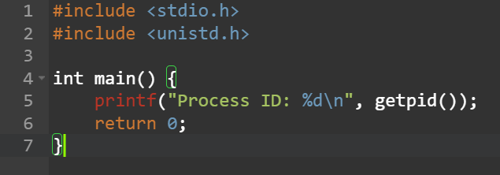

Compile
Compiling the program gcc getpid.c -o getpid
Run
Running the program ./getpid
Output
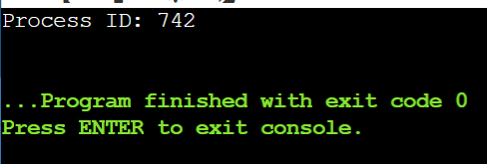

getppid()

Purpose
Returns the Parent Process ID (PPID).

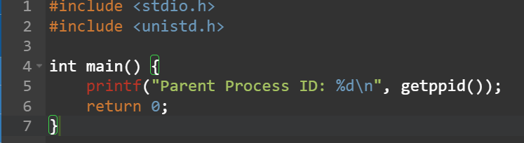
Program

Compile
Compiling the program gcc getppid.c -o getppid
Run
Running the program ./getppid
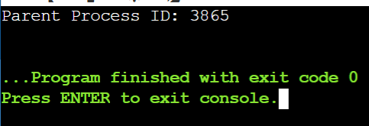
Output

fork()

Purpose
Creates a new child process.

Concepts
The important concepts for fork() call are as follows:
    - Parent process creates child process.
    - Both run independently
    - Child gets a copy of parent process.

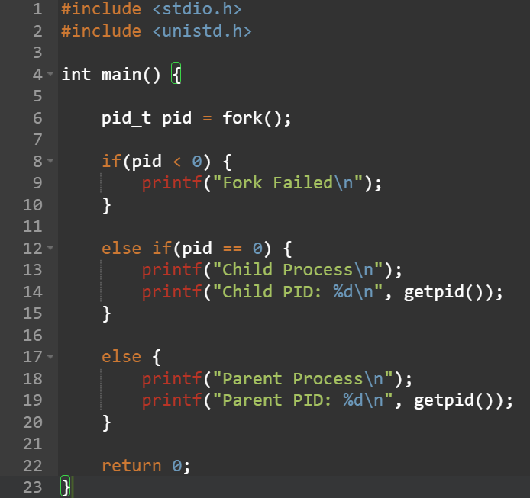
Program

Compile
Compiling the program gcc fork.c -o fork
Run
Running the program ./fork
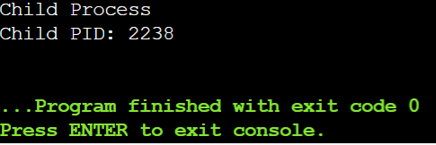
Output

Return Values of fork()
The fork() function returns different values with different conditions, some of which are as follows:
Return Value | Meaning
pid < 0 | Fork failed
pid == 0 | Child process
pid > 0 | Parent process

wait()

Purpose
Parent process waits until child process finishes execution.

Program
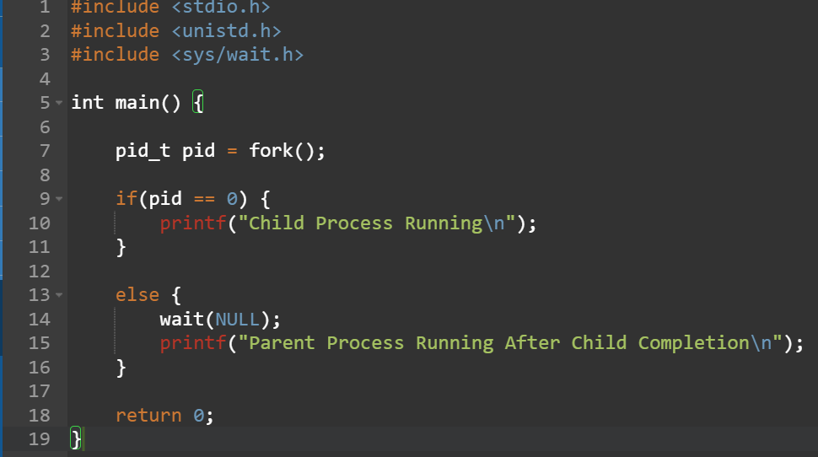

Compile
Compiling the program gcc wait.c -o wait
Run
Running the program ./wait
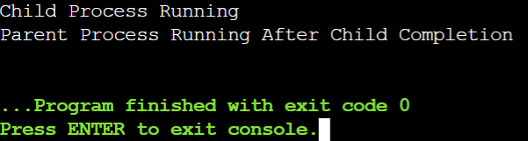
Output

exit()

Purpose
Terminates a process.

Program
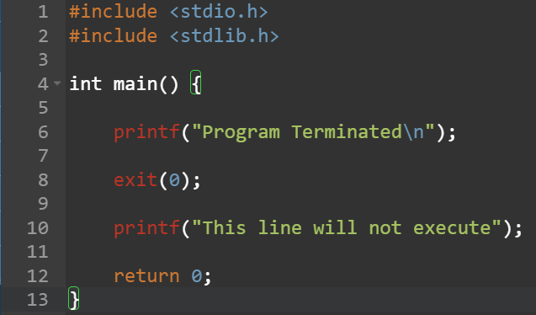

Compile
Compiling the program gcc exit.c -o exit
Run
Running the program ./exit
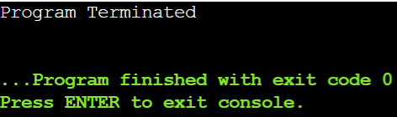
Output

execl()

Purpose
Replaces current process with another program.

Program
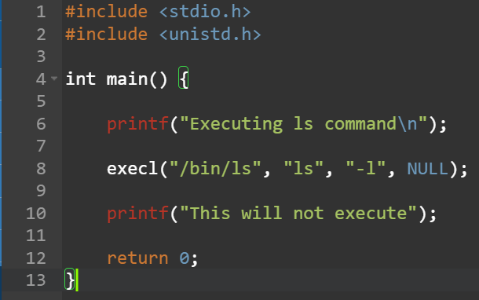

Compile
Compiling the program gcc execl.c -o execl
Run
Running the program ./execl
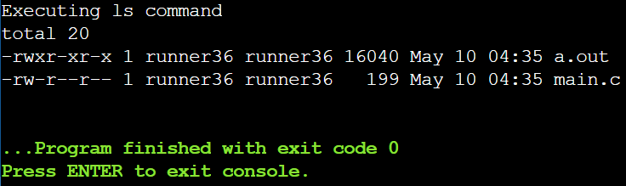
Output

Understanding

Parent Processes
The process that creates another process.
Child Processes
The newly created process using fork().
Zombie Process
A process that has completed execution but still exists in process table because the parent has not read its exit status.

Cause
When the parent does not use wait(NULL).
Orphan Process
A child process whose parent process terminates before the child.
Result
The orphan process becomes adopted by init/systemd process.

Inter Process Communication(IPC)
IPC allows processes to communicate and share data.

Pipes

Definition
A pipe is used for communication between processes.

Example
The examples for using Pipes on the terminal are as follows:
- ls | wc

Explanation
The explanation for using the above command is as follows:
  - ls gives file list.
  - wc counts lines/words/characters.

FIFO

Definition
It is nothing but a named Pipe.

Create FIFO
- mkfifo mypipe

Write Data
- echo "Hello" > mypipe

Read Data
- cat < mypipe

Sockets

Definition
Sockets allow communication between processes over a network.

Types
The types for the sockets are as follows:
- TCP Socket
- UDP Socket

IPC Tools in Linux

Tool | Purpose
Pipe | Communication between related processes
FIFO | Communication between unrelated processes
Socket | Network communication
Message Queue | Message-based communication
Shared Memory | Fast shared communication

Linux Pipe Command

Command 1)
- cat file.txt | sort

Command 2)
- ps aux | grep firefox

Mkfifo Command Practice

Create FIFO
- mkfifo fifo1

Check FIFO
- ls -l

Threads and Scheduling

pthread_create()

Purpose
Creates a thread.

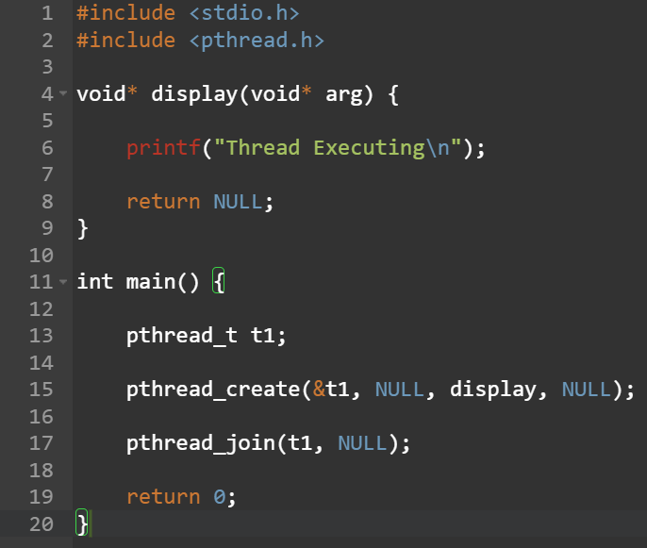
Program

pthread_join()

Purpose
Waits for thread completion.

Syntax
- pthread_join(thread, NULL);

pthread_exit()

Purpose
Terminates a thread.

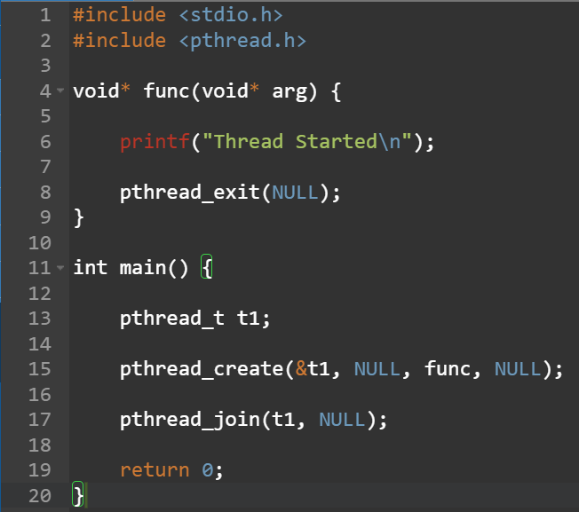
Program

Compilation of pthread Program

Command
The command to compile the pthread program is as follows:
- gcc thread.c -o thread -pthread

Platform
For this assignment the platform that we had used is Kali-Linux.

Software
For this assignment the Software that we had used are as follows:
- GNU gcc Compiler
- POSIX pthread library
- Linux Terminal / Command Line

