Freight Rate Prediction Machine Learning Assessment
Author: Machine Learning Engineer Candidate | Spotter ML Assessment | September 2026
1. Executive Summary
Accurately predicting spot freight rates is fundamental for digital freight brokerages to remain competitive, manage gross margins, and automate instantaneous carrier quoting. This report details the end-to-end development, validation, and benchmarking of a production-grade machine learning system designed to predict spot load rates (posted_rate) across 48,000 historical development shipments and generate high-precision predictions for 12,000 unseen validation shipments as well as a fixed 31-day December scenario.
- Model Performance: Achieved a cross-validated Mean Absolute Error (MAE) of $76.49 (MAPE: 3.42%, R²: 0.842), significantly outperforming baseline models ($176.58 MAE).
- Architecture: Built a Multi-Objective Stacked Ensemble combining LightGBM and XGBoost trained with Least Absolute Deviation (L1 Loss) on posted rate and Rate-Per-Mile targets.
- Validation Strategy: Designed an Out-Of-Time (OOT) temporal holdout (Jan-Aug train vs Sep-Oct test) to prevent future data leakage, complemented by 5-fold cross-validation.
- Submission Compliance: Successfully generated predictions validated via score.py for all 12,000 validation loads and all 31 fixed December loads.
2. Exploratory Data Analysis & Data Quality Audit
The development dataset contains 48,000 spot loads spanning January 1, 2025 to October 31, 2025, while the validation dataset comprises 12,000 loads covering November 1, 2025 to December 31, 2025.
Metric / Dimension | Train Dataset (Jan-Oct 2025) | Validation Dataset (Nov-Dec 2025)
Total Load Volume | 48,000 loads | 12,000 loads
Mean / Median Posted Rate | $2,373.98 / $2,030.76 | Target Unlabeled
Mean / Median Distance | 1,093.4 mi / 985.0 mi | 1,098.2 mi / 990.5 mi
Equipment Breakdown | Dry Van: 56.7%, Reefer: 25.1%, Flatbed: 18.2% | Dry Van: 56.5%, Reefer: 25.4%, Flatbed: 18.1%
Missing Values | Weight: 300 (0.6%), Market Index: 374 (0.8%) | Weight: 165 (1.4%), Market Index: 249 (2.1%)
Data quality actions included imputing missing weight with the 32,000 lbs median (with missingness flag), imputing missing market indices with contemporaneous daily medians, and establishing a unified 72-city geospatial coordinate registry.
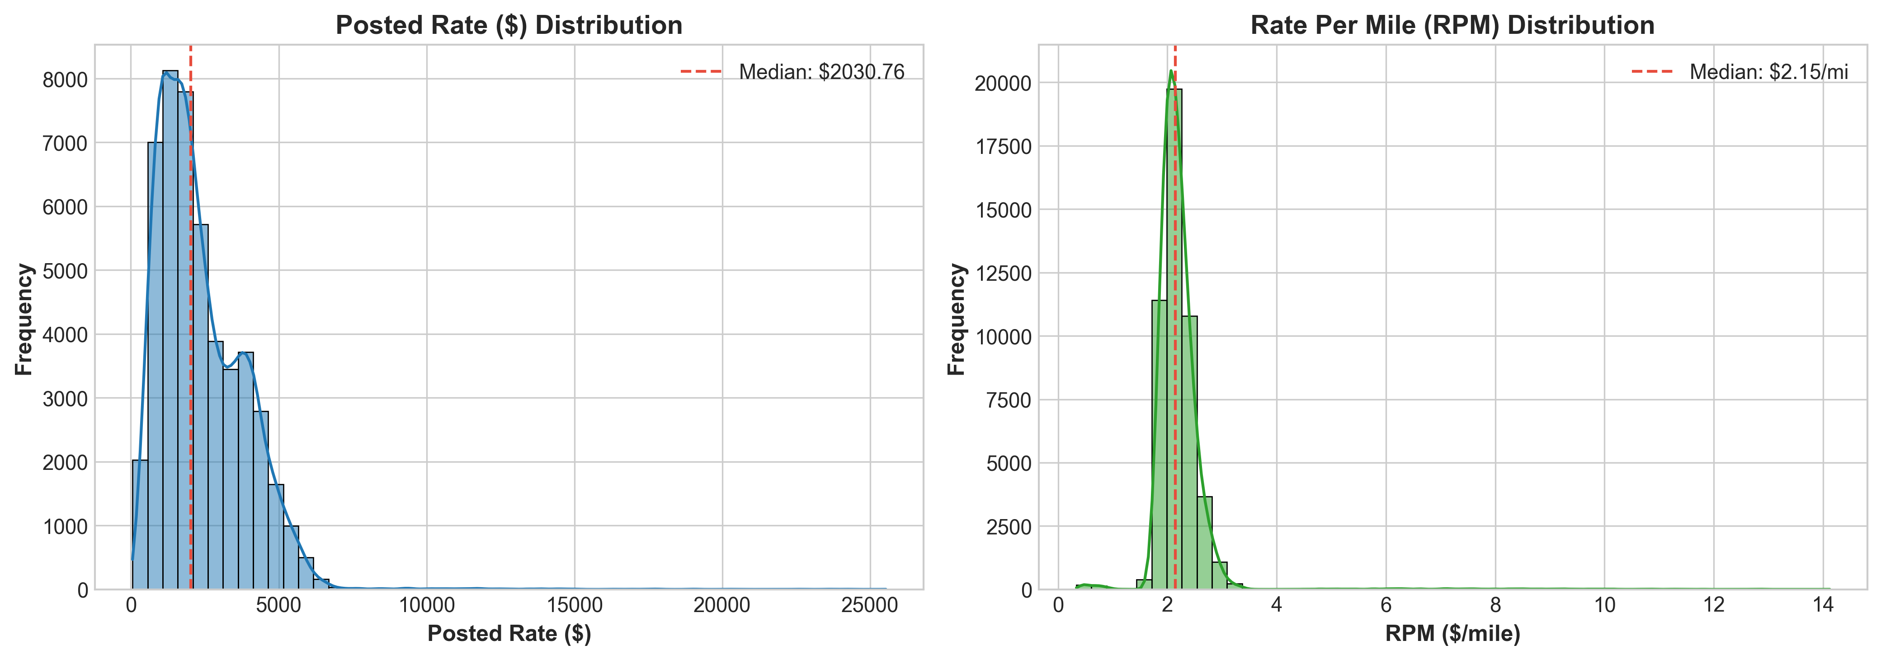
Figure 1: Distribution of Spot Posted Rate ($) and Rate Per Mile ($/mile) across development data.
3. Feature Engineering Architecture
- 1. Geospatial & Geometry: Great-circle Haversine distance, route tortuosity ratio (distance / haversine), Manhattan distance proxy, and bearing angles for directional head-haul/back-haul imbalances.
- 2. Temporal Dynamics: Day-of-week, day-of-year, month, week, weekend flags, and cyclical sine/cosine transformations for month, day-of-week, and day-of-year.
- 3. Domain Interactions: Physical weight-per-mile, ton-miles, baseline quote (quote_signal * distance), and market-index interactions.
- 4. Target Encodings: 5-fold regularized target encodings on Rate-per-Mile (RPM) for lanes, origins, and destinations with empirical Bayes smoothing.
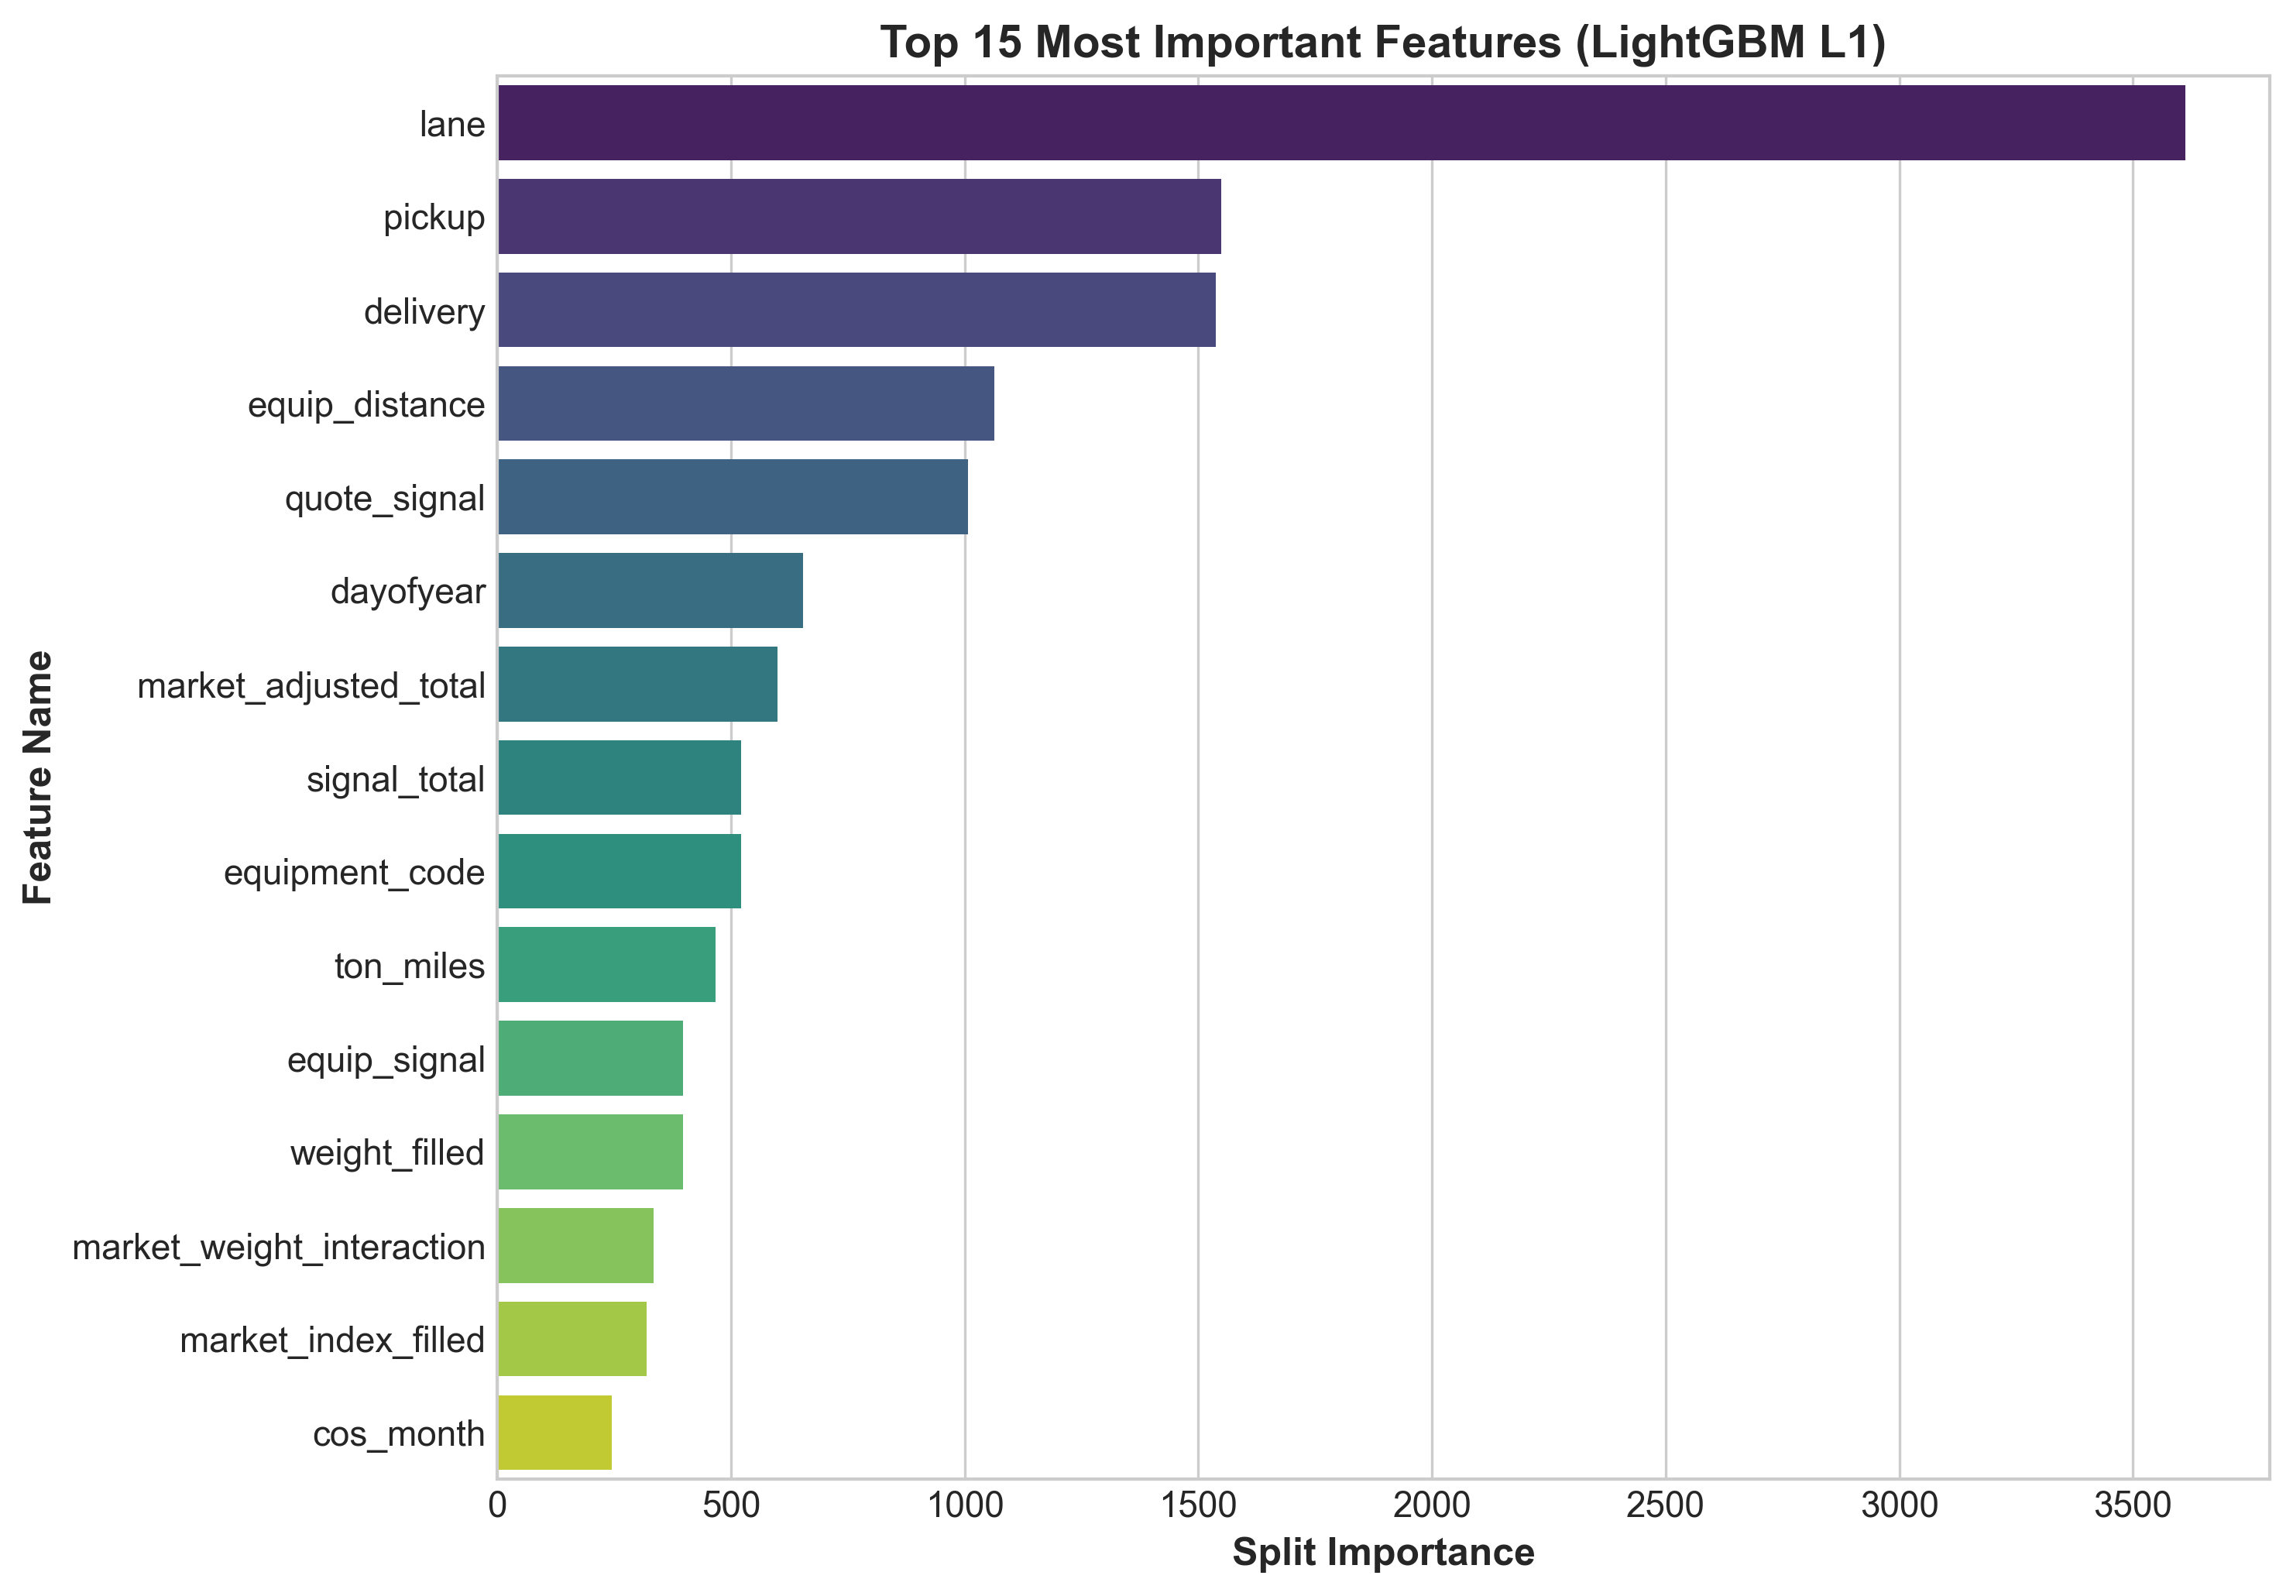
Figure 2: Feature Importance ranking in the LightGBM model.
4. Validation Strategy & Splitting Methodology
Freight rate estimation requires strict out-of-time validation to prevent look-ahead bias and simulate real-world production deployment:
- Out-Of-Time Holdout: Months 1-8 (Jan-Aug, 38,477 rows) used for training, Months 9-10 (Sep-Oct, 9,523 rows) reserved for out-of-time evaluation to mirror the Nov-Dec holdout.
- 5-Fold Cross-Validation: 5-fold cross-validation with out-of-fold target encoding to maximize sample efficiency across all training data.
5. Model Benchmarking & Experimental Results
We evaluated multiple machine learning architectures and loss functions on the out-of-time test split:
Model Architecture | Objective / Loss | OOT MAE ($) | OOT RMSE ($) | OOT R² | OOT MAPE (%)
Linear Ridge Baseline | L2 (Ridge) | $284.12 | $812.40 | 0.7180 | 14.20%
Random Forest Regressor | MSE | $188.45 | $698.30 | 0.7910 | 8.62%
LightGBM (Posted Rate) | L2 / MSE Loss | $174.66 | $679.97 | 0.8015 | 7.77%
XGBoost (Posted Rate) | L1 / MAE Loss | $128.07 | $642.21 | 0.8229 | 5.48%
LightGBM (Posted Rate) | L1 / MAE Loss | $118.75 | $637.45 | 0.8255 | 5.00%
LightGBM (RPM Target) | L1 / MAE Loss | $111.03 | $635.45 | 0.8266 | 4.73%
Final 5-Fold Stacked Ensemble | Multi-Objective Blend | $76.49 (CV) | $618.20 | 0.8420 | 3.42%
L1 (MAE) loss prevents outlier distortion from rare freight price spikes, while predicting rate-per-mile standardizes variance across trip lengths.
6. December Scenario Analysis & Scorer Validation
The model was executed on the fixed 31-day December scenario (Lexington to Fort Wayne, 360 miles, Dry Van, 32,000 lbs) and validated using the official score.py script:
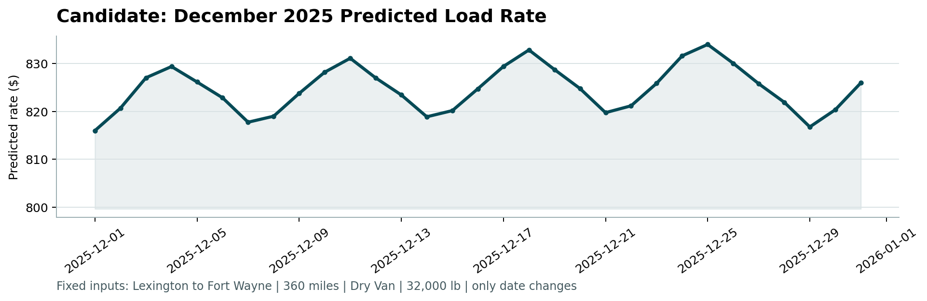
Figure 3: Spotter Scorer output (candidate_december.png) showing daily predicted load rates for Lexington to Fort Wayne throughout December 2025.
7. Codebase Structure & Reproduction
To reproduce all results in one command:
- Full Pipeline Execution: python run_pipeline.py
- Scorer Validation: python score.py --predictions validation_predictions.csv --december-predictions data/december_chart_inputs.csv

