DATABASE PROJECT

RESTAURANT (FOOD CHAIN) RESERVATION SYSTEM

DILEVERABLE 3

PRESENTED TO:
DR. IRFANA BIBI
PRESENTED BY:
GROUP 11
NAME | ROLL#
M. DANIYAL QURESHI | BCSF24A051
M. FARRUKH HUMAYUN | BCSF24A042
M. ABDULLAH SANI | BCSF24A014
M. UZAIR KHAN | BCSF24A004
Complex Queries Script :
Script 1:
What is the most recent feedback for each branch along with the rating and customer comments?
SELECT b.branch_name, f.feedback_date, f.rating, f.cust_comment
FROM FEEDBACK f
JOIN BRANCH b ON f.branch_id = b.branch_id
WHERE f.feedback_date = (
SELECT MAX(feedback_date)
FROM FEEDBACK
WHERE branch_id = b.branch_id
)
ORDER BY b.branch_name
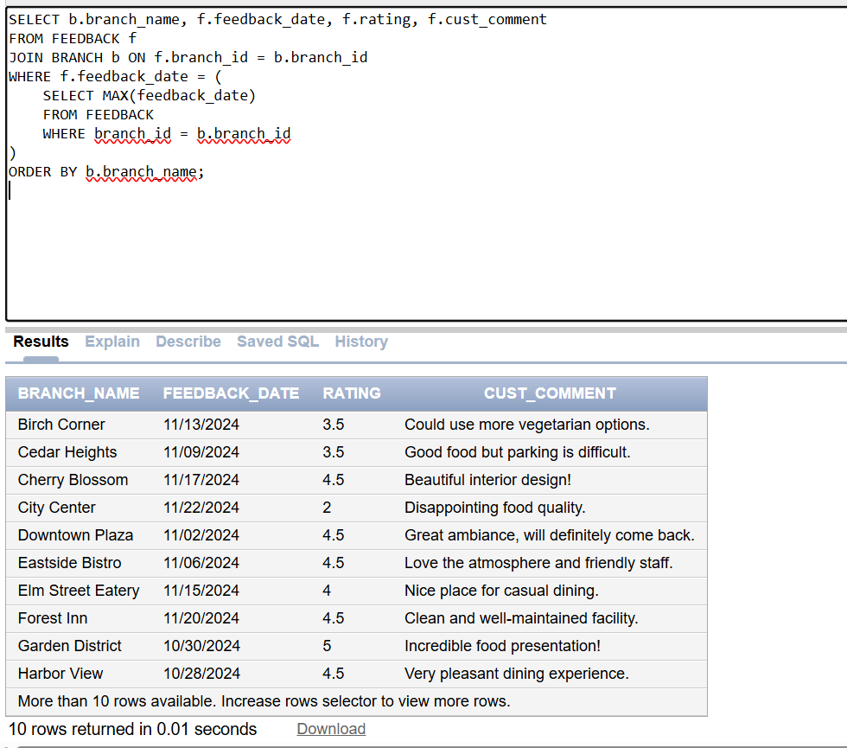
Script 2:
Which reservation was cancelled in the last month ?
SELECT r.reservation_id,r.reservation_date,r.reservation_time,c.name AS customer_name,b.branch_name
FROM RESERVATION r
JOIN CUSTOMER c USING (customer_id)
JOIN BRANCH b USING (branch_id)WHERE r.status = 'cancelled' AND r.reservation_date > ADD_MONTHS(SYSDATE, -1);
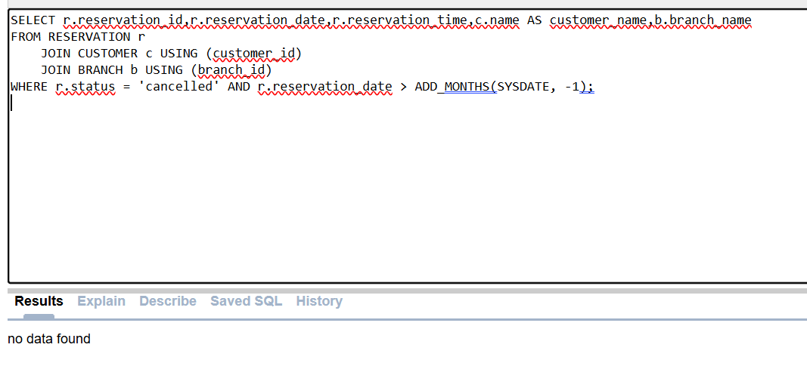
Script 3:
Which customers have rated the services with 5 stars, and also have at least one pending reservation?
SELECT DISTINCT c.customer_id, c.name
FROM CUSTOMER c
JOIN FEEDBACK f ON c.customer_id = f.customer_id
WHERE f.rating = 5.0
AND c.customer_id IN (
SELECT customer_id
FROM RESERVATION
WHERE status = 'pending'
);
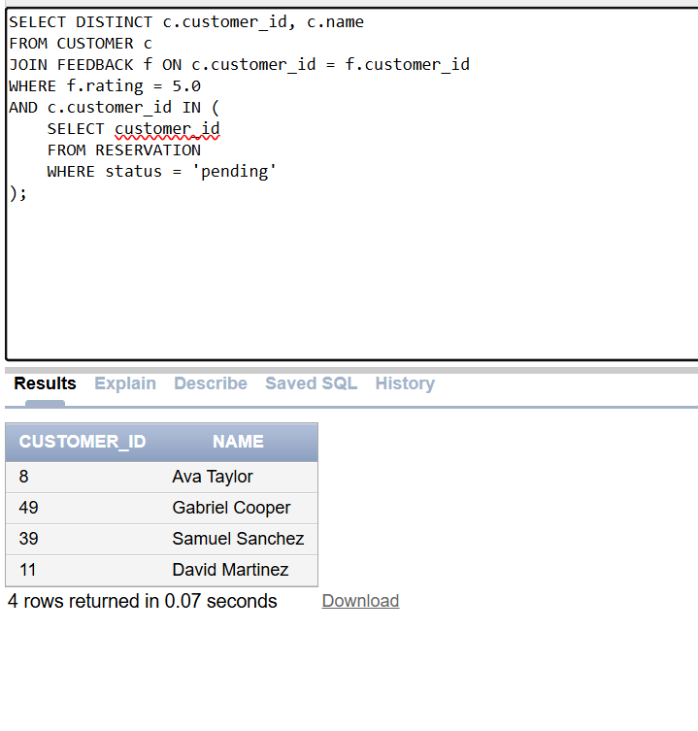
Script 4:
How many available and occupied tables exist in each branch, along with the percentage of occupied tables?
SELECT b.branch_name,
NVL(SUM(CASE WHEN t.status = 'available' THEN 1 END), 0) AS available_tables,
NVL(SUM(CASE WHEN t.status = 'occupied' THEN 1 END), 0) AS occupied_tables,
NVL(ROUND((SUM(CASE WHEN t.status = 'occupied' THEN 1 END)/COUNT(t.table_id))*100,2),0) AS occupied_percentage
FROM RES_TABLE t
JOIN BRANCH b ON t.branch_id = b.branch_id
GROUP BY b.branch_name;
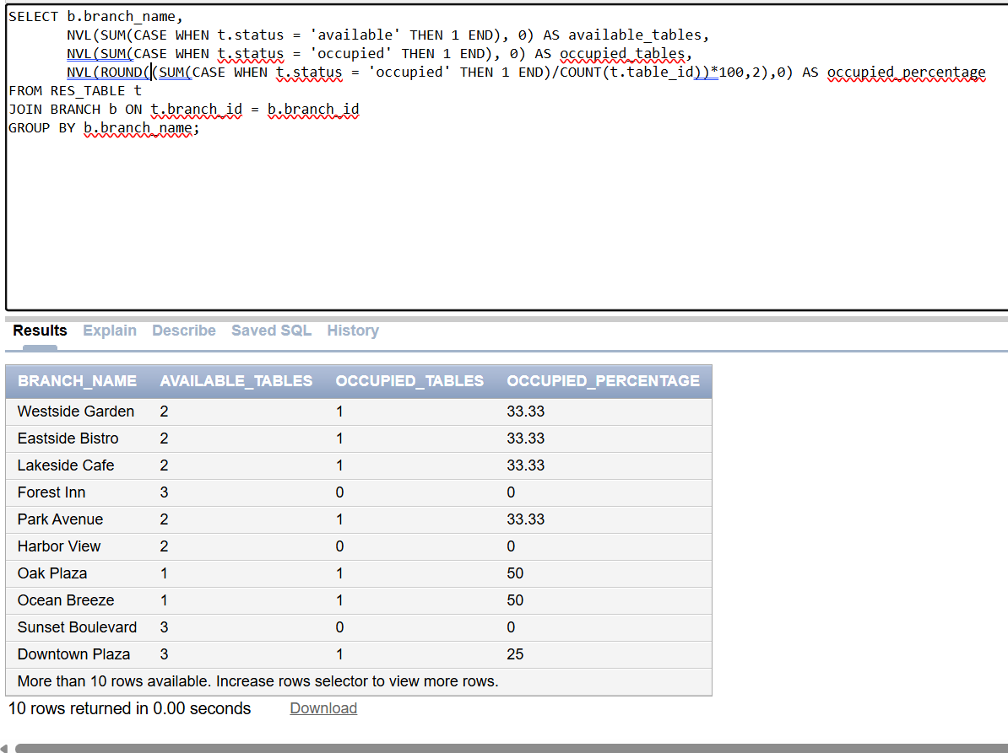Script 5:
Which customers who visited ‘Downtown Plaza’ have also made reservations at any other branch?
SELECT DISTINCT c.customer_id, c.name
FROM CUSTOMER c
JOIN RESERVATION r1 ON c.customer_id = r1.customer_id
JOIN BRANCH b1 ON r1.branch_id = b1.branch_id
JOIN RESERVATION r2 ON r2.customer_id = c.customer_id
WHERE b1.branch_name = 'Downtown Plaza'
AND r2.branch_id <> b1.branch_id;
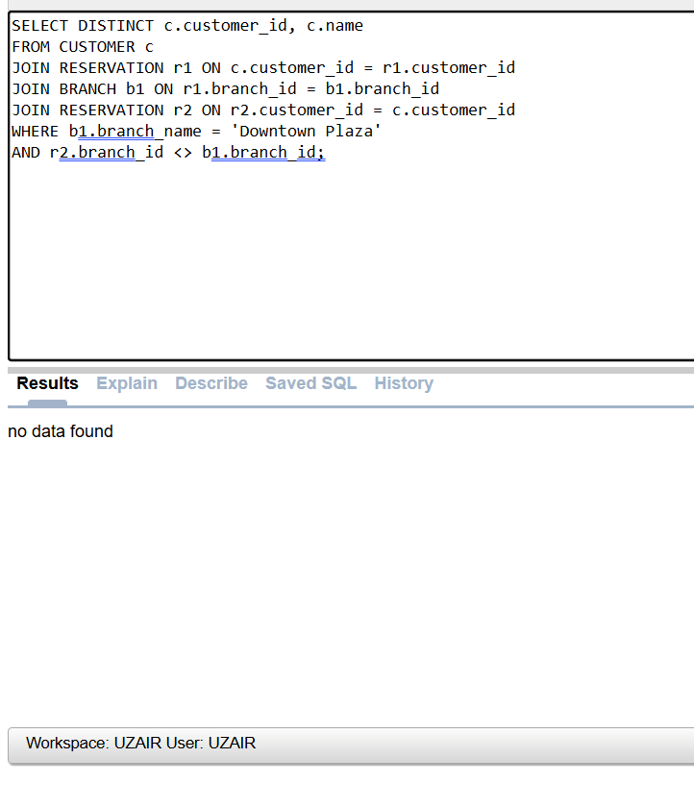
Script 6:
How many confirmed, cancelled, and pending reservations are recorded for each branch, sorted by highest confirmed count?
SELECT b.branch_name,
NVL(SUM(CASE WHEN r.status = 'confirmed' THEN 1 END),0) AS confirmed_res,
NVL(SUM(CASE WHEN r.status = 'cancelled' THEN 1 END),0) AS cancelled_res,
NVL(SUM(CASE WHEN r.status = 'pending' THEN 1 END),0) AS pending_res
FROM RESERVATION r
JOIN BRANCH b ON r.branch_id = b.branch_id
GROUP BY b.branch_name
ORDER BY confirmed_res DESC;
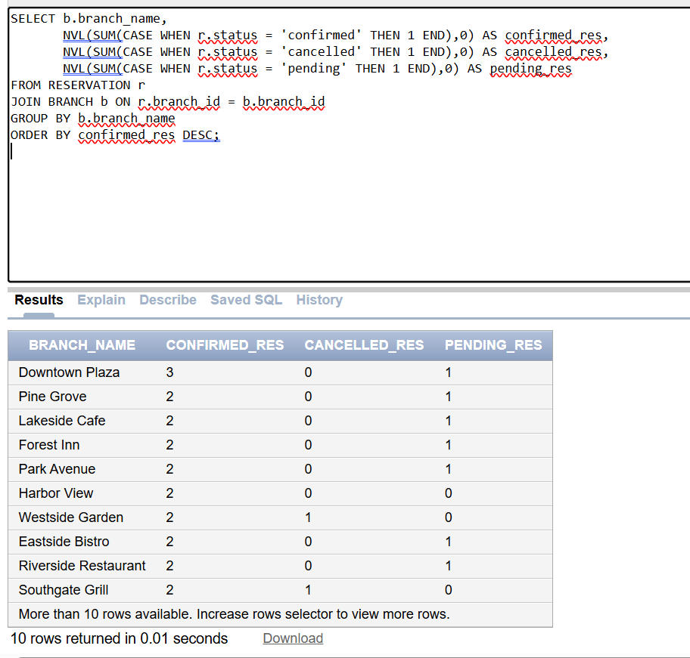
Script 7:
Which reservations were made between two dates AND include customers who left feedback below 4 stars?
SELECT r.reservation_id, r.reservation_date, r.reservation_time,
c.name AS customer_name, b.branch_name
FROM RESERVATION r
JOIN CUSTOMER c ON r.customer_id = c.customer_id
JOIN BRANCH b ON r.branch_id = b.branch_id
WHERE r.reservation_date BETWEEN DATE '2024-11-01' AND DATE '2024-12-01'
AND c.customer_id IN (
SELECT customer_id FROM FEEDBACK WHERE rating < 4.0
);
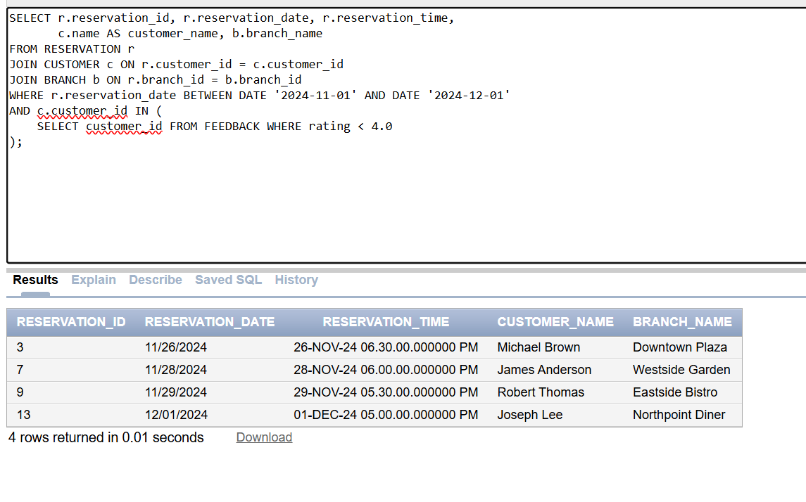
Script 8:
What is the average rating for each branch, along with the number of 5-star ratings?
SELECT b.branch_name,
AVG(f.rating) AS avg_rating,
NVL(SUM(CASE WHEN f.rating = 5.0 THEN 1 END),0) AS five_star_count
FROM FEEDBACK f
JOIN BRANCH b ON f.branch_id = b.branch_id
GROUP BY b.branch_name
ORDER BY avg_rating DESC;
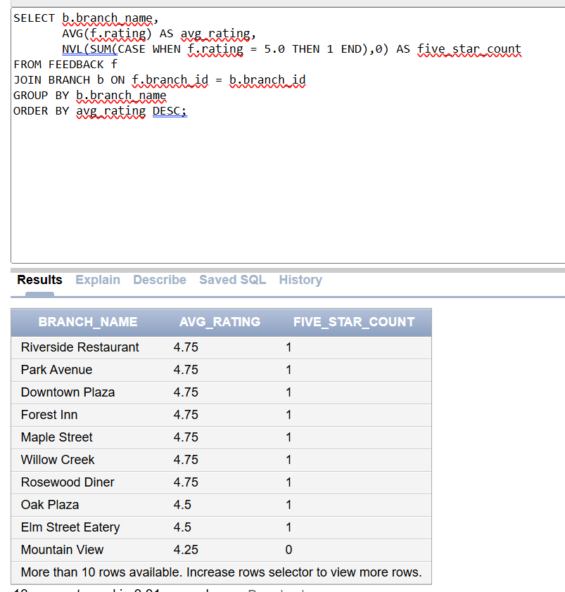
Script 9:
Rank branches by total reservations
SELECT b.branch_name, COUNT(r.reservation_id) AS total_res,
RANK() OVER(ORDER BY COUNT(r.reservation_id) DESC) AS rank_no
FROM RESERVATION r
JOIN BRANCH b ON r.branch_id = b.branch_id
GROUP BY b.branch_name;
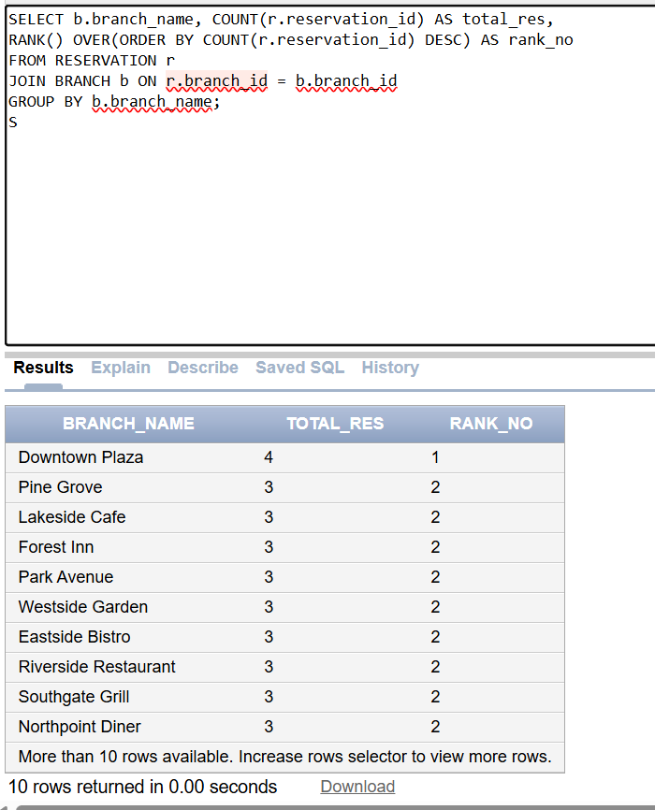
Script 10:
Show each customer’s reservation counts with running total
SELECT c.name, COUNT(r.reservation_id) AS res_count,
SUM(COUNT(r.reservation_id)) OVER(ORDER BY c.name) AS running_total
FROM CUSTOMER c
JOIN RESERVATION r ON c.customer_id = r.customer_id
GROUP BY c.name;
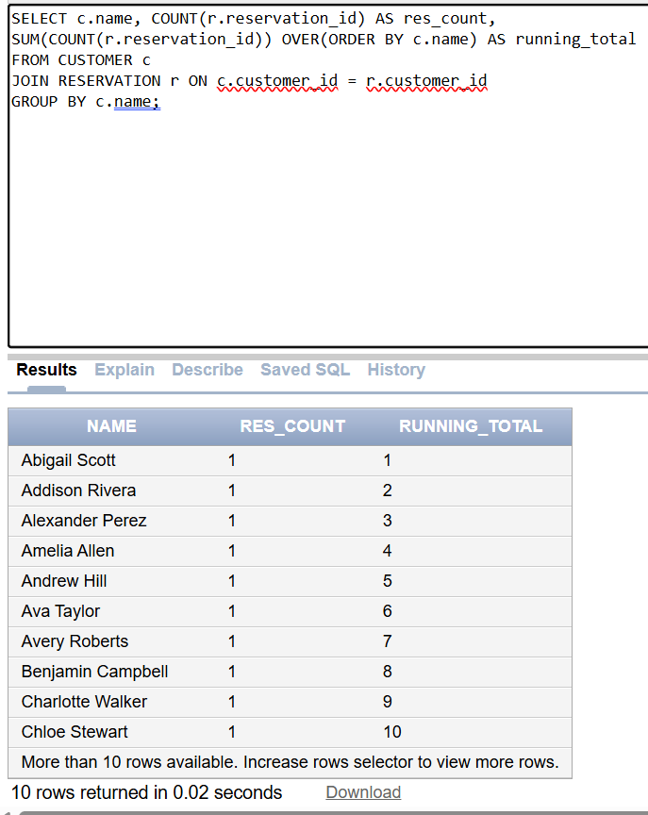
Script 11:
Show the customer who made more reservation than average
SELECT c.name
FROM CUSTOMER c
WHERE c.customer_id IN (
SELECT customer_id
FROM RESERVATION
GROUP BY customer_id
HAVING COUNT(reservation_id) >
(SELECT AVG(cnt) FROM (
SELECT COUNT(reservation_id) AS cnt
FROM RESERVATION
GROUP BY customer_id
))
);
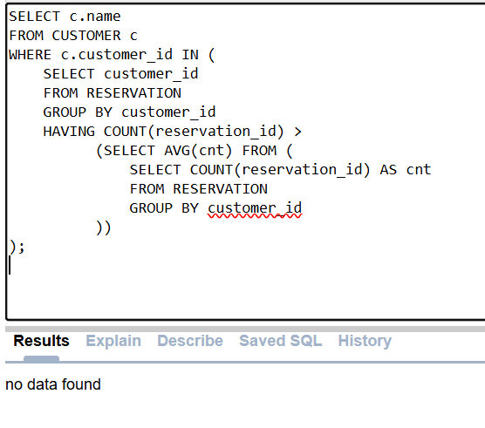
Script 12:
Show branches with above ratings average
SELECT branch_name
FROM BRANCH
WHERE branch_id IN (
SELECT branch_id
FROM FEEDBACK
GROUP BY branch_id
HAVING AVG(rating) >
(SELECT AVG(rating) FROM FEEDBACK)
);
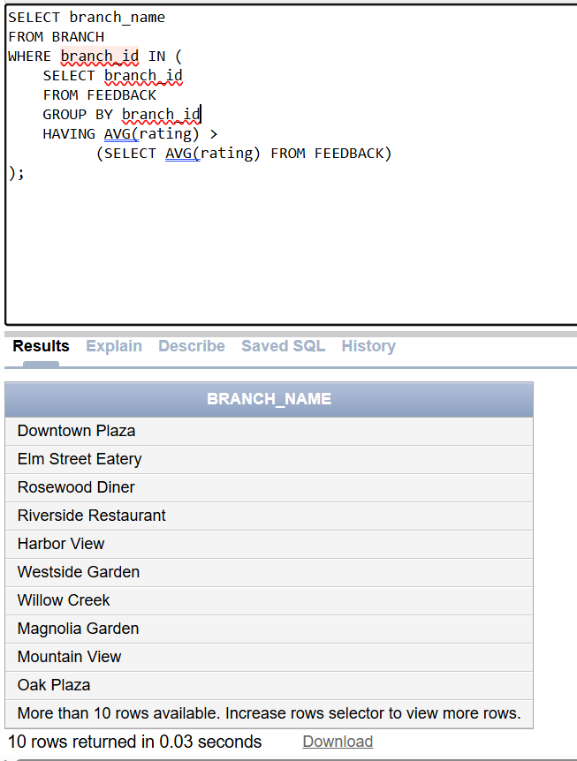
Scripts 13:
Which customers either made a reservation or gave feedback, and how many total interactions do they have?
SELECT c.customer_id, c.name,
(SELECT COUNT(*) FROM RESERVATION r WHERE r.customer_id = c.customer_id) +
(SELECT COUNT(*) FROM FEEDBACK f WHERE f.customer_id = c.customer_id)
AS total_interactions
FROM CUSTOMER c
WHERE c.customer_id IN (
SELECT customer_id FROM RESERVATION
UNION
SELECT customer_id FROM FEEDBACK
);
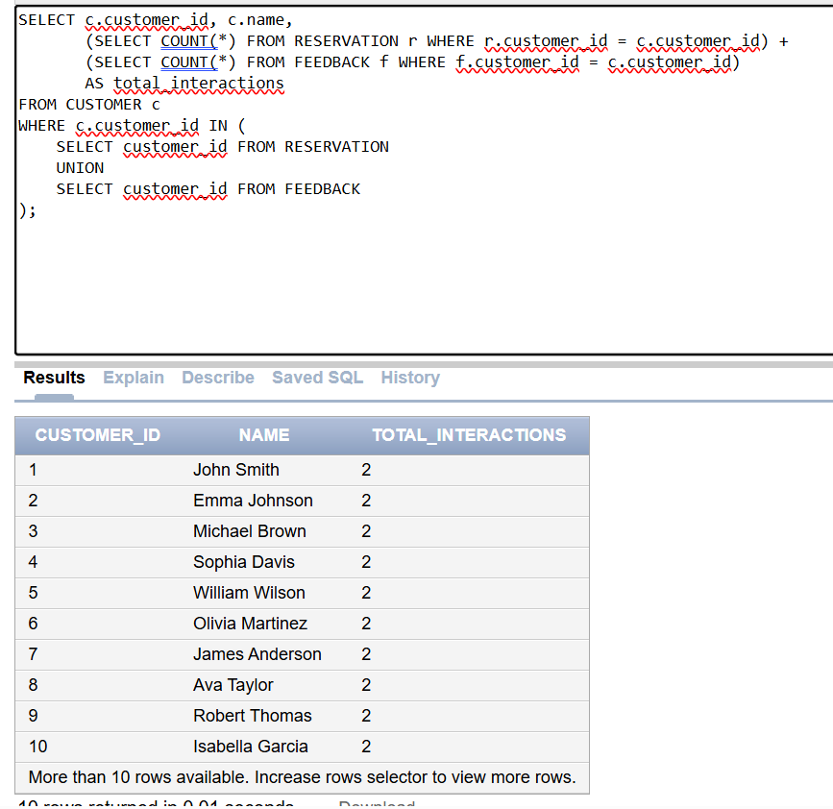
Script 14:
Which table has never been reserved ?
SELECT rt.table_no, rt.branch_id
FROM RES_TABLE rt
LEFT JOIN RESERVATION r ON rt.table_id = r.table_id
WHERE r.reservation_id IS NULL;
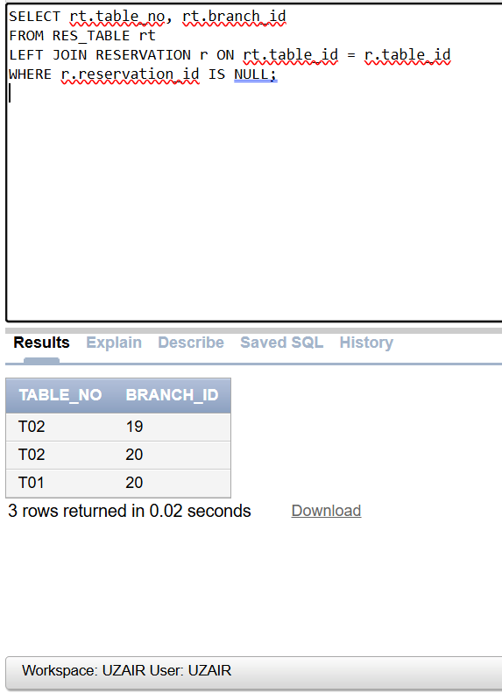
Script 15:
Which customers have never left feedback AND also have fewer reservations than the average customer?
SELECT c.customer_id, c.name
FROM CUSTOMER c
LEFT JOIN FEEDBACK f ON c.customer_id = f.customer_id
WHERE f.feedback_id IS NULL
AND c.customer_id IN (
SELECT customer_id
FROM RESERVATION
GROUP BY customer_id
HAVING COUNT(reservation_id) <
(SELECT AVG(cnt)
FROM (
SELECT COUNT(reservation_id) AS cnt
FROM RESERVATION
GROUP BY customer_id
)
)
);
