**Namal Institute Mianwali**

**Computer Networks Laboratory Manual #11**

**Dynamic Routing**

|  |  |
| --- | --- |
| Name | Muhammad Abrar Hussain |
| Roll No. | **NIM-BSCS-2020-62** |
| Assignment No. | **11** |

|  |  |  |  |
| --- | --- | --- | --- |
| **Course Title** | Computer Networks | **Course Number** | CS – 331 L |
| **Instructor** | Shahzad Arif  shahzad.arif@namal.edu.pk | **Lab Engineer** | Asad Majeed  [asad.majeed@namal.edu.pk](mailto:asad.majeed@namal.edu.pk) |

**Dynamic Routing**

**Dynamic routing**, also called adaptive **routing**, describes the capability of a system, through which routes are characterized by their destination, to alter the path that the route takes through the system in response to a change in conditions.

|  |
| --- |
|  |
| Static routing allows routing tables in specific routers to be set up by the network administrator. Dynamic routing use Routing Protocols that dynamically discover network destinations and how to get to them. Dynamic routing allows routing tables in routers to change if a router on the route goes down or if a new network is added.  In Dynamic Routing, Routing Protocols running in Routers continuously exchange network status updates between each other as broadcast or multicast. With the help of routing updates messages sent by the Routing Protocols, routers can continuously update the routing table when ever a network topology change happens.  Examples of Routing Protocols are Routing Information Protocol (RIP), Enhanced Interior Gateway Routing Protocol (EIGRP) and Open Shortest Path First (OSPF).  There are three basic types of routing protocols.  **Distance-vector Routing Protocols:** Distance-vector Routing Protocols use simple algorithms that calculate a cumulative distance value between routers based on hop count.  Example: Routing Information Protocol Version 1 (RIPv1) and Interior Gateway Routing Protocol (IGRP)  **Link-state Routing Protocols:** Link-state Routing Protocols use sophisticated algorithms that maintain a complex database of internetwork topology.  Example: Open Shortest Path First (OSPF) and Intermediate System to Intermediate System (IS-IS)  **Hybrid Routing Protocols:** Hybrid Routing Protocols use a combination of distance-vector and link-state methods that tries to incorporate the advantages of both and minimize their disadvantages.  Example: Enhanced Interior Gateway Routing Protocol (EIGRP), Routing Information Protocol Version 2 (RIPv2) |

**Important steps for dynamic routing**

**Step # 01** Design the below given network in packet tracer workspace

**Step # 02** Assigning IP address on Fast Ethernet interface of router

**Step # 03** Assigning IP address on serial interface of router

**Step # 04** Assigning IP address on PCs using DHCP

**Step #05** Apply dynamic Routing on Routers

**Step # 06** Verify connectivity among different users (Use ping command)

**Step # 01 Design the below given network in packet tracer workspace**

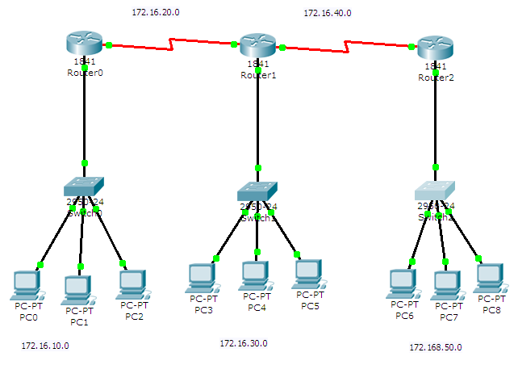

Figure 11.1 shows the network diagram

Table 11.1 shows the list of IP address used in above network

|  |  |  |
| --- | --- | --- |
| **INTERFACE** | **DEVICE** | **IP ADDRESS** |
| Fast Ethernet 0/0 | R1 | 172.16.10.1 |
| Serial 0/1/0 | R1 | 172.16.20.1 |
| Serial 0/1/0 | R2 | 172.16.20.2 |
| Serial 0/1/1 | R2 | 172.16.40.1 |
| Fast Ethernet 0/0 | R2 | 172.16.30.1 |
| Fast Ethernet 0/0 | R3 | 172.16.50.1 |
| Serial 0/1/0 | R3 | 172.16.40.2 |
| Fast Ethernet 0/2 | PC1 | 172.16.10.2 |
| Fast Ethernet 0/3 | PC2 | 172.16.10.3 |
| Fast Ethernet 0/4 | PC3 | 172.16.10.4 |
| Fast Ethernet 0/2 | PC4 | 172.16.30.2 |
| Fast Ethernet 0/3 | PC5 | 172.16.30.3 |
| Fast Ethernet 0/4 | PC6 | 172.16.30.4 |
| Fast Ethernet 0/2 | PC7 | 172.16.50.2 |
| Fast Ethernet 0/3 | PC8 | 172.16.50.3 |
| Fast Ethernet 0/4 | PC9 | 172.16.50.4 |

Step # 02 Assigning IP address on Fast Ethernet interface of router

Router (config) #int fastEthernet 0/0

Router (config-if) #ip address 172.16.10.1 255.255.255.0

Router (config-if) #no shutdown

*Note: Repeat above steps on all Fast Ethernet interfaces of all routers*

**Step # 03 Assigning IP address on serial interface of router**

Router(config)#int serial 0/1/0

Router(config-if)#ip address 172.16.20.1 255.255.255.0

Router(config-if)#no shutdown

Router(config-if)#clock rate 56000

Router(config-if)#exit

*Note: Repeat above steps on all serial interfaces of all routers*

*Note: Clock rate will only be set to DCE end of serial connection but not on DTE end.*

**Step # 04 Assigning IP address on PCs**

Router(config)#

Router(config)#ip dhcp pool IP10

Router(dhcp-config)#network 172.16.10.0 255.255.255.0

Router(dhcp-config)#default-router 172.16.10.1

Router(dhcp-config)#exit

*Note: Repeat above steps on all PCs*

**Step #05 Apply dynamic Routing on Routers**

Router(config)#router rip

Router(config-router)#network 172.16.0.0

Router(config-router)#exit

*Note: Repeat above steps on all routers*

**Step # 06 Verify connectivity among different users (Use ping command)**

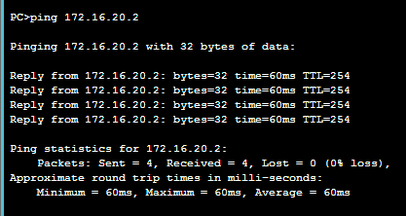

*Note: Repeat above steps on all PCs*

### **Configure OSPF routing on the routers.**

1. Use the **router ospf** command in global configuration mode to enable OSPF on R1.

R1(config)# **router ospf 1**

1. Configure the **network** statements for the networks on R1. Use an area ID of 0.

R1(config-router)# **network 192.168.1.0 0.0.0.255 area 0**

R1(config-router)# **network 10.1.1.0 0.0.0.3 area 0**

1. Configure OSPF on R2 and R3.

R2(config)# **router ospf 1**

R2(config-router)# **network 10.1.1.0 0.0.0.3 area 0**

R2(config-router)# **network 10.2.2.0 0.0.0.3 area 0**

R3(config)# **router ospf 1**

R3(config-router)# **network 10.2.2.0 0.0.0.3 area 0**

R3(config-router)# **network 192.168.3.0 0.0.0.255 area 0**

### Verify OSPF neighbors and routing information.

1. Issue the **show ip ospf neighbor** command to verify that each router lists the other routers in the network as neighbors.

R1# **show ip ospf neighbor**

Neighbor IDPriStateDead TimeAddressInterface

10.2.2.21FULL/BDR00:00:3710.1.1.2GigabitEthernet0/0/0

1. Issue the **show ip route** command to verify that all networks display in the routing table on all routers.

R1# **show ip route**

Codes: L – local, C – connected, S – static, R – RIP, M – mobile, B – BGP

D – EIGRP, EX – EIGRP external, O – OSPF, IA – OSPF inter area

N1 – OSPF NSSA external type 1, N2 – OSPF NSSA external type 2

E1 – OSPF external type 1, E2 – OSPF external type 2

i – IS-IS, su – IS-IS summary, L1 – IS-IS level-1, L2 – IS-IS level-2

ia – IS-IS inter area, * – candidate default, U – per-user static route

o – ODR, P – periodic downloaded static route, H – NHRP, l – LISP

a – application route

+ – replicated route, % – next hop override, p – overrides from PfR

Gateway of last resort is not set

10.0.0.0/8 is variably subnetted, 3 subnets, 2 masks

C10.1.1.0/30 is directly connected, GigabitEthernet0/0/0

L10.1.1.1/32 is directly connected, GigabitEthernet0/0/0

O10.2.2.0/30 [110/2] via 10.1.1.2, 00:01:11, GigabitEthernet0/0/0

192.168.1.0/24 is variably subnetted, 2 subnets, 2 masks

C192.168.1.0/24 is directly connected, GigabitEthernet0/0/1

L192.168.1.1/32 is directly connected, GigabitEthernet0/0/1

O192.168.3.0/24 [110/3] via 10.1.1.2, 00:01:07, GigabitEthernet0/0/

**Lab Exercises:**

**Exercise 1**

Implement RIP on a network consisting of Four routers.

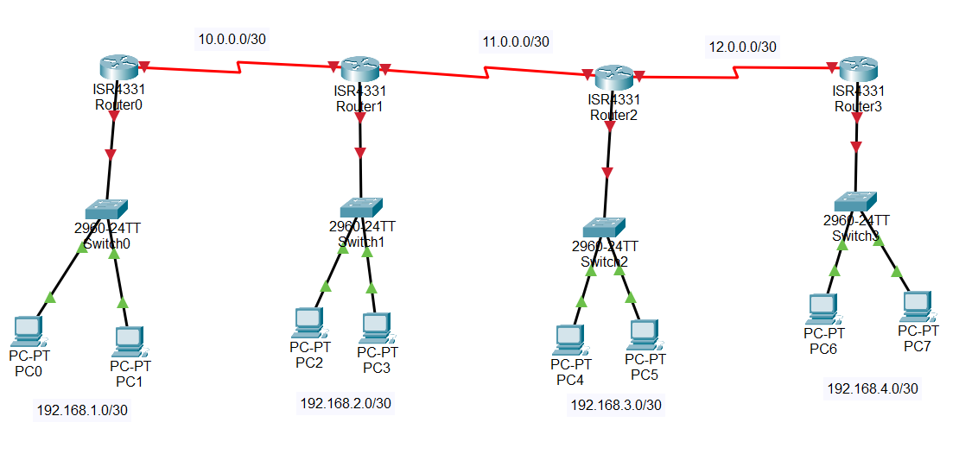

**Snapshot of CLI with routing commands on Router0**

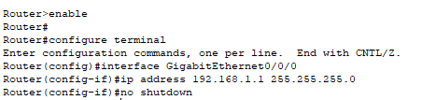

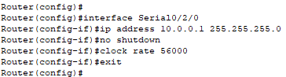

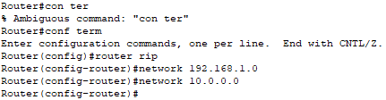

**Snapshot of CLI with routing commands on Router1**

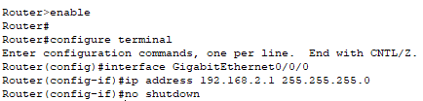

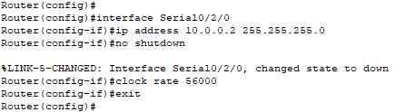

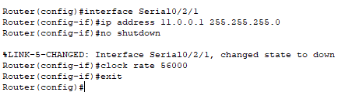

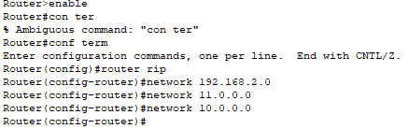

**Snapshot of CLI with routing commands on Router2**

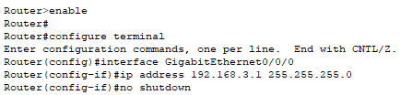

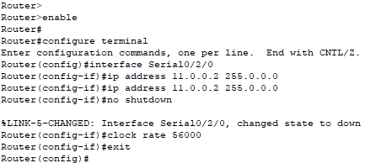

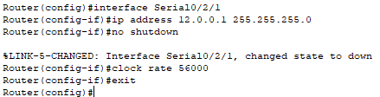

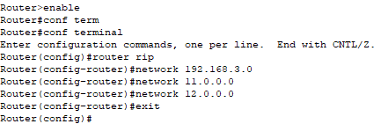

**Snapshot of CLI with routing commands on Router3**

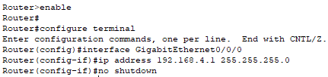

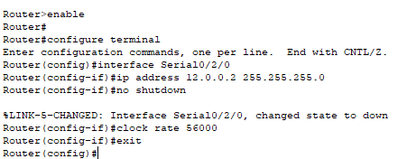

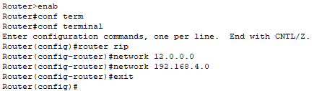

**Ping Responses:**

**Paste the snapshot of Ping from PC 0 to PC2, PC4 and PC6**

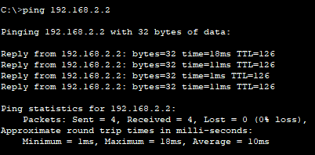

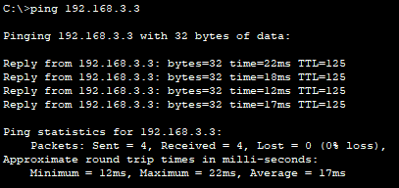

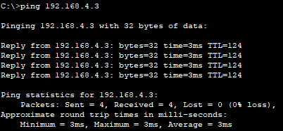

**Exercise 2**

Implement OSPF on a network consisting of Four routers.



**Snapshot of CLI with routing commands on Router0**

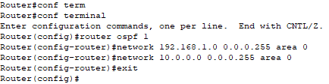

**Snapshot of CLI with routing commands on Router1**

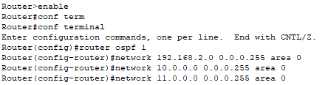

**Snapshot of CLI with routing commands on Router2**

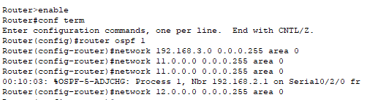

**Snapshot of CLI with routing commands on Router3**



**Ping Responses:**

**Paste the snapshot of Ping from PC 0 to PC2, PC4 and PC6**

Note: attach the **(.pkt)** file for each exercise and upload it to QoBE.

**Rubrics Sheet**

|  |  |
| --- | --- |
| **Task** | **Marks** |
| RIP Configuration | 4 |
| OSPF Configuration | 6 |