**Namal University Mianwali**

**Computer Networks Laboratory Manual #2**

*Introductory Session:* **Introduction to Network Devices i.e. Hubs and Switch**

|  |  |  |  |
| --- | --- | --- | --- |
| Course Title | Computer Networks | Course Number | CS – 270 |
| Instructor | Shahzad Arif   1. shahzad.arif@namal.edu.pk | Lab Engineer | Asad Majeed  asad.majeed@namal.edu.pk |

|  |  |
| --- | --- |
| Submitted BY | Muhammad Abrar Hussain |
| Roll NO. | BSCS-2020-62 |
| Lab NO. | Lab_2 |

1. **Introduction:**

Understanding a complex system is difficult. We try to use divide and concur approach; convert the complex problem into smaller simpler sub-problems easier to understand and easier to optimise. In systems engineering this approach is also termed as Abstraction, based on the principles of Hierarchy, Modularity and Regularity. Therefore, to comprehend the underlying principles and protocols used in today’s massively networked devices, we shall employ the same approach.

By getting our hands dirty on configuring simple network devices, which allow us to share resources, we learn the building blocks of a computer network.

1. **Objective:**

To familiarize oneself with one of the tools such as network simulators to study connectivity of data networks.

The learning objectives of this lab:

* + The students can understand the working of a hub, switch, and router.
  + They can understand the differences between the devices mentioned above.
  + They can implement the networks based on these devices in cisco packet tracer.
  + They can understand the scenario and make decisions about which device is suitable fora particular scenario.
  + They can understand and work on the real and simulated environment of the cisco packet tracer.
  + They can know the real-world scenarios where these devices could implement.

1. **Methodology:**

For the said objective, use of network devices shall be studied / investigated in a simulation environment provided by Cisco’s Packet Tracer [1], which can simulate the device behaviour as close to reality as is required in this course.

Packet Tracer v8.0+ should have been installed in the previous Lab activity, if not done, please ask for Lab Demonstrator for assistance.

**Every activity comprises of Tasks, which need to be performed within the Lab Time, and shown to Lab Demonstrator.**

This laboratory session and subsequent sessions are divided into tasks. Each tasks requires its own setup, configuration and associated learning. You are going to be assessed on the performance in implementing the lab tasks under supervision of Lab Demonstrator. Without further ado, lets get our hands dirty.

**4. Activities**

**Activity A:**

To study the behaviour of **Hub** as the Network Device for connecting several Hosts.

1. Start the Packet Tracer in Simulation Mode. (If you have not installed or configured Packet Tracer in the previous lab, ask Lab Demonstrator for assistance.).
2. Build a logical topology of 5 hosts (PCs) connected via a Hub.
3. Note down the MAC address of each host as well as the interface name to which it is connected to of the HUB in the Table below:

|  |  |  |  |
| --- | --- | --- | --- |
| SR. No. | Host Label | MAC Address of Host | Interface of Hub |
| 1 | PC3 | 0001.4335.1C13 | FastEthernet 0 |
| 2 | PC1 | 00D0.BC06.7622 | FastEthernet 1 |
| 3 | PC4 | 0000.0C2C.8113 | FastEthernet 2 |
| 4 | PC2 | 0004.9AA0.DB20 | FastEthernet 3 |
| 5 | PC10 | 0004.9A27.9457 | FastEthernet 4 |

1. Assign a PDU from one of the hosts to another host, to observe the behaviour of HUB. Is the HUB retransmitting the message in unicast or multicast manner. Note down your observation here.

**Answer:**

I will explain the transmitting process of HUB by a example. Suppose I want to transmit message from PC1 to PC10. Message go from PC1 to HUB, then HUB transmit message to all hosts not only to specific given host. Message will be rejected from all other hosts and reach the target host. In the reponse of message same process occur, as the processor occur of message transmission

**

1. Switch off the Hub and note down the observed behaviour. Does the connect link change colour, if so, can you explain why?

**Answer:**

When we switch off the HUB, wire connection between Hub and hosts change color from green to red and connection break and no transmission of message occur.

1. Change the interface card of one of the hosts to wireless and observe if it could connect to the hub. If not explain the reason.

**Answer:**

When we change the interface of pc to wireless, it not connected with HUB. Because, when we made pc wireless, we change its ethernet cable. Hub only made connection with the ethernet cable. That’s why hub not made connection with host.

1. Activity ends here.

**Activity B:**

To study the behaviour of **Switch** as the Network Device for connecting several Hosts.

1. In the same canvas now build a logical topology of another 5 hosts (PCs) connected via a Switch.
2. Note down the MAC address of each host as well as the interface name to which it is connected to Switch in the Table below:

|  |  |  |  |
| --- | --- | --- | --- |
| SR. No. | Host Label | MAC Address of Host | Interface of Switch |
| 1 | PC8 | 0002.4A02.E6D3 | FastEthernet 0/1 |
| 2 | PC5 | 0060.2F6B.0671 | FastEthernet 0/2 |
| 3 | PC11 | 0001.C73D.9B82 | FastEthernet 0/3 |
| 4 | PC9 | 0030.A365.D49B | FastEthernet 0/4 |
| 5 | PC7 | 00D0.FF18.96AB | FastEthernet 0/5 |

1. Assign a PDU from one of the hosts to another host, to observe the behaviour of switch as compared to the hub. Note down your observation here.

**Answer:**

I will explain the transmitting process of switch by a example. Suppose I want to transmit message from PC5 to PC7. Message go from PC5 to switch, then switch transmit message to specific given host. In the reponse of sending message switch send message to that PC(PC5) from which message gone.

**Therefore, switch work in unicast manner.**

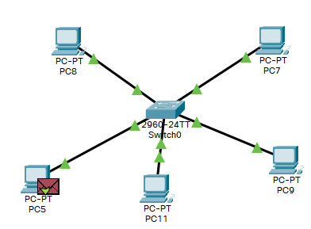

1. Switch on the switch manually and note down the observed behaviour. Does the connect link change colour, if so, can you explain it takes some time to show green triangles?

**Answer:**

When we connect host with switch via wire, in the start wire not fully show green arrow on it. Arrow on wire take time to change into green color from yellow color. Because switch does not made connection immediately, but hub made connection immediately.

1. Change the interface card of one of the hosts to wireless and observe if it could connect to the switch. If not explain the reason.

**Answer:**

When we change the interface of pc to wireless, it not connected with switch. Because, when we made pc wireless, we change its ethernet cable. switch only made connection with the ethernet cable. That’s why hub not made connection with switch.

1. Activity ends here.

**Activity C:**

To study the behaviour of **Wireless Access Point** as the Network Device for connecting several Hosts.

1. In the same canvas now build a logical topology of another 5 hosts (PCs) connected to the hub via wireless access points.

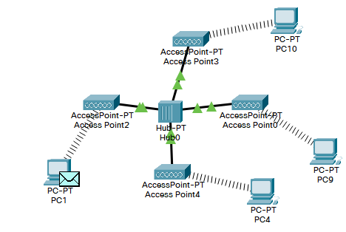

1. Explain how the wireless access point connections are different from the connections in previous two activities.

**Answer:**In the previous two activities we directly connecting wireless host with hub or switch. Therefore, connection cannot build.

In this scenario, we use access point between the wireless host and Hub to create connection and for message transmission. If we do not use access point message cannot be transmitted from one host to another.

1. Write down the MAC address of the new hosts, and interface name of the wireless access point.

|  |  |  |  |
| --- | --- | --- | --- |
| SR. No. | Host Label | MAC Address of Host | Interface of wireless access point. |
| 1 | PC1 | 00D0.BA45.1D88 | Port0 |
| 2 | PC4 | 00E0.A3B4.55B9 | Port0 |
| 3 | PC9 | 0090.2BA8.9939 | Port0 |
| 4 | PC10 | 00E0.A339.ADD5 | Port0 |
| 5 | PC7 | 00D0.FF18.96AB | Port0 |

1. Activity ends here.