|  |  |  |
| --- | --- | --- |
|  | **Namal University Mianwali** |  |
| Computer Networks Laboratory Manual #4 |
|  |
| *Lab title:* **FTP, Email, and DHCP Services** | | |

|  |  |  |  |  |
| --- | --- | --- | --- | --- |
| Course Title | Computer Networks | Course Number | | CS – 270 |
| Instructor | Shahzad Arif  shahzad.arif@namal.edu.pk | Lab Engineer | | Asad Majeed  [asad.majeed@namal.edu.pk](mailto:asad.majeed@namal.edu.pk) |
| Name | | | Muhammad Abrar Hussain | |
| Roll No. | | | BSCS-2020-62 | |
| Assignment No. | | | Four (4) | |

# 1. Introduction:

In the previous lab HTTP and DNS servers were configured. This lab is a continuation of lab #3 in which three more servers shall be experienced. In this lab the students will learn how to transfer files, send and receive emails. In addition, we shall learn the ease of operations by Dynamic Host Configuration Protocol (DHCP).

# 2. Objective:

The learning objectives of this lab:

* The students are able to understand & implement services for:
  + file transfer using the FTP.
  + send / receive email using SMTP, and POP.
  + Dynamic Host Configuration using DHCP.
* Learn basic configuration for the said services.
* Learn the flow of exchange of different types of messages, each demanding own rules for message exchange.
* Learn basic commands used by FTP protocol.
* Observe the structure of message/packet.
* They can discriminate the functions of all the discussed Servers.

# 3. Software/Tool:

* A network simulator by Cisco Packet Tracer is used to conduct practical activities.
* A word processor is used to record observations in the manual.

# 4. Methodology:

For the said objective, use of FTP, Email, and DHCP Servers shall be studied / investigated in a simulation environment provided by Cisco’s Packet Tracer, which can simulate the FTP, Email, and DHCP Servers behaviour as close to reality as is required in this course.

Packet Tracer v8.0+ should have been installed in the previous Lab activity, if not done, please ask for Lab Engineer for assistance.

This laboratory session and subsequent sessions are divided into tasks. Each tasks requires its own setup, configuration and associated learning. You are going to be assessed on the performance in implementing the lab tasks under supervision of Lab Engineer. Without further ado, lets get our hands dirty.

# 5. Activities

## Activity A:

To study the behaviour of FTPServer as the file transfer protocol for accessing and passing files of any type using FTP. In other words, a server use a set of rules defined in the protocol to allow transfer of files between hosts. Remember, a server must be up to provide services to a client – Client-Server pair work in coordination.

1. Build a logical topology of 2 Laptops connected via a switch and then to the FTP Server.

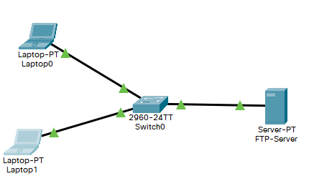

Figure 1: FTP Server in LAN Network

1. Assign each host the IP address according to the Table

Table 1: IP Address for Activity A

|  |  |
| --- | --- |
| **Label** | **IP Address** |
| Laptop0 | 192.168.1.1 |
| Laptop1 | 192.168.1.2 |
| FTP-Server | 192.168.1.3 |

1. Connect Laptop0 to FTP-Server by giving command in Laptop0 command prompt. i.e., ftp 192.168.1.3. Enter user name as well password (cisco) to access the FTP Server services.

**Answer:**

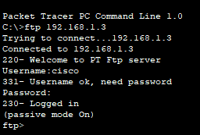

(4) Create a text file on Laptop1; Use the text editor to create a file which is saved by the name **demofile.txt**.

(5) To make it available to other hosts on the network, we place it on the sever. Which means the FTP server needs to be configured for access and sharing. It should run an FTP protocol, and it should be able to authenticate the users which can access the files on it.

* In the services tab of Server, ensure all other services are off, except FTP.
* Add a user named **guest,** with password **guest_980#.**
* Give the guest permission to Read, Write, List only. Tick on the small boxes against the listed names under the username. Since the aim is to share the files, amend it and know if the file is available or not.
* Don't forget to **add** the record in the FTP server. Is the guest added in the list below.

***Observation:***

**Answer:**

In the services tab of the server off all services except FTP. Add username guest, and password **guest_980#** to login into the server and allow permission of reading, writing & list only. Create file demofile.txt on latop_1 & put it into the server by put command. We can access file by get command from ftp server.

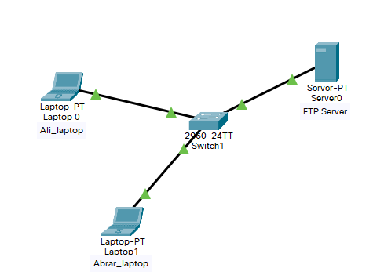

1. Now add a user admin with any password. What permissions shall you give to the admin?

**Answer:**

Now create a file by the name of admin and give passwords 1 to 6. And give permission to reading, write, and rename.

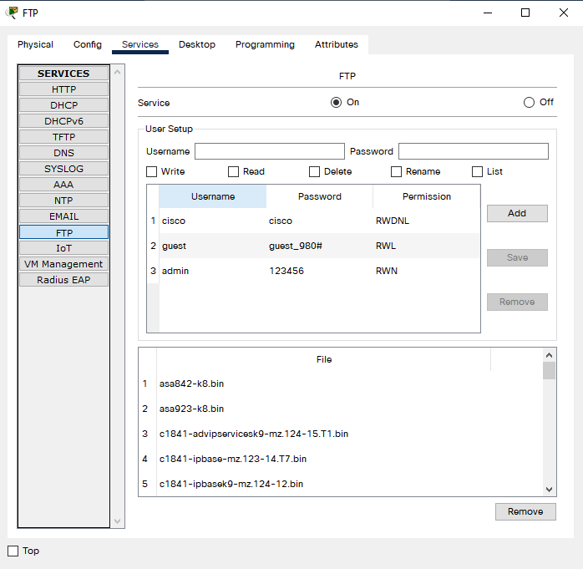

1. 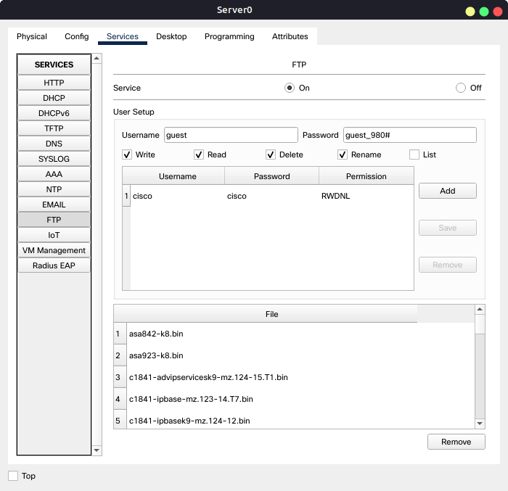From one of the Laptops, the client needs to first login in the FTP server. In the command prompt, type **FTP 192.168.1.3.** Use the credentials made to login the server. Observe the change in command prompt. What did it change into?

***Observation / Reasons:***

After entering the username & password, I log in to the FTP server. Now we can access the file from the server.

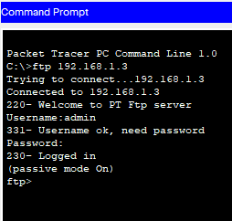

1. To upload the text file created earlier, use the command **put demofile.txt** in the console.
2. Did you observe any information in the console? Note it down, and comment on the observation.

***Observations and Reasons***

**Answer:**

upload the demofile.txt by put command. Screenshot attached below.

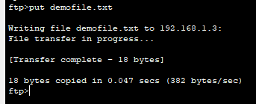

1. On ftp console type **?** and read the commands. Write the purpose of other commands that you see on the console. e.g. get command help to download a file from server. These commands are Microsoft’s implementation in their FTP.

***Observations and Reasons:***

|  |  |  |
| --- | --- | --- |
| **Command** | **Syntax** | **Purpose** |
| Put | Put *filename* | Transfer the file from host to server. |
| get | get *filename* | For transferring a file from remote system to a local machine. |
| cd | cd *location path* | For changing current working directory on remote system. |
| delete | delete *Filename* | Deletes a file. |
| dir | dir | List Files, if connected. |
| quit | quit | Exits from FTP. |
| rename | rename s*,* *oldname*, *newname* | Renames a file. |

**NOTE**: the above commands are only for MS FTP client implementation. What about Linux / Unix FTP clients. Can you check from the internet FTP commands for Linux.

For Linux all the commands are almost same except for few ones.

1. Activity ends here.

## Activity B:

To study the electronic mail transfer mechanism. Obviously, servers need to be configured for Email as well.

1. Build a topology of 3 PCs connected with two servers. Name the two servers as an Email Server and a DNS Server.

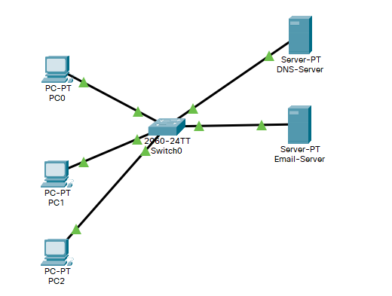

Figure 2: Email server topology in LAN Networks

1. Assign the Ip addresses, and labels as given in the table below.

|  |  |
| --- | --- |
| **Labels** | **Ip Addresses** |
| PC0 | 192.168.1.3 |
| PC1 | 192.168.1.4 |
| PC2 | 192.168.1.6 |
| DNS-Server | 192.168.1.5 |
| Email-Server | 192.168.1.2 |

1. Let’s configure an email service, with the domain name **email.com,** using the SMTP and POP3 protocol for outgoing and incoming email. Email addresses need to be assigned to the respective clients namely, Ibrahim, Taha. We begin by setting up the email clients on the hosts, and then configure the server in the following steps.

|  |  |  |  |  |
| --- | --- | --- | --- | --- |
| **User** | **Email address** | **User Name** | **User Password** | **Domain** |
| Ibrahim | [ibrahim@email.com](mailto:ibrahim@gmail.com) | Ibrahim | ib1234 | email.com, |
| Taha | [taha@email.com](mailto:taha@gmail.com) | Taha | ta123 | email.com, |

1. In the desktop of PC0, click mail client application. A dialogue box opens.
2. Email services by giving **user name, email, and passwords** for each PCs. Make sure to type **email.com** in Incoming and outgoing mail server box.

Example ibrahim[@email.com](mailto:client1@gmail.com) is configured in the Figure.

Note the entry in User Information, Server Information, and Login Information.

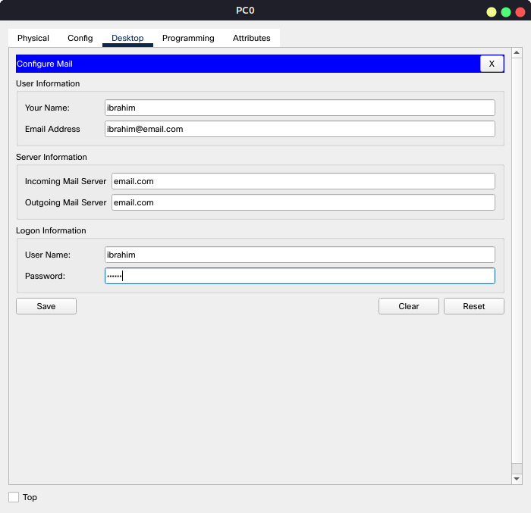

1. Configure rest of the hosts according to the configurations given in the table as follows: Note you need to click each host select email client and enter the details manually.

|  |  |  |  |
| --- | --- | --- | --- |
| **User on PC** | **Email address** | **User Name** | **User Password** |
| Ibrahim (PC0) | [ibrahim@gmail.com](mailto:ibrahim@gmail.com) | Ibrahim | ib1234 |
| Taha (PC1) | [taha@gmail.com](mailto:taha@gmail.com) | Taha | ta123 |
|  |  |  |  |

1. Now configure Email-Server. Enable the **SMTP** and **POP3** services. Add user name and passwords under the USER SETUP tab.

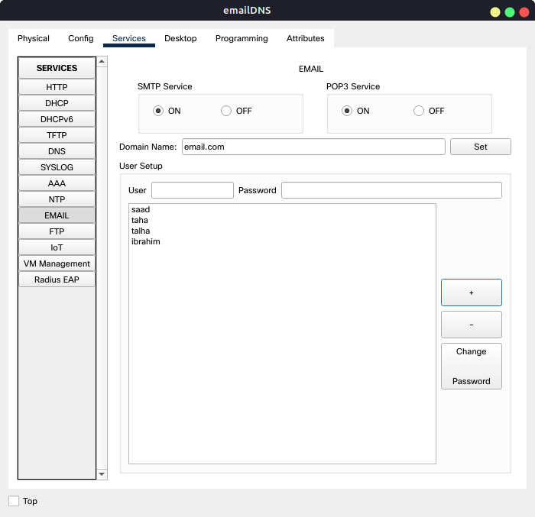

1. Since we already know, any name given must be resolved first, so the name email.com must be resolved by a DNS server. So a DNS server needs to be setup so that the hosts know what it means to be **email.com**.
2. Enable the DNS services in a DNS-Server (preferably a separate server with a separate IP address given earlier).

Do not forget to configure each host to know the IP address of DNS server.

1. Now compose email on PC0 and send it to PC1. Enter the recipients email address, title of email, and body of email. Type test or something.

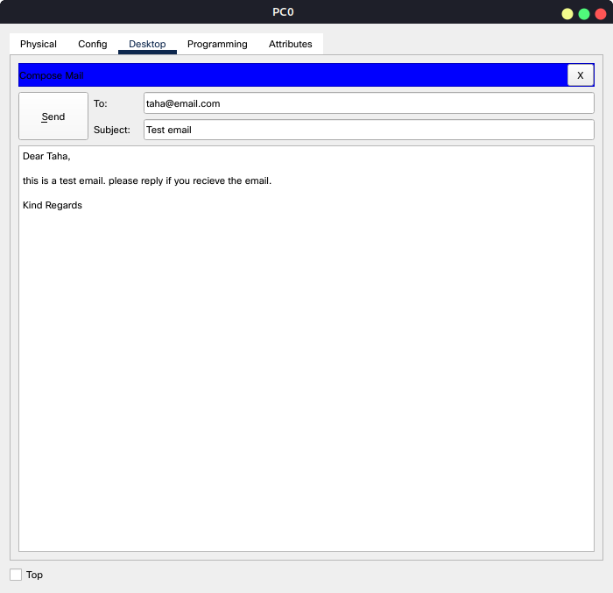

1. Select the host on which Taha email account is configured. Open email client, and note no email is received. Click receive button. Did you receive the email? ***Attach the screenshot here.***

**Answer:**

Send e-mail from PC0 to PC1 it received on PC1 to taha. Screenshot is attached below.

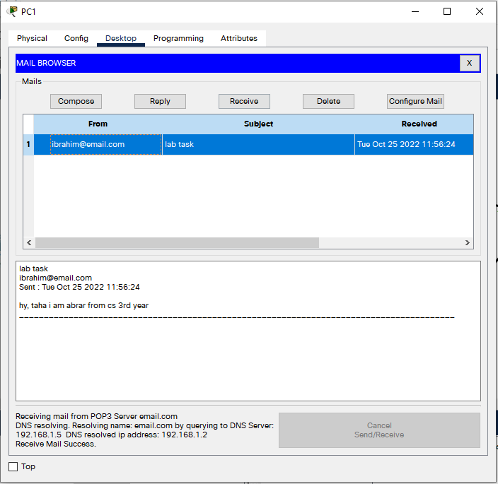

1. If we send an email to [client5@email.com](mailto:client5@mail.com). What happens? Do you see any error messages the Email client. Which error message you have shown paste it here and give your comments.

***Observations and Reasons***

**Answer:**

Successfully email sends to [client5@email.com](mailto:client5@email.com). As shown in the screen below. Not occur error because our pc did not identify any mail present or not of this kind. It sends mail receiver present or not.

But if we check our receiving box, we will see a warning email telling us that user is not available on the email server.

The message in the mail was:

“Delivery to the following recipient failed permanently:

client5@email.com

Technical details of permanent failure:

***Server tried to deliver your message, but it was rejected by the recipient domain. We recommend contacting the other email provider for further information about the cause of this error. The error that the other server returned was: 550 550-5.1.1 The email account that you tried to reach does not exist. Please try***

550-5.1.1 double-checking the recipient's email address for typos or

550-5.1.1 unnecessary spaces”.

So, in simple words, if our receiver is present in the email server then email will be sent successfully, otherwise it will be rejected.

Below is the screenshot of the message thrown when we try to email [client5@email.com](mailto:client5@email.com):

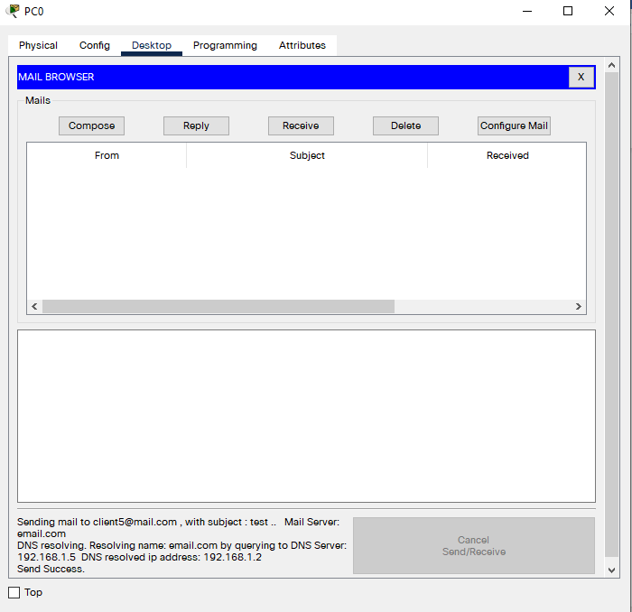

1. Repeat the above steps by disabling the SMTP and POP3 services in the Email-Server. Are you able to send the email from PC0 to PC1? If no then state your reasons below.

***Observations and Reasons***

**Answer:**

After off POP3 and SMTP functionality, we cannot receive and send mail. Because, SMTP use to send mail from one host to another. POP3 use to receive mail from one host to another.

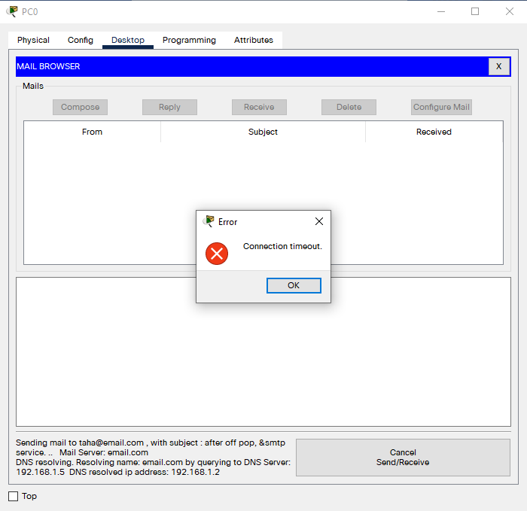

1. Activity end here

## Activity C:

To learn DHCP configurations which ease host configurations dynamically.

1. Build a topology of 4 PCS connected to a DHCP-Server via a switch.

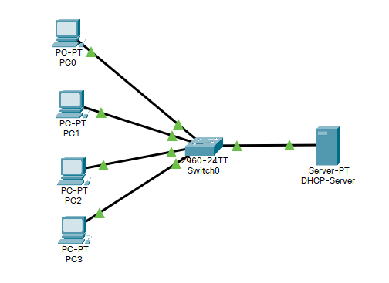

Figure 3: DCHP- Server implementation in LAN Networks

1. To automatically get an IP address, we need to first configure, DHCP server. We need to tell the DHCP server the pool of IP address which can be used to assign host IP address, also the static IP address of DNS server. Do not forget to save the entries.
2. Enable DHCP services in the DHCP-Server services tab. Assign a gateway address (**0.0.0.0**), and start Ip address (**192.168.1.10**), and place **10** as number of users of your network for our lab. It can be varied based on the LAN network size. Click on **Save** button. The configurations will be added. Note the changes in entries at the bottom.
3. DHCP server itself needs an IP address, which can be setup under the config tab, the interface. Select manual or static IP address here. Assign **192.168.1.1**.
4. Now click on PC0 and enable DHCP service instead of assigning static Ip address as we were doing so far. What happens when you enable DHCP service? Wait for a few seconds for the magic.

***Observations and Reasons***

**Answer:**

When we enable the DHCP functionality of pc it automatically assigns the IP address to the pc. A DHCP server automatically assigns an IP address to the PC. We do not need to add manually.

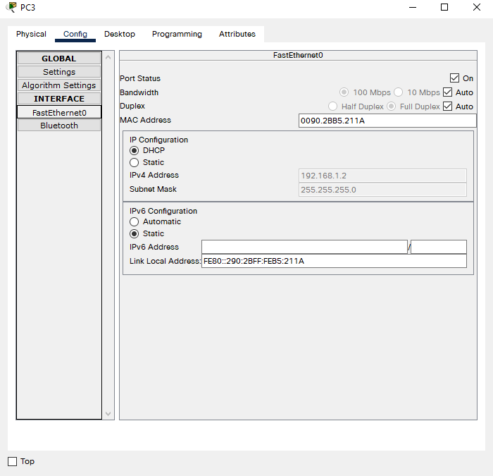

1. Now assign a static Ip address to DHCP-Server before enable the DHCP services. Click on each host and enable the DHCP services again. What results you see. What things are common in each hosts and what are different? Write your observations below:

***Observations and Reasons***

**Answer:**

If we turn off DHCP configuration in a DHCP server, then IP address assigned to the PCs will be removed. But when we turn it on then again IP address will be assigned to the PCs.

The different thing in host is the IP address. Each host will be given unique and different IP address.

The common things in the host are subway mask and default gateway ID.

1. Activity ends here.