**Namal Institute Mianwali**

# Computer Networks Laboratory Manual #10

**Static Routing**

|  |  |  |  |
| --- | --- | --- | --- |
| **Course Title** | Computer Networks | **Course Number** | CS – 331 L |
| **Instructor** | Shahzad Arif  shahzad.arif@namal.edu.pk | **Lab Engineer** | Asad Majeed  [asad.majeed@namal.edu.pk](mailto:asad.majeed@namal.edu.pk) |

# Static Routing

Static routing is a form of routing that occurs when a router uses a manually configured routing entry, rather than information from a dynamic routing traffic.

Routers forward packets using either route information from route table entries that you manually configure or the route information that is calculated using dynamic routing algorithms.

IP route command is used to configure the static route. In this article we will explain IP route command and its parameters in details. Static routing is useful in small network where numbers of routes are limited. In static routing we need to add route manually with IP route command. Like other routing methods static routing also has its pros and cons.

# Advantage of static routing

* It is easy to implement.
* It is most secure way of routing, since no information is shared with other routers.
* It puts no overhead on resources such as CPU or memory.

# Disadvantage of static routing

* It is suitable only for small network.
* If a link fails static route cannot reroute the traffic.

Static routes, which define explicit paths between two routers, cannot be automatically updated; you must manually reconfigure static routes when network changes occur. Static routes use less bandwidth than dynamic routes. No CPU cycles are used to calculate and analyze routing updates.

You can supplement dynamic routes with static routes where appropriate. You can redistribute static routes into dynamic routing algorithms but you cannot redistribute routing information calculated by dynamic routing algorithms into the static routing table.

You should use static routes in environments where network traffic is predictable and where the network design is simple. You should not use static routes in large, constantly changing networks because static routes cannot react to network changes. Most networks use dynamic routes to communicate between routers but might have one or two static routes configured for special cases. Static routes are also useful for specifying a gateway of last resort (a default router to which all unroutable packets are sent).

# Important steps for static routing

**Step # 01** Design the below given network in packet tracer workspace

**Step # 02** Assigning IP address on Fast Ethernet interface of router

**Step # 03** Assigning IP address on serial interface of router

**Step # 04** Assigning IP address on PCs

**Step #05** Apply static Routing on Routers

**Step # 06** Verify connectivity among different users (Use ping command)

**Step # 01 Design the below given network in packet tracer workspace**

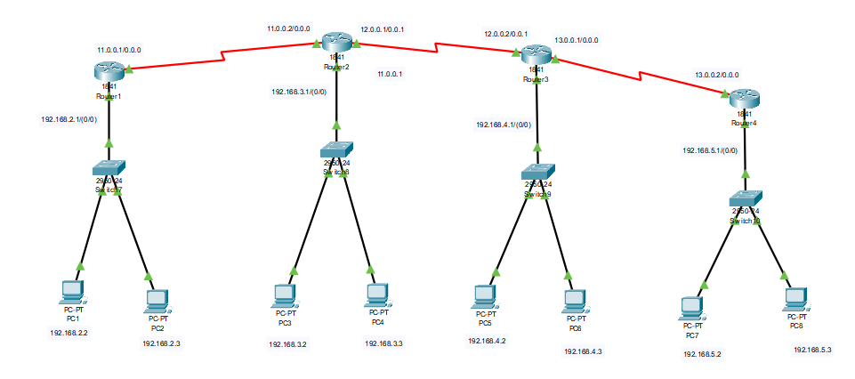

Figure 7.1 shows the network diagram

Table 7.1 shows the list of IP address used in above network

|  |  |  |
| --- | --- | --- |
| **INTERFACE** | **DEVICE** | **IP ADDRESS** |
| Fast Ethernet 0/0 | R1 | 192.168.2.1 |
| Serial 0/0/0 | R1 | 11.0.0.1 |
| Fast Ethernet 0/2 | PC1 | 192.168.2.2 |
| Fast Ethernet 0/3 | PC2 | 192.168.2.3 |
|  |  |  |
| Fast Ethernet 0/0 | R2 | 192.168.3.1 |
| Serial 0/0/0 | R2 | 11.0.0.2 |
| Serial 0/0/1 | R2 | 12.0.0.1 |
| Fast Ethernet 0/2 | PC3 | 192.168.3.2 |
| Fast Ethernet 0/3 | PC4 | 192.168.3.3 |
|  |  |  |
| Fast Ethernet 0/0 | R3 | 192.168.4.1 |
| Serial 0/0/1 | R3 | 12.0.0.2 |
| Serial 0/0/0 | R3 | 13.0.0.1 |
| Fast Ethernet 0/2 | PC5 | 192.168.4.2 |
| Fast Ethernet 0/3 | PC6 | 192.168.4.3 |
|  |  |  |
| Fast Ethernet 0/0 | R4 | 192.168.5.1 |
| Serial 0/0/0 | R4 | 13.0.0.2 |
| Fast Ethernet 0/2 | PC7 | 192.168.5.2 |
| Fast Ethernet 0/3 | PC8 | 192.168.5.3 |

**Step # 02 Assigning IP address on Fast Ethernet interface of router**

Router (config) #int fastEthernet 0/0

Router (config-if) #ip address 192.168.2.1 255.255.255.0

Router (config-if) #no shutdown

*Note: Repeat above steps on all Fast Ethernet interfaces of all routers*

**Step # 03 Assigning IP address on serial interface of router**

Router(config)#int serial 0/0/0

Router(config-if)#ip address 11.0.0.1 255.255.255.0

Router(config-if)#no shutdown

Router(config-if)#exit

*Note: Repeat above steps on all serial interfaces of all routers*

*Note: Clock rate will only be set to DCE end of serial connection but not on DTE end.*

**Step # 04 Assigning IP address on PCs**

Go to Desktop 🡪 IP configuration and enter the following:

IP address 🡪 192.168.2.2

Subnet Mask 🡪255.255.255.0

Default Gateway 🡪192.168.2.1

*Note: Repeat above steps on all PCs*

**Step #05 Apply static Routing on Routers**

Router (config) ip route destination network subnet mask next- hop

Router (config)#ip route 192.168.3.1 255.255.255.0 11.0.0.2

*Note: Repeat above steps on all routers*

**Step # 06 Verify connectivity among different users (Use ping command)**

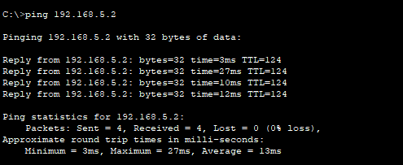

*Note: Repeat above steps on all PCs*

**Exercise:**

Using different IP address design 8 networks with minimum two users in each network and apply static routing. Make a table of all IP addresses of routers and PCs as given in this experiment.

Task to do

* Show ip configuration
* Show Ping Responses

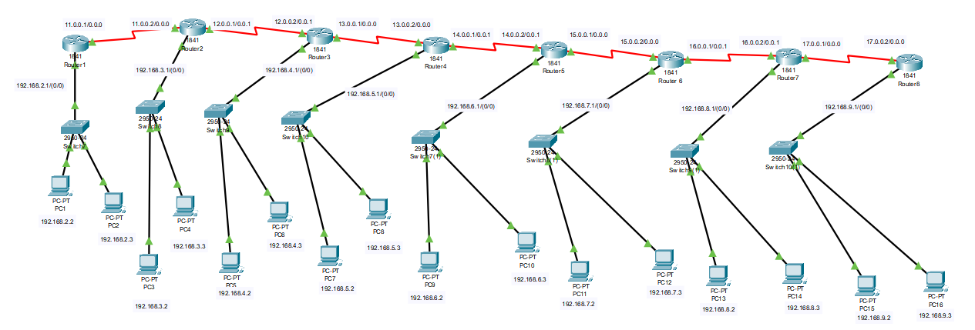

**IP Configuration:**

The list of IP addresses used in the above network.

|  |  |  |
| --- | --- | --- |
| **INTERFACE** | **DEVICE** | **IP ADDRESS** |
| Fast Ethernet 0/0/0 | R1 | 192.168.2.1 |
| Serial 0/2/0 | R1 | 11.0.0.1/24 |
| Fast Ethernet 0/2 | PC0 | 192.168.2.2 |
| Fast Ethernet 0/3 | PC1 | 192.168.2.3 |
|  |  |  |
| Fast Ethernet 0/0/0 | R2 | 192.168.3.1 |
| Serial 0/2/0 | R2 | 11.0.0.2/24 |
| Serial 0/2/1 | R2 | 12.0.0.1/24 |
| Fast Ethernet 0/2 | PC2 | 192.168.3.2 |
| Fast Ethernet 0/3 | PC3 | 192.168.3.3 |
|  |  |  |
| Fast Ethernet 0/0/0 | R3 | 192.168.4.1 |
| Serial 0/2/1 | R3 | 12.0.0.2/24 |
| Serial 0/2/0 | R3 | 13.0.0.1/24 |
| Fast Ethernet 0/2 | PC4 | 192.168.4.2 |
| Fast Ethernet 0/3 | PC5 | 192.168.4.3 |
|  |  |  |
| Fast Ethernet 0/0/0 | R4 | 192.168.5.1 |
| Serial 0/2/0 | R4 | 13.0.0.2/24 |
| Serial 0/2/1 | R4 | 14.0.0.1/24 |
| Fast Ethernet 0/2 | PC6 | 192.168.5.2 |
| Fast Ethernet 0/3 | PC7 | 192.168.5.3 |
|  |  |  |
| Fast Ethernet 0/0/0 | R5 | 192.168.6.1 |
| Serial 0/2/1 | R5 | 14.0.0.2/24 |
| Serial 0/2/0 | R5 | 15.0.0.1/24 |
| Fast Ethernet 0/2 | PC8 | 192.168.6.2 |
| Fast Ethernet 0/3 | PC9 | 192.168.6.3 |
|  |  |  |
| Fast Ethernet 0/0/0 | R6 | 192.168.7.1 |
| Serial 0/2/0 | R6 | 15.0.0.2/24 |
| Serial 0/2/1 | R6 | 16.0.0.1/24 |
| Fast Ethernet 0/2 | PC10 | 192.168.7.2 |
| Fast Ethernet 0/3 | PC11 | 192.168.7.3 |
|  |  |  |
| Fast Ethernet 0/0/0 | R7 | 192.168.8.1 |
| Serial 0/2/1 | R7 | 16.0.0.2/24 |
| Serial 0/2/0 | R7 | 17.0.0.1/24 |
| Fast Ethernet 0/2 | PC12 | 192.168.8.2 |
| Fast Ethernet 0/3 | PC13 | 192.168.8.3 |
|  |  |  |
| Fast Ethernet 0/0/0 | R8 | 192.168.9.1 |
| Serial 0/2/0 | R8 | 17.0.0.2/24 |
| Fast Ethernet 0/2 | PC14 | 192.168.9.2 |
| Fast Ethernet 0/3 | PC15 | 192.168.9.3 |

**Ping Responses:**

**Ping from PC 1 to PC3, PC5, PC7, PC9, PC11, PC13, PC15**

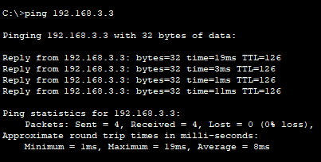

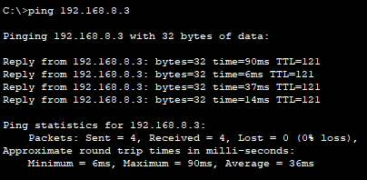

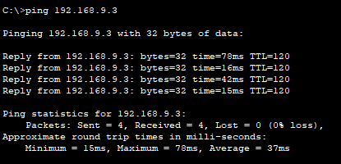

**Ping from PC15 to PC1, PC3, PC5, PC7, PC9, PC11, PC13**

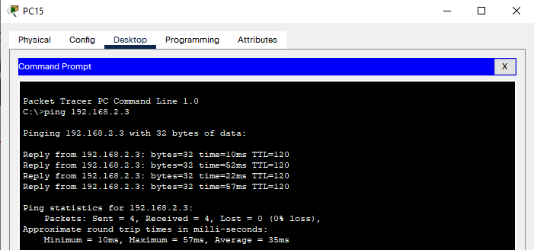

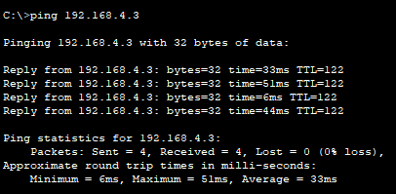

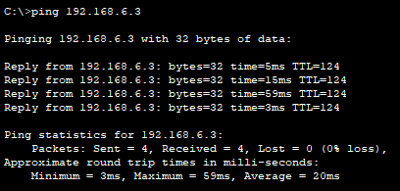

Note: Attach the solution here also upload the **(.pkt)** file to QoBE.

.pkt file attach in same zip file.

**Rubrics Sheet**

|  |  |
| --- | --- |
| **Activities** | **Marks** |
| **Static Routing Configuration on Routers** | **8** |
| **Ping Response Screenshots** | **2** |