OBJECTIVE
Enthusiastic and hardworking final-year Computer Science student seeking an entry-level position to start my professional journey in the tech industry. Eager to learn, grow, and gain hands-on experience while contributing to a team environment. Committed to developing my skills and adapting to new technologies.
Matriculation (2019)
EDUCATION HISTORY
CAREER INTEREST
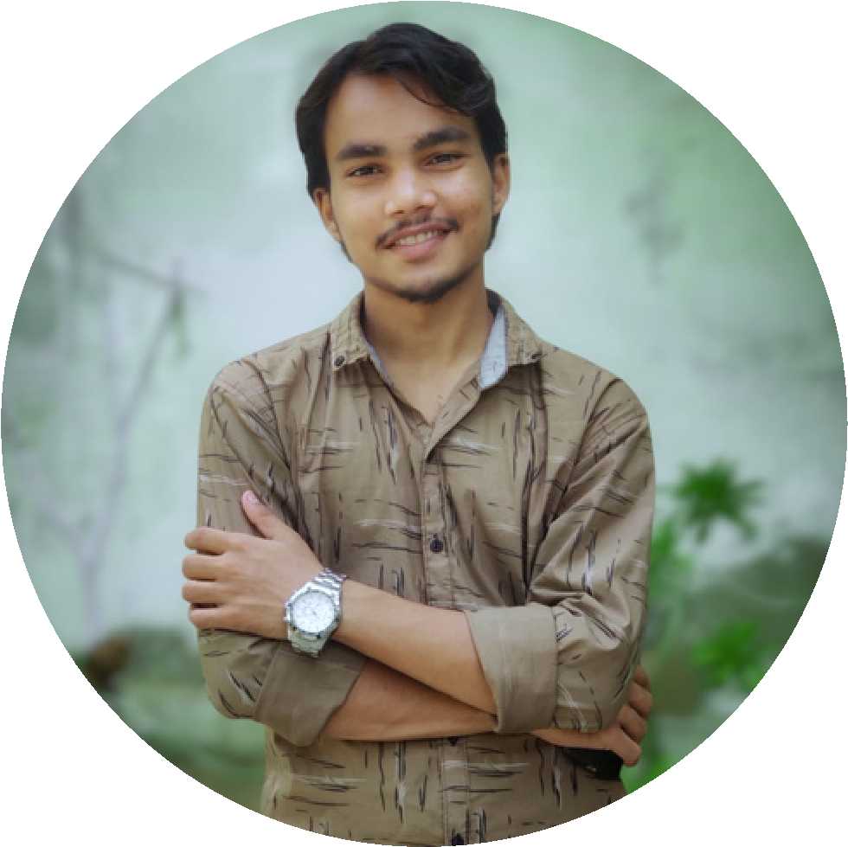
Hermain Acme Grammer School
TehseenAfroz
tehseenafroz2611@gmail.com
0312-1232511
Sector 14 Block G karachi, Pakistan.
TEHSEEN
AFROZ
RELEVANT SKILLS
MS Office
Willingness to Learn
Good Communication
Team player
LANGUAGE
English
Urdu
84%
Intermediate (2021)
Govt Dehli College
65%
Bachelor’s in Computer Science (Continue)
Federal Urdu University
Software Development
Web Designing
Cybersecurity
Networking
Data Entry

