QUESTION-1

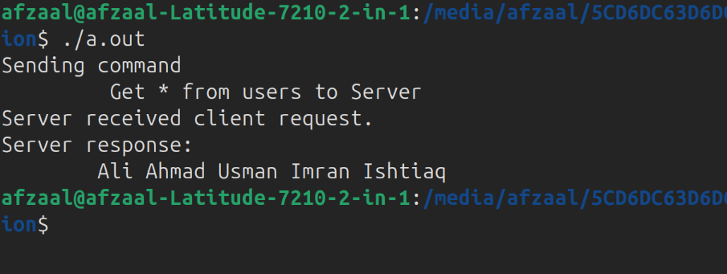

#include <stdio.h>
#include <sys/types.h>
#include <unistd.h>
int main(){
int c2s[2], s2c[2];
pid_t pid;
if(pipe(c2s)== -1){
printf("There is error in pipe creation from c2s.\n");
return 1;
}
if(pipe(s2c) == -1){
printf("There is error in pipe creation from s2c.\n");
return 1;
}

pid = fork();

if(pid == 0){
close(c2s[0]);
close(s2c[1]);

char command[] = "Get * from users";
printf("Sending command\n\t %s to Server\n", command);
write(c2s[1], command, sizeof(command));

char response[100];
read(s2c[0], response, sizeof(response));
printf("Server response: \n\t");
printf("%s\n", response);

close(c2s[1]);
close(s2c[0]);
}
else{
close(c2s[1]);
close(s2c[0]);

char command [100];
read(c2s[0], command, sizeof(command));
printf("Server received client request.\n");
char response[] = "Ali Ahmad Usman Imran Ishtiaq";
write(s2c[1], response, sizeof(response));

close(c2s[0]);
close(s2c[1]);
}
return 0;
}

