**Comsats University Islamabad**

**Lab – 06**

**Database Systems**

**Submitted to**

Ms. Nimra Iqram

**Submitted by**

Muhammad Ahmad (FA23-BCE-113)

**Computer Engineering**

**🡺School Management System:**

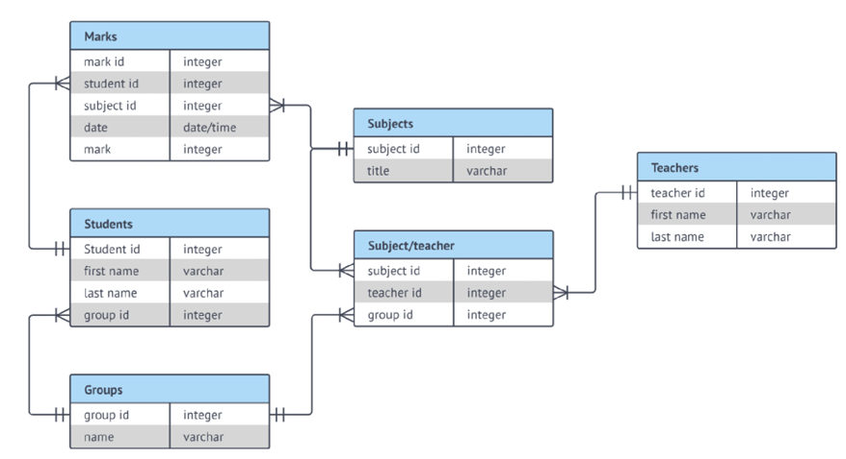

Table 1: A basic ER model of a school

🡺**TASKS:**

**Task 1: To implement an ERD as per the given requirements, entity sets must be created as provided.**

**CODE:**

-- Subjets

**create** **table** Subjects**(**

subject_id int **primary** **key,**

title varchar**(**50**)** **not** **null**

**);**

-- Teacher

**create** **table** Teachers**(**

teacher_id int **primary** **key,**

first_teacher_name varchar**(**15**)** **not** **null,**

last_teacher_name varchar**(**15**)**

**);**

-- Groups

**create** **table** Groups**(**

group_id int **primary** **key,**

group_name varchar**(**15**)** **not** **null**

**);**

-- teacher-subject

**create** **table** subject_teacher**(**

subject_id int **foreign** **key** **references** Subjects**(**subject_id**),**

teacher_id int **foreign** **key** **references** Teachers**(**teacher_id**),**

group_id int **foreign** **key** **references** Groups**(**group_id**)**

**);**

-- Students

**create** **table** Students**(**

student_id int **primary** **key,**

first_student_name varchar**(**15**)** **not** **null,**

last_student_name varchar**(**15**),**

group_id int **foreign** **key** **references** Groups**(**group_id**)**

**);**

-- Marks

**create** **table** Marks**(**

marks_id int **primary** **key,**

student_id int **foreign** **key** **references** Students**(**student_id**),**

subject_id int **foreign** **key** **references** Subjects**(**subject_id**),**

datte Date**, -- date is misspelled to make difference with datatype(DATE)**

marks int **not** **null**

**);**

**EXECUTION:**

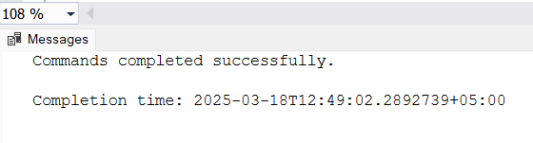

**ER-Diagram generated by SSMS according to my data**



**Task 2: Constraints/rules must specified for all entities as per the relationships in Table. 1.**

Constraints and rules are specified during the creation time (done above).

**Task 3: Populate the data with instances.**

I'm showing only 4 to 5 records to save space.

**CODE:**

**INSERT** **INTO** Groups **VALUES**

**(**1**,** 'BCE'**),**

**(**2**,** 'BEE-P'**),**

**(**3**,** 'BEE-E'**),**

**(**4**,** 'BEE-T'**);**

**INSERT** **INTO** Teachers **VALUES**

**(**1**,** 'Usman'**,** 'Rafiq'**),**

**(**2**,** 'Jehangir'**,** 'Arshad'**),**

**(**3**,** 'Modassir'**,** 'Ishfaq'**),**

**(**4**,** 'Imran'**,** 'Ahmed'**),**

**(**17**,** 'Sobia'**,** 'Baig'**);**

**INSERT** **INTO** Subjects **VALUES**

**(**1**,** 'Islamic Studies'**),**

**(**2**,** 'Discrete Mathematics'**),**

**(**3**,** 'Linear Algebra'**),**

**(**4**,** 'Digital Logic Design'**),**

**(**24**,** 'Entrepreneurship'**);**

**INSERT** **INTO** Students **VALUES**

**(**1**,** 'Ali'**,** 'Khan'**,** 1**),**

**(**2**,** 'Ahmed'**,** 'Raza'**,** 2**),**

**(**3**,** 'Sara'**,** 'Ali'**,** 3**),**

**(**4**,** 'Fatima'**,** 'Ahmed'**,** 4**),**

**(**5**,** 'Usman'**,** 'Khan'**,** 1**);**

**INSERT** **INTO** Subject_Teacher **VALUES**

**(**1**,** 1**,** 1**),**

**(**2**,** 2**,** 1**),**

**(**3**,** 3**,** 2**),**

**(**4**,** 4**,** 3**),**

**(**17**,** 17**,** 4**);**

**INSERT** **INTO** Marks **VALUES**

**(**1**,** 1**,** 1**,** '2023-10-01'**,** 85**),**

**(**2**,** 1**,** 2**,** '2023-10-02'**,** 90**),**

**(**3**,** 2**,** 3**,** '2023-10-03'**,** 78**),**

**(**6**,** 5**,** 6**,** '2023-10-06'**,** 80**);**

**EXECUTION:**

**Task 4: Analyze your implementation and see if the rules are implemented appropriately for all entities.**

**CODE:**

**SELECT** **\*** **FROM** Subjects**;**

**SELECT** **\*** **FROM** Teachers**;**

**SELECT** **\*** **FROM** Groups**;**

**SELECT** **\*** **FROM** Subject_Teacher**;**

**SELECT** **\*** **FROM** Students**;**

**SELECT** **\*** **FROM** Marks**;**

**EXECUTION:**

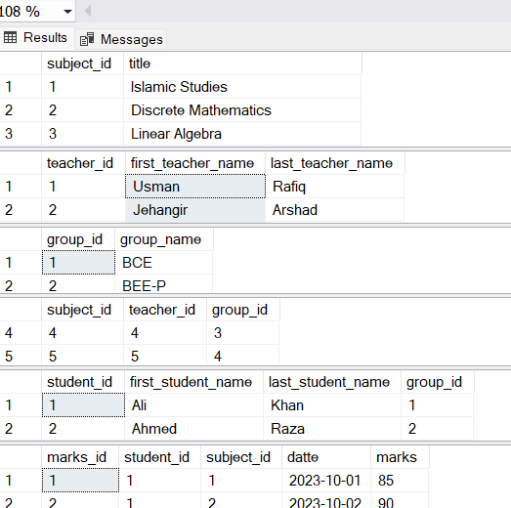

**Task 5: Retrieve the name of all students and teachers (Hint: Union operator)**

**CODE:**

**select** first_student_name **+** ' ' **+** last_student_name **as** student_teacher_names **from** Students

**UNION**

**select** first_teacher_name **+** ' ' **+** last_teacher_name **from** Teachers

**EXECUTION:**

**Task 6: Retrieve the name of all students of BCE group.**

--inner join

**SELECT** s**.**first_student_name **+** ' ' **+** s**.**last_student_name **as** students_of_BCE_group**,** g**.**group_name

**FROM** Students s

**JOIN** Groups g **ON** s**.**group_id **=** g**.**group_id

**WHERE** g**.**group_name **=** 'BCE'**;**

--sub-query

**select** first_student_name **+** ' ' **+** last_student_name students_of_BCE_group **from** Students

**where** group_id **=** **(select** group_id **from** Groups **where** group_name **=** 'BCE'**)**

**EXECUTION:**

**Task 7: Retrieve the name of all teachers who taught the students of BEE-E group.**

**CODE:**

**SELECT** **DISTINCT** t**.**first_teacher_name **+** ' ' **+** t**.**last_teacher_name **AS** teacher_name

**FROM** Teachers t

**JOIN** Subject_Teacher st **ON** t**.**teacher_id **=** st**.**teacher_id

**JOIN** Groups g **ON** st**.**group_id **=** g**.**group_id

**WHERE** g**.**group_name **=** 'BEE-E'**;**

**EXECUTION:**

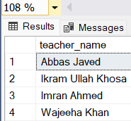

**Task 8: Retrieve the name of all students & subject name who were registered in any subject taught by Dr. Abbas Javed**

**CODE:**

**SELECT** **DISTINCT** s**.**first_student_name **+** ' ' **+** s**.**last_student_name **AS** student_name**,**

sub**.**title **AS** subject_name

**FROM** Students s

**JOIN** Marks m **ON** s**.**student_id **=** m**.**student_id

**JOIN** Subjects sub **ON** m**.**subject_id **=** sub**.**subject_id

**JOIN** Subject_Teacher st **ON** sub**.**subject_id **=** st**.**subject_id

**JOIN** Teachers t **ON** st**.**teacher_id **=** t**.**teacher_id

**WHERE** t**.**first_teacher_name **=** 'Abbas' **AND** t**.**last_teacher_name **=** 'Javed'**;**

**EXECUTION:**

No records

**Task 9: Supposedly, there is a student named Ali. Retrieve all subjects studied by Ali.**

**CODE:**

**SELECT** **DISTINCT** sub**.**title **AS** subject_studied

**FROM** Subjects sub

**JOIN** Marks m **ON** sub**.**subject_id **=** m**.**subject_id

**JOIN** Students s **ON** m**.**student_id **=** s**.**student_id

**WHERE** s**.**first_student_name **=** 'Ali'**;**

**EXECUTION:**

**Task 10: Building upon the previous task, retrieve the obtained marks too**

**CODE**

**SELECT** sub**.**title **AS** subject_name**,** m**.**marks **AS** obtained_marks

**FROM** Subjects sub

**JOIN** Marks m **ON** sub**.**subject_id **=** m**.**subject_id

**JOIN** Students s **ON** m**.**student_id **=** s**.**student_id

**WHERE** s**.**first_student_name **=** 'Ali'**;**

**EXECUTION:**

**Task 11: Continuing from the previous task, retrieve the teachers along with the previous details as well.**

**CODE**

**SELECT** t**.**first_teacher_name **+** ' ' **+** t**.**last_teacher_name **AS** teacher_name**,**

sub**.**title **AS** subject_name**,**

m**.**marks **AS** obtained_marks

**FROM** Teachers t

**JOIN** Subject_Teacher st **ON** t**.**teacher_id **=** st**.**teacher_id

**JOIN** Subjects sub **ON** st**.**subject_id **=** sub**.**subject_id

**JOIN** Marks m **ON** sub**.**subject_id **=** m**.**subject_id

**JOIN** Students s **ON** m**.**student_id **=** s**.**student_id

**WHERE** s**.**first_student_name **=** 'Ali'**;**

**EXECUTION:**

**Task 12: Retrieve the name of all subjects taught by Dr. Arsla Khan**

**CODE**

**SELECT** **DISTINCT** sub**.**title **AS** subject_name

**FROM** Subjects sub

**JOIN** Subject_Teacher st **ON** sub**.**subject_id **=** st**.**subject_id

**JOIN** Teachers t **ON** st**.**teacher_id **=** t**.**teacher_id

**WHERE** t**.**first_teacher_name **=** 'Arsla' **AND** t**.**last_teacher_name **=** 'Khan'**;**

**EXECUTION:**

**Task 13: Retrieve the name of students who are part of BEE-T group**

**CODE**

**SELECT** s**.**first_student_name **+** ' ' **+** s**.**last_student_name **AS** student_name

**FROM** Students s

**JOIN** Groups g **ON** s**.**group_id **=** g**.**group_id

**WHERE** g**.**group_name **=** 'BEE-T'**;**

**EXECUTION:**

**Task 14: Retrieve the name of teachers who are not teaching any subject**

**CODE**

**SELECT** t**.**first_teacher_name **+** ' ' **+** t**.**last_teacher_name **AS** teacher_name

**FROM** Teachers t

**LEFT** **JOIN** Subject_Teacher st **ON** t**.**teacher_id **=** st**.**teacher_id

**WHERE** st**.**subject_id **IS** **NULL;**

**EXECUTION:**

No records

**Task 15: Retrieve the name of students along with their grades for the subjects that were taught by Dr. Zaid Ahmed**

**CODE**

**SELECT** s**.**first_student_name **+** ' ' **+** s**.**last_student_name **AS** student_name**,**

sub**.**title **AS** subject_name**,**

m**.**marks **AS** obtained_marks**,**

**CASE**

**WHEN** m**.**marks **>=** 90 **THEN** 'A'

**WHEN** m**.**marks **>=** 80 **THEN** 'B'

**WHEN** m**.**marks **>=** 70 **THEN** 'C'

**WHEN** m**.**marks **>=** 60 **THEN** 'D'

**ELSE** 'F'

**END** **AS** grade

**FROM** Students s

**JOIN** Marks m **ON** s**.**student_id **=** m**.**student_id

**JOIN** Subjects sub **ON** m**.**subject_id **=** sub**.**subject_id

**JOIN** Subject_Teacher st **ON** sub**.**subject_id **=** st**.**subject_id

**JOIN** Teachers t **ON** st**.**teacher_id **=** t**.**teacher_id

**WHERE** t**.**first_teacher_name **=** 'Zaid' **AND** t**.**last_teacher_name **=** 'Ahmed'**;**

**EXECUTION:**

