**Labtask_3**

x = -2:0.1:2;

y = x.^2;

plot(x, y, 'b', 'LineWidth', 2);

xlabel('x');

ylabel('y = x^2');

title('Plot of y = x^2 for −2 ≤ x ≤ 2');

grid on;

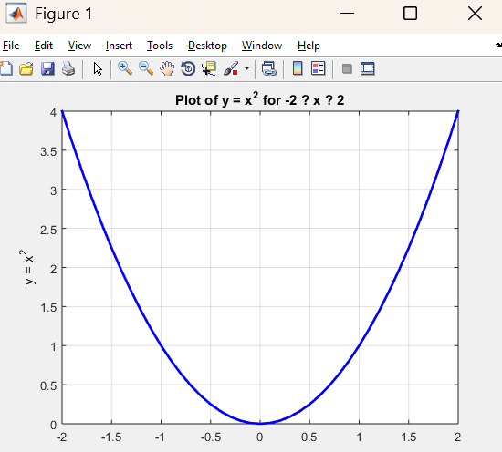

**Labtask_5**

x = linspace(0, 2*pi, 500);

y = x.^2 .* cos(x);

g = x .* cos(x);

subplot(2,1,1);

plot(x, y, 'b-', 'LineWidth', 1.5);

title('Subplot 1')

subplot(2,1,2);

plot(x, g, 'g--', 'LineWidth', 1.5);

title('Subplot 2')

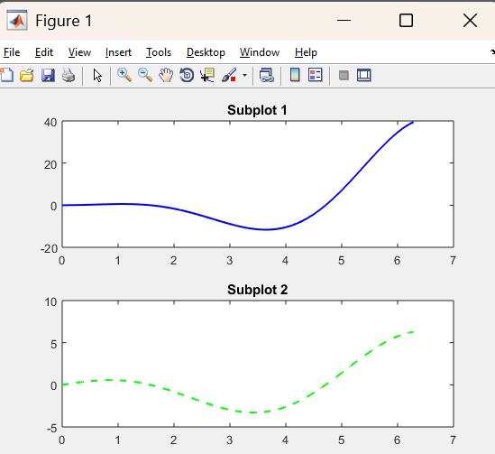

**Labtask_6**

n = -3:0.01:3;

% or

n = linspace(-3, 3, 50);

f= n.^2 ;

stem(n,f) ;

xlabel('Time Axis')

ylabel('Amplitude')

title('Graph of f(n)')

