**Pre_lab 01**

t=-5:5:5

x=cos(pi*t)

plot(t,x)

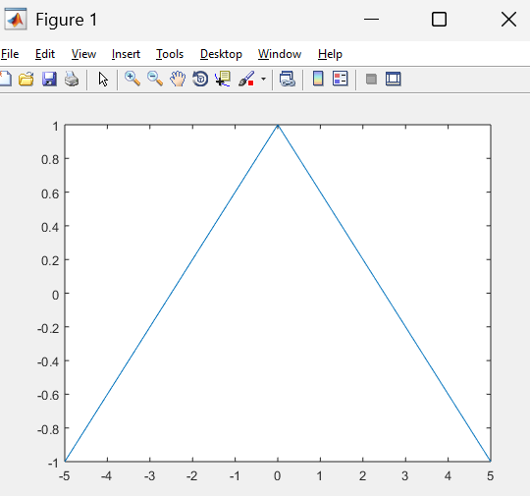

**Pre_lab 02**

t=0:0.1:2*pi/3;

y=exp(3*j*t);

plot(t,y)

xlabel('Time Axis')

ylabel('Amplitude')

title('Graph of f(n)')

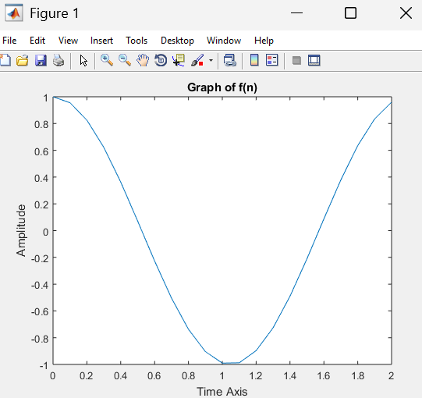

**Pre_lab 03**

R=8;

T=R/2;

t=-6:0.1:6

p=heaviside(t+T/2)-heaviside(t-T/2)

plot(t,p)

axis([-8 8 -0.1 1.2])

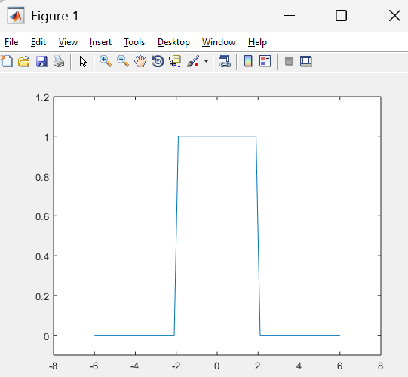

**In_lab 01**

%ROLL IS 113

t=-113:0.01:113

x=cos(t)

plot(t,x)

axis([-10 10 -1 1])

title(' continuous time signal x=cos(t)')

xlabel('time')

ylabel('amplitude')

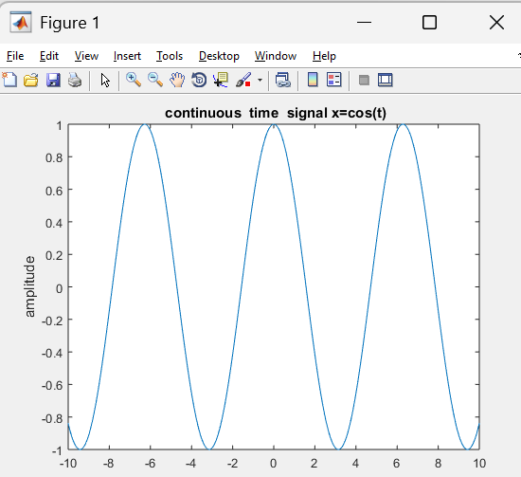

**In_lab 02**

%ROLL IS 113

n=-113:0.1:113

x=cos(n)

stem(n,x)

axis([-10 10 -1 1])

title(' continuous time signal x=cos(t)')

xlabel('time')

ylabel('amplitude')

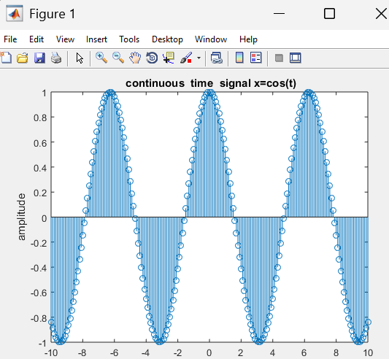

**In_lab 03**

%1

t1=-113:0.1:113

x1=cos(t1)

%2

n1=-113:0.1:113

x2=cos(n1)

% Plot both on the same figure

figure;

plot(t1, x1, 'b-', 'LineWidth', 1.5); % Blue solid line for linspace

hold on;

stem(n1, x2, 'ro', 'MarkerSize', 4); % Red circles for colon operator points

hold off;

axis([-10 10 -1 1])

% Labels and title

xlabel('Time');

ylabel('Amplitude');

title('Comparison of CT vs DT');

grid on;

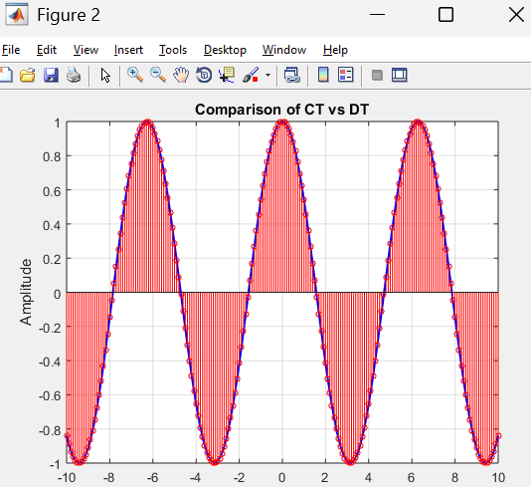

**In_lab 04**

**In_lab 05**

clc;

clear;

close all;

T = (2/3); % Fundamental period

t= 0:0.001:4*T;

x=3*cos(3*pi*t +pi/3)

% Plot the signal

figure;

plot(t, x, 'b', 'LineWidth', 2);

xlabel('Time (t)');

ylabel('x(t)');

title('Four Periods of 3 cos(3\pi t + \pi/3)');

grid on;

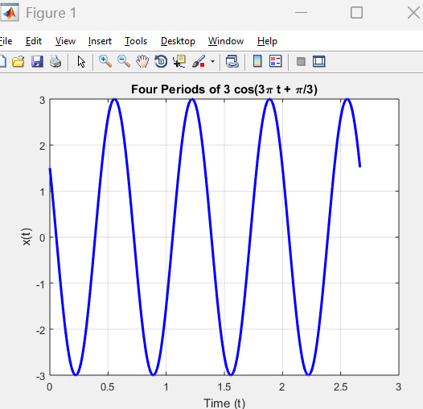

**In_lab 06**

t = -2*pi:0.01:2*pi;

x1 = cos(t);

x2 = sin(t + pi/2);

subplot(2,1,1); % 2 rows, 1 column, 1st plot

plot(t, x1, 'b', 'LineWidth', 2);

xlabel('Time (t)');

ylabel('Amplitude');

title('Cosine Wave: cos(t)');

grid on;

subplot(2,1,2); % 2 rows, 1 column, 2nd plot

plot(t, x2, 'r--', 'LineWidth', 2);

xlabel('Time (t)');

ylabel('Amplitude');

title('Shifted Sine Wave: sin(t + ?/2)');

grid on;

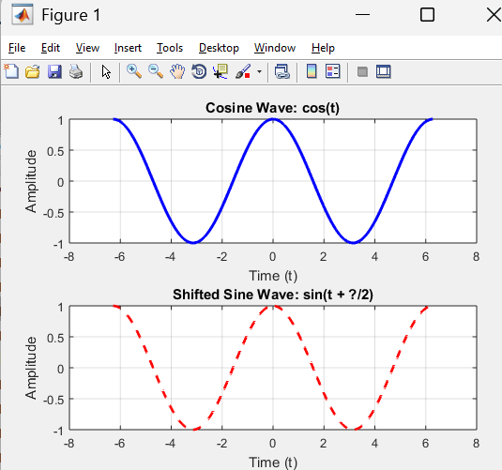

**In_lab 07**

A = 113;

B1 = A / 100;

B2 = -A / 100;

T = A / 2;

% Define time range

t = -T:0.1:T;

% Compute signals

x_t = A * exp(B1 * t);

y_t = A * exp(B2 * t);

% Plot signals using subplot

figure;

hold on

plot(t, x_t, 'b.', 'LineWidth', 2);

hold on

xlabel('Time (t)');

ylabel('Amplitude');

title('Signal x(t) = A e^{\beta_1 t}');

grid on;

plot(t, y_t, 'ro', 'LineWidth', 2);

legend('Growth Exponential', 'Decaying Exponential');

hold off

axis([-20 20 0 4000])

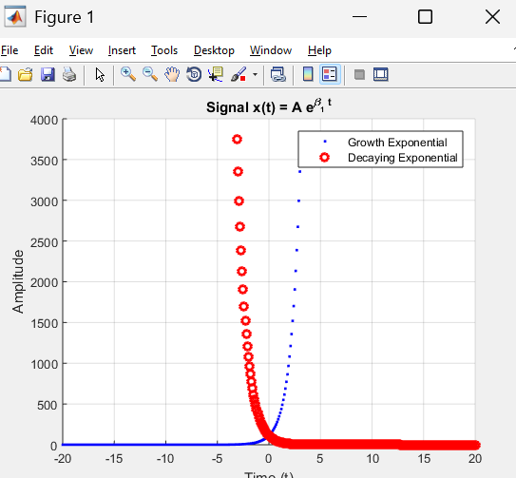

**In_lab 08**

T = 2;

t = 0:0.1:T;

y_t = exp(1j * (pi * t + pi/3));

real_part = real(y_t);

imag_part = imag(y_t);

hold on;

plot(t, real_part, 'b', 'LineWidth', 2);

plot(t, imag_part, 'r--', 'LineWidth', 2);

xlabel('Time (t)');

ylabel('Amplitude');

title('Real and Imaginary Parts of y(t)');

legend('Real Part: cos(\pi t + \pi/3)', 'Imaginary Part: sin(\pi t + \pi/3)');

grid on;

hold off;

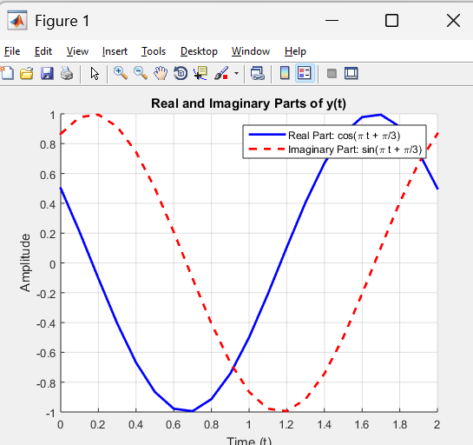

**In_lab 09**

t=-5:0.01:5;

x=heaviside(t)

plot(t,x)

axis([-8 8 -0.1 1.2])

**In_lab 10**

t = -5:0.01:5;

t0 = 2;

x = heaviside(t - t0);

plot(t,x)

axis([-8 8 -0.1 1.2])

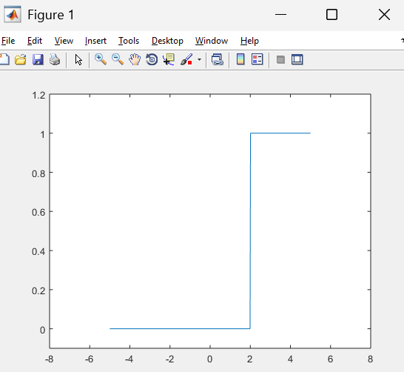

**In_lab 11**

t=-3:0.1:3

y= inf==dirac(t)

plot(t,y)

xlabel('Time')

ylabel('Amplitude')

title('Unit impulse using dirac(t)')

