**labTask 01**

t = 0:.1:2*pi

x=sin(t);

T=2*pi;

%using command window

for k=1:10

xk(k,:)=sin(t+k*T)

end

**labTask 02**

t = 0:0.1:6*pi;

x = cos(t) + sin(3*t)

plot (t,x) 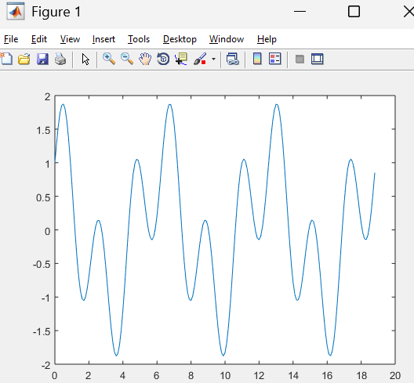

**labTask 03**

subplot(311)

% Causal Signal (t >= 0)

t = 0:0.1:5;

x = t .* exp(-t);

plot(t, x)

title('Causal Signal')

subplot(312)

% Anti-Causal Signal (t <= 0)

t = -5:0.1:0;

x = t .* exp(-t);

plot(t, x)

title('Anti-Causal Signal')

subplot(313)

% Non-Causal Signal: x(t) = t*exp(-t) for t from -5 to 5

t = -5:0.1:5;

x = t .* exp(-t);

plot(t, x)

title('Non-Causal Signal')

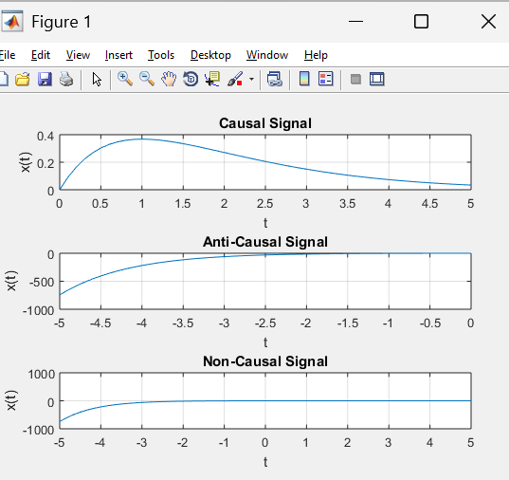

x = -10:0.1:10;

y_even = x.^2;

y_odd = x.^3;

plot(x,y_even)

figure

plot(x,flip(y_even))

plot(x,y_odd)

plot(x,-flip(y_odd))

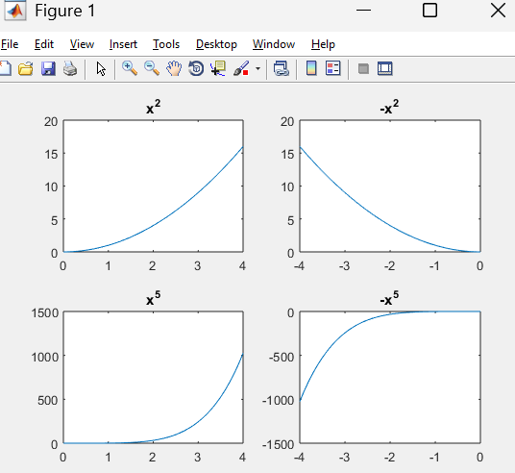

**labTask 05**

n = -113:113;

u = heaviside(n);

u_neg = flip(u);

u_even = (u + u_neg) / 2;

u_odd = (u - u_neg) / 2;

u_reconstructed = u_even + u_odd;

**labTask 06**

syms t T

x = heaviside(t);

d = int(abs(x)^2,t,-T,T)

Ex = limit(d,T,inf)

Px = limit( (1/(2*T))*d,T,inf)

**labTask 07**

syms t T

x = 2 * cos(pi * t);

enrg_integral = int(x^2,t,0,2);

Ex =enrg_integral

Px = Ex / 2

**labTask 08**

t = -1:0.1:3;

% x(t)

x_t = t .* exp(-t);

% x(-t)

x_neg_t = (-t) .* exp(t);

% Plot both signals

figure;

subplot(211);

plot(t, x_t);

title('Original Signal x(t)');

subplot(212);

plot(t, x_neg_t);

title('Time-Reversed Signal x(-t)');

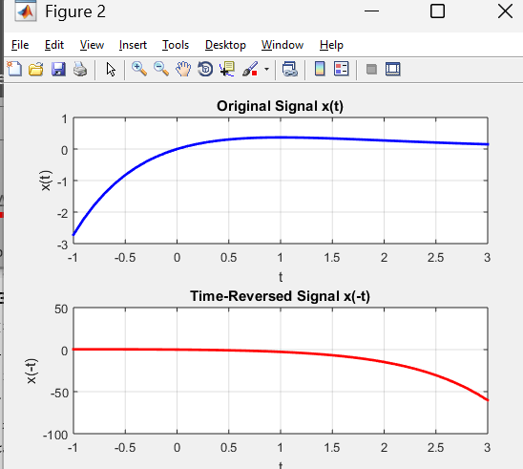

**labTask 09**

t = -1:0.01:3;

x_t = t .* exp(-t); % Original signal x(t)

% Time compression (a = 2): x1(t) = x(2t)

x1_t = (2*t) .* exp(-2*t); % *2 with t

% Time expansion (a = 0.5): x2(t) = x(0.5t)

x2_t = (0.5*t) .* exp(-0.5*t); % *0.5 with t

% Plot the original and scaled signals

figure;

subplot(311);

plot(t, x_t);

title('Original Signal x(t)');

subplot(312);

plot(t, x1_t);

title('Time-Compressed Signal (x(2t))');

subplot(313);

plot(t, x2_t);

title('Time-Expanded Signal (x(0.5t))');

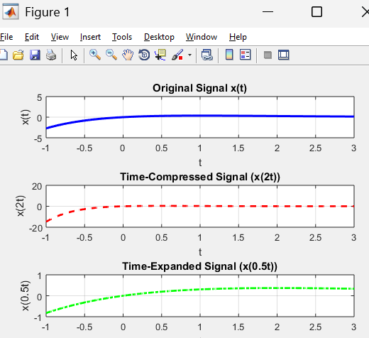

**labTask 10**

t=-1:.01:3;

x_t = t .* exp(-t);

x1_t = (t - 2) .* exp(-(t - 2)); % put t = t-2

x2_t = (t + 3) .* exp(-(t + 3)); % put t = t+3

subplot(311)

plot(t,x_t);

subplot(312)

plot(t,x1_t,);

subplot(313)

plot(t,x2_t);

