**TASK1**

syms t w

x = exp(-t^2)

x1= fourier(x)

x2=int(x*exp(-j*w*t),t,-inf,inf)

**TASK2**

syms t w

Xw = 1 / (1 + 1*j*w);

x1 = ifourier(Xw);

x2 = ifourier(Xw, t);

x3 = ifourier(Xw, w, t);

**TASK3**

syms t w

c =exp(-t) * heaviside(t)

X = fourier(c,w)

**TASK4**

syms t w

X = sin(pi*t)/(pi*t)

b = fourier(X,w)

ezplot(b,[-10 10])

**Plot:**

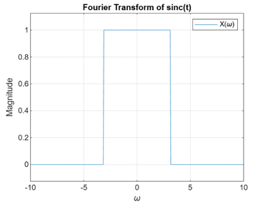

**TASK5**

syms t w

X = t * exp(-3*t) * heaviside(t);

C = fourier(X, t, w);

w1 = -20:1:20;

B = subs(C, w, w1);

**TASK6**

subplot(2, 2, 1);

plot(w1, abs(B), 'LineWidth', 1.5);

title('Magnitude');

xlabel('\omega'); ylabel('|X(\omega)|');

grid on;

subplot(2, 2, 2);

plot(w1, angle(B), 'LineWidth', 1.5);

title('Phase');

xlabel('\omega'); ylabel('\angle X(\omega)');

grid on;

subplot(2, 2, 3);

plot(w1, real(B), 'LineWidth', 1.5);

title('Real Part');

xlabel('\omega'); ylabel('Re\{X(\omega)\}');

grid on;

subplot(2, 2, 4);

plot(w1, imag(B), 'LineWidth', 1.5);

title('Imaginary Part');

xlabel('\omega'); ylabel('Im\{X(\omega)\}');

grid on;

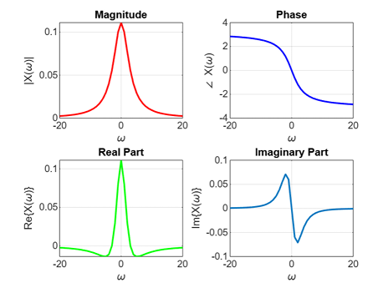

**TASK7**

syms t w

h = exp(-t) * heaviside(t);

x = exp(-t) * cos(2*pi*t) * heaviside(t);

H = fourier(h, t, w);

X = fourier(x, t, w);

Y = H * X;

Z = ifourier(Y, w, t);

subplot(2, 1, 1);

fplot(Z, [-10, 10], 'b', 'LineWidth', 1.5);

title('Convolution via Fourier Transform');

xlabel('t');

ylabel('y(t)');

grid on;

legend('Symbolic Result');

t1 = -10:0.1:10;

h_num = exp(-t1) .* (t1 >= 0);

x_num = exp(-t1) .* cos(2*pi*t1) .* (t1 >= 0);

y_num = conv(x_num, h_num, 'same') * 0.1;

subplot(2, 1, 2);

plot(t1, y_num, 'r', 'LineWidth', 1.5);

title('Convolution via Numerical Method');

xlabel('t');

ylabel('y(t)');

grid on;

legend('Numerical Result');